Top Students  Inspired by a Captioned Image  From vthunder42 on Deviant Art  By Maryanne Peters  Of course we could have just said that it was a draw. We both won. But we both lost too. Why go through with the makeover? I guess that we both wanted to see how we might turn out. We just looked at one another and we both knew. And losers have to pay a price.  The class knew all about the bet. I guess there were plenty of guys who wanted to see Jen in skirts and makeup. Some may have thought that she cold really look great if she was prepared to try. I could not imagine anybody wanting to see me in drag.  But it was competition that started this who thing. I guess I am just competitive by nature. So when we turned up at the salon side by side and Sally the head beautician said: “It is hard to say which one of you might turn out the prettier”, I just wanted it to be me.  That means going along with everything that she suggested. I mean the extensions, the eyebrow plucking, the facial, the full body wax. It was me insisting on the full treatment, and Jen tagging along behind to keep up.  But by the time that I knew I had gone too far, I had. I had gone too far.  Sure, my Mom loved my look like crazy. I just snarled, but the truth is on my face it that pose in front of the fire: I loved my look too.  We had both gone shopping together before the salon. Dresses and shoes where new to both of us, but the ladies in the shop were helpful, and there was even more help for me in the underwear department to ensure I had the right shape | 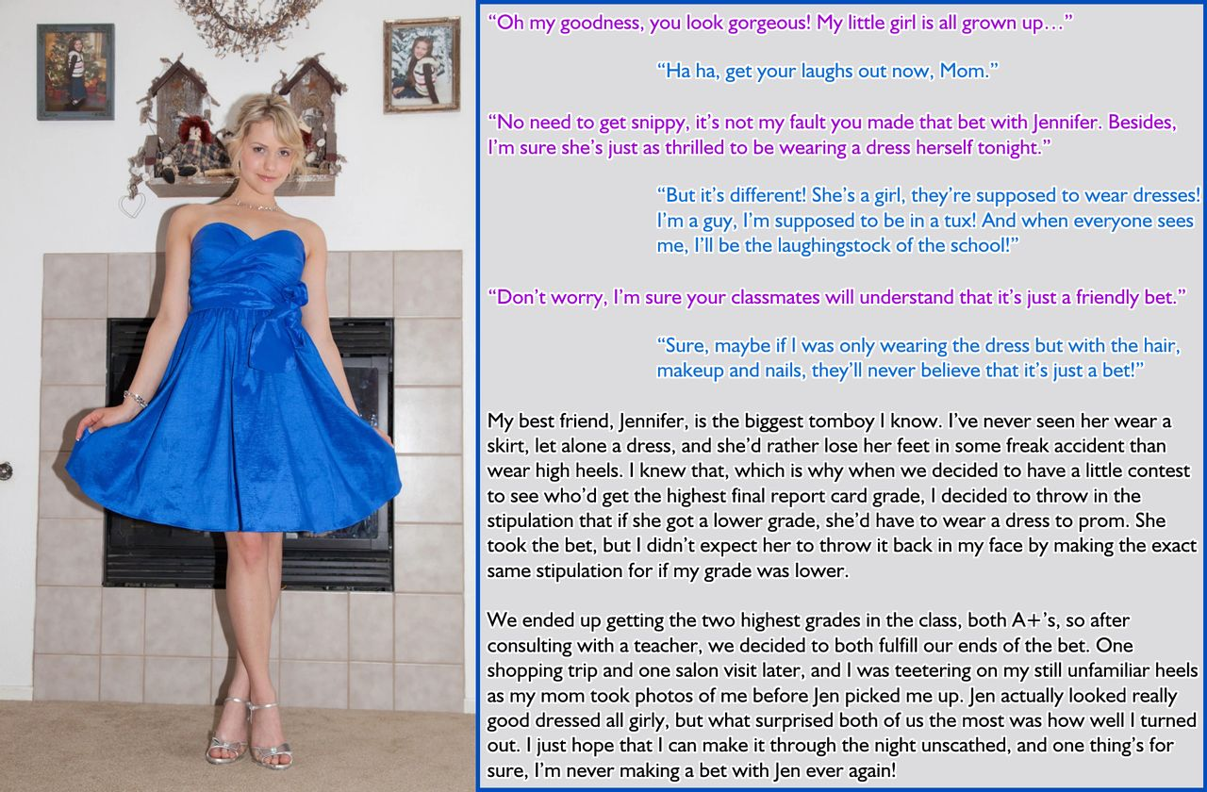

As for learning how to walk in heels and present in a lady like fashion, that was pretty much new to both of us as well. It was not that Jen was rough, it was just that she was more keen on study that in being pretty. I was the same. After Matt Kowalski and Jimmy Halcombe we were the top students the scholars. None of us was too concerned with high school social activities. The prom was going to be our first and probably our last social event.

Then my mother ended up talking to Jen’s Mom and inviting them both around to our place.

“We have been talking,” Mom said. “With you two looking so beautiful it seems wrong to us that you should be going to the prom together as two girls. So we have made some calls and we have arranged dates for you tonight. Matt Kowalski and Jimmy Halcombe are going over in twenty minutes, so I you had better check your lipstick, both of you.”

“That’s crazy. Those guys would not want to take us to Prom,” Jen said.

“They have been running around since we suggested it, getting tuxes to wear,” her Mom said. “And Matt has specifically asked to accompany you, Richie,” she said to me. “So I suppose you will need to answer to Rachel tonight!”

Like Jen said to me later that evening – she said that she never realized how good-looking Jimmy was before that night. She had only admired his intellect, and never his body. But now with Jimmy looking at her and drooling, she suddenly started looking at him differently.

Of course, it could not be like that between me and Matt, but yet it was. He was the perfect gentleman. He was not just a scholar but a bit of a jock too, so nobody was going to tease him about his date. Instead everybody just looked at me in amazement. I just clung to Matt’s arm and smiled.

It was like Sally at the salon said to me: “Brains are great, and beauty is good too, but brains and beauty are the best combination ever.” Matt thinks so too.

The End

© Maryanne Peters 2020

Replacing my Baggage  Inspired by TG-Man on Deviant Art  By Maryanne Peters  So that was the story I had to say to Customs and TSA. I mean I don’t look anything like my passport photo. Not any more. I just felt that I could not explain my personal background. And the truth of it was that it was a bit like what I said. It just came over me.  My bags had disappeared – that was true. Apparently they had got chewed up in the baggage handling machinery, together with a few others. Heading home with all the men’s clothing I had bought in Milan, now just oily rags stuck in some cogs or conveyor belts.  I had nothing. Except I did have that policy on my credit card, and receipts for everything I had lost. They said as I was still there in Milan Malpensa I could buy replacement clothing.  I was not asleep, but I woke up then and there. I was talking on my phone and looking across at a boutique with just the most gorgeous outfit in the window. It is the one I am wearing. A pink shawl jacket with matching pants, and a grey top to match the lining. Women’s clothes. My secret desire.  I have always wanted to wear women’s clothes. Maybe that was why I went into fashion, but I ended up in menswear. Because the truth is that I had found out that women’s clothing was not enough for me. I needed to be a woman.  Now I was in a foreign country with nothing to wear and money to spend. I woke up. I could make this happen. Right here. Right now. | 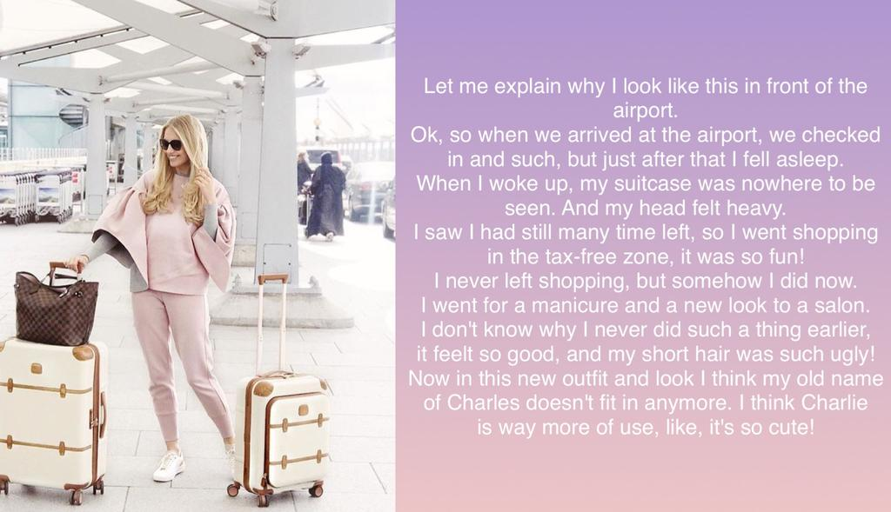

I had time. The baggage handling collapse had delayed the flight. I could buy everything and still have time to go to the salon right there in the departure area. Once I had bought my new outfit and filled my two new suitcases I still had hours to get the body wax, the manicure, the blond hair extensions and the makeover. I was in heaven.

Honestly, I never even thought about the consequences. It was as if a huge burden had been lifted off my shoulders. I could consign Charles to history and be Charlie, the woman I had always dreamed of being.

The truth is that I never spent enough time with trans-people to understand it, but does it happen this way for others? You fight it and tell yourself that you will beat it, and then one day you just look across and say: “Fuck it. I am going to do it!”

And I had the credit card in my hand and I was talking to card company and the guy said: “You are all good to go, Sir. You can buy up to that value.” And I was looking at the very thing I wanted to buy, and it was so stylish and feminine, and pink.

“Thank you,” I said. “And its not Sir. It’s Miss.”

The End

© Maryanne Peters 2021

The Music Festival  Inspired by a Caption  By Maryanne Peters  We met these two guys, Jack and Ben, at the music festival. I mean, you are never going to meet two bigger assholes than these guys. Dirty long hair, beards, smelly clothes, loud, objectionable, and out of their tiny minds on weed. | 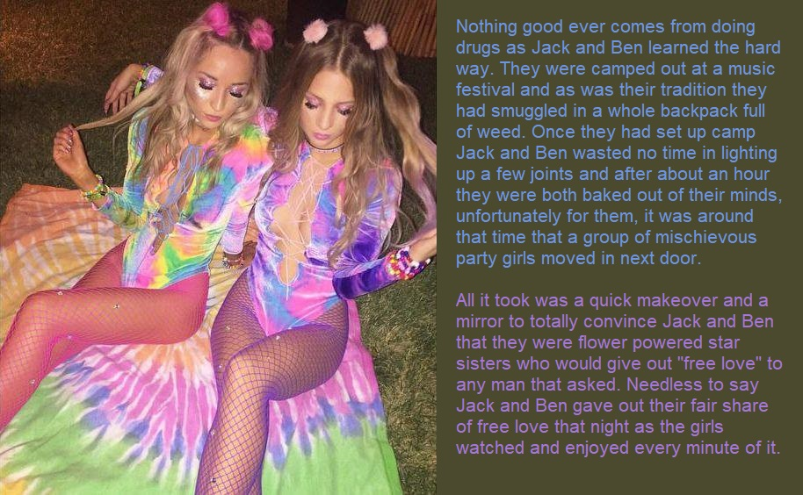

They had a van parked up next to our plush RV in a section of the camping ground set aside for auto-campers. They made our lives a misery from the day we arrived, two days before the music even started. So, my girlfriends and I got to thinking about how could deal with it. Short of killing we needed to send them away. Have them look for “free love” elsewhere. And to do that we needed to put these guys under our control.

We had party drugs, but we also had something special. I won’t give the name because guys out there will want to find it and use it for all the wrong reasons. But we had that stuff, and also a bunch of other “Non-recreational” drugs. You see, all four of us were studying pharmacology and two of us (me included, I have to admit) were a little light-fingered when it came to discarded pharmaceuticals.

Anyway, one of the girls said: “If only they were girls instead of guys, we would not have a problem.” That got us to thinking. Could we?

Well, we had the stuff on hand. We had sedatives to sow them down, soporifics to knock them out, facial depilatory compounds to rip out their beards, creams to condition their faces, wax to strip all the hair from their bodies, and powerful hormones and hormone blockers to play with their bodies.

It was easy to lure them into our RV and do everything. Plus we had everything we needed

We were all very surprised how well they turned out. They really did look like girls. Their hair came up really well, and with a bit of color it was spectacular. They must have had good enough bone structure, because the makeup we applied transformed them.

“It’s a pity that these massive doses of hormones are going to take so long to take effect,” somebody said. “These new girls need to have the bodies to match those gorgeous heads.”

There was nothing for it, we needed to order some made to measure body shapers from Glamor Boutique and have them forwarded by DHL direct to us. They arrived just before the first act went on stage. We squeezed Jackie and Bella into them complete with the matching tie-dyed leotards and fishnet hose.

We gave each of them a shoulder bags containing just the essentials for a music concert: Lipstick, mascara, Kleenex and condoms.

These Glamor Boutique body shapers are incredible. With a little concealer the boobs look totally real and feel like it to. There is a built in cincher and some hip and ass padding to create that hourglass shape. The groin area tucks away little penises no problem at all, and best of all they come with a string coming out of that realistic fake pussy and a hole surrounding the asshole. Woops, it’s rag week but give it to me up the back!

I can tell you, they got plenty of that free love they were looking for.

Jackie and Bella staggered out of our RV and off to the action in about the same state as we found them, drugged up to the eyeballs and not sure whether they were Arthur or Martha. But we know that it was definitely Martha, right?

The End

Cuckolded  From one of Sydney’s Sissy Caps  By Maryanne Peters  I always knew that I was gay, and more a catcher than a pitcher. But I never wanted to be a woman. That was his idea.  “Honey, I can’t be seen with a guy. I am a professional sportsman. I need a girl on my arm.” I can still hear the words. | 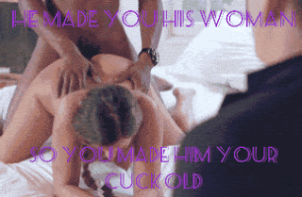

“Just grow out your hair and grow some little tits on your chest. It is not like you have a body like mine. You could dress up a bit in public. People can do the work on you for public appearances. And in bed, we would still be the same. I will suck your cock and the ream out your ass.”

Why did I agree? Because it seemed to me that he was making a proposal for a long term relationship. I would have preferred that he come out as gay, but I understood why he could not, at that stage in his career. So I did as he asked. I took the hormones and watched my cock with away to just a tassel to pee out off; I watched my hard body become soft, and the boobs and butt even; I grew my hair half way down my back.

I did everything he asked because I thought he loved me. Maybe he still does, but he needs to thrust his cock between hard hairy cheeks, and that is not me anymore.

Whatever the reason, when I found out I knew what I had to do. There was only one guy in his team that new my secret, and he was always secretly flirting with me.

“I have never fucked a chick with a dick before, so if you are ever available?”

Before he betrayed me, I never was. But I made sure that when he got home that afternoon his teammate was donkey deep inside me and I was pushing back.

Feast your eyes on this, Cuckold!

The End

My Father’s Debts  Inspired by a Captioned Image by Think Pink  (https://www.deviantart.com/think-pink1)  By Maryanne Peters  Do not think for a minute that my father traded me to pay his debts. My father loves me, and I love him. If I had refused, he would have taken a bullet for me. I don’t doubt that. I was just not prepared to let that happen.  “The Red Room” private club was an illegal joint, and nothing short of cash would satisfy them. My father offered to do any work for them, and I offered too. I said that if they wanted a floor show I could do my “Polly Tix” comedy drag routine that I had put on at the college revue. It was not a great act, but I looked good enough.  The manager said that if I was any good, I might buy my father a day or two, so I did my best. What I was not excepting was for Enzo to fall for me.  I guess that he was gay. He knew that I was a guy. It was just that he liked his boys to be girls. He was quite particular about what he wanted.  Once I understood that, I led him on, I guess. I wanted my father to live. I told Enzo that I would do whatever he wanted if he would make sure that my father was not maimed or killed.  “Baby, all I want is you,” he said. | 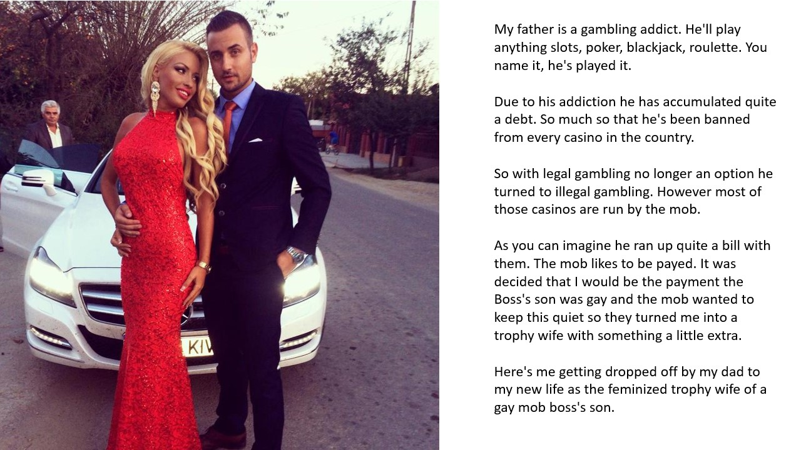

That meant he wanted me the girl on stage, to be his girl, 24 hours a day, seven days a week. It could no longer be an act. It had to be full time. No wig – hair extensions; No falsies - breast implants; and hormones to soften my body.

It sounds like a horror story, but I was ready to carry my father’s debts. And after a while, that became no burden. As it turns out, life with Enzo is cruisy. He likes the good things in life, and (as I have discovered) so do I. But most of all, he likes me, and he likes being with me. He says that there is no other woman like me, and I have to agree, because (as I like to say) I am not one.

Although with every passing day I am not so sure of that. Because each day as Enzo’s girlfriend makes me a little more of a girl. I wonder if it is love. Can it be?

Dad is Enzo’s driver these days. That is him stepping out of the Mercedes to admire his beautiful daughter and her handsome man. He is safe now. He knows it and I know it.

I think when it comes to giving me away, he will be a proud man. But I have made it clear to Enzo: If he wants me to say yes, he will have to scrub my father’s debts.

The End

© Maryanne Peters 2022

