Walkthrough for Shuggerlain v.0.22

Prologue Part
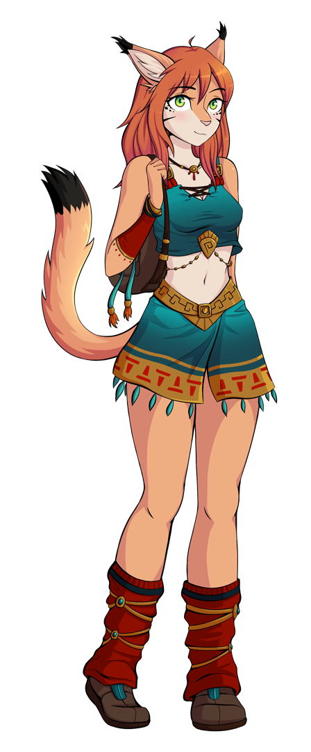In this part of the game there are no bad or good choices in the story, as it’s a prologue and it’s still quite linear. However we’ll tell you useful information for the combats of the update.
The first one is the encounter with the lesser succubus Misha. To make sure she’ll attack you in the alley, make sure to have breakfast both times you have that option available. Otherwise she won’t appear and you’ll miss the event.
After that, you only need to have a walk at night with Dynae to activate the event.
After Dynae leaves with the two Ashteran girls, Misha will appear. At that point select free her to start the combat. “Scare her” option will do exactly that and you’ll miss the event.
Ok, now you’re in the combat.
You have avaiable the following attacks from the beginning (and how many damage points every action takes to her health bar):
Kiss her: 8 damage points
Kiss her neck: 7
When Misha’s health drops under 90 you’ll also have:
Touch her breast: 9
When Misha’s health drops under 70 you’ll also have:
Nipples: 9
Stimulate Crotch: 11
When Misha’s health drops under 55 you’ll also have:
Finger her: 9
When Misha’s health drops under 40 you’ll also have:
Sex: 16
So basically the most effective combination with Misha would be: Kiss, breast, crotch and sex
Misha will also attack you. And like you, some of her attacks will become unlocked when Nulkan’s HP drops down:
Kiss: 6 damage points
Kiss neck: 5
Handjob: 9 (Needs Nulkan’s HP under 80)
Lick tip: 10 (Needs Nulkan’s HP under 80)
Assjob: 12 (Needs Nulkan’s HP under 60)
Blowjob: 12 (Needs Nulkan’s HP under 60)
Titjob: 12 (Needs Nulkan’s HP under 60)
Anal Sex: 11 (Needs Nulkan’s HP under 60)

With all this, you’ll have the tools to beat this lynx girl and avoid other men to suffer under her charms :D

LITTANOS BATTLE
Shuggerlain uses a combat system we called VN battles. First of all you need to understand the 3 phases in it.
Tactic phase: In this phase you’ll have to take decisions that will affect directly to the battle.
Choose the correct option to reduce the damage taken and maximize the damage you cause.
Correct choices will also generate 50 fever points. Neutral decision 20 points. Bad ones 0 points.
Skill Phase: In this phase you’ll be able to spend generated fever points in powerful skills. In battle, you confront bigger enemies, so the skills of your heroes are essential to make victory happen.
This phase comes always after finishing your tactical phase.
Combat Phase: Questions 3, 6 and 9 are Combat Phase questions. It’s similar to tactic phase, but in this case you have to choose which unit will confront a specific enemy unit. For this, you’ll have to take into account the strong points and weak points of your units and the enemy’s.
In this battle you’ll only manage infantry and light cavalry units. What you need to know for this update is that a same unit type (let’s say infantry) will always do a neutral damage to their own type (it means, another infantry).
Light Cavalry is good against Ranged units, like Mages (they are quick to avoid combat with other soldier, they can reach fastly their target and they are agile enough to avoid the most of the projectile attacks).
In future walkthrough we’ll do a more complex and comphrensive damage sheet, but for now it’s not really necessary.
So basically, the best options for winning the Littanos Battle would be:
- Command Occultattions Spell
- It’s time. Charge!
- Light Cavalry
- Calm her down
- Nadine! Fall back!
- Infantry/Light Cavalry (Both cause neutral damage as there are not better units available yet.)
- Let them escape. Focus on the remaining ones.
- Send Nadine to charge against that flank.
- Infantry/Light Cavalry (Both cause neutral damage as there are not better units available yet.)
- Scream something to humiliate him.
Of course, don’t forget to use the skills when you can.
With these choices Tregor’s army will be way below the 3000 and you should win the battle.
Notice that all values in battles are temporary and they may change in future updates in order to balance the combat and the units.

Yalen (after finding Izuin)
The beginning of the update is pretty linear. Just go ahead and after some time...you’ll be fighting against Yalen’s army.
YALEN BATTLE
To win this battle just try to select the correct choices and just use 1-2 skills at max, because you need the fever points for Dynae’s spell (200).
If you spam skills in this battle, you’ll lose. Also, some choices will require fever points.
- Reposition behind the mages
- Tortoise formation
- Light Cavalry (Note: cavalry > ranged units)
- Retreat for now (Note: cavalry is good against range, but they suffer in battle)
- Keep close to araxian infantry
- Infantry
- Heal them
- Knockout Phenn
- Light Cavalry
- Kill that bastard
After the battle you’ll be able to acces to the camp. Do what the game says and visit Nadine to congratulate her great job in battle.
Surprise! She’s masturbating thinking about Nulkan. At this point you may want to save your game because you’ll have to decide: let her releave you or go back to your tent.
-First option will unlock a Nadine handjob scene + 30 xp points of relationship with Nadine
-Second option will unlock a Dynae blowjob scene + 30 xp points of relationship with Dynae
After that, there’s no much more to do so go to your tent and Rest.

Next day is pretty linear, just go ahead and...be witness of the happenings.
The next day, you’ll only be able to visit Dynae’s ceremony. Do that.
After the HAPPENING, you’ll talk with Dynae and among other things, she’ll give you a stone of spacial convergence. This will be useful for future dates (not now).
Ok, so...you’ve heard Dynae. With the current situation, you’ll have to start knowing better the girls of the game. You’ll be able to visist Dynae (no options available with her for now), Nadine, Luth and Saraith.
Talk and Ask with them. When your level with one of these girl is 3, you’ll be able to date them. On the date you’ll only need to select the correct choice to trigger the H-scene. It’s pretty easy, but anyway:
Nadine -> Kiss her
Luth -> Obey the voice
Saraith -> Move her away by her shoulders

There no much more to do in the camp. If you talk 3 times with your soldiers on the next battle you’ll start with 50 fever points (instead of 0), but as there’s no more battles yet, it has no real use in this update.
After these 3 dates, go to your tent and decide to advance to Nocverchis (next nation). Of course, this is not developed yet, but an event will trigger. After that the update finishes.

GIFRIX SEX BATTLE
To trigger it, wait at least until day 7. Then, in the camp, select “Take a walk through camp’s surroundings” when your actions points are just 1.
Tips
Gifrix is a Nocverchan, a bat-human race. She will regenerate after any attack where she uses her mouth and gets Nulkan’s fluids. These attacks are:
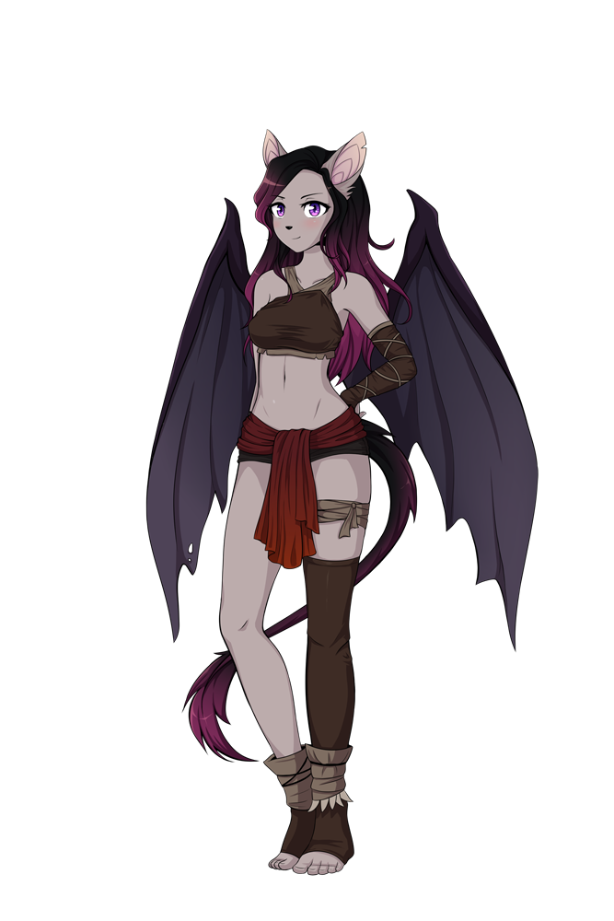
[You kiss her] [She kisses you] [Lick tip] [Blowjob]
You want to avoid these attacks. Well, in fact, the only thing you can avoid is kissing her, so at the beginning just kiss her neck.
Too hard? Don’t worry. Gifrix has a weak point. She’s very sensitive in the nipples. So focus on them to be sure you win. If she doesn’t perform too much blowjobs or other hard attacks, you can also check other attacks just to see the animation :)

Nocverchis
Once you travel to Nocverchis, land of bat furries, you’ll meet them and things won’t be easy at first. You’ll find some inhabitants of Nocverchis that don’t seem happy to meet you. Anyway, go ahead until you have your camp installed.
In the camp, you’ll be able to do the regular actions but if you want to go ahead with the plot, just spend some points until your action points is 1. Then, you’ll have a visit in the camp: a Nocverchian girl.
The next day in the morning, the camp will suffer an attack. If you want to succeed in this battle read carefully the next lines:

NOCVERCHIS BATTLE
- Take into account which the objectives to win this battle are: Nocverchis forces can’t be below 3000 and gather 300 fever points.
During this battle you don’t want to kill as many enemies as you can, but give enough time to Dynae. If you kill too much, you’ll be able to go ahead with the game, but Nocverchis will never be your allies, and of course Vex won’t be joining you.
- Decisions can be classified in:
  - Defensive: You suffer and cause less damage. You want to go for these options to succeed in this battle.
  - Suffering damage: you don’t deal much damage, but Nocverchians make important damage to your forces. You could still succeed with these decisions, but as your army size is accumulative and you will have to spend money to replenish your army from the casualties. These decisions are not very recommended.
  - Causing damage: you cause lots of damage to the Nocverchians. A few of these decisions are enough the screw the battle and make impossible the alliance with Nocverchis.
- In this battle try not to use skills. You may need the fever points and the skills are only causing more damage to the Nocverchians. We don’t want that.

You can try to succeed with those hints... or just select the following choices:

- Circle formation around the camp.
- Nadine! Don’t lose sight of them.
- Infantry (Mages cause and suffer too much damage, and Nadine’s cavalry squad is just not effective against flying units)
- Position next to Dynae.
- Dismount and protect your horses.
- Infantry
- Not a big problem
- Damn! Come back! To the center of the camp!
- Infantry
- Cavalry behind the soldiers! Soldiers shields up!
Once you’ve won the battle, go ahead and you’ll be in the camp again. To advance through the plot, visit the Shaman.
After talking with the Shaman and once you’re in the camp again, now select Explore the north of Nocverchis, to keep going with the plot.

Now you’ve resolved everything in Nocverchis, we’re done. But of course, don’t forget to keep talking with Saraith, Nadine, Luth and now Vex to improve your relationship with them and of course unlock new dates and H-scenes :)

New dates
The correct decisions to trigger the H-scenes on these dates are:
- Luth (requires affection level 6). On date 2, “Know better about you”.
- Nadine (require affection level 6). On date 2, “No, enough for today”.
- Saraith (requires affection level 6). On date 2 “I will not be prey”.
- Vex (requires affection level 3). On date 1 “Think about it”.

3rd Succubus


To trigger this event you need to spend 6 days on the camp being in Nocverchis. When the event starts, three Yalenite mages will talk with Nulkan. Select “Go ahead with the tests”
Now you have 3 different options. All of them will unlock some sexy content:
- Go behind the trees: Ione will drink Nulkan’s cum from a flask.
- I’d need something enticing...: shows a topless Ione.
- Reject: to start the sex battle.

This battle is a bit harder because Ione has some really powerful attacks and some supposedly Nulkan strong attacks don’t do much damage on her.

Tips:
-Ner neck is her weak point. Focus in it at the beginning.
- Fingering is not much effective
- Sex is effective, but Nulkan also will suffer damage from this move.
- Assjob, blowjob and especially titjob are the most dangerous attacks from her.

