Waited
Inspired by a cap from Anne Michelle’s World
By Maryanne Peters

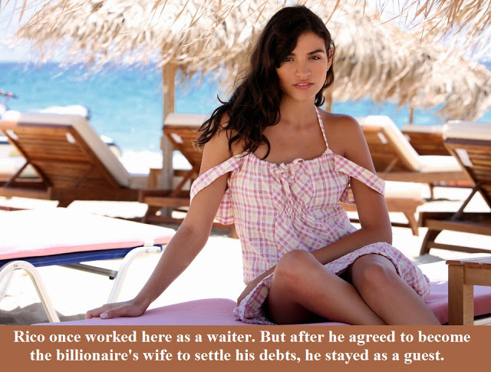

Rachel shifted in her lounger to stay in the shade. She loved to lie there by the sea, but she knew that she needed to look after her skin. With complexion like hers she could enjoy the sun when she swam in the warm sea, but she needed to avoid prolonged exposure and moisturize. She smiled as she thought it – ‘Oh, the burdens of a perpetual vacation’.

She raised her hand to get attention. That was all she needed to do. People were told to look out for her. After all she was the owner’s wife. She had been chosen by Quentin Underwood.

“Yes, Ma’am,” said Manny, arriving with a cool moist towel in anticipation.

She took it and said – “Just a glass of iced water with a twist of lime, please Manny.”

She was always polite. She had been in his position once. It seemed like a lifetime ago.

Rico had waited tables in the casino not far from the beach. He had to take a job because the money had run out. His stake had disappeared but like all compulsive gamblers, Rico believed that the big win was only just around the corner.

The only problem was that the casino did not allow its employees to gamble in the only casino on the island. It was a nightmare – he was so close to the action and yet barred from it. The only way he could gamble was to do it in disguise.

A fake beard and glasses just did not cut it. He spent ages in his little room provided for casino staff, working on disguises, but everything looked so fake. It was only when a group of drag performers put in a week of guest performances in the main theater that he stuck upon the idea of Rachael.

He managed to get close the performers and press them for some tricks of the trade and a few items of essential underwear, and then he was able to borrow some suitable evening wear from the theater wardrobe and become the glamorous Rachel.

Unfortunately, Rachael proved to be no more lucky than Rico.

Nobody had ever seen Quentin Underwood, the reclusive owner of the casino and several hotels on the island. The rumor was that he hated the tropics and lived in Iceland, but that was just a rumor. The man who introduced himself to Rachael as “Bob” was just another punter, or so it seemed.

“I think it would be improper to give you money,” he said to her. “You might think my motives were less than honorable. But I will stake you if you like. You look trustworthy enough. I can let you have $10,000.”

The sum was unbelievable. Rico imagined that it was all that he would need, and by following his formula he should have millions within a week. It lasted him a day. The next $10,000 was the same.

In time “Bob” was looking for repayment, but he came with desires rather than threats.

Once they were in a private space so as not to make a scene, it seemed that there was only one thing to do.

“I will have to find another way to repay you,” Rachael explained. “You see, I am not Rachael at all, in fact I am not even a woman.”

The look on Bob’s face in response was hard to interpret. There was shock, perhaps disappointment, some consideration, but somehow the look of desire never quite evaporated.

“Oh you are a woman, no matter what you might be hiding down there,” said “Bob” with a smile. “No man has ever cost me as much as you have. The only people who have cost me that much have been my wives – all three of them.”

Which was how Rachael became number four.

Manny arrived with the glass, and she thanked him. So much better to be waited upon than being a waiter.
Emily Time  A Short Story for John from a Cap by Becca  By Maryanne Peters  What child does not love their mother? The truth is that I have always worshipped mine.  She is forty now, but you would not know it. Just look at her. She always dresses so stylishly and her hair and makeup is always so perfect. What child of hers would not want to be just like her?  I mean I want to be like her in every way. Not just dress like her but act like her and have a body like hers, with breasts and a vagina. I suppose that makes me transgender. But somehow wanting to be just like the person you most love and admire does not seem so strange.  I think that is the way Mom saw it when I came downstairs that Saturday. She was not surprised.  She knew that my sister had dressed me sometimes when I was very little – I suppose that I was her living dress up doll. Mom must have known that I wore her clothes because I would put them in the wash while my sister lived at home, as if she had been wearing them. But after she went to college, how was I supposed to explain the extra panties in the wash?  Of course, Mom knew.  After that we went shopping to Etoile Boutique and bought a super feminine dress to wear at home after school. For now, I need to attend school as Adam. But what I really want is to be Emily all the time. | 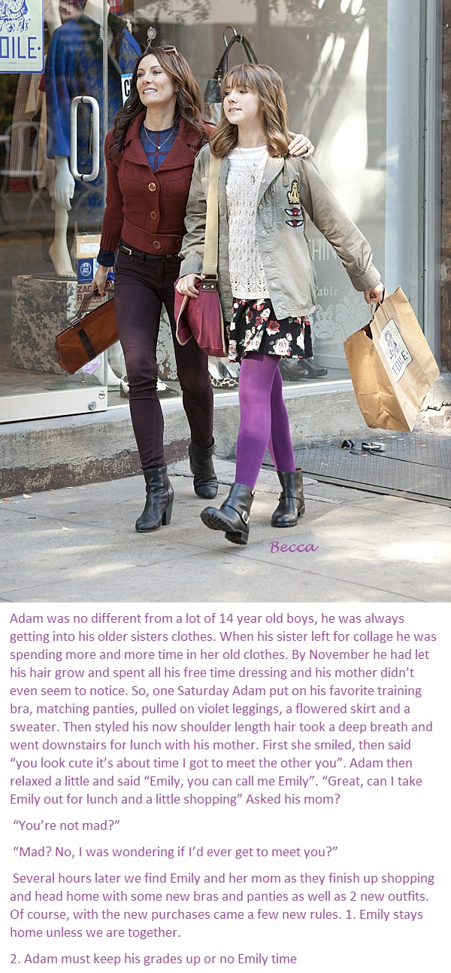

And now I have started looking at the guys in my class differently. To be really like Mom I have to find somebody like my Dad was before he died. Somebody strong and handsome and committed to looking after me.

I loved my Dad but I don’t think that I ever wanted to be like him. I have always wanted to be like Mom.

The End
Poisoned  For John inspired by a Cap by Sydney  By Maryanne Peters  JJ entered Kel’s apartment without knocking as he had done many times. Kel, Jake and Larry were sitting around the TV drinking beer.  “Hey guys,” said JJ. Then he cleared his throat, before growling in a much lower voice: “Can a guy set a beer around here?  He was in Kel’s line of sight. He just stared at him open-mouthed. The others on the sofa had to turn before they stared to. | 

“What’s with the hair?” said Kel.

“It just kept growing back,” said JJ, going to the fridge to get his own. “I just left it to find a length where it would stop. This is that length.”

“And the eyes?” Larry this time.

“It’s just me Bro. I didn’t do anything. Natural dark coloring. I don’t know. This is what this shit has done to me. You were all there. I went in to shut it down and look what has happened.”

“We’re grateful JJ,” said Jake. “You know we are. Somebody had to do it. Anyone of us would have. You know that, right?”

“Well it was me.” JJ’s voice had gone up again. It sound almost like a wail. To settle it he took a slug from the beer bottle. It tasted foul. All beer seemed to these days.

“How is the compensation claim coming along?” asked Larry.

“Slow,” JJ replied. “The plant says that I have been re-engaged at higher pay and better conditions in the office, so I am not to be classed as injured. It’s all about the effect of the change in my appearance and the … the loss of function.”

The other men in the group gulped collectively, as they thanked each of their Gods that it was not them who had entered the chamber to shut off the leak from the bio-vessel. Only one of the men on duty that night had been exposed. JJ had taken the full brunt of the concentrated synthesized estrogen. Now it seemed that he would never be the same.

The loss of function.

“What are you watching?” asked JJ. He was still one of them. At least he should be.

“It’s an MMA fight,” said Kel. “But not a good one. We have been waiting for you to arrive. Maybe you would rather not watch this?”

“Why?” JJ looked at him accusingly.

“No reason. We can turn up the sound if you like.”

“No,” said JJ. “You’re right. This stuff has affected my head as well. You all know it, so let’s talk about it. I don’t like MMA anymore. I don’t look at girls anymore. If I do, its not because I am thinking about sex. This has really fucked me up. Sometimes I just sit down and cry.”

“Hey man, if you’re depressed, we’re here for you. You know we are.” Larry put a comforting hand on JJ’s shoulder, no matter how awkward that seemed.

“I didn’t say I was depressed,” said JJ. “I just said that I cried. That’s what I do these days. I feel things. Not like before. I really feel things.”

“But no sex drive.” Jake said it as if it were a statement. JJ was not affirming so he added: “Right?”

“I think about sex all the time,” said JJ, looking across directly at Kel.

“Take off your shirt,” said Kel. It was an instruction. It caught Jake and Larry by surprise. Nobody gave orders in their group.

But JJ responding by unbuttoning the loose heavy plaid shirt he was wearing, and slipping it of his pale shoulders, now devoid of the muscle that was once a feature of his body.

On his chest were two unmistakable breasts.

“Fuck!” said Larry.

“Fuck!” echoed Jake.

“They’re beautiful,” said Kel. “Hell, you’re beautiful.”

“I know you want to do it,” said JJ. “Go on. Pull your cock out. Do what I can’t do anymore. Jack off by looking at a pair of tits. I know you want to do it.”

Kel unzipped.

“Whoa,” exclaimed Larry. “What is happening? Where is this going?”

“Right. Dead right. Where is this going?” JJ was nodding towards Kel’s penis, now fully exposed and pointing directly across at JJ.

“Wherever you will let me put it,” said Kel.

Going All The Way  Inspired by Kenneth to Willow’s Caption  By Maryanne Peters  I just got caught up in it. Once I had decided that I was going to honor the bet but not make a fool of myself, I just threw myself into the task of being able to appear as a believable girl. Actually, the hardest part about it was appearing to be a believable boy in the weeks leading up to the prom.  I bound up my growing chest and kept my hair in a greasy rat-tail. I experimented with makeup and walking in heels in private. I went online and coached myself to acquire a feminine voice and be able to achieve those feminine movements without pretense. The big problem was not slipping into that voice or those mannerisms at school.  But as time went on, I wondered what it would be like to make the leap – to go all the way. Maybe I could even go to college as a girl. I could walk on the other side, if only for a little while | 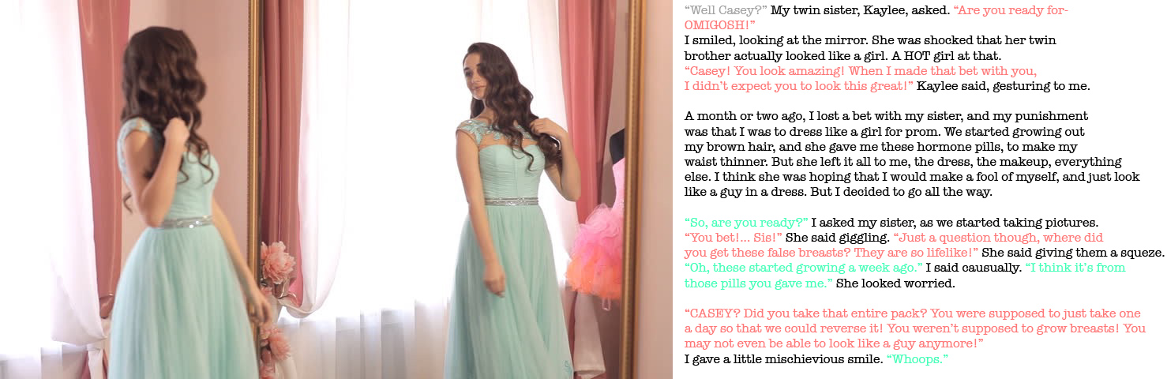

And then on the day of the prom I took that extra step. I went to the salon and had my brows plucked and the extensions put in and curled. I had already waxed and hidden it, but now I was able to live in the feminine body that I had been working towards, taking those hormones my sister had arranged.

That was when Kaylee walked in. She saw my breasts fully on display for the first time and could not believe that the flesh was my own. She started to get very worried. I think she was concerned that our parents might think that it was her fault. They had heard about the bet but had no idea that I was talking it so seriously.

“Did you take the entire pack?”

“Whoops,” I said.

It looks like I will be going to college as a girl after all. Oh well. At least I will be a pretty one, with a nice pair of boobs!

The End

The Pageant: Then and Now  Inspired by a cap by Lorna Samuels  By Maryanne Peters  Part 1 – Before the Pageant  “Is that really your hair? I can’t believe it,” said Mac, at last working the mouth that had just gapped for a full minute  Color highlights, curlers, backcombing and hair spray and shit. You would not believe what I have been through.” said Brad. “Like I just said, I wish I had never got Mom involved.”  “You will win the prize, Man,” said Mac. “You just have to looking like that.  “But the shoulders. What do you think? The spaghetti straps make them look like the wrestler I am – don’t you think?”  “Not when you look down and see those tits of yours,” marvelled Mac  “It’s the off-season flab in my pecs pushed up. The rest is all padding. But with these shoulders I still think I look like a guy.”  “Trust me, you don’t” said Mac. “Hey, there is no hair on those arms.”  “None on my legs too,” said Brad pulling up his taffeta skirts to reveal shapely legs. “Or anywhere else for that matter.” | 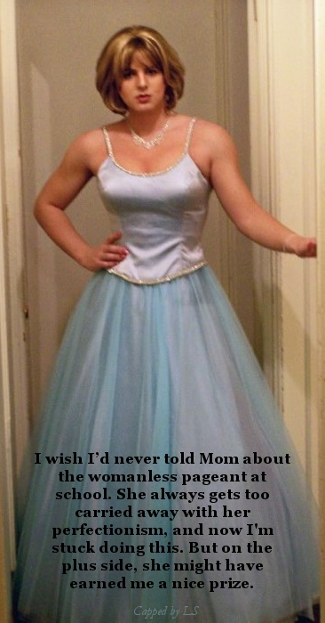

“She gave you a full body wax? Man, those legs look smooth and soft. It that the smell of moisturizing lotion? And you have had a pedicure too, to match the manicure.”

“She is a perfectionist like I said. She said no way was I turning up not looking right. She said that I was like - representing her salon. She said that he reputation was at stake. She even had me practising the runway walk. You want me to show you?

“Sure … Yeah, you have that down pat. If you get down to the final placings then you will probably get asked the stupid question and have to take the microphone.”

“I have that worked out too,” Brad said: “My name is Bryony and I want to work for the United Nations and build world peace and freedom from hunger.”

“Bryony. That’s a nice name.” Mac didn’t notice the irony. He was looking at his friend admiring those legs and how the heels made them look shapely. It prompted Brad to look down. He never had very well defined legs, but now they looked perfect. It seemed a pity that the long skirts would hide them. He would have to find time to lift them at some stage on the night.

Part 2 – After the Pageant

“We have all seen beauty pageants, Mac. We know how the beauty queens behave when they win the title,” said Brad. “It just all clicked in, I just gushed and thanked everybody, including you.”

“I love that voice,” said Mac. “It seems like you can’t throw it off.”

“Not while I am dressed like this. Not while I am wearing the crown.”

“Even though it is just you and me here, at my place.”

“Somehow it seems like a special night. Is that too weird? It is like a fairy tale and I am under a spell. Like an enchanted frock or something. As long as I wear this, I am Brida.” Brad could not resist doing another twirl, suddenly realizing that he was indeed at Brad’s house, and Brad’s parents were away.

Mac reached out to grab an arm and stop the twirling. He asked - “Why did you thank me in your acceptance speech.”

“I dunno. I suppose because you were there … or maybe because when you look at me you make me feel as if I am a girl.” Brad has spoken the words, and they could not be taken back. Now he was worried, and biting a painted lip.

“But you are only a girl while you wear that enchanted frock?”

“Am I?” Was Brad still worried? Or was the excitement building.

“I suppose you will have to take it off before we will know for sure?”

“Will you help me?” Brad simpered, placing his has behind Mac’s neck.

He was about to collect the real prize of the evening.

The End

© Maryanne Peters 2022

