Walkthrough for Shuggerlain v.0.27

Prologue Part
In this part of the game there are no bad or good choices in the story, as it’s a prologue and it’s still quite linear.
In the first Battle, the defense of Bertresh, it’s really really hard to lose, but anyway, just feel free to get used to the mechanics of the new system of battles. And yes, the boiling oil is a bit OP. Use it ;)
After the first part of the prologue and once you are in Littanos you will already have some choices to make.
In Littanos there’s a succubus battle hidden. Check Succubus Guide on this walkthrough to trigger it.
NOTE: Keep in mind that triggering this event makes possible the sex training with her later, when you advance to Eldrien/Nocverchis.

In Littanos Battle just follow the tips on the “Battle Guide” of this walkthrough.
After all that Dynae and you finally share your feelings with each other and magic happens. So here you’ll get the first H-scene with her.
Next morning Saraith will come, then the tale about the 2 dragons will be explained and you finally will find Izuin.
The next day you will recruit Luth, an araxian soldier, as Izuin’s babysitter.
After that, Fredic (that old drunk man from the tavern) will explain you that you can get some special currency after defeating a succubus girl and he will give you some presents you can use to boost your relationship with the girls later.
Then you depart to Yalen.
Yalen
Go ahead through the plot and soon you will find that an army is waiting for you. Check the “battle guide” for more info about this battle.
After the battle you’ll be able to access to the camp. Do what the game says and visit Nadine to congratulate her for her great job in battle.
Surprise! She’s masturbating thinking about Nulkan. At this point you may want to save your game because you’ll have to decide: let her relieve you or go back to your tent.
-First option will unlock Nadine’s handjob scene + 30 XP points of relationship with Nadine.
-Second option will unlock Dynae’s blowjob scene.
After that, there’s not much more to do so go to your tent and Rest.

The next day is pretty linear, just go ahead and... see what happens.
The next day, you’ll only be able to visit Dynae’s ceremony. Do that.
After the HAPPENING, you’ll talk with Dynae and among other things, she’ll give you the stone of Spatial Convergence. This will be useful for dating other girls.
Ok, so... you’ve heard Dynae. With the current situation, you’ll have to start getting to know better the girls of the game. So from now on, you can spend time with the other girls.
Talk and Ask with them. When your level with one of these girls is 3, you’ll be able to date them. On level 6 you will unlock Date 2 with them (Vex, Luth, Nadine, and Saraith) and in level 9 Date 3 (only Saraith for now).
On the dates you’ll only need to select the correct choice to trigger the H-scene. Check the part “Dates Guide” for more info about them.

NOCVERCHIS
After the initial dialogue, in the camp just spend some Action points until the evening comes. Vex will show up in the camp, warning you about an attack next day.
Once you’ve won the battle, go ahead and you’ll be in the camp again. To advance through the plot, visit the Shaman.
After talking with the Shaman and once you’re in the camp again, now select Explore the north of Nocverchis, to keep going with the plot.
ELDRIEN
Eldrien is pretty linear for now. Just advance through the dialogue. Once in the camp, just spend some AP or you can also directly rest to keep going with the plot.
Once you win the battle, there’s no more plot for now.

Dates guide
These are the correct decision that will trigger the H-scene on the dates with every girl.

Nadine
Date 1:Kiss her
Date 2: No. Enough for today.
Luth
Date 1: Obey the voice
Date2: Get to know her better
Saraith
Date 1: Move her away by her shoulders
Date 2: I will not be prey
Date 3: Awake her demon side
Vex*
Date 1: Think about it
Date 2: Offer her some bread and some lunch meat you have.
Yraselle*
Date 1: Did you really want to marry Pyrus?
*Dates with these girls are available once you are an ally of their nations

Succubi Guide
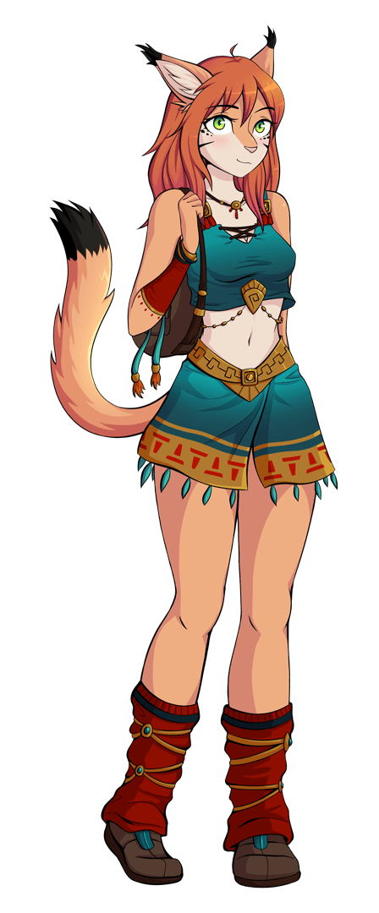
MISHA SEX BATTLE
Just to make sure to trigger the succubus battle in Littanos, make sure to have breakfast both times you have that option available. Otherwise she won’t appear and you’ll miss the event.
After that, you only need to have a walk at night with Dynae to activate the event.
After Dynae leaves with the two Ashteran girls, Misha will appear. At that point select free her to start the combat. “Scare her” option will do exactly that and you’ll miss the event.

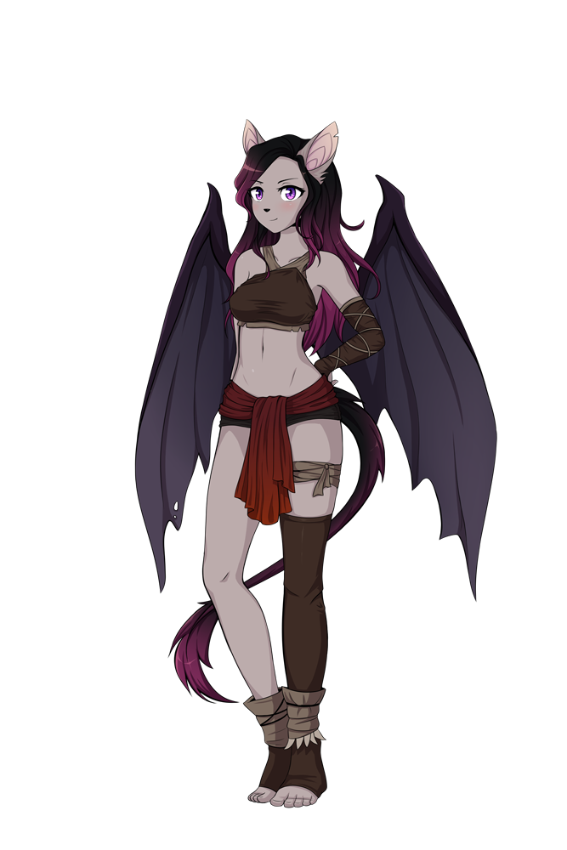
GIFRIX SEX BATTLE
To trigger it, wait at least until day 7. Then, in the camp, select “Take a walk through camp’s surroundings” when your actions points are just 1.
Tips
Gifrix is a Nocverchan, a bat-human race. She will regenerate after any attack where she uses her mouth and gets Nulkan’s fluids. These attacks are:
[You kiss her] [She kisses you] [Lick tip] [Blowjob]
You want to avoid these attacks. Well, in fact, the only thing you can avoid is kissing her, so at the beginning just kiss her neck.
Too hard? Don’t worry. Gifrix has a weak point. She’s very sensitive in the nipples. So focus on them to be sure you win. If she doesn’t perform too many blowjobs or other hard attacks, you can also check other attacks just to see the animation :)

IONE SEX BATTLE


To trigger this event you need to spend 6 days on the camp being in Nocverchis. When the event starts, three Yalenite mages will talk with Nulkan. Select “Go ahead with the tests”
Now you have 3 different options. All of them will unlock some sexy content:
- Go behind the trees: Ione will drink Nulkan’s cum from a flask.
- I’d need something enticing...: shows a topless Ione.
- Reject: to start the sex battle.

This battle is a bit harder because Ione has some really powerful attacks and some supposedly Nulkan strong attacks don’t do much damage on her.

Tips:
-Her neck is her weak point. Focus on it at the beginning.
- Fingering is not much effective
- Sex is effective, but Nulkan also will suffer damage from this move.
- Assjob, blowjob and especially titjob are the most dangerous attacks from her.

ARMY BATTLE’S GUIDE

After Littanos Battle, all the casualties you will suffer in combat should be replenished. This costs gold. Gold is obtained after each day. The amount of gold you receive each day is increased the more nations are allies of Ashtera. To recruit more soldiers, just visit the city of any of the nations, you will find Hann there and he will get the troops in exchange for gold.

Now, about the new battle system. The basics of this new system are not hard to understand, however, we’ll give you some information that can help you win or minimize the casualties you suffer in each battle.

- The most of the first skills of the heroes, generate +25 mana.
- You also get +25 after ending a turn
- When you attack with infantry to another infantry unit, you also suffer some counter damage.
- Cavalry doesn’t receive reply damage when attacking, except from spearmen.
- Range unit doesn’t receive reply damage

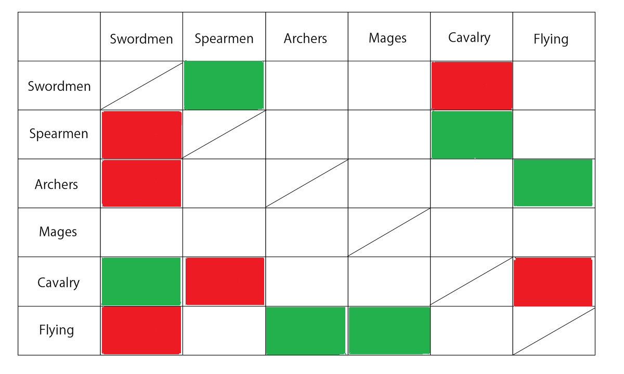And now, here is the table of weaknesses and strengths (the left column is the attacker):

- Green indicates that the squad is effective against the other squad and will cause bonus damage.
- Red indicates that the squad is not effective against the other squad, it will cause less damage and probably receive more damage.
- Empty white slots mean neutral damage.
So you know, look for green combinations and avoid the red ones.

You will also realize that at the beginning of every wave you should make a decision. The effects of these decisions are:

Bertresh Battle

1.1- Wait for it just under the city gate" +50 Mana points
1.2- Go find them” You suffer 300 HP of damage
2.1- Hide behind the walls > +50 Mana points
2.2- Keep fighting You suffer 250 HP of damage

Littanos Battle
1.1-Soldiers, keep your forces! Dynae, keep gathering mana
+50 Mana points
1.2- Start casting spells against them
You start the battle without mana, but you cause 250 HP on the enemy
2.1- Pressure her consumes 25 Mana Points
2.2- Calm her down generates 50 Mana Points
3.1-Araxians! Yalenites! Look how your Executor is trying to run away!!" Some enemy flee. You cause 500 HP on the enemy
3.2- Just focus on your battle Nothing happens

Yalen Battle
1.1-Soldiers, hold position! Dynae, keep gathering mana +75 Mana points.
1.2-Start casting spells against them You cause 250 HP damage to the enemy. Your also empty your mana.
2.2- Defensive tactics! Tortoise formation, now! Minimize the damage taken.
2.1- We'll reach them before the cast anything! Cause damage on the enemy, but you also suffer some damage.

Nocverchis Battle
1.1- Don't worry for us Dynae. Focus on gathering mana. We'll protect you!" +75 mana points.
1.2 -Cast something to scare them! you spent some mana and you also cause 250 HP of damage on the enemy
2.1-Put order Nothing*
2.2-We can only keep fighting Nothing*
*Take into account that, if in this battle you don’t gather the required mana before wave 2 starts, the battle will be lost and you won’t have Nocverchians as allies because you are causing too much casualties.

Eldrien Battle
1.1- We need to stop them before it's too late! You suffer 500HP of damage
1.2- We are facing a dangerous pyromancer!! Shields up, guys! Active defensive tactics
2.1- Shields up! Shields up!! Activate defensive tactics.
2.2 -We need to finish them soon to reach Pyrus! You cause 300 HP of damage to the enemy.
3.1- We have some time to recover +100 Mana points
3.2- Recover youselves, guys. But don't forget about your shields +50 Mana points. Defensive Tactics activated as well.
Note: In this battle on enemy turns 1, 4, 7, 10… (+3) Pyrus will be casting his flames against you. This is a dangerous attack. Be sure to get defensive tactics activated before finishing any of these turns.

About Nulkan’s Corruption System
The Nulkan‘s corruption system indicates how long Nulkan has been without “releasing” the corruption of the demonic sword and armor and how much affected he is.
After each day corruption will be increased 15%. Just make sure to release before it goes to 100%. How? Do any sex scene where Nulkan cums. You can also reduce it with Sex Training.
If the Corruption level reaches 100%, the first time that that happens, Saraith will save you but she will warn you, again.
If it happens a second time, that will mean a game over.
HOWEVER, is it possible that you want your corruption to be above 50% at some times...
Why? Because that’s how you will trigger hidden quick sex scenes (not animated though)
Raise you affection with Saraith to level 7. If you spend 2 actions with her (let’s say, talk with her, and after that make a question…) and then you kiss her, she will tease you a little bit.
Do exactly this on level 8 when the Corruption is above 50% and Nulkan won’t be able to hold himself after Saraith’s teasings :P
This is only available with Saraith for now, but there will be hidden “quick sex scenes” with the rest of the girls in next updates.

