In the Group
Inspired by a Captioned Image by Kenneth to Willow (Deviant Art)
By Maryanne Peters

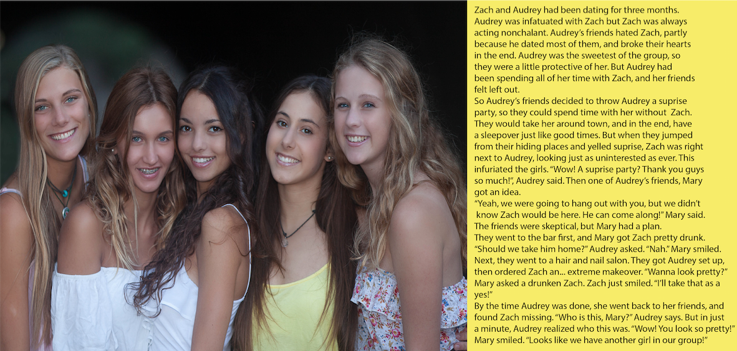
That is me on the left, Zoe. Audrey is in the middle. She is still the prettiest, but I must be running a close second. Tell me you think so.

We are a great group of girls. We have so much fun. I guess that was never really part of a group until I became a part of this group. Some boys are loners, especially ones who seek out girls as conquests. Such guys have no time for friends. All they want is one on one with some poor girl, then they dump her and move on. That was what I was like.

It now seems to me that everything I did was trying to make up for something missing in my life. I misunderstood my attraction to women. It was not sexual desire - it was envy.

Maybe being intimate with girls was somehow allowing me to enter their space, and become one of them. I always preferred sex with them on top. I would cry out and imagine that the spurt was coming into me instead of out of me.

I had slept with all of them except one. I had dumped them all, and I would have dumped Audrey too, despite her being the best of them. It was not that I was a bad guy, it was just that I was not a guy at all. I just never understood that until I became one of them.

They now trust me on the choice of boy. You know them better if you used to be one. There are boys like the one I used to be, and then there are true gentlemen, who love you for who you are and will wait for the girl to signal when it is time for sex.

The group needs to approve if it looks like it is getting serious. Five heads are better than one when it comes to making lifetime decisions.

It was only three heads that made the call that Zach was wrong for Audrey, and they were right. Audrey needs a man, and I was not that. Instead they made me into Zoe, and made me one of the Group , and I am ever grateful for that.

Now Audrey has a man we all approve of. In fact we all have a man approved by the Group – even me. He is somebody who is prepared to wait until I am ready.

But I am. I have always been ready. That is one thing I have carried over from living as Zach. I want sex. But now I want that spurt coming into me instead of out.

The End

© Maryanne Peters 2022

Ringlets  Inspired by a Cap Image by SpottyCat44  By Maryanne Peters  I was proud of my long hair. I had been growing it for years to be as much like my anime hero Kotaro Katsura. I have to admit that I was obsessed with anime, and Kotaro in particular. I locked myself away in the my loft room and watched my screen, growing my hair and sometimes posing in front of the mirror with my samurai sword. I played sword fighting games all the time.  My sister thought I was sick. She was always trying to persuade me to go out. She said that she knew some young girls that I might like. I just said no.  Then suddenly I started picking up messages from a girl on one of the games I was playing. She was hopeless at the game and said that she just liked watching me fight in mass battles. I guess she stroked my ego.  I told her that I had long hair, just like my hero Kotaro. She said that she thought long hair was really sexy. I guess I was cyber-smitten. | 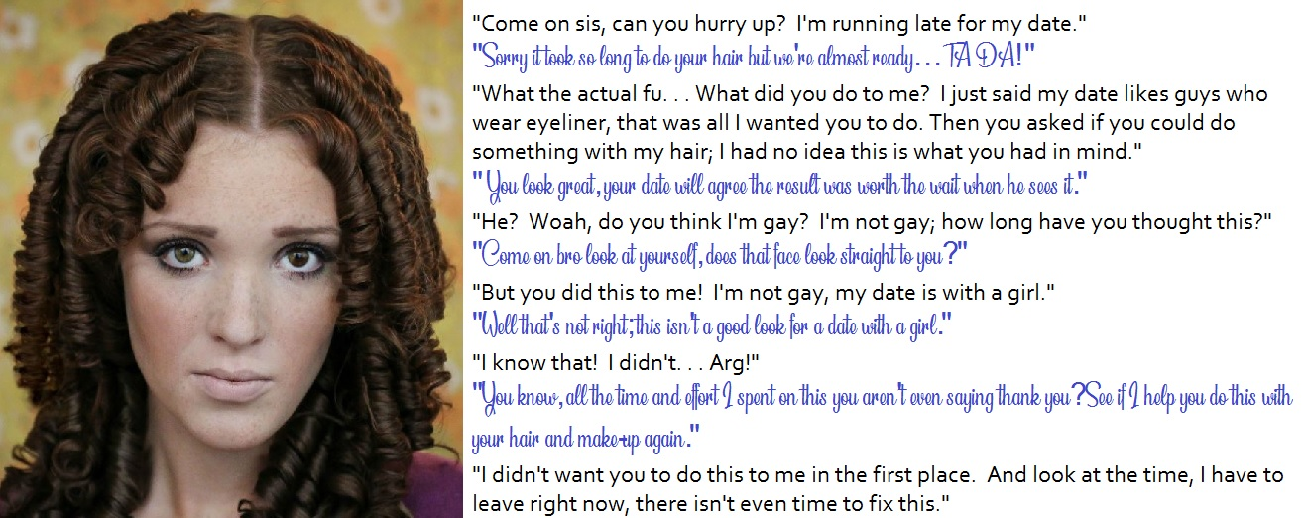

You assume that people on the net are on the other side of the world, or at least the country, so imagine my surprise when she told me she lived in my town.

I made the mistake of telling my sister, or so I thought. I found out later that my admirer was her all along. She must have been planning it for ages. She had been on the gaming sites I played on, stalking me online. She knew all about anime.

She played it all so well. I mean she played me like a fiddle, as they say. She told me that I should go on a date with this girl – the first date I had ever been on. She said that she would guide me through it. She had been dating for years. She knew what girls expected.

It turns out that the eyeliner was her idea. It was all her idea – everything. That included “doing something with my hair. And this is the result.

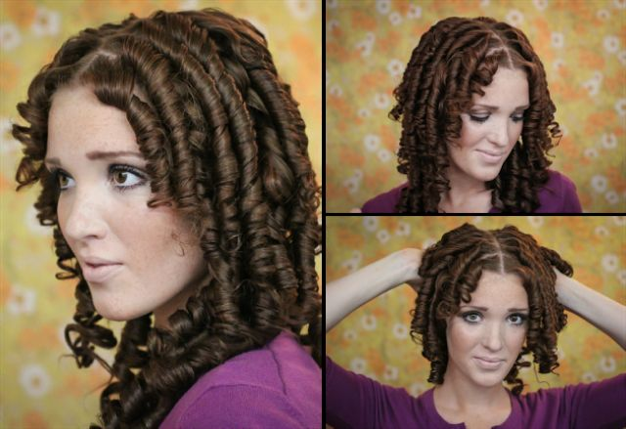

She said that she would post the photos if I did not agree to go out with Ricky. Nobody on line knew what I looked like, and this is what they would see. Me in ringlets

“Who the hell is Ricky?”

“He is the best friend of my new boyfriend Kyle,” she said. “He is a bit shy like you, and really into gaming and anime just like you are. And he is a nut for ringlets, so … well look at yourself. Scrunch them with your fingers a bit.”

I have to admit they did feel good. And the way they bounced around my head and into my face when I turned my head. They did look pretty good but most of all they looked like fun. That’s it – fun. It made me feel like smiling.

“This guy Kyle likes ringlets, huh?”

No. A nut for ringlets was what she said. And a nut about anime just like she said. He is just crazy about my ringlets, and crazy about me too.

The End

Always a Cheater
Inspired by a Captioned image by SilversTG
By Maryanne Peters

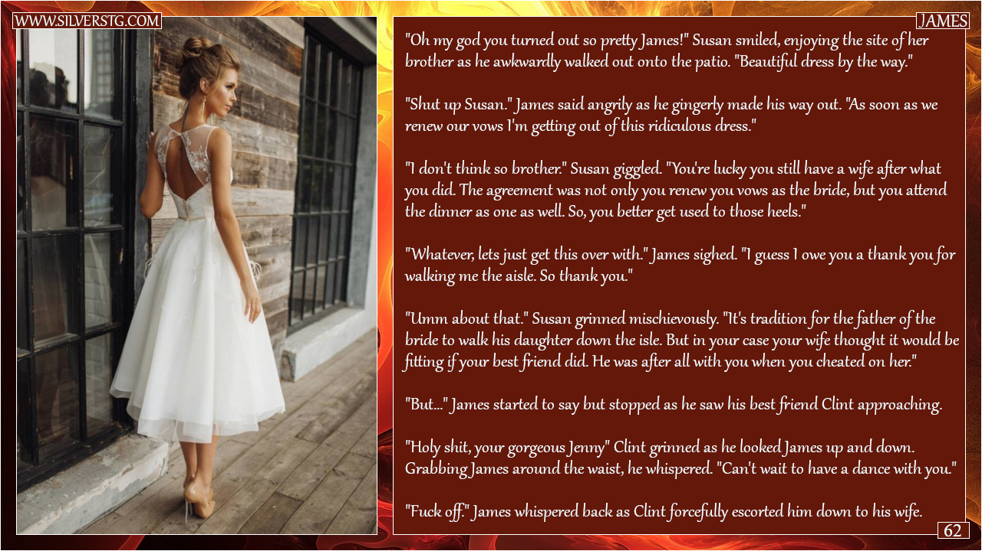

Why did he have to look so good? I mean his sister Susan is in the beauty business, but this was so way over the top.

I guess he looks a lot like her. I mean he is not a big guy. James was not sporty like me, but man we had some fun together, fucking anything that moved.

He needed to marry for money. I understand that. When his business failed, he was cleaned out. The only thing he had left was those little-boy-lost good looks and that twinkle in his eye. That is the twinkle that got us the chicks, but also got him into trouble.

I guess he just cannot stop himself. He sees her and wants her – it does not matter who she is. Even after he was married, we would go on the prowl together.

But he needed her to stay with him. Divorce was not going to work for him. His sister Susan came up with a plan. It would be a punishment that would announce to everyone that his days as a stud were over. He would marry his wife again but submit and promise to obey her. He would reaffirm his vows as a woman – as a bride.

I think that Susan had always nursed a desire to dress up her brother ever since they were kids. Maybe James had dressed as a girl way back then. He always said that his sister was always “beautifying” things. As I said, she was in the business, but it was more than that – it was what she was born to do.

And she was so good at it that James just blew my mind. I mean, people say that: “Blew my mind”, but in my case, that is exactly what it did to me.

Susan was able to persuade James’ wife that if he did this, he would be able to put his two-timing ways behind him. That would have to be bullshit, but the poor girl still wanted him. James could have that effect on women. She agreed to the wedding, and even dress as the groom, with her hair pulled back in a tight bun.

Susan asked me, as James’ best friend and his accomplice in most of his infidelities, to build an invitation list including women that he had wronged. He would need to walk down the aisle in drag in front of all of them. It was to be a cruel thing.

But why did he have to look so good? I swear that when I led him down all the women who should have been looking down on him just looked confused. ‘Who’s the woman on Clint’s arm?’, they were thinking. So was I. Who was this person?

Jenny. That was the name his sister had given him for the day. Somehow, she had managed to gather up his longish hair on top of his head and crown it with some ornate hairpiece. It looked so feminine. I knew that he was skinny, but his neck looked so long and slender it just cried out to be kissed. There was not a hair anywhere else on his skin, so smooth it must have been plucked rather than shaved. His sister’s makeup artistry made his face shine like gold – a goddess fashioned in 24 carats.

I put my arm around his waist and told him how good he looked.

I have to say that all kinds of unnatural thoughts went through my head. OK, so I mentioned dancing with him. What I was really thinking was that I wished he had a pussy I could ram myself up.

“Fuck off,” he said, as if reading my thoughts.

We walked down the aisle and we could both hear the giggling and gossiping of all the girls that I had invited as instructed. It was the ultimate humiliation, to be capped off when he promised to obey his wife, standing there waiting at the altar.

“Don’t let it get to you,” I whispered in that pretty ear. “You are the best looking woman in the room, Jenny, by a mile or more. Work it. Let them know it.”

She did. She held her head high. But what can I say, once a cheater always a cheater. That very night Jenny was having sex with somebody other than her groom – me in fact.

The End
Concentration
Inspired by a Captioned Image by Jennifer
By Maryanne Peters

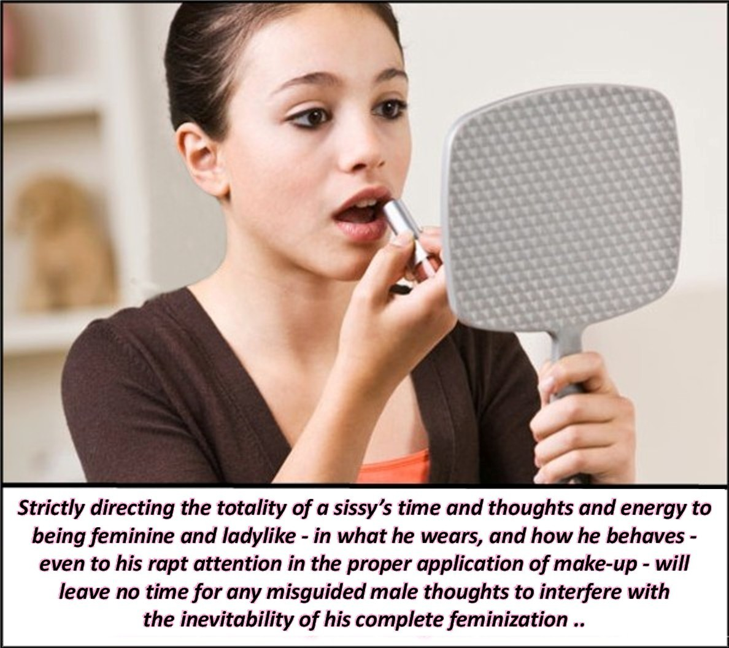

There is just so much to do to stay pretty. My skin regime is very important. He says it is like preparing the canvas for a masterpiece. A wrinkly canvas will never do. I pay a lot of attention to it. Devoid of all hair, and soft. The hormones help. Patches under my breasts and pessaries shoved up my boi pussy with a little help from my tool, Richard.

I have to tweeze out any little hairs that appear on my chin. I seem to have more than other girls. I used to know why, but I have completely forgotten.

Hair tied back. It is so long now that it is easy to tie back and up and hold with a claw clip. I used to have short hair, although I don’t know why. He hates short hair on me, and what he doesn’t like, I just can’t abide.

Now eye makeup. I have dark hair so I can get away with well-drawn eyes. That means eye liner and just a touch of mascara. I do not believe in false eyelashes unless it is a special occasion. My eyes are good enough on their own – don’t you think?

There is just so much to do. I need to get on and get tucked. I know that most girls don’t need to, but I do. I don’t want any bumps showing where they don’t belong, and my bump does not belong.

It does get uncomfortable, but he likes to be the one to free it. He says that when he is ready for me to get naked he will tell me, or maybe even help me – not because I need help but because he likes it. But when it comes to breaking the tuck, that is for him to do. It serves to remind me that I am his, and I am only free when he is inside me, or just before.

I used to think about a lot of things, but nowadays I only think about that.

And also this lipstick. Do you think it is the right shade?

The End

Makeover and Dress Up  Inspired by a Caption image by Think Pink  on Deviant Art  By Maryanne Peters  The games we play as children prepare us for life – don’t you think? We learn to play roles through those childish games. I learned my role that way.  And yet there are plenty of boys who are raised in a house full of girls who did not grow up to be like me. I suppose that means that I was different from other boys right from the start.  I howled about being dressed up at first. It was just that the only clothes in the house apart from my own were hand-me-downs from my four older sisters. I wanted to be the prince or the cowboy, but I was always consigned to being the youngest princess or the littlest squaw.  As they got older, they became more interested in hair and makeup and the game became “Makeover and Dress Up” which really was a game all by itself. One of my sisters went on to make it in that profession. All of them practice beauty on a daily basis. They are all very attractive women, my sisters.  So where does that leave me? I used to think that an occasional makeover was all I needed, but now it seems that it is just not enough. | 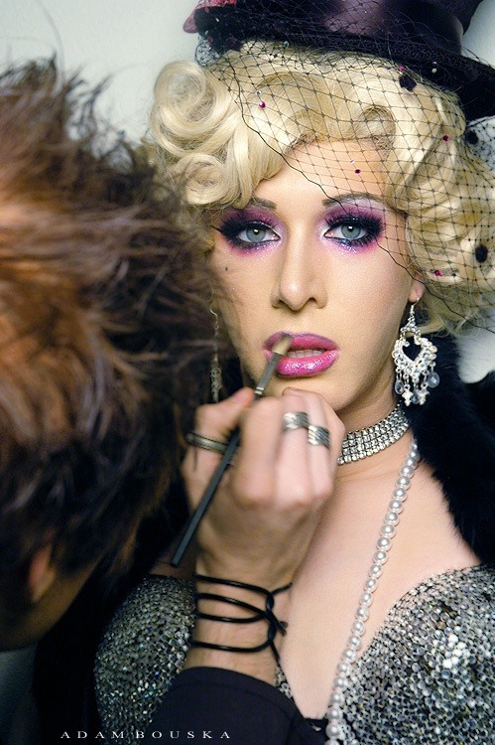  Growing up with all girls in the house was tough. My sisters would only allow me to play with them if I joined in with their girly games. But their favorite was Makeover and Dress Up. They would always be the hair and makeup artist and I would always be the customer. They would dress me up all sorts of outfits. When I complained to Mom she would say that they would grow out of it. Now where adults they still play Makeover and Dress Up with me.

The games we play as children prepare us for life. “Makeover and Dress Up” was always my favorite game. Somehow if hairstyles, makeup and woman’s clothing are not a bigger part of my life it seems as if it is hardly a life at all. I am not sure where this will lead me, but I have a feeling that I am going to love the journey.

The End

© Maryanne Peters 2022

