Paying the Rent  Inspired by a Cap Image  By Maryanne Peters  Am I gay? The truth is that I feel less so with every day that passes. Because with every day my Kendra becomes more of a woman. Kenny is now just a distant memory, for us both. | 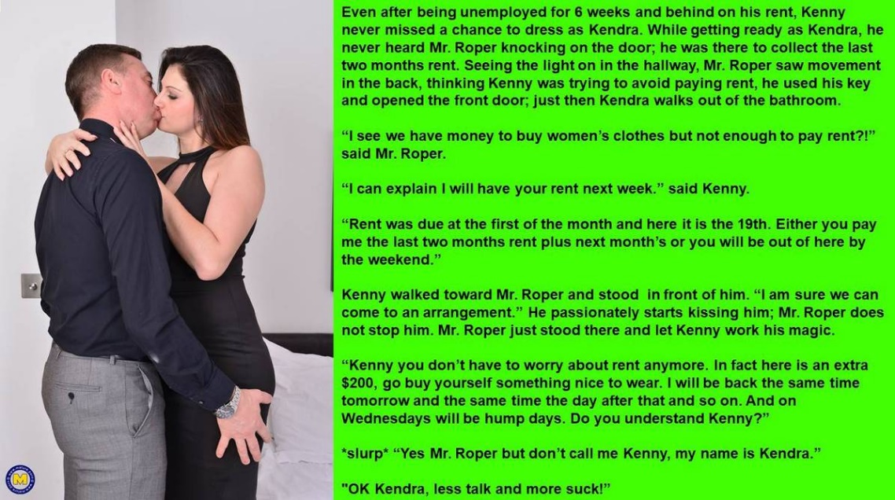

I never should have let the place to Kenny. I should have seen that he was flaky. It was a good job, but his heart was never in, nor was his brain. He was a girl, you see. All he thought about at work was getting home and getting dressed as Kendra. His boss complained that his hair was too long. People he had to do business with were starting to think that he looked weird.

He never told me that he had been fired. He just stayed at home and went all out. He stripped every bit of hair off his body and swallowed huge mouthfuls of hormone tablets. Kendra told me that Kenny did not care if he if he died, so long as he died being as close to a woman as he could be.

I suppose I saved a life?

I had seen no coming or going from the apartment for weeks. I just thought that Kenny had abandoned the place. I used my pass key to get in. Everything looked very tidy. Kendra is a tidy person. And then she walked out of the bathroom. She was rubbing hand cream into her soft hands with the fingernails she had been growing polished and painted. She was wearing a figure-hugging black dress, and that figure was great, with a cleavage showing real breasts. Her hair had been washed and blow dried and was down to her shoulders.

I have to say that I had no idea who I was looking at. My first thought was that the prick had sublet without my permission. But then I realized. And instead of being revolted, I wanted to see more.

Am I gay?

Of course I read him the script. I demanded the rent. He just looked at me. Then he looked down at my crotch and he looked back up. I must be gay. I was growing to bursting right there in front of my tenant, who could see it.

I am not sure whether Kenny had ever done it before, but I could see the idea forming in his head, or was it her head? I like to think that it was her who walked up to me and kissed me. If it was her, Kendra I mean, and not Kenny, then I am not a fag – right?
When Kendra freed my cock from my pants, it was like I was going to heaven. Those hands with the hand cream on, worked me to a spasm of pure ecstasy, and left trails of my cream all over her black dress.

I told he that we could come to an arrangement. She could stay in the apartment and I would take rent weekly, collecting every Wednesday, but I could not stick to that arrangement. I mean, I am running a business. I needed the cash from that apartment. I have to pay the mortgage and build up the funds for maintenance.

Within a week that deal was off. Kendra moved in to my place. I get a full return from her apartment and I get to fuck my Baby every day. She likes the new arrangement just as much as I do. She is always underneath, taking me, squealing with joy while those growing tits shake about.

Like I say, she is Kendra. So I am not gay – right?

The End

Now a Housewife
Inspired by a Captioned Image
By Maryanne Peters

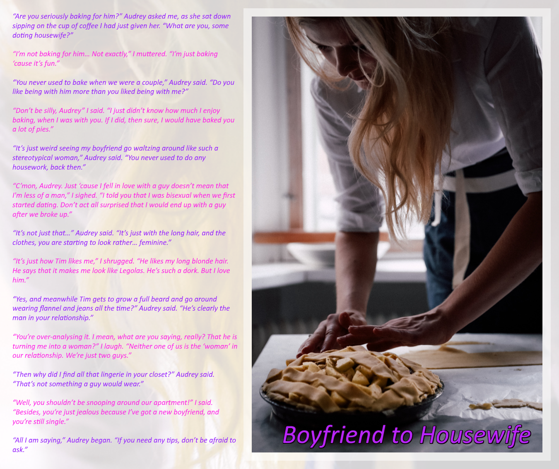
Tim was listening at the door. Listening and smiling.

He found it amusing that his boy-wife’s ex-girlfriend should be so confused, then he was genuinely touched by the words “He’s such a dork, but I love him.” But when Audrey offered her assistance, Tim knew that was his cue.

“Hello, Audrey,” he said cheerily as he crashed into their conversation. “You are looking very fine tonight.” Then he turned to the face looking at him adoringly. He went up and planted a kiss on his lover’s lips as they trembled in the excitement of his presence, running his fingers through that long blonde hair.

“I’m baking you a pie, Tim my love.” The words were full of adulation.

“Nice,” said Tim. “Sweetie, I’ve bought you a present.”

It was a parcel that I presented, the appearance of which brought the expected reactions. Those soft hands, still dusted with flour, went to the to the cheeks, the lips rounded into a gasp that was fuckable if it had been at waist level.

“Oh, Tim, what have you bought me? I can’t open it. I have dough on my hands. Could you open it for me, please, Audrey?”

Audrey pulled open the crepe paper. “It’s a dress,” she said. “He has bought you a dress.”

“Save the pie for later,” said Tim. “Let’s go out. You too Audrey. My treat. Put on that dress sweetheart, and make yourself look attractive, and we’ll go out. All three of us, but we won’t be alone. I have done well today, and we need to celebrate with some of my team tonight. Save the pie for tomorrow.”

“But Tim …”. A look of confusion on his lover’s face, and Tim thought Audrey looked annoyed. Not surprised, but annoyed.

“Sweetie, I want you to be a part of this. I want you beside me. But my team, they expect me to turn up tonight with my girlfriend. Not a guy.”

“You said it wasn’t going to be like this.”

“Not long-term Sweetheart, but tonight, please, pretty please, be Suzy.”

“Suzy? You have a girl name for me?”

“Audrey has offered to help. Haven’t you Audrey. Shave those legs and arms and Audrey can help you with your hair and makeup. I want you looking spectacular tonight. I want all of the guys to be envious of me. The best sales and the prettiest girlfriend.”

“But Tim, I can’t be a girl.”

“Nonsense,” said Tim. “Just look at yourself, with that wonderful hair, and that soft skin. Those hormones I have been putting in your breakfast smoothie have done wonders.”

“Tim, what are you talking about? What have you done to me?”

“I have made you more perfect, my Darling. I am ambitious, you see. A boyfriend does not work for me. I need a wife, and a housewife. You’ll be perfect as both.”

The End

Fundraising  Inspired by a Captioned Image  By Maryanne Peters  “Dave, the key to winning is not just to look like a woman but be like a woman”. That is what she said. He got the new skateboard for entering, but if he won, he was going to get the skateboard and cash as well. Dave was in dire need of funds.  “That means you need to live as a woman in order to win this thing,” she said. | V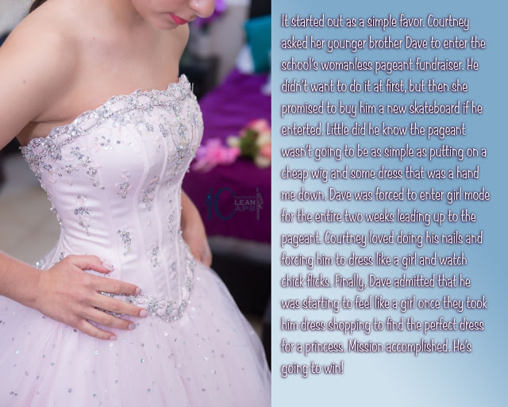

She told him that everyone would be doing it, but he was not sure who else was in it. They were all in his sister’s year. He would be the youngest competitor.

His sister did all that she could to bring out his feminine side, by involving him in girly things with her friends, but it all went over Dave’s head. He was just thinking about the skateboard and the cash.

But it was trying on the dress outfit with the corset that changed everything. When It tightened around his midriff and pushed up, the inserts in the bra cups seemed to become his wobbling flesh, and the smooth belly and wide hips came into view with his hand resting on them, Dave felt that his body had been transformed. He felt as if he was somebody else. Not Dave. Not a boy.

And with that his young face he looked girlish, even without makeup, and his mop of hair looked like a pixie cut even before it was styled, with the fake hair pinned to it for the contest. He needed to see the real him – the beautiful person he was going to be.

“Please can you do my hair, Sis,” he said. “Do my hair and makeup. I want to look pretty.”

And he did. And he won. And Dave will never be a boy again.

The End

At Attention  Inspired by this Caption Image by who?  By Maryanne Peters  It was a while back – before the pandemic. Jobs were hard to find, especially if your degree was in theater arts. I finally found the perfect job working for a design company doing specialist interiors. It was just a gopher (go for this, go for that) job, but I loved it. I did not want to put it at risk in any way. The problem is that some impulses make you do very stupid things.  It was just one idle moment. I had been looking at a site the night before Ok, I had dabbled with dressing up in women’s clothing, just because I felt that I needed a woman in my life, even if she was only a pretend one in the mirror. I suppose that it makes you think what it might be life to choose to live life full time dressed as a girl. What it might be like to live as a sissy. | 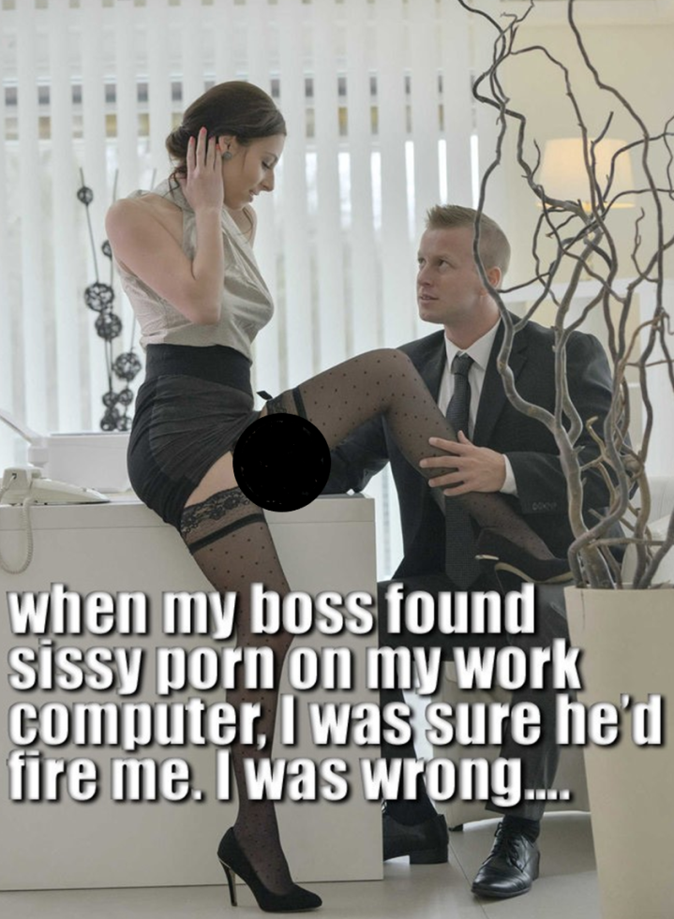

It was still on my work computer. My boss was doing a routine scour of our browser histories and there it was.

Company policy is strict on this, so I knew that I was in trouble. I was prepared to beg to keep my job. I really wanted to stay, and I told him that I would do anything to keep it.

“I would like to see you dressed as a woman,” he said. “What are you doing tonight? No, in fact let me tell you what you are doing tonight. You are going out to dinner with me. Wear something nice.”

He was taking control. Not like a boss, but like … a master. It don’t know why, But I liked it.

I suppose That I should have not let it get this far, but he is just so … in control. I just gave into him that night. Once you have had a man inside you then you will never be the same. I never was after that.

We did it in an apartment above the restaurant, which it turned out was his little secret from his family. I am living there now. I am part of that secret, living as a woman full time, and turning up at work in the outfits he chooses for me. He like short skirts and black stockings. I would happily wear no panties but if I did that I would be tenting all day with him giving me that look. So I wear something very constraining. That means that when everybody else has gone home a hole day of pent up sexual energy is freed in a moment, and I jump to attention.

The End

Lied to  Inspired by this Caption Image  by an unknown author  By Maryanne Peters  She thought that it was funny to take photos of me around the house doing the chores. Photos like this one, with me in a slip and heels with my hair in a claw clip, trying to find my maid’s smock among the laundry. But I think that this is the photo that caused the confrontation. This was the beginning of the end of us.  I mean, it is the breasts, you see. When you put on your bra they seem almost created by that item of clothing, and to some extent they are. When in bed she might play with them and make them seem like I had a new g-spot, or two of them, perhaps to replace the lack of response in my wizened cock.  You don’t notice until you see yourself like this. When you see your breasts just hanging like that, it makes you realize that you are probably never going to be a man again. It makes you realize that she knows it, too.  I put it to her. I was blunt and maybe a little hurtful. I was always told that she was the fragile one, but surely now that is me? I just don’t like the deception. | 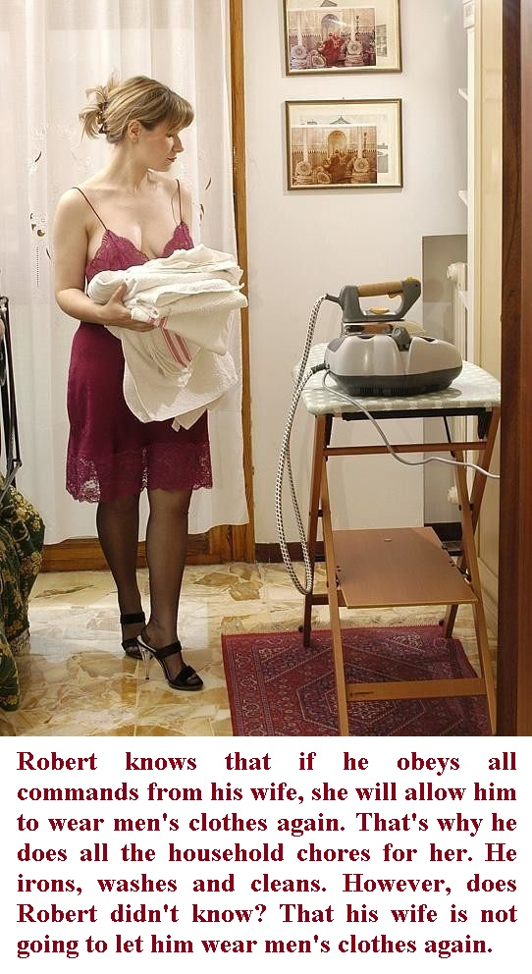

“If you follow my instructions, then I will allow you to step outside in men’s clothing again.” She said it all the time. But look at me! What would I look like in men’s clothes? Even if I cut off my wonderful hair, how could I hide those breasts?

My hair is wonderful. I have become proud of it and I admit it. It was a nuisance at first, but now it is a length where it is easy to put up, and when it is down around my face, I think that it makes me look good. It softens the angles of my face, and the bangs hide a slightly manly brow. That all makes it easy for me to go out and be accepted as a woman at the mall or the market.

So, will she ever allow me to wear men’s clothes as she promised? And if she did, would I want to wear them? Would people say – “Why is that woman wearing men’s clothes? Her breasts are bursting out of her shirt!”

Why would I even want to? Men’s clothes are so dull. And men’s shoes? Positively ugly. I am wearing my new heels around the house at the moment. I am just getting used to walking with that extra height. They make my legs look so good – don’t you think?

“If you follow my instructions, then I will allow you to step outside in men’s clothing again.” I don’t think so. I would rather keep wearing clothes I look good in.

The End

© Maryanne Peters 2022

