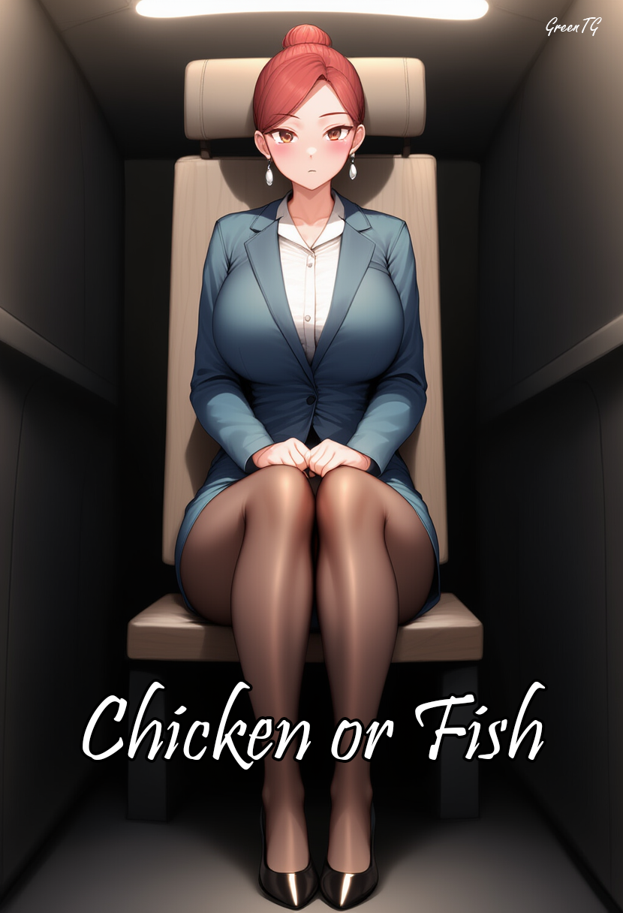

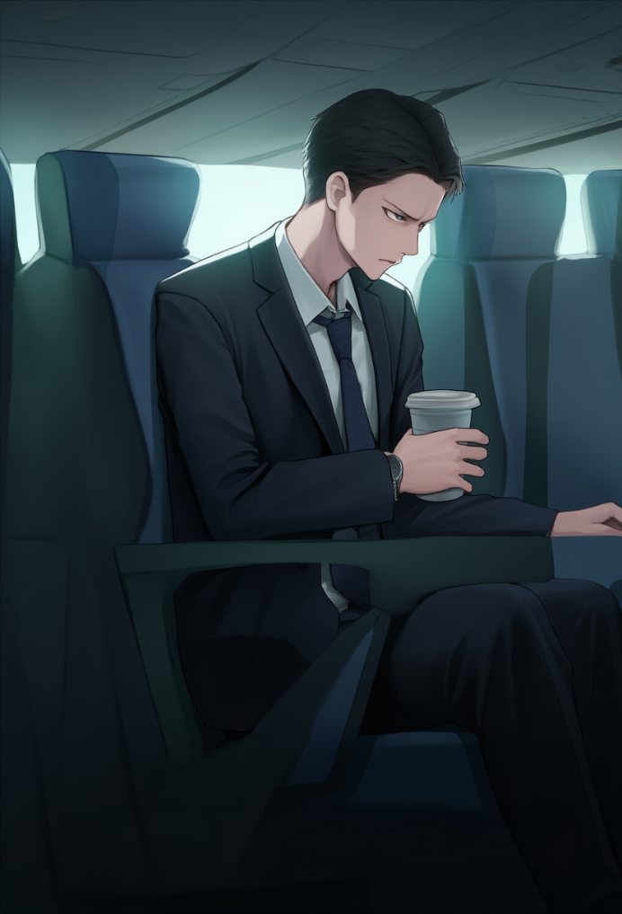
Damn, this seat is uncomfortable as hell—especially when you’re six-foot-three. I’m Jason Miller, top manager at an international company, a guy whose office is bigger than this whole flying tin can. And yet here I am—on a New York to Paris flight, stuck in goddamn economy class. Because my dumbass assistant didn’t book me a business seat in time. Well, that’s fine—he can go look for a job somewhere else now, because I don’t tolerate incompetence. Especially when it ends with me crammed into this sardine can.
— Chicken or fish? — the redhead asked gently, looking at me like I was some homeless guy they were feeding out of pity.
— Chicken. — I muttered, then added, glancing up from under my brow. — What are they serving in business?
My gaze instantly locked on her chest, which... wasn’t anything special. Just a regular pair of breasts under the tight uniform—barely a curve, not even a hint of cleavage. But I stared anyway, eyes catching on her name tag: “Camille Marchand,” with a smaller, italic inscription underneath: “Senior Flight Attendant - Air France.”
She seemed slightly flustered, looked away, and replied:
— In business—filet mignon and tiger prawns with mango sauce... — She said it in an even tone, but I could hear that little note of smug satisfaction in her voice. A tiny victory over the arrogant prick in economy.
— At least cute girls bring the food — I added with a smirk. — Otherwise, I’d be losing my mind in this flying hearse.
She didn’t respond. Just handed me the tray calmly, like she hadn’t heard a thing I said. Oh, we’ll see who gets ignored here. I pretended to focus on the food, but my eyes kept drifting back to the redhead—how smoothly she leaned over other passengers, how her skirt lifted just a bit, showing off slender calves in sheer black tights... She knew how to play indifferent, but her whole body screamed: I know you’re looking.
Alright then. Let’s test that.
I stood up, pretending to reach for something in the overhead bin. Truth was, I just wanted to be near her—she was bent over the aisle, handing a tray to another passenger. My hand “accidentally” slid down and stopped on her thigh, just below that rounded line where the skirt met the sheer tights. A little finger movement—and I could feel that firm, warm flesh yield under the thin fabric. I froze for a split second, savoring the moment like a gourmet thief stealing an extra bite of dessert.
In an instant, I felt her tense up. She straightened, turning her face to me with icy calm, and I could sense the contempt pulsing behind it.
— Please don’t do that again, sir, — she said quietly but clearly, her eyes suddenly far from innocent. No, that was the look of a woman who’d learned to take a hit and never sink into cheap drama.
I gave her a crooked grin, pretending not to understand.
— Sorry, accident, — I said with fake elegance, and without waiting for a reply, returned to my seat.
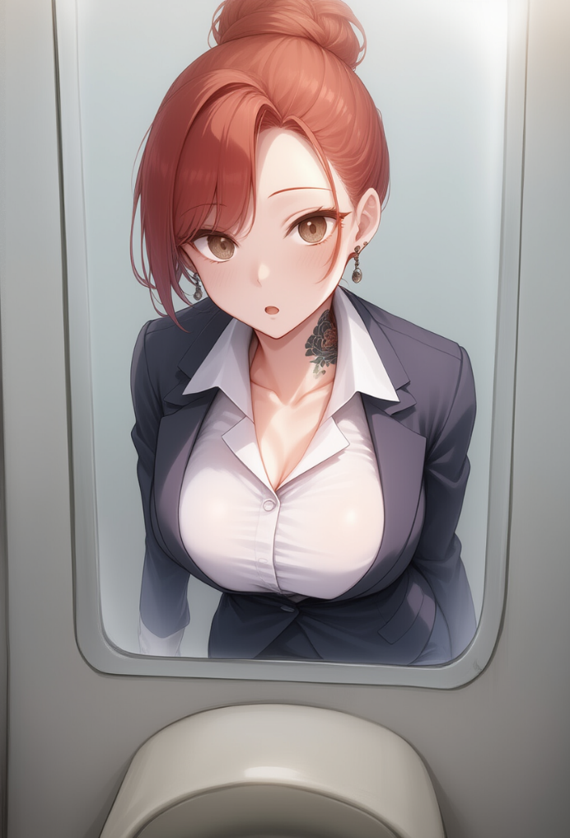
But I didn’t even get a chance to take a bite of that pathetic piece of chicken when, from across the aisle to my left, I heard:
— Young man, — said an old lady with curled gray hair and a glasses chain around her neck. She was sitting across the aisle, watching the whole thing. — Were you raised at all?
I laughed. A real, loud, condescending laugh.
— Oh, come on, granny, — I smirked. — You better make sure your pills don’t spill all over the aisle. And honestly, you should be in a coffin already, not giving lectures.
The old woman didn’t reply. She just kept staring. Silently. I never gave a damn about stares, especially from senile old hags, but this one was looking at me in a way that actually killed my appetite a bit.
— What’re you staring at, you old hag?! — I snapped, turning to her sharply. Normally, I’d keep it together, but for some reason this time everything was starting to piss me off. Fuck, can’t even grope some chicks in peace! What kind of flight is this?!
She didn’t blink. Didn’t gasp, didn’t say a word — nothing. Just slowly raised her hand, like she was about to fix her glasses… but instead pointed her finger straight at my face. Stern. Almost ceremonial.
— You’re too proud, Jason, — she said in the same calm, almost church-like voice. — You haven’t really looked in the mirror for a long time.
— What the hell? — I frowned, leaning in sharply. — What mirror, and how the fuck do you know my name, granny? You completely nuts?
— Everything that comes next — is the result of your choice. Enjoy it.
And then, I swear, there was a flicker of a smile in her eyes. Like she knew something I didn’t. And right in that second, the plane gave a faint shudder — turbulence. Or... something else?
I shook my head, pushing away the weird feeling, like I was getting dizzy. Then I stood up, muttering something about the bathroom, and headed there. My brain needed a break, a reset, a switch. I was starting to feel nauseous — and not from the chicken I still hadn’t touched.
The path to the bathrooms felt longer than it should’ve. Like the plane had stretched out, become... unreal. I reached the tiny compartment, locked the door behind me, and stared into the foggy mirror, breathing heavily.
— Well, Jason, — I hissed to myself, — everything’s already fucked, just ride it out.
I splashed cold water on my face, but the tension wouldn’t go. Inside, everything was humming — from irritation, or exhaustion, or rage.
I looked up at the mirror and everything suddenly just… froze.
The reflection wasn’t my face. On the other side of the glass stood… a woman. Young, with smooth skin, refined features, and red hair pulled into a tight bun. She was in uniform — the same uniform the flight attendants on this flight wore: a fitted white blouse, indigo blazer, tight skirt, stockings. I saw every little detail. I saw the tiny nose piercing on her left nostril, how the earrings pulled down her earlobes, even a glimpse of a tattoo peeking from under the collar on her neck.
— What the... — I breathed out, stepping back and blinking, nearly bumping into the wall of the cramped cabin.
Looking again, I let out a relieved breath — my reflection was back.
My hair, my eyes, my face. Everything in place.
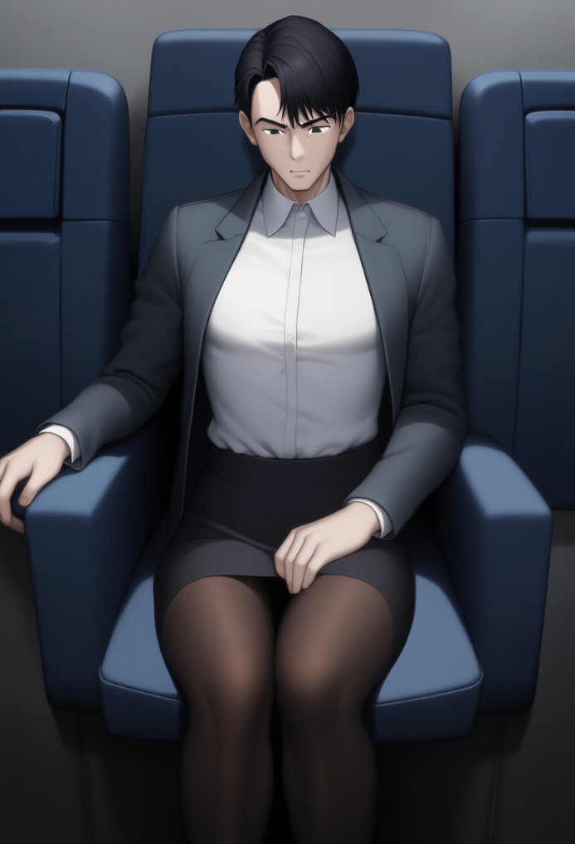
I ran my hand over my cheek, feeling the familiar stubble, and splashed cold water on my face again. Alright, better head back to my seat before the stench in economy starts messing with my head. I opened the stall door, still hearing that old senile bitch’s words ringing in my ears.
The walk to my seat took less than a minute, but… the moment I sat down, I felt something off. First — the smell. Subtle, sweet, way too… floral. It wasn’t coming from anyone nearby — it was coming from me. I lifted my arm and sniffed — seriously? What the hell is this? Why do I smell like some cheap-ass jasmine and rose body lotion?
I frowned. This wasn’t just weird — it was straight-up insulting. I always used the same expensive cologne with a woody base that screamed masculinity. And now I reeked like a damn shelf of body sprays at Victoria’s Secret. What the...
Then I noticed my shirt cuff was gone. It just wasn’t there. In its place — a short sleeve, snug around my arm. And my grey Hugo Boss blazer? Gone. Instead, I was wearing something else, deep navy blue.
— What the fuck... — I muttered, tugging at the collar — underneath was a crisp white collar, neat, gently pressed against my neck. It sat tight, uncomfortably so. I glanced down and saw a white blouse, hugging my now flat chest. I reached out to check if this was real or if I was really tripping, and my fingers immediately felt thin fabric — cool and silky to the touch.
At the same moment, I felt something tight around my hips, like I wasn’t in my usual tailored trousers anymore, but in something clingy, now pressing against my thighs, wrapping them tight.
— Fuck! — I exhaled, not believing my eyes as I looked down.
My pants were gone. In their place… a skirt. Tight, dark blue, just above the knees, same fabric as the blazer. And under it, on my legs — black, semi-sheer tights hugging my masculine legs all the way down. I could feel every damn inch of those fucking tights pressing against my skin — stretching at the bends, the cool synthetic fabric hugging my calves, thighs… ugh!
I tried wiggling my toes, but they hit something tight and stiff. Shoes. Black, glossy, with a short heel, snugly strapped to my feet, pointed toes, a strap across the instep. They felt unbearably tight — my toes squished like I’d shoved them into a shoe two sizes too small. With every tiny movement, I felt the inner lining rub, my heel sliding slightly in the soft padding. These shoes weren’t made for comfort — they were made to look pretty.
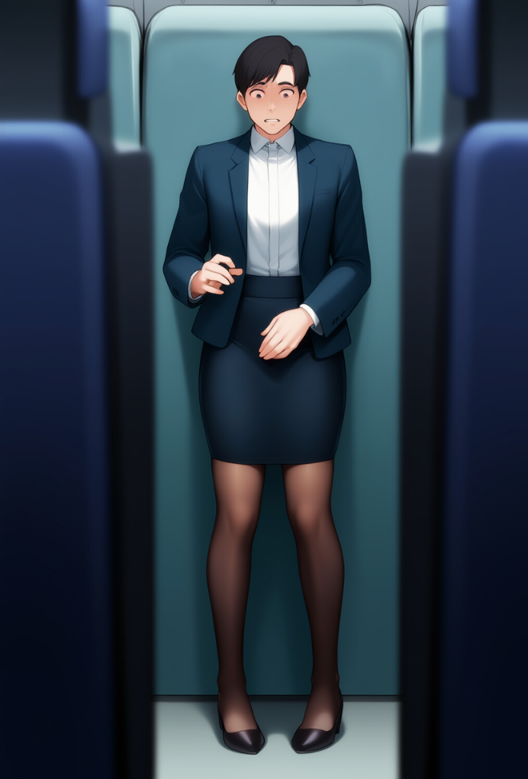
I stood up, gripping the armrest for balance in these damn shoes. The skirt instantly pulled tight across my hips, squeezing already snugly — like someone had wrapped my legs in an elastic band and was watching me try to move with dignity. The tights stretched at the knees, almost alive, gliding cold against my skin with every move. The blazer’s fabric pulled tight across my back — I could feel it pressing firmly against my shoulders, and that damn blouse collar pressing on my neck felt even more suffocating.
I looked around. People barely paid any attention to me. Some were asleep, some were glued to their tablets, others were poking around in their plastic trays with food scraps. As if no one was bothered by the sight of a grown man in a stewardess uniform, like it was the most normal thing in the world. No way, someone had to explain to me what the hell was going on. Or maybe I was just hallucinating and needed a doctor.
But before I could even start to process what was happening, I felt it again — a thin strap settled on my shoulders, pressing into my skin. Something dug in just above my shoulder blades and wrapped tightly around my chest. I looked down and saw a slight shape pressing through the blouse — and the moment I touched it, I realized it was a bra. Empty, but still a bra, with stiff cups and underwires digging in beneath the chest. And under the skirt, a thin strip — like a string — was cutting into my skin, pulled tight inward. Thong. Yeah. That’s exactly what it was.
My hand instinctively went to my crotch, like my subconscious already knew what was going on. But thank God it was still there. My dick, my manhood — intact. And where else would it go? This was obviously some kind of hallucination.
Out of the corner of my eye, I finally saw that old woman. Still sitting in the row next to me, watching me with some calm expression on her face, even a flicker of sympathy flashing across it. Shit, it all started after she said something. Maybe she sprayed some kind of poisoned air at me or something like that?! I opened my mouth, ready to scream at her, demand answers, threaten her with lawyers, courts — all the things that usually worked. But I didn’t get the chance...
Something tickled the edge of my left nostril. A thin, almost weightless metallic point, like a speck of dust stuck to my skin. I brushed it with my finger — and my heart dropped. It was a tiny earring, a little piercing. I, Jason Miller, now had a piece of jewelry in my nose like some bratty student from the Sorbonne.
— No-no-no, fuck, — I whispered through clenched teeth, and at that exact moment, I felt my earlobes grow slightly heavier. I ran my hand over them — two earrings, clearly there, dangling and pulling my ears down, like foreign objects that didn’t belong. At the same time, a burning sensation started to spread over different parts of my body. Under the collar, on my back, below the waist right above the ass, in the crotch area, and under my breasts. A tight, searing burn — like something fresh, painful... a tattoo?!
I froze, feeling my skin blaze like it had just been scorched with a hot needle. My hand reached up to my neck, to the spot hidden beneath the blouse collar. My fingers felt something raised, uneven — ink lines carved into the skin. What the fuck? I had never gotten a tattoo. Ever. That was beneath me. But now... now I could feel them. On my neck, my back, under my tits, near my crotch...
— Justine, are you asleep or what? — came a voice from the left, and I turned my head sharply. Standing in front of me was that redhead stewardess — Camille — holding a tray. She looked at me with mild confusion, like I was... her coworker. — You’re supposed to be helping with service, not standing around like a statue. Go hand out drinks in rows ten to fifteen.
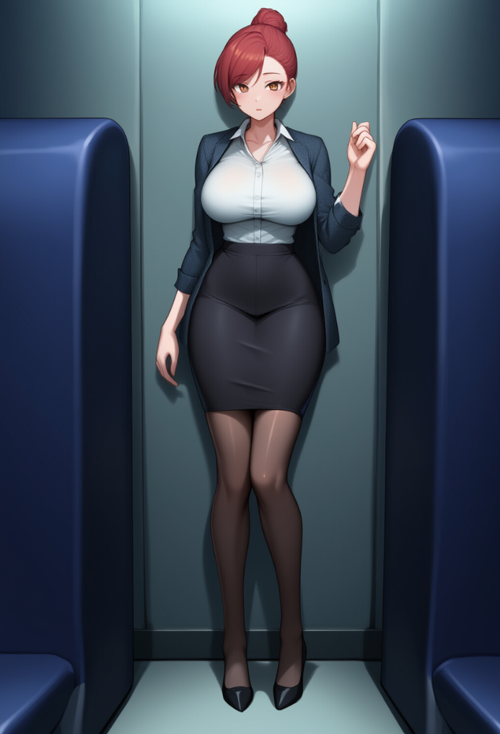
I opened my mouth to snap back at her, but instead, I said:
– Yes, of course, Camille. Right away.
What?! Why the hell did I say that? I looked down. There, on the left side of my chest, neatly pinned to the jacket, was a name badge. Small, with a silvery rim. In elegant cursive, it read:

Justine Meunier
Trainee Cabin Crew – Air France

No. No fucking way. This is insane. Who the hell is Justine? What the fuck is Trainee Cabin Crew?! My heart was pounding like crazy as my gaze shifted to the old woman. She was still sitting across the aisle, same posture, same serene expression. But now, when our eyes met, I… suddenly… smiled. Almost involuntarily. Some part of me told me I should smile.
The old lady nodded back slowly. Approvingly, without judgment or smugness. Like a primary school teacher nods at a student who finally figured out the answer on their own.
– Justine! – Camille’s voice cracked through the air like a towel snap on wet skin. – Serve drinks in rows ten to fifteen. Quickly, please.
I turned toward her, a sharp pang of shame stabbing through me, like I — a real, living girl — had just messed something up. Like I really was this “Justine”, the clumsy little trainee who forgot her duties and was now getting scolded by her senior. And the worst part was, there was no malice in Camille’s tone. Just irritation, a touch of disappointment. I felt… guilty?
My legs started moving on their own. I could feel the skirt pulling against my stride — every step took effort, heels catching slightly on the carpet, breasts—wait.
Something was happening. Right now, as I moved.
Slowly but unavoidably, the bra cups, which just moments ago had felt empty, started to fill out. I felt the fabric stretching, a firm pressure spreading at the center of my chest. At first — a light tickling sensation under my nipples. Then — growing tension, like warm, living pillows inflating from the inside. I instinctively held my breath and arched my back slightly, because suddenly the blouse tightened, pressing in, highlighting the new curves.
My… tits. And they were still growing.
Jesus. This wasn’t just visual. It was physical.
I could feel them. The weight, the movement, the faint tingling like blood rushing in. The bra cups, those damn underwires, weren’t just digging into my skin anymore — they were hugging, holding, supporting my boobs. My fucking boobs! They were heavy now, blocking my view — I couldn’t even see my feet anymore.
Every step reminded me how much had changed. The tights no longer bunched up awkwardly on male legs — they hugged me perfectly. The material sat smooth, snug, like it was made for me. And under the skirt, nothing felt out of place or pinching… on the contrary — there was this weird sense of comfort. Like I’d been wearing these fucking thongs my whole life. I could even feel them tightening slightly with each step, the thin strip sliding across the sensitive skin between my ass cheeks.
And… oh God!? My dick!? Don’t tell me that’s gone too?!
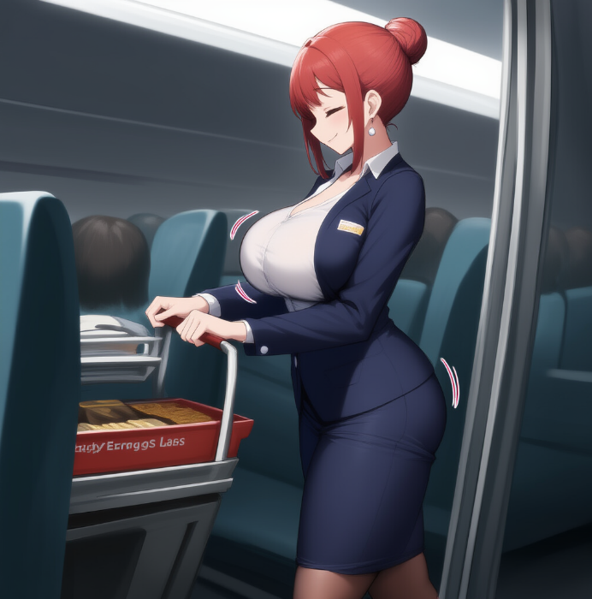
I froze for a second, my eyes locked onto the metal drink station. My head was buzzing, and there was a tight knot of fear and… shame in my stomach. I… had just thought about losing a dick. Not just in passing — I realized it, I felt it: it was gone. It was no longer there. My body… was no longer mine.
But my hands weren’t shaking. On the contrary — they started reaching out on their own toward the little plastic cups, the cardboard juice boxes, the bottles. My movements were careful, confident, almost mechanical — like I’d done this hundreds of times before. And the worst part was catching myself doing it all correctly. Fast. Neatly. By the book.
At some point, my gaze dropped to my fingers. They… were thinner. Longer. With elegant joints, a delicate wrist curve, nails that were shiny, long, and painted. I stared at them like they belonged to some other woman. But they were the ones preparing the tray of drinks. It was them reaching for the glass bottle of mineral water, pouring it silently into a cup, holding the rim with practiced precision to avoid spilling.
What the hell is wrong with me? Why am I doing this? Why does it matter to me right now?
— Justine, — came a voice from right behind me. It was calm, but there was a clear note of supervision in it. The kind that made it obvious she was in charge — and I wasn’t.
I turned around and saw her again. That same redheaded girl I’d been groping not so long ago. It was Camille Marchand — I knew she was my boss now, just like I knew she had been absolutely no one to me just hours ago. But my knees went a bit weak, especially when I realized I was now looking up at her. I, Jason Miller, who had been ten centimeters taller than most men in the boardroom just six hours ago, was now looking up at this bitch. Because I was smaller. How? How the fuck was any of this even possible?!
— Move it, Justine. We’ve got twenty minutes before tray collection. Smile, even if some of them are extra entitled.
I nodded obediently — almost sincerely, like I understood what she meant, even though everything inside me was screaming in protest. Then I turned back to the counter and lifted another tray of drinks. It was heavier than it looked. Not because it had too many cans or bottles — no. Just because this body… this fucking fragile body, with its thin arms and soft hands, felt weight differently.
My shoulders burned under the bra straps — they seemed to dig into my skin on purpose, like a constant reminder that I now had two massive weights on my chest. A reminder that I was a woman. Or worse, a girl. Because I didn’t feel like a grown woman — I felt like some twenty-year-old intern who’s about to get fired for spilling coffee on a passenger in an expensive suit.
Walking down the aisle in a skirt and heels — that’s its own special kind of torture. The heels snagged on the carpet, and the skirt, tight around my hips, slowed every step, forcing me into short, mincing strides. My tits… fucking hell. They had a life of their own. Heavy, firm, as if deliberately pulling me down, and with every bend, threatening to spill out of the bra cups. And the worst part was that I felt them. Constantly. Like two dumb pillows strapped to my chest — annoying, distracting, always drawing stares.
And all that time… her. The old lady. She sat as before, in her seat. Not turning around on purpose, but I kept catching her gaze. Once, twice, a third time — and every time, her eyes weren’t judgmental. No. There was something... gently strict in them. Like someone who knows: you’re walking a path, and it’s going to hurt, but there’s no other way for you to understand.
The second time I looked at her — with a tray full of drinks in my hands, bottles clinking, my fingers trembling with tension — she leaned toward me and whispered:
— Once the plane lands, it’ll all be over, sweetheart.
I froze. The word sweetheart hit me like a whip to the ego. That word wasn’t meant for Jason Miller. But I… I didn’t argue. I just nodded. Slowly, with the same strange calm that was in her voice. And I kept walking, gliding forward in those devilishly tight shoes, feeling my boobs bounce with each step, the bra shifting and pressing into my back like it had a mind of its own, the thong slicing into the sensitive skin between my ass cheeks.
And then something strange happened. One of the passengers — a man around forty, with a comb-over, in a blue polo — snapped his fingers in the air:
— Miss, still water, please.
I turned to him, and in that very second, a wave of heat hit me. His gaze — no, not just curious. It slid down, straight to my breasts. I saw it. How his eyes instantly jumped to my tits and stayed there. He stared shamelessly, with a calm confidence, right where the fabric of the blouse stretched tight, where the bra cups couldn’t quite hold the shape, where my breasts lived a life of their own. And there was no admiration in that look. It was my own look. The kind I once used on waitresses, secretaries, random girls at the airport. The way I used to look at Camille.
And now I feel that look on me, though I never should’ve even imagined something like this. But now someone’s looking at me like that. And somehow, with a sixth sense, I know I have no choice but to smile.
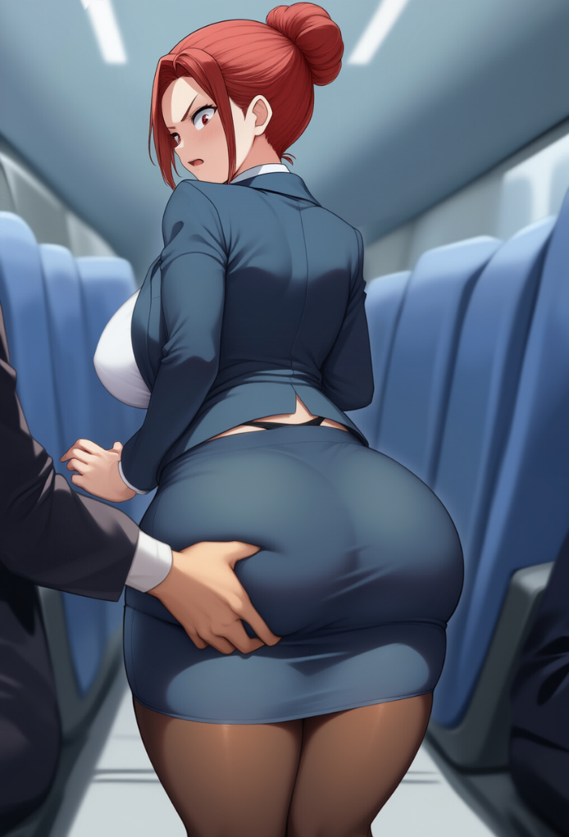
I handed him the bottle of water and stepped forward, already knowing what to do next, when suddenly I felt something touch me — right on my butt. A warm, cocky hand, with the nerve of an ordinary asshole, landed on my ass and squeezed it like he was checking fruit for ripeness at a supermarket. I flinched. Every muscle in my body tightened, especially in my ass, my lips trembled — and in that moment I felt the blood rush to my face.
I turned sharply, and my eyes landed on that same guy in the blue polo. His face was completely calm. He wasn’t even looking at me — just kept browsing the menu on the screen like my ass was part of the seat.
— Are you fucking serious?! — it burst out of me with unexpected sharpness, though my voice trembled. A couple of heads turned. Someone stifled a laugh in surprise.
— Justine! — Camille was suddenly beside me, so fast I jumped like a schoolgirl caught cheating. Her hand landed softly but firmly on my shoulder. — Come. Now.
I was still breathing hard, feeling my breasts shaking under the blouse from anger and humiliation. Yeah, that guy kept sitting there, pretending nothing had happened, but my ass, still burning from his bold hand, screamed otherwise. I wanted to go back, to tell him exactly what I thought. Say it like a man. Like the man I used to be.
But Camille was already leading me toward the crew area by the cockpit.
— What the hell was that, Justine? — her voice was calm and strict — We are the face of the company. Even if someone acts like a pig, we’re not allowed to snap. Not ever. Do you understand?
I nodded. Again. This time slowly. And once more I felt the earrings trembling slightly with the movement of my head. Felt how heavy my chest dropped after a deep breath, and how my throat tightened — not at her, but at myself. At the fact that I… I’m supposed to smile when someone gropes you. Not growl, not shove him off, not land a punch in the jaw. Just smile. What kind of curse is this?
— I’m sorry, — I whispered, not even sure why I felt so awkward, how my voice could be so... soft. — He... just...
— I know what he did. I saw. But you have to be above that. — Camille looked at me a bit warmer now. — Never react emotionally. If someone behaves inappropriately — you tell me. Or the lead crew member. But you never, hear me, never get into it with a passenger. Understood?
— Understood...

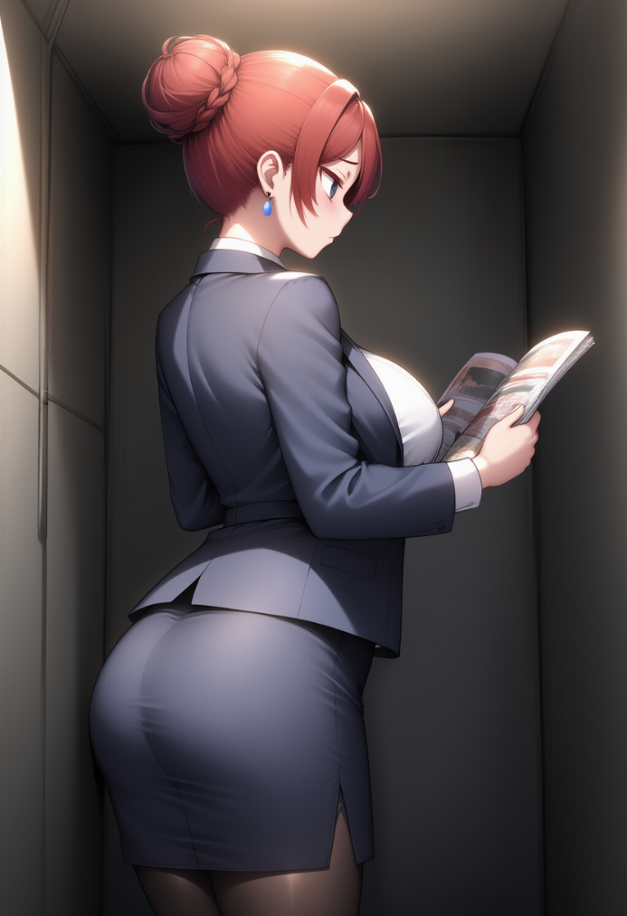
— Just... keep a straight face. And remember — it's not your fault. — she added, seeing the tears forming on my face. And with a kind of concern that only made it worse, she said — You can stay here for now...
I nodded, but it wasn’t enough to hide the trembling in my lips. Camilla lingered for a couple more seconds, as if she wanted to say something else... and still left, leaving me alone in the crew compartment. I stood there like a lost child at a train station, with a heaviness in my chest — not just physical anymore, but emotional too.
I leaned my palms against the metal edge of the counter. It was cold, and maybe that’s why my fingers calmed down a little. The damn heels were crushing my feet like shackles, my breasts swayed even from breathing, and the bra — almost mockingly — pressed beneath them, reminding me that I was now the proud owner of this pair of heavy, firm fucking curses.
What the hell is this? Am I seriously this upset because some guy groped me?... Fuck, what kind of thoughts are these? Is this really happening to me? Get a grip, Jason. This is bullshit. The old hag said it would all end once the plane lands. I just have to hold on, and then I’ll deal with that wrinkled bitch! I need to distract myself, get it together! You're a man, dammit!
My eyes fell on a magazine lying nearby. On the cover — a man in a business suit and the headline: “L'avenir du management en Europe.” I instinctively brought it closer and... understood every word.
French. I... knew it. Not just reading it — I felt the language like it was my native tongue. I flipped through the pages and read quickly, fluently, easily. Then — an ad in German. Understood it. Then — a blurb in Spanish. Understood that too. Like... I’d been learning all of it since childhood.
On the wall nearby were some more papers, in French and English, and as I looked closer, I saw they described crew behavior standards in different situations — and suddenly, with absolute clarity, I realized: I knew all of this too. The rules, the instructions, the onboard behavior standards, the emergency landing procedures — all of it lined up in my head like I’d been cramming it for months. I knew how to interact with VIP passengers, how to be invisible yet polite, how to speak, smile, breathe, even... how to fix my hair so the pin wouldn’t fall out.
And then I tried to recall my old life, and a shiver ran through me.
I used to do... what did I do? I remember being some big shot, the kind no one made decisions without. But what exactly did I do? I... I remembered nothing. No names of coworkers, no strategies, not even my assistant’s name.
‘What’s your deputy’s name in corporate policy?’ — I asked myself silently. — ‘What was the profit last quarter? God, at least tell me why the hell you're flying to France?’
Nothing. Just emptiness.
I couldn’t remember anything from my life as an executive. No office, no assistants, not even, fuck me, the password to my work email.
I sat down on the folding chair, staring at the plastic panel in front of me. My breasts rested heavily in the bra cups. The thong stretched tight under the skirt. In my nose — a tiny piercing I now felt every time I took a deeper breath.
I wanted to cry. Not like a man — but like a woman...
...
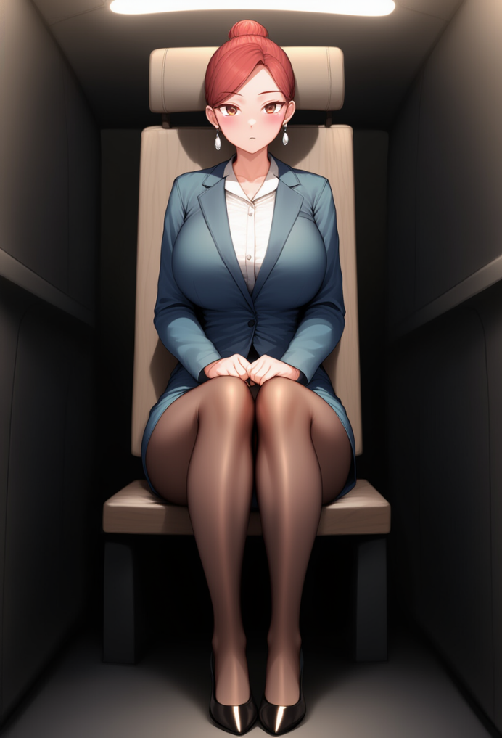
When the captain announced the beginning of descent, I was already strapped in, sitting in the same seat by the emergency exit, in a straight, almost perfect pose. Knees together, heels tucked under the seat, hands folded on my skirt. I noticed how my blouse was slightly damp under the arms from the tension, how the waistband of the skirt dug into my waist, and how my breasts, like weights sculpted from flesh, were pressed down by the seatbelt. I lifted my chin, almost on cue, when Camille walked in, as if trying to show her I’d done well.
— Good job, Justine, — said Camille as she walked by with a smile. — You really showed yourself today. Sure, there were a few hiccups, but for training — very respectable. You handled it.
I nodded. Not just to show I’d heard — for a moment, I actually felt… pleased. Not like Jason Miller would feel. Like Justine Meunier. Silly, unbearably shameful to admit, but in that moment, I felt something close to pride. Even if none of it was real and I hadn’t been acting on my own will this whole time, more like moving as a puppet. Even if this was some crazy dream or fucking psychedelic coma, still… I pulled it off.
I was counting the minutes till landing. Till returning to my body, to my life. The old woman said — it would all be over once we landed. I clung to that thought like a drowning person to a straw. And when the landing gear touched the runway and the plane shuddered slightly — I flinched and closed my eyes. This was supposed to be the moment it all ended. I was ready to be back in that now-so-desirable economy seat, in my own body, but… but nothing happened.
Only my tits bounced slightly from the sudden braking, and the bra straps dug painfully into my shoulders. The plane rolled onto the runway with a screech of the wheels, the cabin lights came on. Some were already unbuckling seatbelts, others pulling bags from under the seats, and I… I was still sitting there, like I’d turned to stone, feeling the taut seatbelt digging into my stomach. My knees were still together, heels tucked under the seat, hands folded on the skirt. I was still a fucking flight attendant...
— Justine, — came Camille’s voice. — Passengers are about to start disembarking. Take your position by the door.
I nodded and stood up. My heels clacked against the floor again. My legs, numb from sitting, trembled but quickly steadied — the body already knew what to do. I walked over to the front door, stood at my spot by the exit, straightened my skirt and adjusted the jacket.
— Merci d’avoir voyagé avec Air France, bonne journée, monsieur, — I said with the standard smile, and immediately noticed how his gaze slid to my chest, lingered for a second, and only then rose to meet my eyes.
— Merci… mademoiselle, — he said with a barely noticeable smirk.
I nodded, feeling my earrings sway. Next. The very one who had groped me, and now I was standing here smiling at him.
— Thank you for flying with Air France. Have a pleasant stay.
— Thank you, — he said lecherously, with a kind of cheerful grin, then winked. — Lovely weather today.
And so it went — one after another. Passenger after passenger. A flood of fleeting glances. Men who didn’t look me in the eye. Women who compared, judged. The elderly who ignored. Kids who smiled.
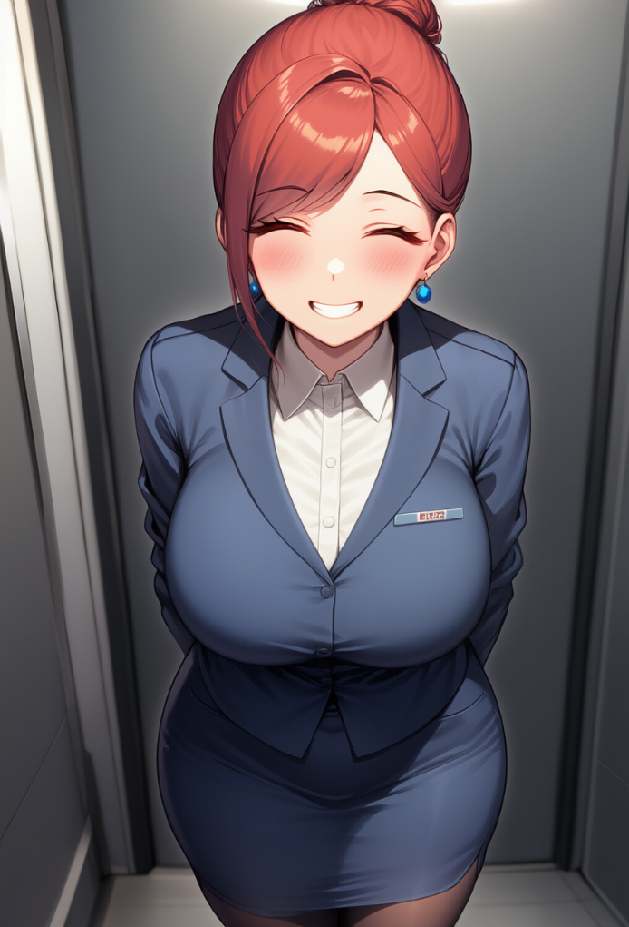
And I was-like a mannequin. I understood what I was doing, but there was no way I could influence even my own movements. I knew I just had to do it. I knew how to stand, how not to fall out of the standard, how to hold a smile and what to say. And only inside… everything was screaming. When will this end? Where's the finish line?
And then-there she was. The old hag. Walking slowly, with a cane. Still the same. Still unshakable. She came closer, her eyes met mine. And in that moment I… hoped. I waited for her to say: "You're free." To wave her hand. To at least wink. For something-anything-to happen. But she just walked past, smiling, and I… I looked her in the eyes. And even now, even in this last moment… I smiled.
- Merci d'avoir voyag? avec Air France, bonne journ?e, madame.
But she did, at least, grant me an answer to my silent pleas:
- Once you take your first step down the ramp… you'll be yourself again.
I flinched. My eyes darted to hers, and for a second, I-Justine, but still Jason inside-felt like I couldn't breathe again. I nodded to her, barely noticeably-not out of gratitude, but more like accepting the deal, a compromise with this madness. The first step. Just the first. After that-everything. The end.
I stood by the exit in uniform, feeling the tight jacket squeeze my shoulders, my feet aching from standing too long, pinched by the shoes. But it didn't matter anymore. There it was-the ramp. There, the door. Outside-cool Paris air and long-awaited freedom.
I stepped forward. One step. The first.
And in that moment-nothing happened.
I froze. Literally-frozen, like a mannequin. The edge of the metal ramp under my right heel, the plane door behind me. And that was it. The world didn't shake, my body didn't change. I didn't grow back to my height. The tits were still there-heavy, warm, hanging in my bra like two sacks of water. The thong was still slicing under the skirt. My ears still pulled from the earrings, and the damn piercing still tingled on my nose.
- What the fu... - was all I managed to exhale, raising my hand to my chest, and I realized that for the first time during the flight, I'd made that move. The one that should've been the first. Soft flesh… responded under my palm with warm, pliant resistance. It wasn't just there-it was felt. Right now. Under my fingers. Through the thin bra fabric, through the tight blouse. I pressed a bit harder-not on purpose, just instinctively-and the boob swayed slightly to the side. It was like I only now realized how real all of it was. These tits. They… lived. They had shape, weight, volume. Fucking D-cup. I'm not even surprised I know that now.
And I could feel it with every inch of my skin: how the boobs pressed against my ribs, how the bra cup stretched and dug slightly into my underarm. I slid my palm downward and… Jesus. The pads of my fingers felt that faint, vibrating tingle-like what was under the blouse wasn't just an object, but part of me. Real. Dense, heavy, sensitive, and completely feminine.

My knees buckled just from the sudden realization: this wasn’t an illusion anymore. This was my body. I was a woman now, with all… this. And my hand — a woman’s hand, by the way — jerked down along my side. Only now did I really feel how tight this skirt was. How unfamiliar it was to have tights pulled across my hips, and how that thin, disgustingly taut line of the thong was mercilessly slicing between my ass cheeks. Up until now, it felt like I was just playing a part. But now I was… stuck in it.
— What the… — I breathed out, but it wasn’t Jason’s voice. It was the soft, melodic voice of Justine, with a faint French accent — and now it was mine.
Panic started to rise. I turned too sharply — too much like a guy. The heels wobbled, and I barely managed to stay upright. My breasts bounced inside the bra, straps digging into my shoulders, and I — I let out a choked gasp, like someone had punched me in the gut. Camille was standing in the doorway, leaning against the frame, staring straight at me. Her expression was surprised, but not alarmed. Then, as if she noticed the look on my face, she stepped forward.
— Justine? — her voice was soft, but cautious. — Are you okay? Why did you… freeze?
I opened my mouth. I wanted to explain. I wanted to say I couldn’t move because, for fuck’s sake, I was still Justine. Because they promised this would all go away, and it… didn’t. Because I was standing here on the tarmac, under the cold wind, in this damn uniform, in these fucking shoes, and this whole body… was mine? This body, worn out from the flight and hard work, with a bra I could feel with every nerve, with tits that were heavy and alive, with these fucking piercings and tattoos... God, I had a butterfly tattoo above my ass, under my boob, and even down where… Ugh… I don’t even want to think about it! No...
I tried to step forward — and felt the heel nearly slip out from under me. My legs… Jesus, I didn’t know how to walk in these shoes. And this body, goddamn it. My knees wanted to give out, and the skirt was holding me back. I jerked my hip — the skirt pulled tight, my breasts swayed, and I felt the thong nearly slicing into my thigh from the inside.
— I’m… I’m fine, — I muttered quietly, trying not to show how bad it really was.
Camille came closer and leaned in. There was concern in her eyes, but not fear. She… cared. Like an older sister. Like a partner. Like someone who had no idea the girl in front of her wasn’t some intern, but a man who had lost himself.
— Just lost my breath for a sec. Must be the nerves, — I added, with a fake, strained smile. And in that moment, my lips trembled not from fear, but from the realization — I really couldn’t speak any other way now. That voice, that intonation — they had become part of me.
— Alright, — Camille said softly. — Walk. Slowly. I’m right here.
I took a step forward. Every step echoed through my body: the tight fabric of the blouse across my back, the bounce of my breasts with each movement, the discomfort of the shoes, the ache in my lower back from exhaustion and from holding it together the entire flight. I walked like a girl who had no clue how to move in this body and didn’t even want to learn. Because goddamn it, I wasn’t a girl, and sure as hell not a flight attendant — I was Jason fucking Miller.
