

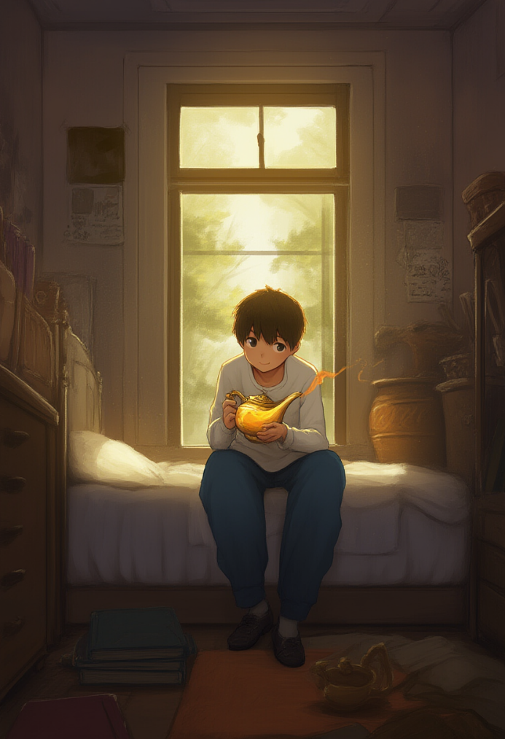
The deafening silence of the small room, its walls covered with posters of worn-out heroes from old video games and yellowed quotes from cult comics, was shattered by a sharp click of the door — Chet stormed inside, tossed his backpack against the wall, and yanked off his hoodie in irritation.
— Ugh, this shit pisses me off... — he muttered through clenched teeth, — why is everything like this!
Throwing himself onto the creaky bed, he stared up at the ceiling, the moment from the school hallway still pounding in his head — when Melissa, holding hands with some new guy, didn’t even glance his way.
No, that’s not true — she did look. Just like through glass. Like he wasn’t a person. Not a guy. Just nobody.
— Play... — he whispered to himself, like it could wipe everything away, — just... play. Fuck everyone.
He reached for his backpack to grab the controller, but his eyes caught a strange glint.
Something had slipped out between his books and a crumpled jacket and rolled across the floor with a dull clunk — an old brass lamp, darkened by time, with a pattern that looked Arabic but could’ve just been decorative. He froze.
— Oh, you’re that... — Chet dropped to his knees and picked up the lamp. — Right. I wanted to show Randy. Forgot, as always.
He’d found it last Sunday, when, armed with a trowel and half-dead curiosity, he was digging around the dirt near the old oak tree in the yard.
His mom said that oak was over a hundred years old, and that people used to bury something like "witches’ stashes" under it — a village legend she heard from her grandmother, the same one who wore long skirts even in the summer and yelled at cats.
God knows why he decided to dig there, but the find was genuinely unexpected.
He hadn’t told anyone about it. Not because he was scared — he just didn’t want to look stupid. He planned to show it only to Randy, mostly just for laughs — like, “look, straight out of an Aladdin movie, all that’s missing is smoke and a sexy slave.”
But then he got distracted by Melissa and forgot about it completely.
Now the lamp was in his hands.
The cold metal under his fingers felt almost damp, like it had soaked in the dampness of time.
Chet ran his thumb over the side, where the darkened patterns looked either Arabic or just made up. And before he could even think about what he was doing, he just wiped it a few times with his sleeve — slow, circular motions, three clockwise, three counterclockwise — smiling a little at the dumb action.
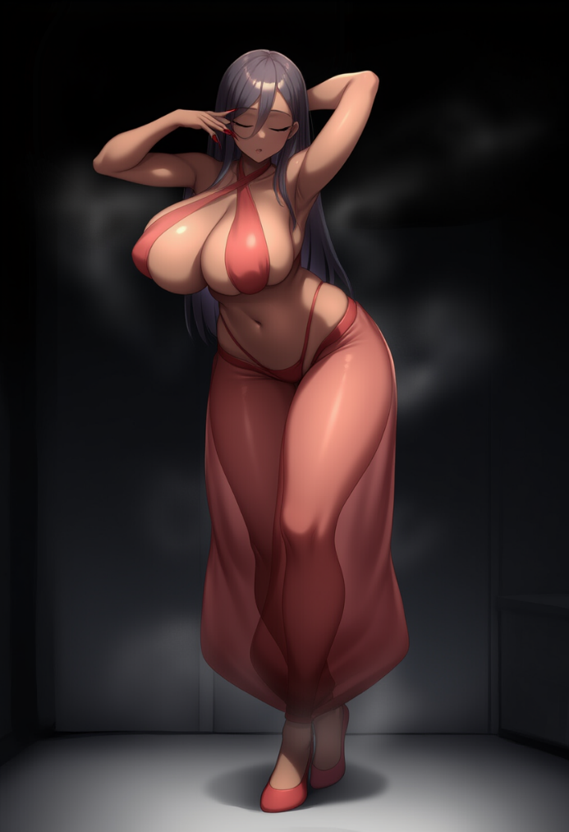
Suddenly, the whole room darkened — not all at once, but over a few seconds, during which the lamp began to tremble in his hands, as if something inside it had started to stir — something that hadn’t breathed in a very, very long time.
From the lamp’s spout, a thin, silvery smoke slipped out — but it didn’t rise up, it crawled along the floor, filling the air with a strange, sickly-sweet scent — jasmine, with a sharp metallic hint, like a soldering iron dipped in perfume.
Chet recoiled, but didn’t let go of the lamp — it felt like it was fused to his palm.
And then — a flash.
The moment he blinked, she was standing there in front of him, framed by trembling shadows.
Tall. Too beautiful. Terrifyingly perfect.
— No fucking way — slipped out of him instinctively, his mouth still open as he stared at her absurdly seductive figure.
She stood slightly arched, as if she had just been dancing a belly dance for someone. Her palms were raised — one above her head, the other lightly touching her face with the tips of long nails, hips tilted to one side, her head slightly bowed, as if frozen mid-dance.
Beneath a veil of mystical haze that still shimmered in the air like heat waves over asphalt, her body began to take shape — the kind of body real women simply don’t have. The kind you only see in photoshopped magazines or testosterone-fueled teenage fantasies.
Skin — warm, golden, smooth like a glossy magazine cover.
Hips — round, shamelessly wide.
Waist — tight and narrow.
Breasts — too big to be comfortable, but exactly the kind drawn on gamepads and posters pinned on Chet’s wall.
Her lips were slightly parted — plump, juicy, like they had just wrapped around a glass of wine… or something entirely different.
And then, after a moment that felt like eternity, she opened her eyes.
Slowly, like she wasn’t even sure she could.
Thick, long lashes fluttered. She blinked, once, then again, breathing in — each breath longer than the last — as she looked around Chet’s room, settling into a more natural human pose.
Then, as if realizing something, she slowly lowered her head and...
— What the... fuck... — she whispered.
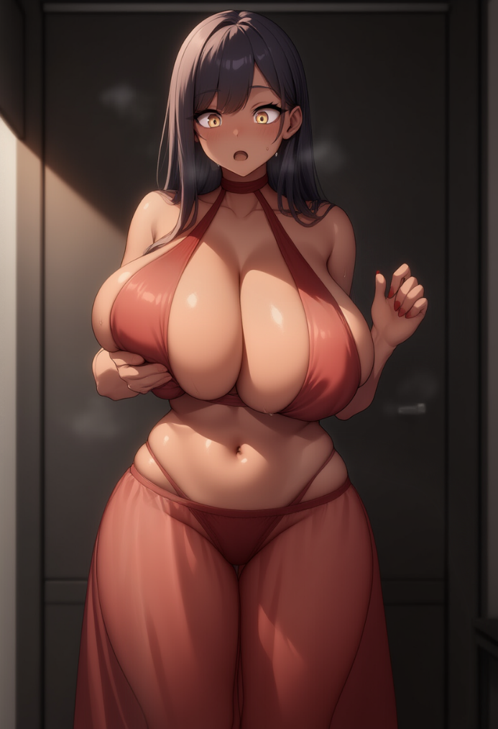
Her voice was velvety, husky, sultry with a smoky rasp — but there was uncertainty in it, almost panic.
Her breasts — those two massive boulders — heaved under the sheer fabric, and she stared down at them.
It was like her gaze couldn’t register anything else — just the deep cleavage beneath that see-through top in some Eastern style, matching her long, equally sheer harem pants, which ended in two curled-toe shoes she definitely hadn’t noticed yet.
— Wh... what the fuck is this? — she blurted louder.
And that voice again... sexy, breathy.
She raised both hands and touched her tits — gently, with bewildered care, like she was afraid they were foam… or an illusion. But no, it was flesh.
Soft, pliable, heavy.
She gasped — not in pleasure, no — more like horror, from how... real it felt.
— Jesus... — she growled. — These... huge... tits? ON ME?!
Chet’s coughing — he’d choked from the shock of the sight — snapped her attention.
She jerked her head toward him, her long hair sliding across her delicate little shoulders, still cupping her heavy, oversized breasts in her hands, her long nails lightly digging into the tender flesh.
Chet immediately staggered half a step back and, slipping awkwardly, crashed down — thankfully, right onto his bed, so the fall turned out okay.
— Ow... — Chet wheezed, quickly scrambling up and locking eyes with the girl again. — Sorry... You... You’re a genie, right?...
The woman — too real, too outrageously out of place for a cluttered teenage room — flinched at his words.
Her hands were still gripping her tits, as if trying to confirm their existence, and only after a couple seconds did she slowly let go — the heavy flesh swayed, making her visibly shudder from the sensation.
— Genie?.. — she repeated, but not like someone hearing about a mythical creature — more like someone who’d just been called a dog or a refrigerator.
She shook her head, and her long dark curls slapped against her shoulders.
— Fuck... what is this... WHAT the hell is...
She took a couple steps forward and nearly fell — her hips, absurdly wide and completely unfamiliar, swayed so sharply she barely stayed upright, throwing one hand forward to catch her balance.

Her tits, which she’d just released with uncertain fingers, now bounced freely under the thin fabric of the top, swinging hard to the sides and forcing her whole body to strain in response just to stay standing.
The movement sent such a sharp, jarring sensation through her back that she let out a short, involuntary cry — not from pain, but from shock, like someone had punched her between the shoulder blades from inside.
— Son of a bitch... — she exhaled, trying to press her breasts back against herself with her hands.
The softness under her palms was too real, and that new weight — heavy, unrelenting — bore down on her harder than even the fact that she was now "free."
She took another step, more cautiously this time, but still uncertain — her ridiculously round ass made her sway like her body was whispering stubbornly: “Honey, you move differently now.”
— Okay, stop — she muttered, touching her temples with both her long, thin fingers, and instantly flinched at the feel of her own long nails.
— Ugh... No, this can’t be real. This is just a dream. Some hallucination... from the goddamn mold in that damn lamp.
She snapped her gaze around and, locking eyes with Chet, asked with that same doomed tone people use when they say: “Am I dead?” — even though they already feel the answer will be worse than death.
— Where am I? — she asked, stepping forward awkwardly, like she was learning to walk again, her face twisted in a mix of pain and horror.
— Uh... — Chet sucked in air like he just realized he’d been holding his breath too long. — This... this is my room...
He blushed — even his ears turned red.
His eyes darted everywhere: from her waist — so narrow he could probably wrap his hands around it — to her breasts, which were impossible not to notice, even in the corner of his eye, down to her belly, barely hidden by the sheer fabric.
Even her leg, the one she’d unknowingly placed forward, was bent at the hip in a way straight out of those dumb poses from body wash ads.
— A room... — she drawled. — A room. A teenager’s room. With posters and dirty socks. Wonderful. Fucking perfect.
She spun around — and again almost collapsed.
Those hips — those goddamn exaggerated hips — shifted the wrong way, throwing her off balance once more.
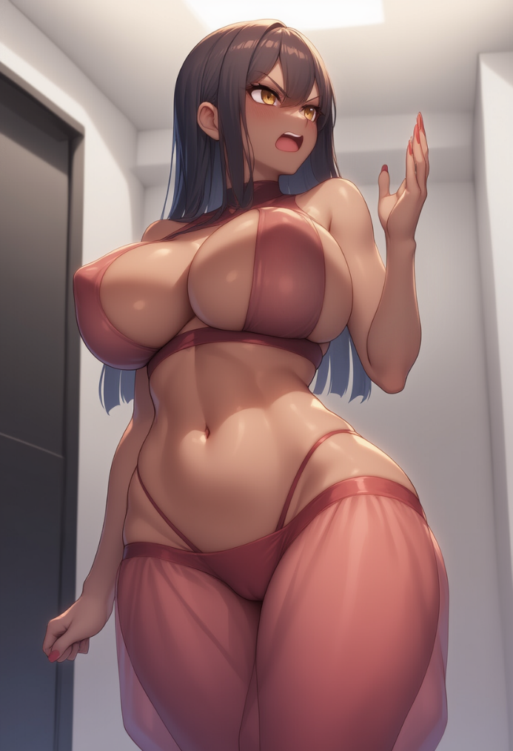
And the hair — that thick, fucking mass of curls — clung to her skin, slid down her back, across her shoulders, tickled the back of her neck.
She cursed under her breath — but even her cursing now sounded like some kind of flirty whisper.
— I’m not... — she paused, staring down at her palms again.
They looked so foreign now. So feminine. So far from the hands she’d known her whole life — sweaty, thick, always smeared with either machine oil or welding slag from night shifts at the factory in Ohio, back in the 1950s in the U.S., where she — or rather he — used to scream at trainees for holding electrodes “like fucking girls hold champagne glasses.”
— Ah, fuck it — she grumbled, too quietly for a body like the one she had now, but just loud enough that Chet couldn’t miss it.
They both fell silent.
Chet stood frozen, paralyzed by some strange daze, feeling a sticky lump rising in his throat — not fear, no — something else.
Something he didn’t want to name.
His palms were sweaty, his breathing shallow, like he was standing in front of the screen during the raunchiest scene in his favorite game — only now, it was all right there.
He stared at the girl, her body too unreal to be real, too impossible to be normal, and suddenly he felt his chest tighten — or maybe swell — with something he was too ashamed to put into words.
His eyes kept sliding toward those hips, those jiggling, heavy... shapes.
And from somewhere deep in his belly, a warm tremble began to rise.
He couldn’t even tell — was it fear, arousal, or just a shockwave crashing into him with the full weight of his teenage unpreparedness?
At that moment, she unconsciously bit down on her full lip, squeezing her eyes shut and clutching her head with both hands.
"Seventy fucking years." — the thought flashed through her mind, and then, like someone flipped a switch, a blinding flashback erupted in her head.
She — back then still he — Frank Delaney — big, with a gut hanging over his belt, always in a filthy undershirt, was strolling along the edge of town, chomping on a sandwich, looking for a patch of shade to crash in.
Another week at the cheese plant, filled with the stench of burnt oil and man-sweat, had come to an end.
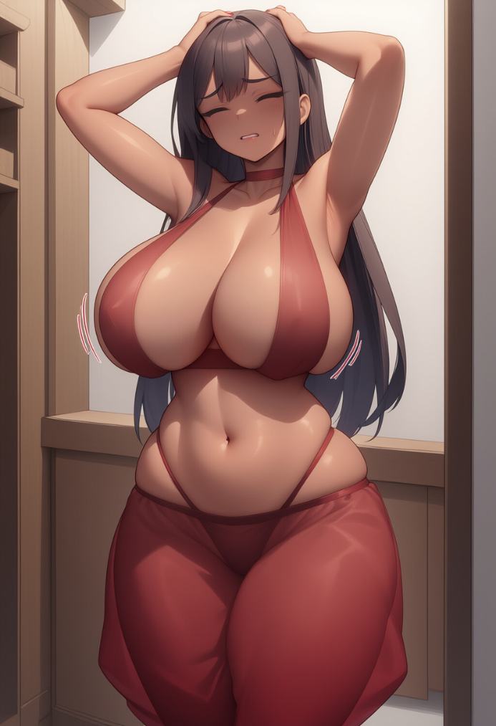
Everyone knew Frank as a crude bastard — rough around the edges, always with a can of cheap beer in hand by evening and long-winded rants about how “everything’s fucked now,” how “women stick their noses where they don’t belong,” and how “things used to be better.”
Conservative to the bone, rusted stiff like bolts in an old pipe.
Rude. Loud as hell. And never one to ask questions as long as shit went his way. But even someone like him sometimes needed a walk where no one “was fucking up his brain.”
The lamp — he didn’t even remember how he stumbled onto it, and definitely didn’t connect it to any of that Arabian Nights genie bullshit or magical crap he never believed in.
It was just there, like it had been waiting for him, under that goddamn oak tree where someone had dug a hole for who knows what reason.
He could’ve walked right past it — but then he wouldn’t have felt that weird pull, like some invisible force nudging him forward, whispering with a smirk: “Go on, old man, stick your nose in it. Don’t be a pussy.”
He spat on his boot, knelt down, and pulled that lamp out of the loose earth like he was yanking something lost — something his — out of the dirt. Maybe it really was.
Within a minute, with that damn thing in his grimy fingers, he snorted and rubbed his hand across the surface... and never had the chance to understand a damn thing.
The next thing Frank Delaney remembered, before being locked in some strange, enclosed space — like buried beneath the skin of reality itself — was a weird voice. Muted and ringing all at once, high and low at the same time — but most of all, speaking a language he couldn’t understand at all. Then — a flash. Like someone shot the sun into his eyes.
And there was nothing left.
No arms. No legs. No body.
Just heat shimmer and a vacuum that sucked not air — but his very essence.
The lamp sealed shut like a metal coffin with no lock.
And that was it.
After that... there was only eternity.
No time. No light. No sound.
Only thought. Only awareness.
That rotting, mind-warping feeling that you exist — but nothing else does.
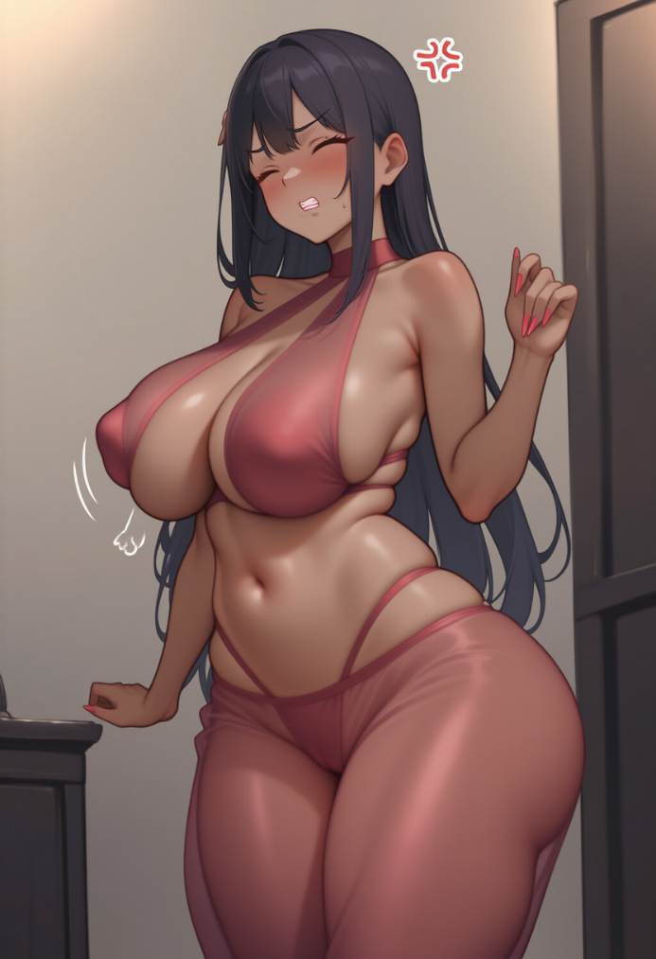
No where. No how. Not even who.
It was hell.
But Frank never lost hope it would end someday — though he had no clue what exactly should end, or how the hell to escape it.
And then came that moment — the one Frank had stopped waiting for, resigned to that bizarre, meaningless existence.
Unaware that he’d spent a whole seventy years inside that lamp, filling the empty role of the trapped spirit — or, as modern pop culture called it, a genie — the all-powerful being locked in a lamp, allowed to use its powers only to fulfill the wishes of the lamp’s "master."
And now, finally feeling solid ground beneath his feet for the first time since, Frank — though that name fit the bombshell standing in front of Chet about as well as boots fit a ballerina — finally accepted that somehow, stupidly, she really had become a genie.
And at that same moment, she understood: this new body wasn’t some genie default setting or ancient template.
No. It was way worse.
This was her first manifestation, her first release.
And the body she now felt — the tits, heavy and warm like sacks of hot sand, the hips moving on their own, the skin too smooth, too young — none of it had been her choice.
It was the image of the Genie... as imagined by the lamp’s first master.
Chet.
And now this image — this form — was stuck to her.
Permanently.
She clenched her teeth, feeling a bead of sweat roll between her shoulder blades, settle in the groove, and slowly slide downward, making her shudder involuntarily.
— F-f-fuck... — she hissed, feeling her voice tremble again, rippling through her tits with a soft, too sensual vibration.
A voice that now sounded like every exhale ought to come with a moan.
— I mean, seriously?.. Just like that?.. Just like that, no warning?..
Chet swallowed hard.
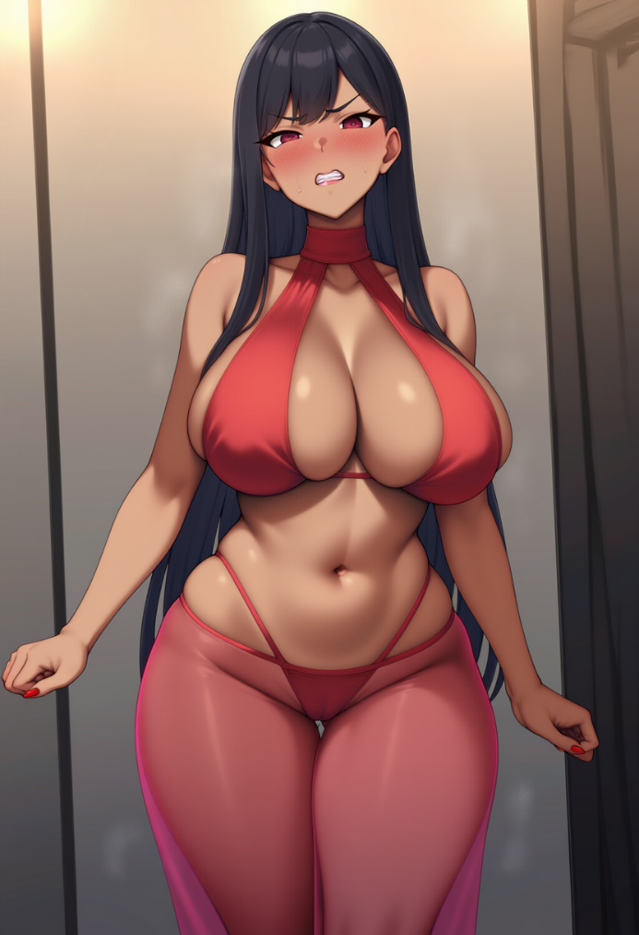
He sat on the bed like a statue — the only thing moving were his eyelashes, and not because he was blinking, but because his heart was pounding so hard it felt like it was trying to punch all the air out of his lungs.
He saw her every move, openly staring — at her tits, then her ass — and he just couldn’t shake the feeling that he’d done something terrible… and at the same time, that this was the best thing that had ever happened in his life.
— Of course... — she kept talking, raising her arms like she was trying herself on, fingers spread. Her palms were trembling. — Of fucking course...
She slapped her hand against her thigh and the sound echoed through the room, her flesh rippling like jelly.
She looked down at that part of her body, face twisting in disgust.
— So you’re telling me... — she turned toward Chet, no longer hiding either her anger or confusion — that because of you, you little perverted shit, I’m stuck walking around like this now?! With Tits that have a mind of their own? An ass like that... what’s her name... Kardashian?
She didn’t even realize at first who that was or how she even knew the name — it had bubbled up on its own, from the new knowledge, the magic now flowing through her.
— Ohhh... — she exhaled sharply, raising a brow and placing a hand on her lower back, staring at the stunned Chet. — Lemme guess, you gave me the name too, huh? Zaliya, seriously?
Though... I guess there’s at least some logic to it.
— I... — Chet mumbled, like an apology, though he wasn’t sure for what exactly. — I didn’t... I just... wiped it. And... you appeared.
— “Just wiped it,” — she mocked, raising her hands and making air quotes. — Do you have any idea what you fucking did?! You pulled me out of...
She stopped herself sharply — she was about to say “hell,” but changed her mind.
— ...out of the longest, muddiest nightmare a person can imagine.
Only it wasn’t a dream.
And now —
She straightened her shoulders, and her breasts swayed heavily again —
— now I’m in a body you jerked off into existence.
Thanks a lot, Lord Wet Dream.
Chet pressed himself against the wall, like he was hoping to melt into it.

His ears burned.
He felt like someone had just caught him with his laptop open on the nastiest tab imaginable.
He wanted to say something smart, something important… something right.
But all he could squeeze out was:
— I... I swear I didn’t mean to…
— Really? — Zaliya snorted, taking a few steps toward him, each one making her hips move like they were having their own private argument with gravity. — Kid, I can see right through you...
She froze.
Her brow twitched.
Her lips parted — not in a smirk, but in a strange, primal kind of shock, like she’d just accidentally turned on a TV that broadcasted Chet himself — every messy thought, every filthy little fantasy he wouldn’t even allow himself while dreaming.
Her eyes widened — and what reflected in them wasn’t just the room... it was something deeper.
— What... — she breathed out, and now her voice wasn’t that playful feminine whisper — it carried the rough confusion of someone still half-man inside. — You... you actually THINK about me like that?
Chet flinched.
He hadn’t said a word, but inside his head, a reel was playing on loop —
Her, on all fours, ass toward him, begging for sex.
Her moaning sweetly while stroking his dick.
Her tits bouncing wildly as she rode him, that sheer top clinging to her skin...
And now, he realized — she saw it all.
Everything.
— Ohhh what the fuck... — Zaliya groaned, her eyes going wide, pupils flicking like they were trying to escape the overload, and she suddenly slapped her hand over her mouth. — Are you fucking serious?
She stepped back, one leg buckling a little like she didn’t trust her new body.
Her breasts jiggled again — each like a separate entity — adding a weirdly tragic kind of emphasis to the moment.
— You... — she pointed at him, her finger surprisingly graceful but moving like that of a welder who just yanked off his glove. — You imagined this?! This is all in your head? My... my Tits, my moans, all of that?! I’m just a walking porno to you, huh? That it?
— I... — Chet gasped, trying to summon some kind of defense, but what came out sounded more like a squeak. — I didn’t... I mean...
— Just shut up — she cut him off. Not harshly, not even angrily — but with that new female voice, carrying an undercurrent of deep, still male irritation. — I just crawled out of forty fucking years of silence in a goddamn metal can!
My ears are still ringing like I was inside a fucking engine bay, and the first thing I learn is that my new master’s a teenager with a dick for a brain — and that dick already fucked me six ways to Sunday without even opening his damn mouth!
She turned around in those weird Eastern slippers with the curled toes, but her new walk snapped her right back to reality.
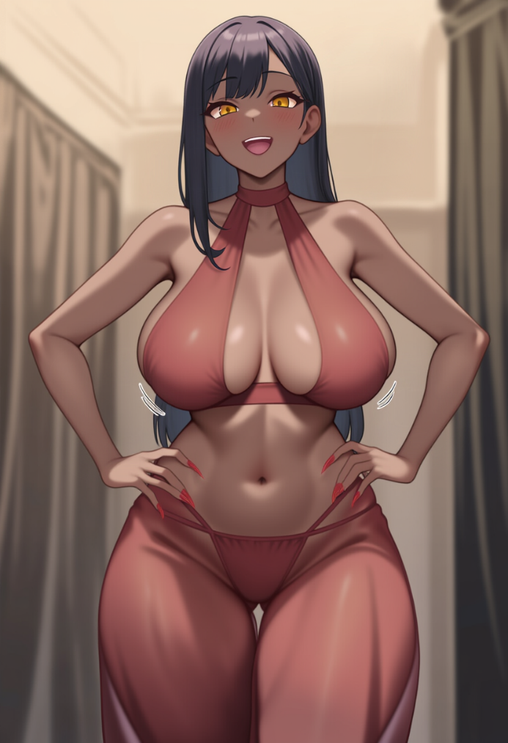
Her ass swayed like some invisible prankster was puppeteering it for laughs, and Zaliya — or rather Frank, who had never in his life felt so betrayed by his own body — hissed through clenched teeth:
— Why the fuck is this happening to me... Jesus. Tits, an ass, hair that sticks to my back like goddamn lint after a shower... And now you, with your... fantasies.
She stopped and glanced back at him over her shoulder, ready to throw some snark — but froze when she noticed the bulge in Chet’s pants.
Her eyes widened so hard they almost popped out of their sockets, her mouth went dry, and panic sparked behind her ribs.
She opened her mouth and said what she already knew was a lie before it even left her lips:
— I’m not granting those kinds of wishes, got it?!
— No-no-no! — Chet panicked, grabbing a pillow to hide his rapidly growing erection, blushing straight up to the roots of his hair and clutching the cushion like it could save his life.
— Oh for fuck’s sake... — Zaliya pinched the bridge of her nose, and then — unexpectedly — burst into a wide grin.
— I’m kidding, obviously. I will grant your three wishes, as per the contract.
But heads up — no bringing back the dead, no making anyone fall in love with you, and no matter how much I might beg or plead... I can’t change the way I look.
This is what I am now, and I’ll stay this way until the end of my days.
The words hung in the air like incense smoke.
And then... her smile slowly faded.
It peeled off her face like bad makeup, revealing something real underneath — something uncertain, heavy, deeply internal.
— What the... — she breathed out, and this time her voice trembled — not with fake sultriness, but real unease. — Did I just say that automatically? Like... like it was sewn into me... like I already knew…
She stepped back, planting both hands on her hips — instantly feeling the fabric of the harem pants stretch tight in all the most sensitive spots, flesh giving under her palms, triggering a weird, unpleasant prickling sensation across her skin.
Her tits bounced downward, and she quickly, irritably pressed them back with her forearm — like she could somehow shove that yielding mass back inside herself.
No luck.
— Fuck... — she muttered, staring at one spot in front of her. — Until the end of my days... Why did I say that... Is it... is it true...?
Chet swallowed and shifted uncertainly on the bed.
Something was stirring inside him, climbing upward, squeezing the breath from his lungs.
— So... you... — he lowered his voice like that would somehow make this whole conversation less absurd — you didn’t mean to say it?
— MEANT TO?! — she snapped, and her hair whipped out like inky tentacles. — I wanted a beer, goddammit! I wanted to scream at the TV and pick my fucking teeth while the radio blared! Not say “I’ll grant your three wishes” in the voice of a damn porn actress while shaking my hips like I’ve forgotten what pants are!
She sat down again — no, more like crashed onto the edge of the bed, still holding her breasts with one hand.
Like they weren’t just body parts, but obstacles — things getting in the way of thinking, moving, even existing.
Her eyes darted across the room — to Chet, to herself, to everything.
— And now... — her voice dropped lower, rougher, like something of Frank was cracking through. — …Now I feel like... I need you to do it.
— Do what? — Chet asked quietly, leaning forward, though still clutching the pillow over his lap.
— Make a fucking wish! — she barked, then winced — not from anger, but from something inside snapping. — I... I feel it, you hear me? Like hunger.
Like there’s this... pull, inside me. Every second, I want it more.
It’s like — like being starved, yeah! And the longer you stay quiet, the worse it gets...
She exhaled sharply, like something clamped down on her chest.
Her hands trembled, and she leaned forward, bracing them on her thighs — legs spread wide, not at all ladylike — her boobs dangling down, the harem pants stretched tight between her thighs, but suddenly she didn’t give a damn.
Something worse, something scary had drowned out everything else.
— I don’t know what this is — she whispered, staring at the floor — but... it’s like I was made for this now.
For wishes.
For granting them.
And until you say something... I’m dying, little by little.
Not my body — the body’s doing just fine, — she gave a crooked smile, shifting slightly, feeling how her boobs swayed, how her nipples brushed the fabric.
— But inside... it’s like something’s eating me alive.
She looked at him — and for the first time, there was no anger in her eyes. No sarcasm.
Just something... weak? Pleading?
— Make a wish — she breathed, clenching her fists. — Please. Anything. Even... even just wish me back into the lamp. Just... something.
Chet opened his mouth — but no words came out.
His hands shook, and he dropped his gaze.
He couldn’t meet her eyes — they were too honest, too human.
Too far from the eyes he’d imagined when he fantasized about a genie.
And he suddenly realized — in this room, surrounded by posters, the smell of sweat, jasmine, and something unfamiliar — it was just the two of them.
And neither of them was ready for any of this.
He was a boy who expected, who fantasized about someone like her — but now, faced with reality, he saw it wasn’t anything like what he thought.
And she... she was a being from a lamp, who instead of feeling powerful, joking, being some mighty force — was now cursing her body and panicking at the sheer absurdity of the magical mess she’d been thrown into without warning.
And Chet... Chet suddenly felt that even if he did make a wish — he had no idea what it would be.
