Russian TransBrides

Fiction: Two Americans find themselves among
Russian Transgender Beauties

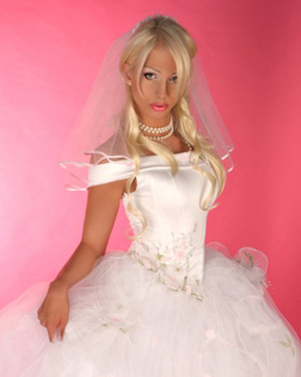

By Maryanne Peters

Warning: Some of these stories contain profanity or descriptions of sex acts between men and transgendered persons.

Russian TransBrides

Part 1.: The Beginning

“You can try to move if you like, both of you, but I can tell you that the muscle relaxant is very effective.” The woman who called herself Madame Gabanova appeared to be in complete control. James could not even turn his head to see Michael sitting beside him, although he knew he was there. The sofa seemed to be holding them both in a vice like grip.

“You see, before I got into this business, I was a captain in the GSR,” she continued. “Working for the State was not profitable enough for me, but I learnt so much from my time with counter-intelligence. I learned how to deal with greedy Americans like you two. But the problem remains - what am I to do with you?”

“You cannot get away with this,” muttered James, trying to speak above a husky whisper.

“My problem is that you will,” said Madame Gabanova. “You see, I have had a microphone placed in your room and I know all about you two. You are not the wealthy bride seekers that you pretend to be. You are penniless adventurers looking for free sex from my girls, who are genuinely looking for good husbands. In a word, you are rapists. Rapists by fraud. You deserve punishment, but what can I do? You are foreign nationals. The police will ask: Where is the crime? The women consented?”

“Please let us go,” whined Michael, his voice sounding strangely shrill. I promise you that we will tell nobody.”

“If you die, you can tell nobody,” said the lady in charge, with a sneer that showed that death was indeed an option. “Anything short of death presents a risk. But I have been thinking that killing you would be a terrible waste of flesh. You boys are young, and small, and slightly built. I am thinking, rather than cost me, could I make money from those pathetic bodies of yours?”

The effect of the relaxant was slowly beginning to wear off, so that both of the young men could turn and see one another.

“Jim, is that you?” Again his voice seemed hard to modulate.

“Mike, you look like a chick,” said the dark haired woman. “And you sound like one too.”

“What have you done to us?” Now it was clear that James voice was different, as he glowered at Madame Gabanova. And as the control returned to his throat and below it, he became aware of pain in his chest, and just the beginning of discomfort further down, comfort that was to turn to intense pain within minutes. “What have you done?” Now it was an anguished wail.

“I am a businesswoman,” she explained dryly. “I always need new brides. They come from all over Russia to seek their fortune. But I always need more. I just make the matchmaker’s fee, but it can justify some … some cosmetic changes for a higher value bride. In your case the surgery has been more substantial, but it is worth it because you are now English-speaking Russian girls. They command the highest prices.”

Michael started to cry, with tears flowing and his now reduced body heaving.

“Do not be concerned Little-one,” said Madame Gabanova. “It is the hormones. You each have a slow release capsule implanted that has been flooding your system for the past three weeks. Yes, you have been unconscious or sedated for over three weeks. So much as changed for you in that time. But there is still much to be done.”

James was now able to move his hands and the went immediately to his groin. He gasped. “Oh my God!” This cannot be true. Please wake me up!”

Obligingly, Madame Gabanova slapped the transformed creature across the face. “Yes, you are no longer male. We have very good surgeons in Russia, and skilled in this kind of operation. In recent times it has been outlawed, so these surgeons sell their special skills on the black market. But their work is better than anything in the West. You will have all the feeling that a born woman would have.”

She stroked the cheek that she had slapped and smoothed back the hair she had disarrayed: “This is your new life, so you had better get used to it. As soon as we complete the examination of your new vaginas you will be off to the dormitory. The other girls will help you with, what is the word … deportment. Then we will have the wedding dress parade tomorrow, so you can show me what good happy brides you will be.”

“You are crazy,” shrieked Michael, tears still streaming down.

“We maybe I am.” Madame Gabanova grinned. “But if you want to get back home, you will need to find an American who is willing to make you his wife. So, I suggest that you work on your smiles and your Russian accents. We have done very good work, so if you behave as feminine as you look, I have a feeling that you will both marry well.”

Part 2.: Jana’s Story

“It’s OK honey,” said John, holding Jana close and stroking her long blonde hair. “We can take steps. We can go to a fertility specialist. It could be me – lack of sperm. I am so much older than you.”

“It’s not you John, it’s me,” she whimpered.

“You don’t know that.”

“I do,” she said. “I know it for sure. I can never have children. You see, John, I haven’t always been a girl.”

Although it was blurted out in the moment, she had to say it, and bear the consequences. The crazy thing was, that she was terrified of losing him, and when she felt his hands on her back freeze, she feared the worst. He was not holding her now. His arms were still around her, but they were not holding her. They were rigid. She could only guess what was the look on his face – Horror? Disgust?

“What are you telling me?” His voice was deep and cold.

“I want to tell you everything,” she said. “I want to tell you everything before you judge me.”

“You’re not female? This is all an act? Everything?” His arms were gone and hung by his side, but she still rested her head on his chest, with her arms around his waist. He had no yet pushed her from him. Still she felt as if she was miles away from her husband.

“No,” she said. “However it started, I have fallen in love with you. I fell in love with you the day we got married. The day you swore to stay with me forever. I lied to you before then, but my vows to you were no lie.”

She still could not lift her head to look at him. He needed to do that. As his hands rose to hold her head she wondered if they would then drop to her throat, and squeeze the life out of her. But instead they compelled her to look into his eyes. Hers were full of tears, but there was the sign of tears in his eyes too.

Time stood still. They looked at one another. He saw the beautiful Russian girl that he had married. So much more than an overweight old widower like him could ever have dreamed of. She saw the man who had rescued her and had given her a life that made her forget all about her time as the spoiled wastrel James.

Time stood still.

“How can I be angry with you?” he said. “You mean everything to me. If you told me you were a Russian spy, using me as a cover, I think I would still love you.”

She smiled through her tears. Her happiness was spared. “I’m not even Russian,” she said.

I think you do owe me an explanation,” he said. “So you said you would tell me everything, do that now.”

“Kiss me first,” she said.

She made a pot of tea. It was a Russian thing, but only one of a few customs that she had adopted. The truth is that Jana only knew six words in Russian. When she had been introduced to Russians since she got back to America she had always said: “Here I speak only English.” Madame Gabanova had coached them in a Russian accent, but Jana had made a point of losing that as quickly as possible. John had thought the accent to be exotic and sexy when they first met (as Madame Gabanova expected) but he thought his bride so clever to have picked up an American accent so easily.

In fact it was Jana’s own accent. James had been born in New Jersey, not far from Stan’s home in Brooklyn NY. Her voice was higher thanks to the surgery, but the accent was his.

She sat next to her husband, crossing her legs as she poured out the tea. She wore short skirts because she learned early on that John adored her legs. They were a feature of her body that really never belonged on a man. She kept them waxed or shaven, and moisturized.

“Kelly and I were in Moscow, as two young men,” she began.

“Hang on, are you telling me that your friend Kelly is also not a woman?” John seemed incredulous. “Are any of you Russian girls really girls?”

“John, I am serious,” Jana scolded. “I am telling you the whole story. We are the exception. Well, there may be a few others, but I think you can say that 95% of the most beautiful girls over here are girls. Maybe even more. I don’t know. Please listen.”

“So what was her name? What was your name?”

“James. I was James. She was Michael. Now she is Michaela, or in Russian Mikhailya. We travelled to Russia together looking for sex workers. I know it sounds terrible. Now that I am a woman I realize how terrible a thing it was. We were awful people. As men we did not deserve to be, and now as men, we do not.”

As she hung her head, a long lock of her blond hair fell down, and John reached over to push it back behind her ear. He said: “Keep talking. I’m listening.”

“We heard about the brides on display. These were not sex workers, but women genuinely looking for foreign husbands. The truth is that Russia is a bit of shithole, so marrying your way out is a plan worth pursuing. But we weren’t looking for brides. We met the lady organizing everything and she arranged for us to meet the girls in a couple of rooms at the Cosmos Hotel. We didn’t know it but the rooms were bugged. I am not sure what was said but this lady, Madame Gabanova, well … she was not happy with us. We made pricks of ourselves but she did not let on that she heard everything. She bought us a drink in the bar, and the next thing we know … we are joining the brides.”

“Hang on a minute,” said John. “Are you telling me that you are not even transgender? That this was forced on you?”

“Well, I could say that,” said Jana, “But I think the truth is far more complicated. You see, something changed. I don’t want to be a guy again. I want to stay as your wife. I mean it Stan. I want you, if you will have me.”

“I don’t think you have finished your story,” said Stan, but there was something in his demeanor that gave Jana hope. He was talking to her, not the stranger he had just met, but her.

“So yes, Kelly and I had our bodies surgically altered. They did a fantastic job, I hope you agree. I had hair extensions put in, but they grew out ages ago. This is all my own hair. And the breasts have been growing ever since we met, as you have noticed and I have always denied. And my pussy is … well, I hope that you think that it is perfect. After all, it is made for sex and sex alone. Which is why there won’t be any child coming out of me.”

“I only wanted children because I thought you wanted them,” said Stan. You know that I have four kids, and two grandchildren with more on the way. I don’t need any more children. I just wanted you to be complete. If you wanted to be a mother I wanted to give you that.”

“Honey, I would love to be a mother,” said Jana. “But that can never be. I am happy just to be your wife, and if your kids are happy with me, to be a stepmother and step-grandmother.”

“You know they all adore you,” said Stan.

“They like me because I make you happy,” said Jana, and with tears forming she added: “At least I used to”.

“Come here,” said Stan extending an arm. Jana moved quickly to drape her lithe body over her husband and wrap her arms around him.

“If you keep me, I promise I will be the best wife that you could ever want,” she said. She moved her hand to check that he still desired her, despite the recent shocking news. She was pleased to feel that he did.

Part 3.: Mikhailya’s Story

“I’m pleased that you know, Stan” said Heath. “I have to confess - it was getting awkward. I think through the girls we have become good friends, and I don’t like keeping secrets from friends.”

“It was a shock,” said Stan. “But to be honest with you, it only lasted a few seconds. I am in love with her, you see.”

“We’re both very lucky,” said Heath, falling back into the soft chair in Stan’s luxurious home.

Stan sipped his drink, and then posed this question: “On thing that does puzzle me is why, if they were both Americans, why does Kelly speak with a Russian accent?”

“She knows I like it,” said Heath. “She would do anything for me, including actually learning how to speak Russian after she got back here. Can you believe it? She studied on the internet. I thought that she was improving her English but the whole time she was learning Russian!”

“That’s hard to come to grips with,” Stan observed.

“You remember when we first met in Moscow, when you had just had your first date with Jana and I had just met Kelly, that whispering so Jana could translate for her friend was just an act. The fact is that Kelly had no idea how to talk to a guy, and your Jana, I mean, she is super confident. My Kelly is just a shy thing really. Aren’t you Baby?”

Jana and Mikhailya had entered the room with a tray of food, and had overheard the last of the conversation.

“You are silly, Heed,” said Kelly. “Is just I don’t know how to talk to boys. This was new zing for me, back then. Jana was better at zis, back then.”

“You’re putting this on,” Stan accused.

“No, I talk like zis always now. Zis is my voice.” Kelly seemed disgruntled.

“Don’t you change, Baby,” said Heath. They were grinning at each other. Their mutual adoration was clear to see.

“So when did you find out?” asked Stan.

“That she wasn’t really Russian?”

“No. That she wasn’t … that she had not always been a woman.”

“Soon after we got home,” replied Heath. “In fact, 3 days before the wedding.”

Stan looked at Jana accusingly. She smiled. She knew that it did not matter anymore. The last few days had been the happiest of their marriage. There was honesty, and somehow sex seemed to be even better.

“So you had time to pull out of the wedding?”

“Both of us did,” Heath said. “She was out of Russia. Sure, she had travelled here on Russian papers, but if she went back to her old life she could not be deported. She could have pulled out and gone back to being an American guy. She had a choice. She chose me.” He was grinning at his wife.

Stan was trying to work this out: “So she told you that she was really a guy, a local guy, not a foreigner, so she did not need you in order to stay here?”

“Well, not quite,” said Heath. “I only found out she was not Russian recently, when we were discussing your wife, here. No, she told me that she was born a boy, but that she now knew that she had always really been a girl. That was it. I thought she was a Russian transwoman. She said that she would understand that if I did not want her. I guess I thought that she would just go back to Russia and I would never see her again. It took a sleepless night for me to realize that I could not let that happen. So, I took a little longer than you.”

Kelly came over and sat on the broad arm of the easy chair Heath sat in, putting an arm around his shoulders. She whispered loudly enough so that they could all hear: “Thank you my Darlink. You keep me from being sent back zere. You are my prince.”

“I am the same as you, Stan,” said Heath. “Sure my kids are with my ex and are much younger than yours, but we don’t need a family. Neither of us need a girl with a womb. I just love a woman who loves being a woman. And Kelly is twice the woman of anybody I have ever known. Except maybe your Jana.”

“You are a charmer,” said Jana. “Now let me freshen your drink.”

“What about your family over here?” Stan asked Kelly, as she nibbled her husband’s ear.

“I was a very bad person,” she replied. “Zat person is dead now. My parents believe zis. I sink zey are Ok wid zis. Zet have two udder children. Zey are not so sad.”

“And Jana’s parents?” asked Heath. “What about them?”

“They are still getting emails from their son,” said Stan. “Jana is clearly much closer to her parents that Kelly is.”

Jana returned with a fresh drink for Heath, and added: “They think that I am travelling to world, and I am living only a few miles away from them.”

“We are talking about … re-establishing direct contact with them,” said Stan. “Clearly it will be a shock. Years after their son goes overseas they discover they have a daughter, and that she is married, to some old rich guy who is keeping her in a life of luxury.”

“We will do it together,” said Jana. “And we will do it soon.”

“I would like to there for that,” said Heath. “But for our part, nobody knows about Kelly’s past except the four of us, and that is the way I want to keep it. My kids, my parents, my ex, she has charmed them all. Nobody would know she is not a woman. I guess some think that Russian girls are a bit different. In our case, they certainly are.”

The End

© Maryanne Peters 2019

Here are some examples of how Russia can make true beauty from male flesh:

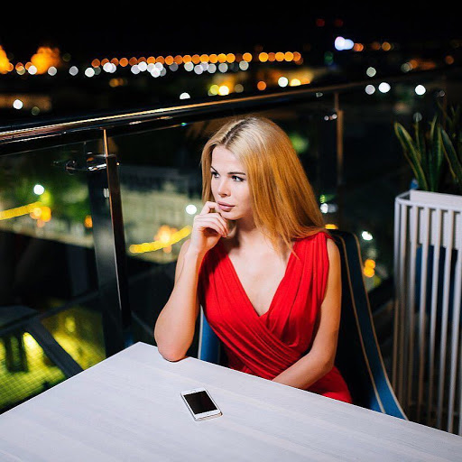  Alice Dankovskaya |   Lyova Fargo
  Stas Fedayin |   Anastasia Kuraeva
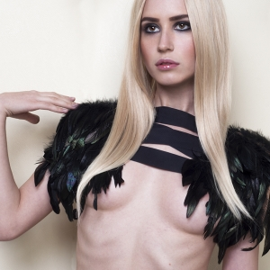  Tima Marso |   Victoria Mazhevsky
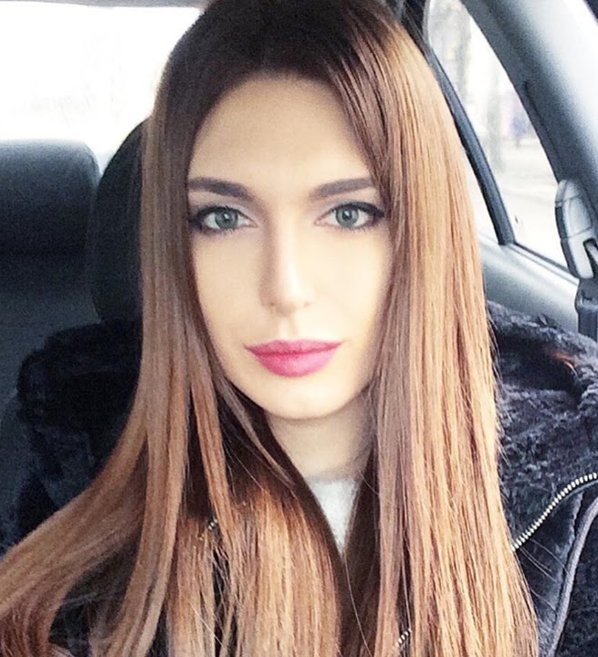  Karina Minaeva |   Arthur Nazarov
  Ivan Rastrepin |   Dimitry Rublyovsky
  Kira Sadovaya |   Sasha Shatlova
  Vadim Shatilov |   Stas Shiryaev
  Stav Strashko |   Joseph Szymansky
  Klementina Tarakanova |   Anastasia Vinogradova

