Happy High School Years
A Vignette
By Maryanne Peters

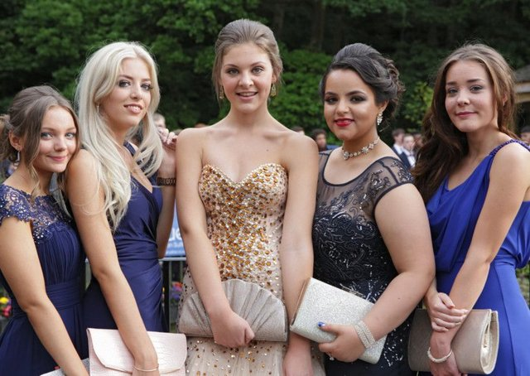

Can you spot the girl in the picture who was born a boy. Prom night 2023. Can you see her? The girl on the far left – that’s not the one. In fact, that is Chloe, the only one of us not born male.

Yardley High School, which is not a big school, ended up having four transgirls in one year group. Imagine that? But it made our high school days the best ever. And prom night was a real night to remember.

That is Ashley next to Chloe, Morgan in Black and Alyssa on the far right, and me in the middle – in the strapless thing showing off my boobs – I am Grace, by name and by nature.

Being transgender is tough, but not so tough when you have girls in the same situation to share the trials with. Four trans girls, and four who give ourselves a daily dose of confidence, are more than a match for any groups of boys, who tend to move in teams of two or three. That would be because boys lack proper social skills and don’t form working teams unless there is a coach involved. No, boys don’t mess with us when we have the numbers.

And then we have Chloe, the other member of our team – the lucky one with the anatomy we would all prefer to have. She was our spirit guide through the process to become as much of a woman as she will be. She is understanding and encouraging – the glue that holds us together.

She was the one who made sure that all of us had dates for the night, with the help of her older brother Damien. She said that it was just plain wrong that four pretty girls like us should not have attentive escorts simply because we were born with a ghastly deformity that is barely visible. As captain of the football team Damien put the word out and he found three guys willing to escort us. Three only because Damien was my escort.

I asked him how he did was able to do it, and he said that he simply told his teammates that we need more pretty girls in the world and that he was going to help add at least one to the roster. I suppose that he felt that what we did after prom was going to ensure that I was never going back to being a guy, but I didn’t need great sex to confirm that my future was female. I don’t think any of us did, but it was sure a great way to end the prom experience, and plenty of material to swap stories the morning after.

Yes, Yardley High School Prom 2023 is a night that none of us will forget, for all the right reasons. Our hearts go out to all our fellow transwomen for whom school years were an ordeal of pain and heartache, but for the four of us (and Chloe) we only remember happy high school years.

The End
505

My Demanding Wife  A Vignette  By Maryanne Peters  “Would you bring me out the cream skirt?” she said. “It is on the bed.”  When I came back there she was, sitting of the coffee table, all dressed up to go out except with nothing on except that stretch thing, and whatever bra it was that showed off her magnificent tits. And those shoes. Why is it that heels make a woman look so sexy?  She had that look on her face that I had seen so many times before. It did not call for words to be spoken. I could read the words – ‘Come over here a fuck my brains out!’  Somewhere in that face was the man I used to know, but everything else is her. She has something of his determination and aggression, which was enough to allow her to pursue her aim to become a woman and find a man to love her to pieces.  I was the lucky one that she chose to be that man. It was not as if I had much choice. Even as a man, she always got what she wanted. It turned out that she wanted me and she always had.  There was reluctance on my part at the beginning, but she always gets her way in the end, and as good husbands know, that is the way it is supposed to be. | 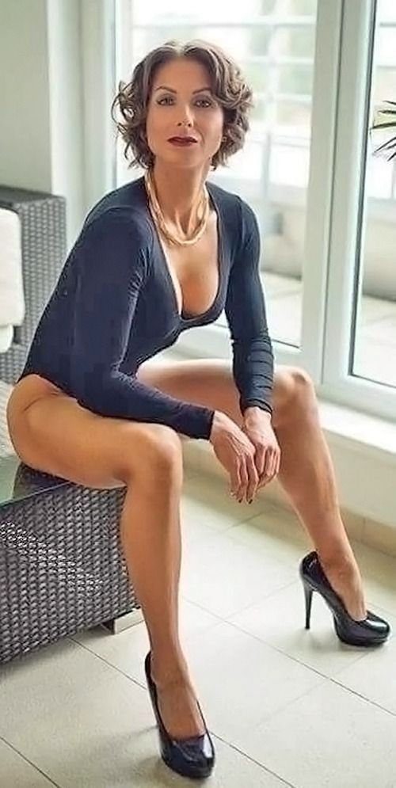

I draped the skirt over the back of the chair, and came towards her like a tiger stalking its prey. She had that little smirk of hers, combined with those come-to-bed eyes. She was daring me, and checking to see if this tiger’s claws were out. Not yet they weren’t, but straining inside my pants.

My God, that woman drives me wild with desire!

“On the couch, woman,” I called out to her as my pants fell to the floor and my dick pointed direct at her face. She looked up from it at me, with a glance of approval. Even a demanding wife loves it when her husband takes control in the moment.

“We only have a few minutes,” she said. “We are expected there at 7:00.” She had unfastened the thing and exposed her pussy, engineered for my pleasure and well used for that. She fell back for me to slide between her thighs.

I took a moment to stroke her smooth face – lasered to perfection smoother and softer than any skin in nature. She is so unbelievably beautiful to me.

“Take me to heaven, and don’t get any jizz on the cushions,” she demanded.

I do what I am told, and I love it. I love her, my demanding wife.

The End

Becoming Best Friends  A Vignette  By Maryanne Peters  People said that we looked alike, and I suppose that we did. We looked like sisters, or we did from the moment that I started living as a woman.  The moment I first saw her I could see that I could be like her if that is what I truly wanted. Her image on Tinder could have been me as a woman, and I just had to meet her. My image was more masculine than I really am because I wanted to meet women and be normal, but for her I was more like the real me.  “I hope you’re not disappointed,” I said to her. “You may have been expecting somebody more manly?”  “I like you and I think we might get on well,” she said. “Perhaps we should be friends rather than something else. I think friends are just as important – don’t you?”  That was how it started. We became friends and then we became best friends. And best friends need to share common interest, so her interests became my interests | 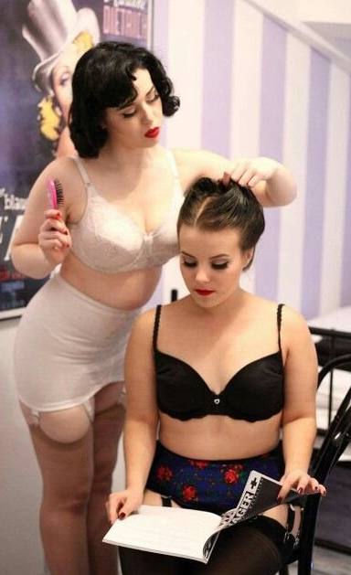

She loved fashion and she loved styling hair, and she got me interested in both. When we weren’t both working at our jobs in fashionable boutiques we could spend ages just hanging around our apartment trying on new stock we had sneaked out or doing one another’s hair, or just going through beauty and style magazines.

But our favorite thing was shopping. Who would have thought that two girls (because we both were) who actually work in retail, could spend every spare hour just going in and out of shops, rustling through the racks and trying things on and just giggling and being happy. It made me realize how good it was to be a girl!

But we could never buy anything. Shop girls don’t earn enough. Ours was a happy life. Everything was lipstick, curls, frills and perfume. But girls have to think about the future.

“Your breasts are looking really good,” she said to me. “Those hormones have really done a number on you. I think now it is time that we put them to use and mine too – we need to go looking for men. We need guys to pay the bills and keep us in the style we know all about but can’t afford.”

I really had not thought about it before. I had thought that she and I were a couple, although not sexually. I had always regarded men as being admirers who could look but never touch. But she was right – if we wanted a drink we just needed to look at two guys across a busy bar and smile, and they would be over in a flash with wallets out. That is where the money is.

“But for me they won’t be able to get past first base,” I pointed out. “Because there is something unpleasant hanging down on the way to second.”

“Problems like that can be snipped away,” she said with the wave of a hand. “We just need to find a couple of guys who are best friends like us, and have the money to keep us all together and happy. We come as a pair – right?”

I have been working on prepping myself for sex ever since.

Is there a pair of wealthy guys out there for us? On of you has to be open-minded when it comes to gender issues.

The End
576

The Art of Beauty  A Vignette  By Maryanne Peters  I studied art in high school. It was the only thing I was interested in. I wanted to spend my life in art. The obvious thing to do was to become a painter or sculptor or create things from mixed media. The problem there was that as my art teacher said, I could acquire all the technical skills that could be taught, but that does not make you an artist. For that you need a talent, and that is what I went searching for.  My art teacher was always talking about the innate beauty in nature or in created functional forms.  “Art is about creating beauty from materials. Even abstract art that involves throwing paint at a canvas, needs to have beauty. The artist is the person who looks at what they have done and recognizes beauty or starts over.”  I figured that my problem was that I did not understand beauty. I needed to seek it out, and study that. And to do that, so I was told, you need to make use of the media and the blank surfaces that are available. At home that turned out to be my sister’s cosmetics and my face. | 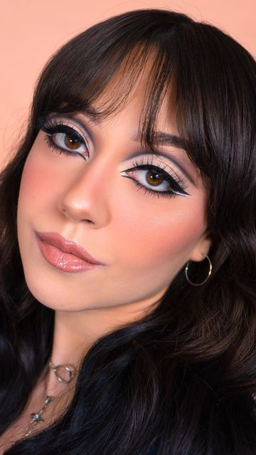

I just played around at first, but I got very interested in the whole idea of cosmetics being used to enhance feminine beauty. Nobody can deny that feminine beauty has inspired artists over the centuries. It is not just the face – it is the hair and the body too – but my journey began with the face, concentrating on the eyes and the lips, and the general coloring.

The eyes are very important, and the whole idea of eye makeup is to make the eyes stand out. Eyes speaker to the observer of art more than any other part of the face, and good makeup draws the onlooker in. By using a living canvas you can then play around with looks and capture them on camera. But the one that draws you in most is the longing look. I spent hours in front of the mirror perfecting that.

The lips are another expressive part of the face. I read somewhere that the lips on the face mirror the vaginal lips that become pink when aroused. Is that true? Anyway, if it is, lipstick is supposed to mimic an aroused vulva, and lip gloss a wet one. I was intrigued by the idea. I experiment with all types of colors and glosses in search of perfect beauty.

Eyebrows are also a part of the fact that can be used to show expressions. There are many shapes of eyebrow that send out messages to the viewer. As my art teacher said, art is about the artist communicating with his or her audience. The right eyebrow shape can speak out loud. I needed to pick the one that worked best, and the hair across the forehead helps to soften them.

The color of the face is all about good health. The book I read said that a heathy color in the face signals that a woman will make a good mate, not that I was looking to be mated with in those early days. All the other tricks with colors and highlights and shadings, are designed to conceal blemishes and reduce heavy features, but I think that when I was done I did not need much more to present my own face as a very good example of feminine beauty.

But art needs a purpose. My art teacher used to say that the purpose of art – “is to evoke emotions – to make people feel. Function is needed to feed, clothe and house the body, but art feeds the soul. Your art needs to affect somebody to be worthwhile.”

So, when I looked at what I had created I knew that I had to put my art on display, and affect somebody. I was the work of art, and my gallery was outside. That was where I needed to exhibit myself.

And that is how I met Kade. I affected him very deeply. It was the making of me as an artist.

He was shocked to find out that I was not a woman and even more shocked to here that I really didn’t intend to be one. But after taking some time to come to grips with his emotions, he decided that I was a work of art that he needed to have.

It was just that he needed to talk to me about function. His statement to me was that art can be admired purely for its appearance, but art that also serves a function is better. That was something that he was prepared to pay money for, or rather provide open-ended patronage in order to enjoy every day.

It did require some functional alterations and some sacrifices, but an artist should be ready to do that, for their art.

So this is me now – feminine beauty from head to toe, created by brush and scalpel. Tell me you are not affected by my work?

The End
850

Looking Back from the Future  A Vignette  By Maryanne Peters  Back in 1999 when I was just 25 years old, I decided that I would enter the new millennium as somebody else. People make New Year’s resolutions every year, but I thought that a New Millenium resolution needed to be dramatic. I made sure that it was.  I was always an admirer of beautiful women, and it was not really sexual. I always put women on a higher plane than men, and I particularly admired women who put themselves on a higher plane than other women. I am talking about women of style, and I will use another word – discernment. Choosy women. Women who were very careful about how they looked and how they presented themselves to the world. I thought those women were special. | 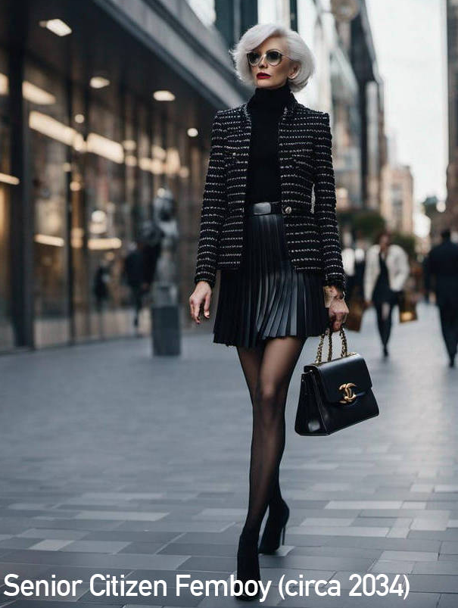

I simply decided that I wanted to be like that – even if only for a little while. If you have to put a label on it then femboy might have worked when I started, but then it really was only supposed to be for a short time. It was not as if I was transgendered and needed to be female, with surgical modification to achieve that. I was not one of those transvestites who might get sexual pleasure by appearing as female to themselves or others. No, I just want to walk the world proudly as one of those people I most admired – a lady – proud, stylish and discerning.

In wonder how many femboys get caught living their feminine lives, unable to return? I started taking the hormones early and then I discovered that sex for me had to be in the passive position. I had my share, but as you have probably worked out, I am fussy about my sexual partners. Sluttiness is the very opposite of style. I prefer to be stared at and desired rather than stroked a cuddled.

So, I have kept myself in good shape, and thanks to a small double sacrifice I have kept all my hair and I keep that in shape too.

But that sacrifice was for more than just vanity. I realized as I found myself older and still loving the way I lived, that I had a purpose in life – a noble altruistic purpose.

I walk proudly now as somebody who had a role to play in saving the world. Femmes like me (femboy seems no longer appropriate to me) have the lead role to play in the “femme not fatherhood” movement that swept the world starting only 10 years ago. Now there are millions of us who are choosing the joys of beauty and non-reproductive sex over contributing to over population. The answer is to start while you are young. Use your sperm to paint the walls, not destroy the planet. Grow to maturity like me, loving the femme lifestyle – living for beauty and pleasure, and making the world a better place!

Why not join the movement?

The End
484

© Maryanne Peters 2024

