Strength of an Elden Wolf
By: Firingwall
Inspired by and featuring the artwork of Da-Fuze

“Hmmm, Link's cap, Parappa's cap… Crash's shoes?” Rachel whistled. “Wow, you have an impressive collection of costumes and props here. I could be almost any video game character I want!”

“And trust me,” Cassidy chuckled, looking very proud, “This selection is only going to grow. If you want the best look, you're gonna want to shop with us this season!”

Halloween was fast approaching and for one blue-haired lady, she needed to find the best costume for the season. There was only one place to go: the magical shop belonging to the witch coven that lived next door. An obvious solution if there ever was one.

Meeting with the coven leader, Cassidy, and discussing her issue, the green woman brought her into the backroom of the shop: storage. It was a vast room that seemingly stretched for eons with costumes and accessories of all sorts.

“It feels endless,” Rachel commented upon seeing it for the first time.

“Only because it is! That's the power of magic!” Cassidy had boasted, snapping her fingers and letting loose green energy between them.

Ten minutes later, Rachel was still looking through the countless racks for something that would work. She looked from the video game costumes to the anime section across the way, one entire shelf covered in Costume in a Can cans. She remembered those very well, but she wasn't interested in an anime girl look for this year.

“So many options,” she breathlessly commented, walking to yet another row on her hunt, “Way more than the old place I used to shop at.”

“Well, I do hope so!” The witch stated, huffing a little, “Not many people would or could supply this many specialized, customly built, magical costumes and props like us!

“So!” Cassidy resumed her polite, business smile. “Is there anything in particular you're looking for? I don't mind waiting, but there is a lot here and you could be searching for a while.”

Rachel sighed. “I know, but… I'm honestly not sure what I want. Sometimes, I just need to browse until something jumps out at me. I'll know it when I see it.”

“I understand. Traci is watching the front, so take as long as you need.”

Rachel smiled. “Thank you and thanks for letting me in “behind-the-scenes”.”

“Of course! Always a pleasure to help a frequent customer and friend.” Cassidy smirked. “Though, maybe come to the front door or just call instead of peeking over our fence and yelling at us next time.”

“Heh, will do!” Rachel blushed. “Sorry, it's just so easy to do when I can see you all just over the fence there.” The two ladies chuckled.

The blue-haired woman continued searching then. She moved past the aisle full of clothes and robes and into the next one, one that held many plushies and stuffed critters. Let's see, Hawk the Pig, Po, King from Owl House, Scooby-Doo, there's a chocobo, and… oh!

Her eyes drifted over the top of those shelves and across the way, catching something that excited her greatly. She hurried past the witch and over to the next two aisles down. There was a tall rack filled with swords of all kinds from the Master Sword to the Nail of Hollow Knight to even a replica of Excalibur from Soul Eater.

However, her eyes locked onto the largest sword there, the one that wasn't up on the wall. It was a sword so large that all that it could be done with it was to lean it against the rack. It was a greatsword, silver for a blade and gold trimming around the base and handle. It looked beautiful as it did powerful.

Blaidd's Royal Greatsword! Rachel's eyes widened as she walked up to it. She leaned in. Or is that the sword from Berserk? …probably the Royal Greatsword. It had been awhile since she read the manga.

Either way, Rachel felt nothing but wonder and awe at the sight of it. “Now this is cool!” She ran her hand against the weapon's flat side, taking in its subtle, accurate details. The witches continued to impress. It looked just like the sword from the game!

She reached forward and grabbed it by the handle. She instantly felt resistance, the sword barely budging. What the…

She grabbed it with two hands and managed to move it a bit. However, she nearly lurched forward and fell trying to do so, letting go of it and watching it fall to the ground with a loud thud. It was incredibly heavy!

Maybe Cassidy should tone down the realism a bit. Rachel frowned, bending down and grabbing the handle again with both hands. She summoned all of her might, slowly lifting it from the floor.

Her face scrunched up, the “prop” rising above her waist as her arms ached. God, why would she make it weigh a ton?!

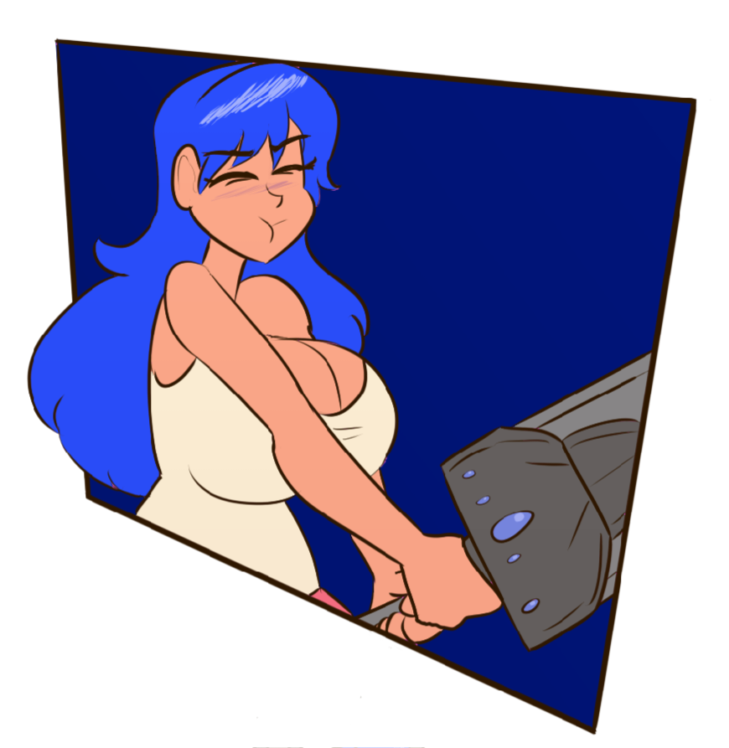

“WAIT!” The witch had finally joined her in the aisle. Her expression was masked in worry, her eyes almost bugging out as she yelled. The shout nearly made Rachel drop the sword, but her hands clutched it tighter.

“Put that down!” Cassidy begged, eyes widening. “The effects kick in-”

There was a low rumble, Rachel's arms trembling. She felt her cheeks warm up followed by the rest of her body. Everything jerked as a “surge” went through her. That sensation felt very familiar.

Then, all at once, her hand grew. Dark gray fur sprouted across them in a wave. Her fingernails shot forward to the tips, thickening and sharpening into claws. Her hands swelled with power, doubling their original size and filling up that handle.

“…fast.” Cassidy mumbled.

Rachel's jaw dropped. Oh… that's… that's-

The blue-haired woman moaned. Her entire body felt like a raging fire, burning up as muscles and bones throbbed. From her hands to her arms and even over her shoulders and into her chest, everything burned and rumbled. The shaking and twitching made her drop the sword, letting it hit the ground again.

Neither ladies noticed, all their attention on Rachel's physique. Her shoulders lifted and broadened, muscle mass rapidly increasing in them. Her chest rose, thrusting forward with rapid expansion like an airbag. Her breasts stretched and widened, soft tissue flattening and turning dense. It was soon apparent she had pectorals, ones that were wider than her head.

Her poor tank top never stood a chance. It tore in several spots, opening holes all over. One of the straps broke, though with how big her chest was, her clothing stayed on without issue. Her bra wasn't so lucky, hitting the ground seconds later.

Rachel trembled, at a loss for words. She gritted her teeth, her face tense. As her ears pulled upwards into gray wolf ears, she struggled to even think. She loved transformation and becoming other things all the time, but such sudden and massive growth was always a lot to take in and handle.

She tensed up again as she felt another throbbed. Her arms shook once and bulked up. Muscle mass ballooned, giving her massive forearms and biceps almost the size of her head too. She felt jacked, pure… masculine… beastly.

It was powerful.

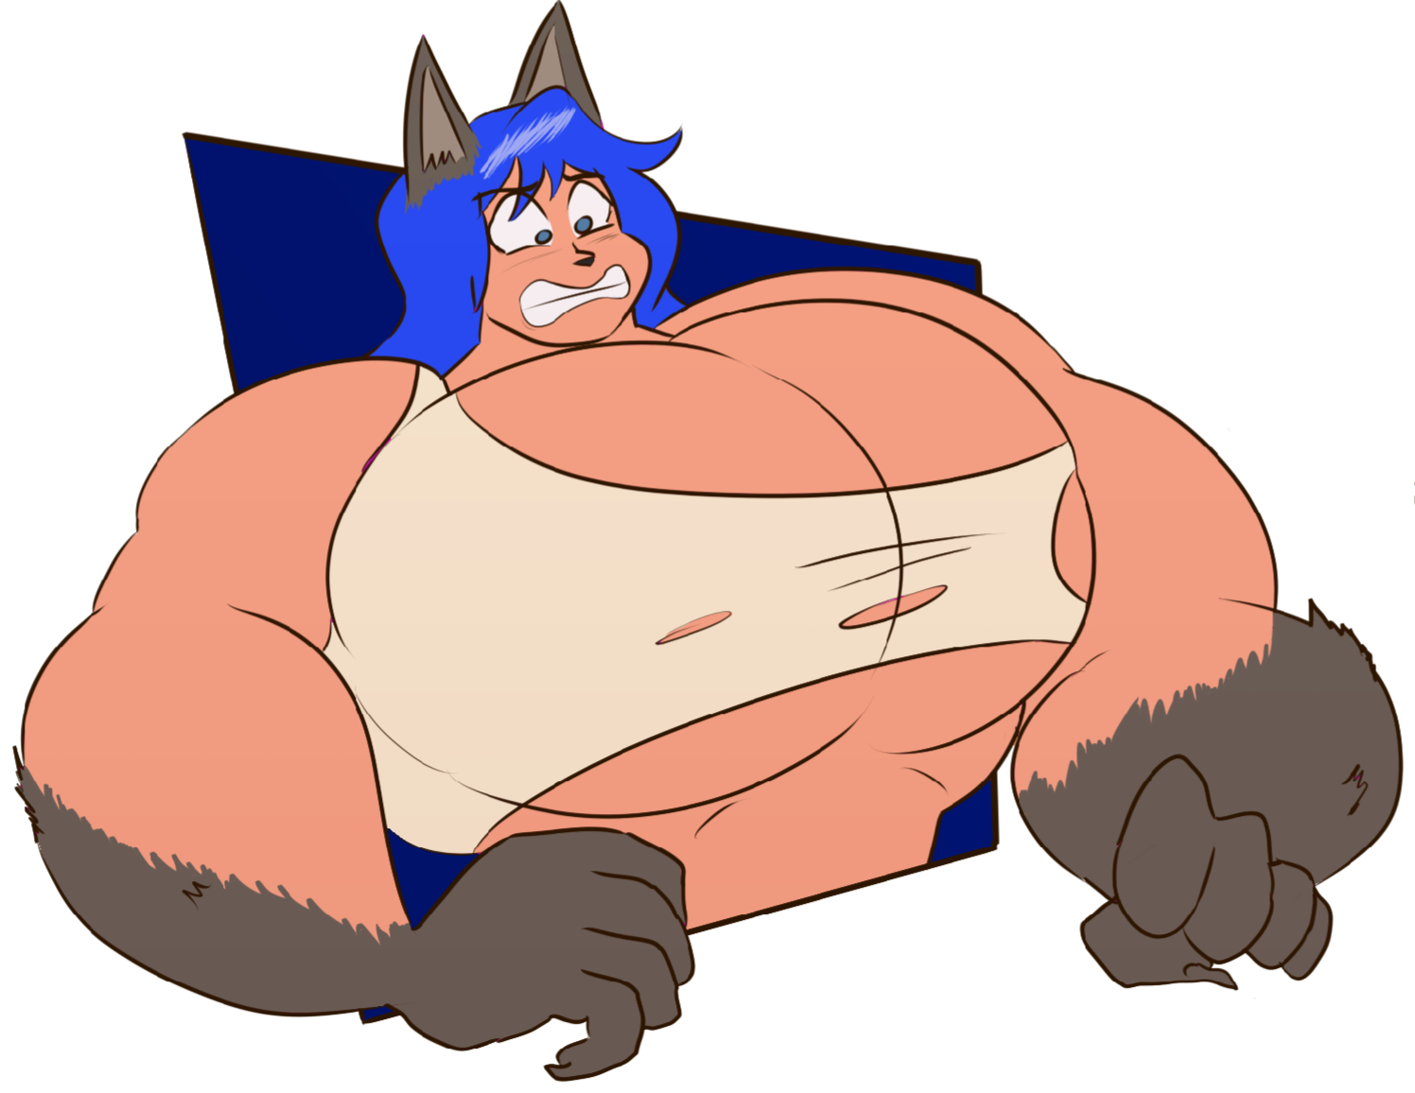

“Crap, crap!” Cassidy groaned, holding her head. “I'm sorry! I really should've warned you about picking up anything!”

Rachel looked at her and then at her meaty paws. The gray fur was slowly drifting up onto her wrists and across her forearms. She took a deep breath.

Then, she released it slowly. She rolled her shoulders and scratched the back of her head. Cheeks reddening further, she awkwardly smiled. “No, it's my fault. I should've just looked. Should've expected this in a witch's shop after all.”

“Witch's storage room but yeah…” The two of them awkwardly laughed. Fur continued growing across her arms and onto her shoulders, reaching her neck in no time. Her chuckling deepened to a rather refined, masculine bass.

It was a familiar gruffness.

Hmmm… Rachel stopped her scratching when she felt something. Her hair was off. It was shortening and its strands felt so thick and unkempt. The blue locks that rested on her shoulders she could see were darkening as the night sky.

Bet I know where this is going. She looked at her heaving chest, growing its own, bestial fur. She pressed one of her wolfish paws against a pec, gently groping it. She felt her cheeks warm again but ignored it. Though, I'm not sure if he's this beefy under all of that armor or-

All thought stopped in her mind. Her eyes went cross, turning bright yellow with ink black for whites. The warmth of her cheeks suddenly raged, a huge heat striking her like a truck. The burning, intense sensation came from her crotch.

And it felt good.

Another airbag force of expansion struck. The crotch of her pink shorts burst open. The button went flying, and the zipper snapped. She quivered.

A huge, coconut sized bulge had forced its way out, throbbing and pulsing to let both people know exactly what it was. The only reason this new equipment didn't come out fully exposed was a rather sturdy, unbreaking speedo. It was black and had a very stretched out, blue crescent moon on it.

Rachel definitely wasn't wearing that before.

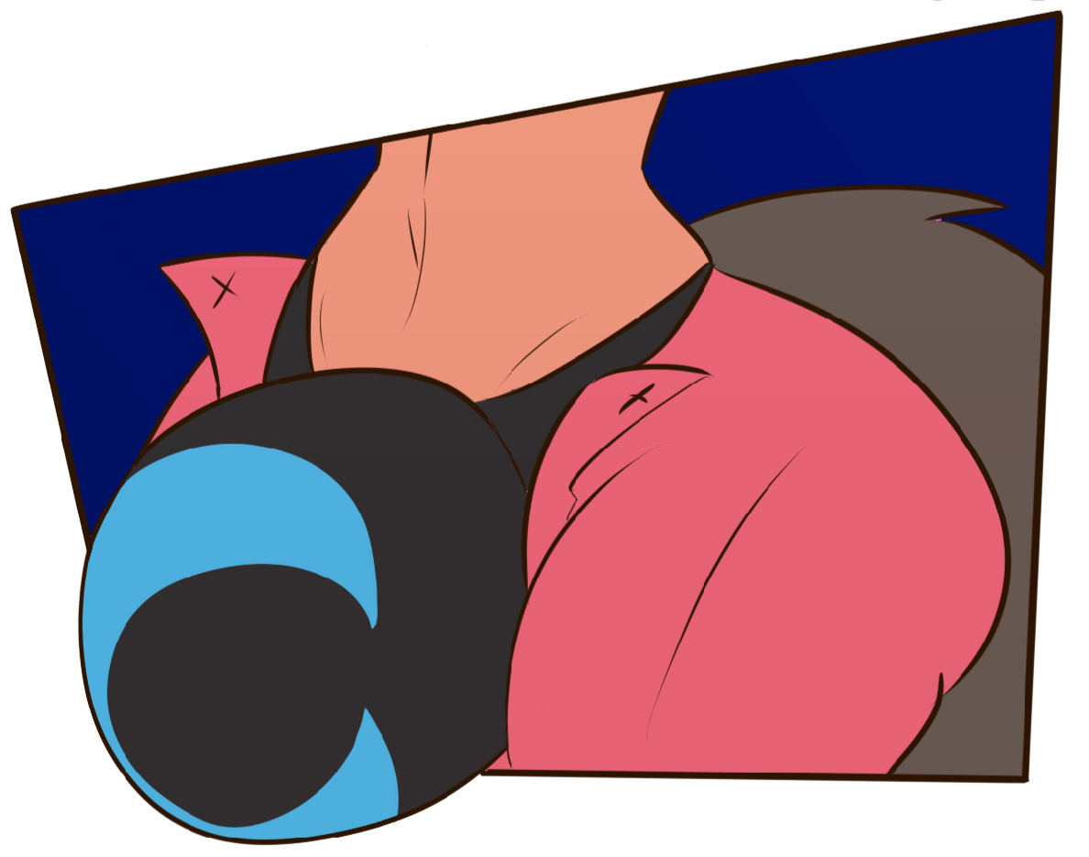

“Whooooaaaa,” she… well, it was he now. HE certainly didn't feel like a “she” or even Rachel now with all of this going for him. He definitely considered himself a Raphael now.

Looking at that fat package, Raphael’s face could only redden more. He was certain that the character he was becoming definitely wasn't packing this much “meat” either.

“Oh no.” Raphael looked up at Cassidy. Her hand was covering her gaping maw. Her eyes were wide as could be, her green cheeks looking fairly red themselves now. “I think… I think I might have overdone it on the manly part.”

The big man slightly smirked, some flashy-looking fangs visible. Overdone it? Oh, most certainly! But, did he really mind it? Not really all things considered.

Raphael tensed up, hands clenching and fangs gritting. He especially didn't mind the pleasure that came along with his changes as they raged through him. It made his bulge positively shake with lustful joy, desiring whatever came next.

In mere seconds, he was towering over the witch, the green lady only up to his navel now. The massive difference amused him, so much so that the fluffy wolf tail had sprouted during the bulge burst, unseen due to being not as impressive of a sight, had begun to wag.

Dark gray fur flowed down from his pecs and across the rest of his body. It flowed across his tummy, which rose with tight abs unfortunately hidden by the fuzz. It spread down his hips and ass, the former losing its round curviness and the latter tightening into a dense behind.

The fur wasted no time rocketing down his legs. His lower limbs happily bulged and bulked, matching the same thickness as his arms. His shorts didn't stand a chance, splitting open and breaking further until they were tattered rags, clinging to such meaty thighs.

Heh, I'm gonna need some new clothes now. As the fur reached his feet, they grew longer and wider, claws jutting out from his toenails. A few snaps followed. And new sandals too.

His face tingled, and he began to pant. Gray fur was sprouting over his mug now, and the anthro man could only grin. Man, Cassidy n-needs to overdo this more often! I feel…

Raphael moaned, his man bulge quivering in his speedo. I feel incredible! His face cracked and popped, nose darkening and turning bumpy. It makes me wanna… wanna…

The wolf leaned back and howled the loudest, longest cry it could. His face crept forward, pushing out into a long, rugged lupine muzzle. It was the perfect face for a perfect-looking beast.

Once he was done, Raphael sighed happily, stretching and cracking his shoulders. He smirked, feeling his pecs and biceps. Now this is my kind of wolf bod!

He had become Blaidd, the handsome, ally wolf man from Elden Ring, adored by all. He was most definitely a muscly, porn parody of the character, lusted and desired by many, but he was Blaidd nonetheless.

“Wellll…” Raphael looked at Cassidy, remembering that she was there again. Funny how gaining a killer wolf body made the rest of the world seem to vanish.

“You seem okay.” Cassidy definitely didn't look too okay in comparison. The head witch was definitely flustered, desperately not trying to look at the wolfman's equipment. “So, no harm, no foul for warning you about everything too late, right?”

“Blaidd” snorted and smiled a grin so slyly. He glanced towards his feet and reached down. It grabbed the fallen sword with one hand and lifted it with ease. He hoisted it up and behind his shoulder.

With his free arm, he gave it a mighty flex. His bicep bulged magnificently, showing off his new, vast power. Pushing out his chest and bulge with pride, he declared, “Please, like I would ever be upset about looking like this!”

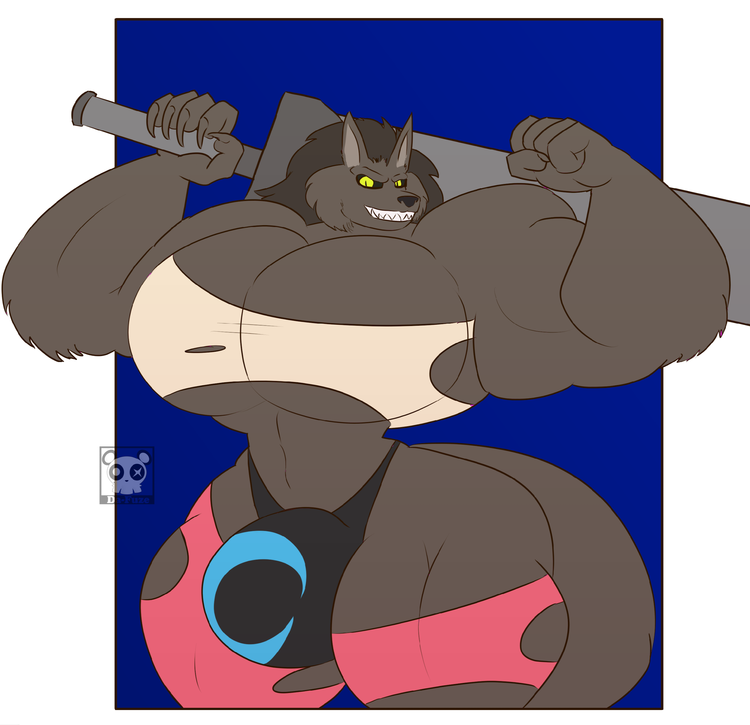

“Oh… well, good! …good.” Cassidy cleared her throat, trying to regain her composure. “S-sorry, you just seemed so surprised at first and-”

“Waaaaay over that!” Raphael placed the sword back in its original position. “I'm all into this. I'll take that sword and a custom set of Blaidd armor.”

“Custom?”

“Sure!” The wolf winked, groping one of his pecs. “Customized to show off the goods.”

“Of course! Right right!” The witch snapped her fingers, making a pen and notepad appear in her hands. She wrote down the order. “I'll get all of that done fast. Will that be all?”

Raphael paused, scratching his chin. He had found the perfect costume and look for Halloween. What else could an incredible wolf need?

Then, a lightbulb clicked in his mind. The love of his life needed something to wear as well, and he had the perfect idea. “Hmmm, think you can whip something up for my very special JD? I'm thinking a matching set.”

“Oh! Something like Ranni's clothes or-”

“PFFFFT!” “Blaidd” snorted and laughed. “You see these muscles?” He flexed eagerly. “Ranni ain't matching this. A wolf like this needs *another* wolf to complete him.” He leaned in. “Think you can whip up a nice Red Wolf of Radagon look for him? Something just as beefy and big down below?”

THE END

