Me First  Inspired by a cap by AlwaysFem  https://alwaysfem.bdsmlr.com/  By Maryanne Peters  That’s me – blonde with the red heels on. Beside me, my wife Janice spooning a little. Still my wife, I suppose. But on the other side of the camera is Gareth, our husband.  The threesome was Janice’s idea. I suppose she was always the more adventurous of us when it came to sex. I was as keen as the next guy when it came to sex. Oh, yes, I am a guy, or I was then.  Guys like sex, right? As much of it as they can get. But the fact is, most of us can’t just keep on doing it continuously. I mean, we shoot our load and then we have to start over. I guess our balls need time to refill. I am not sure how it works.  Gareth is the exception. He seems to just keep on going – just keep on fucking. One fuck, on girl, is not enough for Gareth. | 

Apparently, as a man I was not enough for Janice. So how is a husband supposed to keep her happy? If you want to keep your wife, you need to find other ways to keep her satisfied. That was why I agreed to Gareth.

“We’ll make it a threesome,” said Janice. “I was want you with me when I am making love. We’ll go to bed together. When you are spent, Gareth can take over.”

I was to be included. I was not being rejected. I was being augmented. She loved me too much to abandon me, or to have me sitting outside the bedroom while she had sex with another man. That is the way it seemed. A threesome. It sounded like the perfect solution. Three people sharing a bed.

Most straight guys will tell you that they will never roll over and be fucked up the ass. That is gay – right? There can be no exceptions, unless maybe the first time it is your wife. Like I say, she is adventurous. She did it to Gareth first, or I think she did. Actually, now I think about it, I never saw that. Then she did it to me. She used a strap on dildo.

Gareth asked me whether I wanted to do him, but not with a dildo – like shove my dick inside him. Somehow, I just could not do it. The truth is that Janice offered me her butthole too, but I could not do that either. Honestly, I would rather eat her out that shove my cock up her shithole. I guess I am not so adventurous as them.

But I think Gareth could fuck anything. He said that he would love to show me what anal sex was like.

I was expecting it to be unpleasant, and it was, right up until it wasn’t.

He said that I needed to get over it. He said lots of guys find joy in receiving, and there is nothing wrong with it. He held me and comforted me, and somehow, with his cum oozing out of me, I felt that I was his.

He said that he would prefer having sex with me if I was hairless. I can understand that. I could do that. Janice liked it too. He wanted my body to be softer as well. That was where the hormones came in. He wanted me to look more feminine, so I grew my hair and started wearing makeup.

It was originally just in the bedroom, until it became so normal that I never left the house unless I was dressed as a woman.

I suppose that we are a different kind of threesome now. Gareth is the only man. Janice is the woman, and I am … I am just me.

Do I look happy? Come on Gareth. We are waiting for you. Can you do me first?

The End

Just Another Bridesmaid  Inspired by a cap by AlwaysFem  https://alwaysfem.bdsmlr.com/  By Maryanne Peters  It was a joke, or meant to be. You know what I am talking about if you are reading this. The joke where the ex-boyfriend who hangs around even after he has been rejected, gets offered a spot on the bride’s official party if he is prepared to go as a bridesmaid. That joke. He accepts because he would still do anything for her. That guy. That joke. Me.  She wanted me to share the whole day with her and the girls. That means dressing and getting our hair and makeup done – I mean, properly done. | 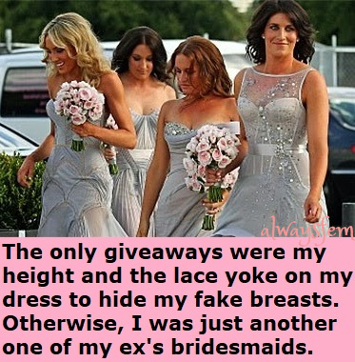

My dark hair was quite long, only because she said she liked it that way. Long enough to anchor proper extensions. I don’t mean those wedding day extensions – I mean the ones that last, if you want them too. And I had to expect some work on my face that might last too – I am talking about the eyebrows and waxing, “because shaving just won’t do. We can’t have a bridesmaid sprouting a beard at the reception!” As if – I have never had that much of a beard.

And the dressing starts with some of us squeezing into underwear, the others to hide bumps but me to add them, including something of a cleavage under the lace yoke. The dresses were all the same color – light grey with silver embroidery.

And the dressing starts with some of us squeezing into underwear, the others to hide bumps but me to add them, including something of a cleavage under the lace yoke. The dresses were all the same color – light grey with silver embroidery.

Then the shoes. Heels for me, but not too high – I was already the tallest of the four bridesmaids. Quite easy to walk in too, and as it turned out, to dance in as well. Legs were to be visible through the fabric so legs shaved from crotch to toe. Arms too, as all the dresses were sleeveless.

Then the flowers, and off to the wedding. I was just one of for bridesmaids as far as most of the guests knew.

Her parents knew otherwise of course. Her mother said: “Thank you for doing this. I know it means a lot to her to have you in support.”

Her father was less kind, but he did say: “I have to say it, you make a very good-looking woman. Perhaps you will have better luck as one”.

Looking back, the joke was all on me. Did she really need to go as far as she did? Did I need to be so completely transformed? What was she trying to do to me?

But I don’t bear a grudge now. If she had not done what she did, I never would have attracted the attention of her husband’s third groomsman, Kelvin. Kel knew what I was, and maybe being lined up with me was a cruel joke on him too. But the both of us wanted to show that we were not beaten by it. We chatted and danced together all through the reception.

I think that we fell in love. It was not what either of us intended – it just happened. How is it possible?

He asked me if I wanted to stay this way. And I said: “Do you want me to?”

He said: “I think I have found somebody very special. If she walked out of my life after tonight it would tear a hole in me.”

Who says something like that? We kissed, as only a man and a woman can. It just seemed so right. So when he asked whether I would spend that night with him in his hotel room, I agreed.

He treated me like a woman, and I discovered that was exactly how I wanted to be treated.

I had nothing to wear in the morning, so I wore that bridesmaid dress to the mall where he bought me something suitable for the post-wedding barbeque, and a few other things. We walked in arm in arm, so that everybody could see. We were an item. He didn’t give a damn what anyone else thought – my Kelvin … my man.

The End

College Life  Inspired by a cap by AlwaysFem  https://alwaysfem.bdsmlr.com/  By Maryanne Peters  My parents were driving me nuts. Somehow, since Melanie have gone to college and the family favorite was no longer there to coo over, I was there to pay all the attention to, and I never seemed to be able to do anything right.  Tidy your room. Get a haircut. Whatever.  I called Melanie and begged her to invite me up for a week or two during school vacation, just to get away.  But she said: “I would love to have you Bro, but the hall is girls only, so unless you want to be to be Kylie for a while, I guess it has to be a no.”  But things were getting dire, so I called back and told her: “I will do it. I have some of your clothes here I could put on. I’ll be on the bus tomorrow.” | 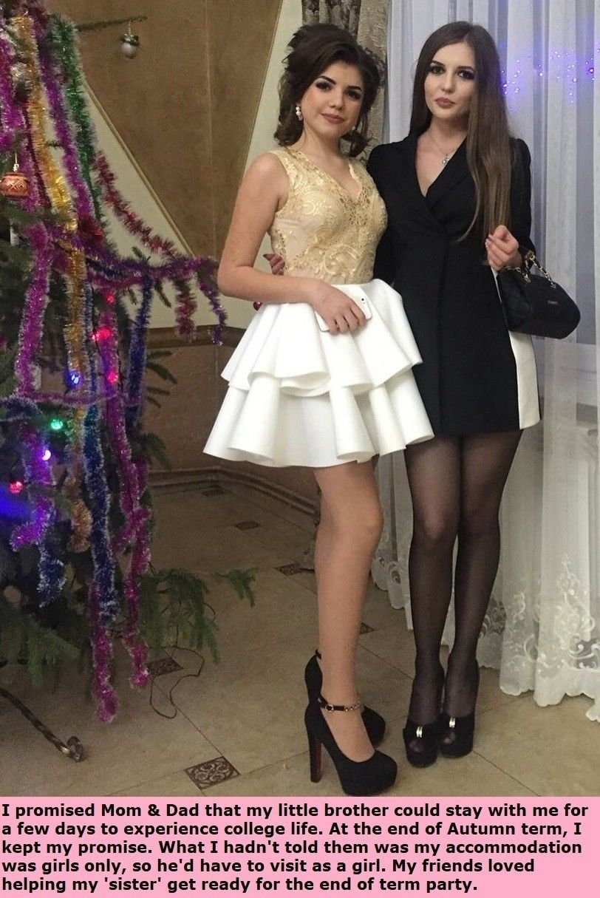

To be honest, I really did not give her the chance to say no. I had already selected the leggings that I would be wearing under my jeans and the top under my sweatshirt. I just needed to get clear of the house and slip on some girly sandals and a little makeup and I would be Kylie.

“Be a good boy and don’t hassle your sister- she is studying,” was all Mom said as I left. I could not get out of that place fast enough. I slipped off the outer layer outside the bus station and walked right into the lady’s restroom to finish the job.

That way when my sister Melanie met me at the station, she could introduce me to her friends as her kid sister Kylie.

“We used to do dress with Mom’s old clothes,” she explained. “I was the princess and she was my dutiful maid Kylie.” Which is exactly the way it was. So much for being the kid brother of an over-achieving older sister.

She never even told her friends that I was a boy. She said that she was ready too, but I was putting on such a good show that she was not about to share my secret.

“All my other friends need to meet Kylie,” she said, excitedly. “We get you ready, just like we used to. Except this time we will be two princesses. I have the perfect outfit for you – am embroidered top and a short white skirt to show off your legs. But we will need to get you some fake breasts, and we will need to style your hair.”

That’s us, with me tottering on heels that are way too high.

The problem is that I am enjoying this week so much that I don’t think that it Kyle who is going to be headed home.

The End

Remembering Me  Inspired by a cap by AlwaysFem  https://alwaysfem.bdsmlr.com/  By Maryanne Peters  I can remember me. I remember that I was naughty. I recall that I was abusive, but I didn’t want to be. It was the male hormones that made me like that. How could she love me when I was like that? She wanted me to change, and for her I was willing to change.  Chastity is about respect. You cannot truly love a woman if you are only interested in fucking her. That is what men do. Take away the power to fuck and what are you left with? Love. You can use your whole body to show her love, just not that bit – the fucking bit.  She said that I should learn to love her like a lesbian. Lesbians don’t fuck. They are equals. They give and they receive in equal measure.  “Be my lesbian lover,” she said. The truth of it is that back then anyway, I could never say no to that woman. | 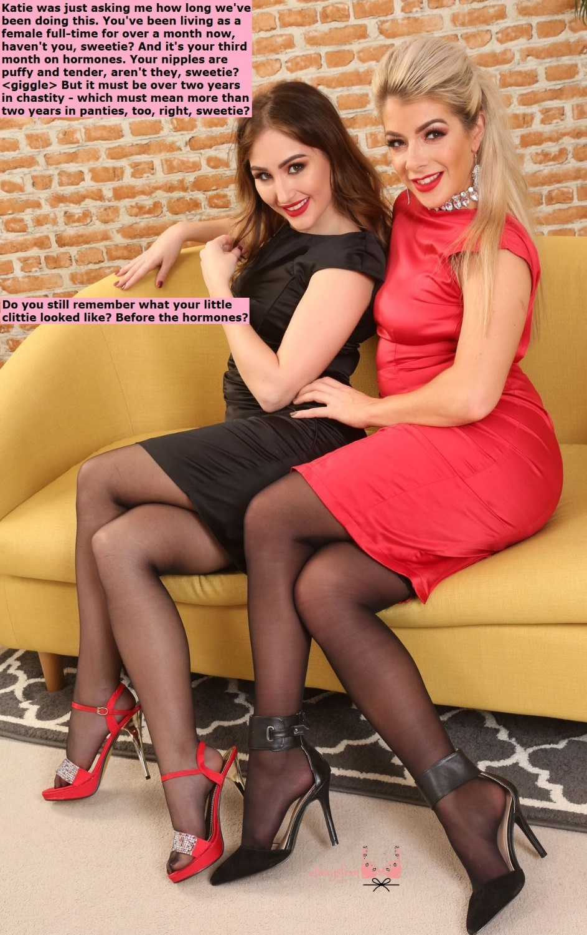

So, I became Katie for her. I took the hormones and got the blonde hair extensions, and I gave up my job to work at the department store, alternating between fashion and beauty. It is a great way to learn more about both.

Katie is right: It all became a bit of a blur. If she says that I have been in chastity for two years, maybe that’s true. But surely it is more than 3 moths on hormones? And how long living as a woman full time? Weeks and weeks. And as for my clittie, my breasts are so big I can’t see past them well, and it looks so tiny in the mirror.

The End
Drinks with Daisy
Inspired by a cap by AlwaysFem https://alwaysfem.bdsmlr.com/
By Maryanne Peters

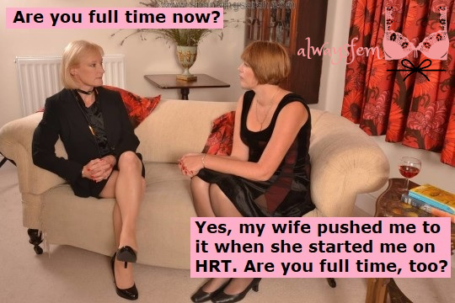

“Pansy, it’s so good to see you. Mwah. Mwah. Do come in … and take a seat on the sofa. I am afraid that I have started drinking already. Would you like a glass of rose?”

“Yes, please Daisy. What a lovely dress you are wearing”.

Do you like it? See through panels at the side. I am wearing a red slip. A bit risqué perhaps, but I am experimenting. I suppose we both are.”

“Are you full time now?”

“Yes, my wife pushed me to it when she started me on HRT. Are you fulltime too?”

“I was going to say that those breasts have on display cannot be solely from hormones – surely?”

“Well you are right. They are implants. Only a few weeks on but settling in nicely. Now I never miss the opportunity to show them off, even to a fellow feminized man such as yourself.”

“I prefer the phrase ‘revealed woman’ to ‘feminized man’, but yes I am fulltime too. About 4 months”.

“I’m about the same. I started on the blockers and hormone patches, but I just could not bear waiting for my boobs to grow. I am too old to be an adolescent.”

“Actually, I have been on hormones a little longer than you and I don’t mind the wait. I get to see them bloom slowly. I check them every morning. So soft and squishy. I love playing with them. Don’t you?”

“It’s all so exciting, the body changes. I just feel that I am getting prettier every day.”

“You are Sweetheart. You are. Quite the picture of femininity. And when you think how sad and ugly we were.”

“Oh, I know! Simply awful!”

“Do you have any other surgery planned?”

“Well there’s a sore point. I have talked about getting a proper front bottom, but my wife is not happy about me raising it. She says that if I had one I might stray. I might become interested in men. What I really want is to look good in my panties, and maybe be able to wear a bikini.”

“I know exactly what you are talking about. There is nothing worse than lumpy panties. And fancy thinking that you would drop her in favor of some smelly man!”

“Well, in truth I don’t mind the smell of men. I never used to, but I … I have changed quite a bit lately.”

“I have too, Darling. Even I am considering getting right of those things. They are hard to keep hidden and hard to keep clean. I don’t even like to touch it.”

“You’re so right. A nice little opening with a tunnel for a tampon would be so much tidier.”

“Just a tampon.”

“And a dildo too, of course. As required. But wouldn’t you be curious to know how it felt to have a man inside … if you had one that is.”

“I suppose I would. If I had one.”

“It’s just that we are not getting much from our wives these days, are we?”

“I suppose it is the next logical step for us, don’t you think?”

“Maybe you’re right.”

The End

© Maryanne Peters 2020

