Experiment in Passivity  Inspired by a cap by Always Fem  By Maryanne Peters  I guess I always knew that I was never meant to be a man. The thing that I really liked about being a man was being with a woman.  Is that so strange? After puberty kicked in, I just abandoned all of my male friends so that I could find a girlfriend and be hers.  I think that if a guy has men friends then he can too easily abandon a girl and hurt her. I am talking about the guy who sits down with his pals in a bar and says – “That bitch? She can sit this one out at home tonight”. Probably in tears.  I never wanted to be that kind of man. In fact, not any kind of man really. Not that I knew it back then.  I found somebody who was right for me. She expected my devotion and she got it. Sometimes the fact that it was not enough was exciting for me. Before long she was my sole focus, and she still wanted more.  Chastity was her idea. She said that she did not want to be a sex object and I didn’t want that either. I wanted to be an object of worship, unsoiled by my slime. | 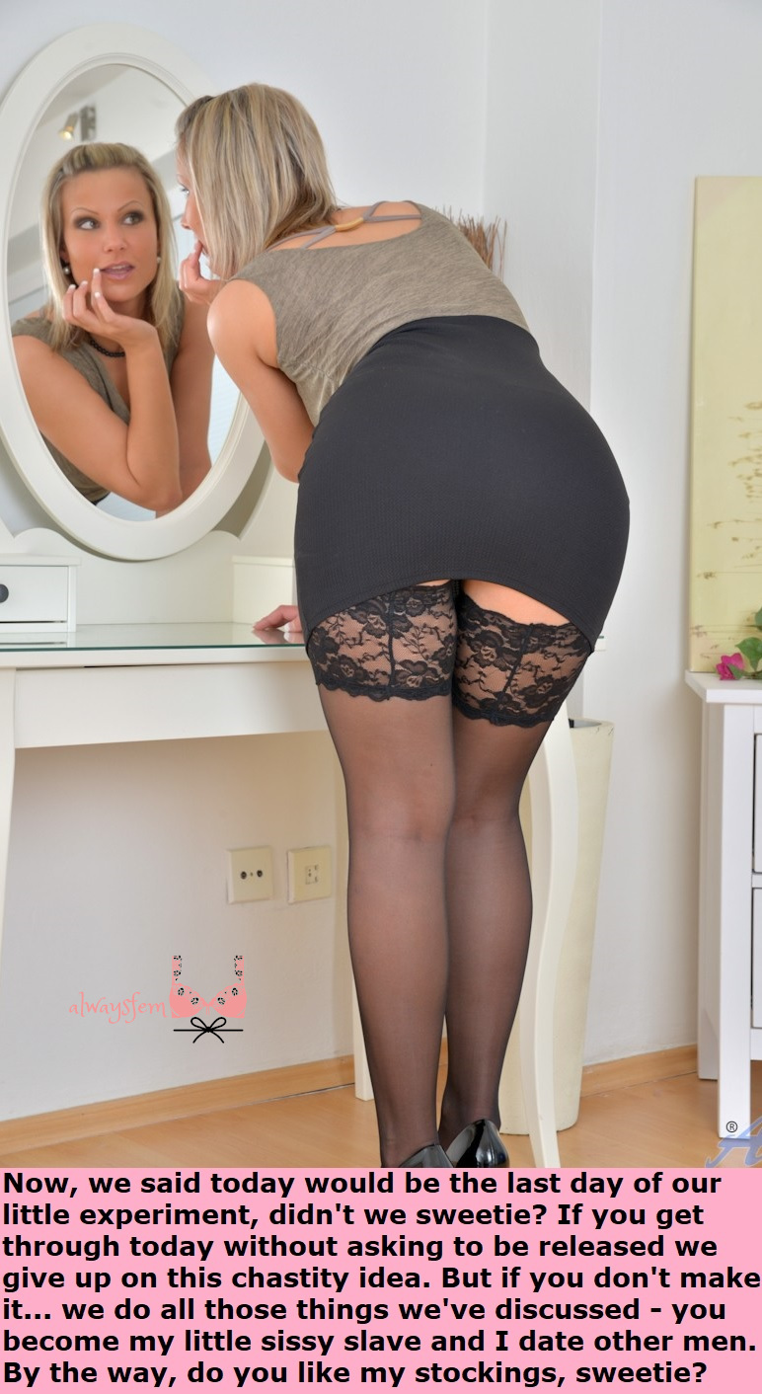

The women’s clothing including the maid’s outfit was her idea too. It was her “little experiment” – how passive and subservient could I be? As long as I was hers, I could foresee no limit. How passive would you like?

She had me grow out my hair and color it, and had my eyebrows plucked to the thinnest arch. I worked from home and worked to care for our home. I was happy, just being hers.

The first shock I received was when I discovered that she was coming home late from work with the smell of a man on her. I know the smell, as I had long lost it by then. I felt betrayed. It seemed as if she was acting as a man might. I sobbed in her arms and she held me and told me that she would always be true.

“It is just that you cannot service me sexually, and haven’t been able to for some time,” she explained. “Sometimes I need that, but there is not love in it. Our love is pure because it is not concerned with the filthy exchange of bodily fluids. Our love is about sacrifice, commitment and loyalty”

It was. On my part anyway.

But all things come to an end, and she announced that our “little experiment” was in its last day. She called me “my little sissy slave” and she said that I was no longer bound to be chaste, and that she was no longer bound to be faithful to me.

Of course, I burst into tears, but she was not there to hold me. It seemed as if my world was over.

I staggered out of the house in one of her outfits – the tight black short skirt and stocks, and the grey and black heels. I was just looking for a cliff to throw myself off.

It seemed like the kind of tragedy that could only end badly. A weeping woman gets accosted by a man in a park who offers help and then discovers she is not a woman at all – which leads to abuse, rape and murder – or at least two of those.

But the funny thing about passivity is that it often attracts the genuinely empathetic. I could not have hoped for better than to be found by a woman who could simply give me but a fraction of the love back that I would give her. But it was not a woman. It was a guy.

I felt that I should explain. I did.

“I know that girls like you do it tough,” he said. “But can I say that I think you are very beautiful and that you should have a great future as a woman.”

I suppose I concluded that men are not so bad after all, so long as I am not one.

The End

Corsetry  Inspired by a cap  by Always Fem  By Maryanne Peters  My wife’s business was driven by shapewear products, sometimes called “formwear” or body sculpting clothing. Historically, the source of all of this is the corset, and also the bodice – it is a different thing. I never intended to get involved in her business, but it is very interesting.  The fact is that in this world of body images shapewear can be the answer. Even as a man I had my own struggles with weight. Dieting is a pain, and the demand for constant exercise can be very hard to meet.  All that plus the modern look for women is for more softness and curves, perhaps held in place by the right outfit. | 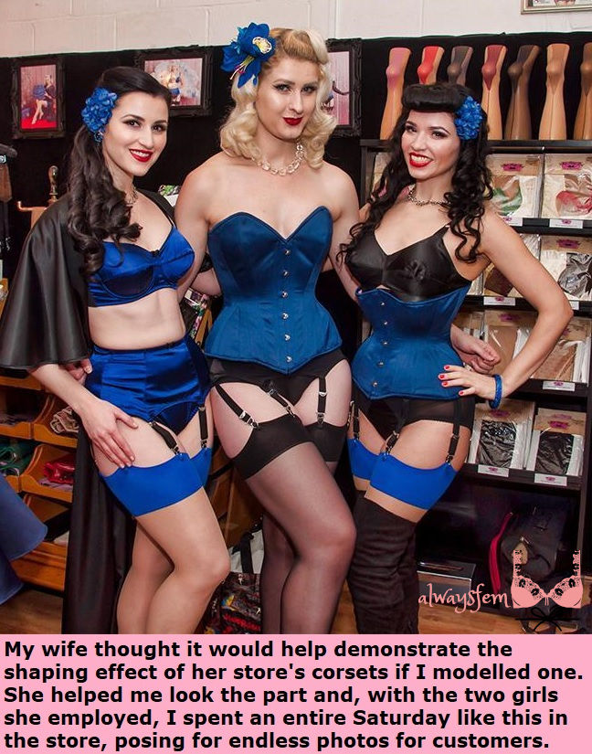

Initially her only customers were for women’s garments. In fact that is the way it was to stay – excuse the pun. There were men who came to buy the products – men who wanted to be shaped like women. I ended up advising them and becoming more interested in their struggles to acquire and maintain the perfect female form. It is about softening the body as well and tightening the garment. Hormones have a role to play.

How can you seriously advise a customer if you do not have the experience. It was just intended to be a small dose but I found that I liked the way they made me feel, and how they made my skin feel too. Male musculature is not something that easily responds to being formed by a quality garment, but remove those muscles from that equation with a decent dose of “girly juice” and the body is far more receptive.

It does wonders for the skin and hair too, that stuff, but sadly it does affect the love life, as my wife complained bitterly. Or the male love life anyway.

Yes, that’s me, the blonde in the middle, with a couple of other models either side. I confess that I have rather sacrificed our marriage to further her business, but as my trans customers now account for around 50% of the trade I find myself now a full partner and working full time in the business.

We are all in great shape, don’t you think?

The End

Toms Other Girl  Inspired by a cap by Always Fem  By Maryanne Peters  It was Lisa who approached me to ask if I was interested in joining them in a threesome. I never would have thought of it myself. We worked for the same company but not in the same division. I had admired her from afar. She must have noticed – she is that kind of person.  I suppose that when a man receives a proposal like that from a woman as beautiful as Lisa, he is quick to say yes with considering what her girlfriend might be like.  “Oh no,” she said. “I have a boyfriend. His name is Tom. He has seen you and when he did, he suggested it.”  “But I’m not gay,” I protested, although not as noisily as I might have, I had been looking forward to getting into bed with Lisa and now it seemed that the chance was lost.  “Tom is definitely not gay,” said Lisa. “It is just that he likes an extra girl in bed, and she must be a girl with something extra. | 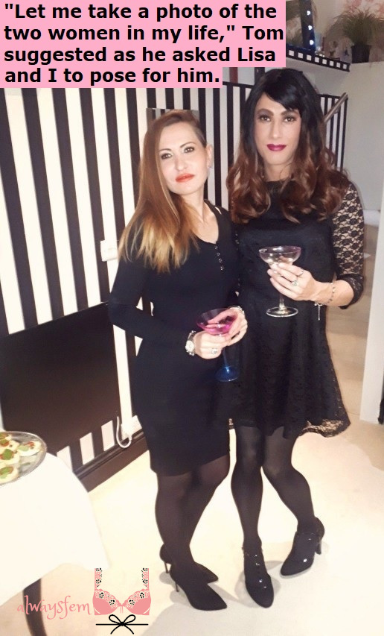

I had no idea what she was talking about. Perhaps that shows just how naïve I was about sex. I thought that there was only one type of threesome. Now I thought that this would be a threesome of two men and one woman.

“Oh no,” said Lisa. “Tom wants you to be a girl too, at least while we are together. He is old fashioned that way, I suppose, being that he is not gay. For my part, I would love to get you into our bed.”

Honestly, all it took was for her to run the back of her hand down my check and I was ready to do anything to have sex with her. But she was checking for whiskers. Tom does not like whiskers on anybody but himself.

I have to admit that when I first met Tom I could understand what she saw in him. He was a customer of our company and I did recall seeing him, and perhaps I had even noticed him looking at me. No face to face there was no hiding the fact that he was attracted to me, and somehow I felt something back.

“I hope that you don’t mind the shave down and the nightie,” he said. “It is just that I do like a three way cuddle and I like a partner’s skin to be smooth and soft, and her nightwear too.”

He used the word “her” but I never really thought that was me. Lisa was the “her” for both of us, and that first night we both enjoyed entering her and pleasuring her. I loved that. When Lisa and I both snuggled up to Tom that was nice too – we leaned over his hairy chest and kissed one another, and then he kissed her, then he kissed me. I felt the whiskers on his face again my face, shaved closely as had been asked of me. It felt new, but not weird.

The next night, he grabbed my cock and I grabbed his. It was massive and really put me to shame. It really left me thinking that there was only one man in this bed and it was not me.

It was the same way when he held me. His arms could completely envelope me. It was an embrace I could never return even if I wanted to. I liked being held by him. You can feel the power that he has. It makes you feel weak but also protected. It is a good feeling.

“You should grow out your hair and have Lisa get you some nice shampoo,” he said, with his face in my dark mop. It was just a suggestion, but somehow, he is the kind of man whose suggestions have to be followed as if they were a command.

I would never dream of trying to stick my cock into any part of Tom. He was just not that type of man. But after a while I was ready to receive him – between my thighs, into my mouth, in my asshole. It just seemed so natural somehow. Lisa would get me started and then he would get involved. Sometimes he would let me enter Lisa’s mouth and he would mount me ad drive me into her until all three of us seemed to climax.

Sex is so much more interesting when there are three of you, and I always thought that the reason for it was hat there were two cocks. His was the one that mattered, but I always thought that mine had a role to play.

But the hormones put an end to that. He did not insist, but it was a suggestion – a suggestion from Tom.

He said that it was time for me to abandon my male life and to adjust this threesome into something new. He wanted me to dress as a woman so that he could go out on the town with a woman on each arm.

“I don’t mind if one of my woman looks like should could be exotic,” he said. “Just so long as I don’t look gay.” I assume by exotic he meant a chick with a dick, because it seemed that was what I was now. I confess that I preferred to look just like any other woman when we were out. He might be ready to take on anybody who call me a “fag”, but I was not up for that.

I think that I make a convincing woman. What do you think? Anyway, Tom is happy with both of the women in his life, and that make me happy. I love being Tom’s other girl.

Maid Up  Inspired by a cap by Always Fem  By Maryanne Peters  I knew what he wanted, and he got what he paid for, but I wanted more. It takes someone who was a guy to understand that commitment is a man’s enemy, but a girl’s must have.  You look hard enough on the Dark Web and you will find them – agencies who can take on somebody of your choosing and weaken and feminize them to the point that they can be actually fucked by the man who paid the bill, without the ability to fight back.  Well, you can’t fight back physically anyway. They use hormones to destroy you muscles and drugs to soften your mind, and sometimes they modify your butthole to become the seat of your orgasm. | 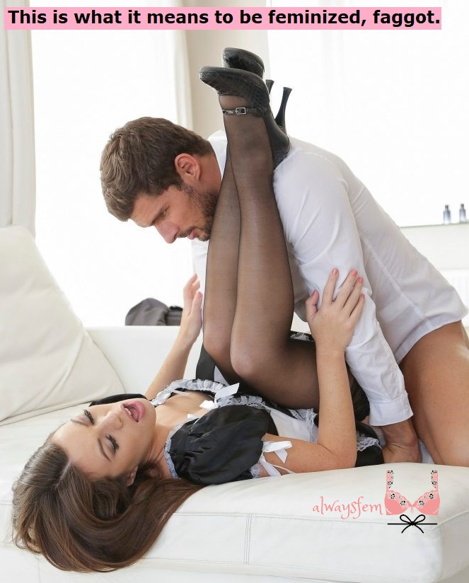

It seems that you have no option to lie back and take the man who hates you deep inside you and squeal before he pulls out and sneers at you – “This is what it means to be a feminized faggot.”

But take a look. Where is the faggot in this image? It is the woman with the long soft brown hair lying on the bed, with her luscious painted lips trembling with delight and her naturally grown and perfectly rounded breasts heave, their nipple sensitive to the point of agony. Yes, that is me, and a few vestiges of manhood belong, but not many.

I cannot resist so I beg for him to take me. I can’t fight him, so I welcome him in. But most importantly of all, I have pulled out all stops to be so completely a woman that to call me faggot seems ridiculous.

“Please get me a vagina. Get me that and I will be yours. We will run away together.” It is not rape if you are begging for it. It is not abuse if you want it.

What is the maid uniform all about? He wants me to be servile and less than him. A mere servant. But I am better than that. Hell, I am better than him. He has no idea what he is dealing with.

I know that I am breaking through. Every time he sees me now I now he sees less of the faggot and more of the woman. And women have power over men. I just need that vagina. Then I am a prospective wife. When he is married to me then we will see who is in charge.

But for now, I just need to keep things going a while longer. I need to make sure that his orgasm will be earth-shattering. I need to stay looking pretty and hungry. I need to squeeze down and wriggle a little at just the right time. I need him to want me.

And when he does I’ll tell him that I want him too. I will cry a little, and his hate will turn to love. Men like his hate faggots but love girls like me.

The End

Cinderella 2022  Inspired by a cap  by Always Fem  By Maryanne Peters  Just the idea of being a stepmother sounds awful – don’t you think? We are brought up on those fairy stories about the evil stepmother. No woman wants to be that.  We all know the story of Cinderella, the girl who was forced to be a servant. Well, this servant with the dustpan and brush is my step-son Robert, although he prefers to be known as Bobbi, short for Roberta.  But he is serving not because I insist on it, but because he wants to be like that - like Cinderella. And I just want to help him to achieve his ambitions.  Isn’t it strange that some males want to be like this? Some men have a need to be subservient that is so strong that pride just disappears. They can never dominate – they can only serve. | 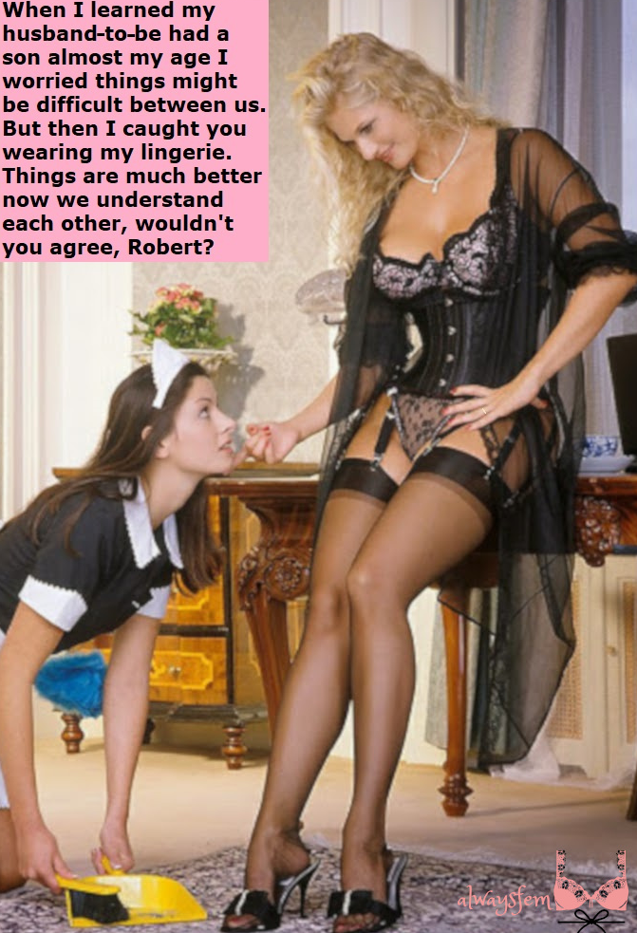

My new husband was horrified at first, but as I explained to him, most men have a kink, including him, although what that is will stay between us. I explained that there was nothing wrong with Bobbi, he just likes pretending to be a maid. It is his thing. It is entirely harmless and seems to be immensely satisfying for the young boy.

I have to say that the hair was my idea. I just don’t like wigs. I had my hairdresser put in extensions. And I had the beard removed too, because a maid with whiskers will never do. And I like real breasts on a maid too, so long as they are not as big as mine. Now I think it is only Bobbi’s Adam’s apple that gives her away. That and the other little bits that I insist that she keeps tucked tightly away. Not so tight as they hurt her, but close to it.

But I am not the evil stepmother. Bobbi is what Bobbi is – born to be a maid, but just born into the body of a boy. We are slowly putting that right.

I am not asking her to stay. If her handsome prince comes to the door he can whisk her away. But for now we are very close Bobbi and me. I am the example of womanhood and an understanding mother figure. I know her needs and I am helping her through it, and keeping a clean Persian rug at the same time.

The End

© Maryanne Peters 2022

