A Sissy Christmas  Inspired by a Captioned Image by ammym2f  By Maryanne Peters  I suppose a lot of families have a weird uncle who is not really an uncle but who turns up for Christmas – right? I mean he might have been married to my aunt’s cousin at one time – so family but only slightly. It is just that Uncle Bart lives alone and has nobody, but he gives good presents so he is always invited. Nobody really understands much about him but he has always seems to join in, and then he just disappears for a year.  But he is not the reason I ended up spending last Christmas dressed as a girl. That is down to me, I guess. It was because we suddenly took on this “dress for Xmas” thing. It was down to my sister inviting her friend Alice to stay over as her parents were spending the holidays in Europe and she was basically home alone. Alice said that all the women in her family dressed in something fancy for Christmas and all the guys wore silly sweaters. Mom thought it would be something different and we should do it.  Dad pulled out an old sweater and Uncle Bart had been told and arrived with a truly awful one. I was offered a sweater that my mother had worn to a Christmas party, but I lost my rag I guess. I was not going to wear any girl’s sweater. I guess I went a little over the top and laid down some abuse about women that got me into serious trouble.  So my sister’s friend said that if it was not going to be Mom’s sweater then she had a bunch of suitable outfits. I was howling.  Mom said – “You choose one and he will wear it. It will do him good to join the ladies this Christmas. Maybe it will teach him a little respect and humility. That is the very essence of Christmas.” | 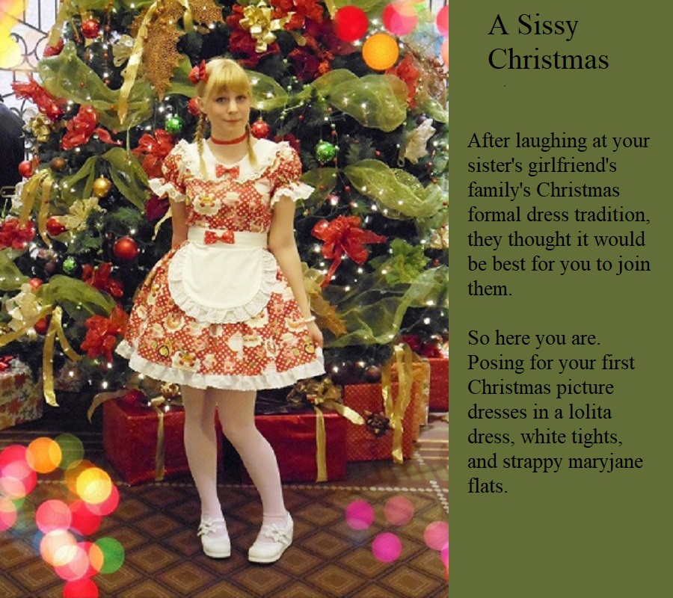

It was much worse than I thought. It was going to be a total look and Mom and Dad said that I had to go along with it. It was ridiculously feminine – a Lolita dress – like in the book, designed to attract an older man. The effect was to make me look like a total sissy. Alice and my sister had me shave my legs under the white stockings. They even colored my long hair and cut girlish bangs in the front, and parted and braided it. I hated it.

Okay, when I posed for that photo in front of the tree I may have had a little smile on my face. I was allowed some of Uncle Bart’s eggnog which was quite alcoholic and I may have overdone it. But it was Christmas after all, and once the presents were all opened we were all a little happier.

It seemed that Uncle Bart was teasing me as his presents were all suitable for girls, or rather young women – an expensive scarf and some makeup and nice hair ornaments, and a smart designed bag to put them all in.

It turns out that Uncle Bart has never got married because his taste in women is a little different from normal. He likes his women to be like me. In fact, he likes me, a whole lot.

It was hard to get Mom and Dad to accept things at first, but Uncle Bart is just like family, and I am family. And this Christmas I have offered to host the festivities at our house, or Bart’s house really, because it is huge and has room for everybody to stay. And of course I have progressed beyond the sissy stage by now – I am more or less a wife. I would like to pull out that Lolita dress to wear again this year, but the truth is, there is no room for my breasts.

The End

Blonded  Inspired by a Captioned Image by Think Pink  (https://www.deviantart.com/think-pink1)  By Maryanne Peters  Life is hard for a young man of color in this town … Hell, in this whole damn country. In particular if you are small, with not much flesh on your bones, and your only assets big brown eyes, a good set of teeth and a fine head of straight hair. And what kind of assets are those? Well, those were what pulled me out of poverty, and made me rich and happy.  I had to be gay. My mother says she knew it from when I was a baby.  “You are just way too pretty to be a man,” she would say. “Some real man is just going to eat you right up.”  What kind of thing is that to say to a young man? But I guess I just assumed that it would happen. I only hoped that whoever it was would care for me and love me, rather than just fuck me.  My hair was straight so I grew it long and kept it in an oiled braid down my back. It was like one of those Chinese coolies of olden days, so some folks called me “China”. My mother would call me her “China Doll”. | 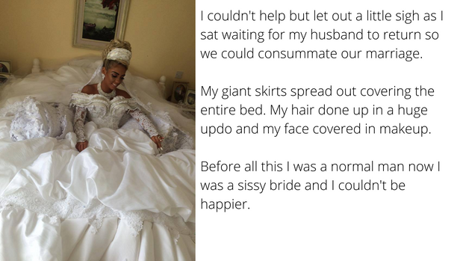

I was not in a position to take offence. I just kept myself to myself and tried not to get hurt. It may sound like a simple enough task, but it is hard for a boy who seems fated to be called a sissy for his whole life, just by the way he looks.

“If only you were a girl, then menfolk would fall over themselves to look after you,” my mother said. “You would just be such a pretty thing.”

I guess that put an idea in my head. I couldn’t do much about school where I was widely known as a sissy boy, but I learned that if I washed my hair and put it in a high ponytail, and I wore a girl’s top with my sneakers and jeans on the street or at the mall, nobody would shout abuse at me. If anything I would get a wolf whistle.

I suppose one thing led to another and I just started to spend more time as a girl. My mother supported me because she wanted to see her child safe. What she said was right – whether or not I was gay was not important – dressed as a girl I was not a sissy – I was normal.

But at school I was now even more of a sissy than I was before. I could not wait to leave. I got a job at the mall working as a shopgirl. I worked in all kinds of stores, but it was when I was working in menswear that I met the man who was to marry me.

“I think you would be prettier as a blond,” he told me.

“If you hadn’t noticed, I’m African American,” I said. But I decided that I would try something new, so I went to the salon and asked for a dye job.

I am not sure if that set me on the path I took or whether I was already on it, but somehow seeing myself with blond hair just made the boy in me disappear completely. With it went any thought that I might have sex with anybody other than him. I gave myself to him completely, and from that point I knew I was not just going to dress as a woman – I needed to be a women – his woman.

Was I ever a normal man? Perhaps I could have been, but as my mother said, I was just way too pretty to be a man. Was I gay from the start? Does it matter now? I am his, and happy to be.

But look at my hair on my wedding day. I am blest with great hair, now blond. I think it suits me. What do you think?

The End

The Dark Side
From one of Sydney’s Sissy Caps
By Maryanne Peters



I can’t deny who or what I was. I was a white male and a racist. I was not alone. In fact, all of my friends were white racist males. Some of them wouldn’t even touch black girls, saying shit like – “I would rather fuck a pink pig than a black bitch”. But I have to say that I liked black pussy. I used to say that – “All pussy is pink on the inside.”

I took it where I could get it. It was not always consensual, but that never seemed to matter in my town. Our police were white in those days. They would always assume that black girls were just begging for it if they let their bootie show. But things can change, and they did in our town – just not before I got more than my share.

In our town if black men want justice for their women, they have to take it upon themselves. That is what they decided to do, and I was one of their targets. Me and two other guys were kidnapped and taken out to a big farmhouse owned by a rich white woman – as it turned out a horny widow with a taste for black cock. We were kept in the basement.

The search went out for the missing sons of the white community, but the old widow would send them off with a hornet in the ear. No officer, black or white, would suspect that what was going on there was happening.

So, what was happening? Well, we were being injected full of hormones and stripped of body hair and dignity by our black captors, for a start. Then they would say to us “Only pretty white bitches get fed, so if you wanna get fed, you gonna wanna get pretty.”

They gave us the magazines and hair and beauty stuff, so the three of us had to help each other. A man has gotta eat after all. Hunger makes a man give away anything he’s got, and we didn’t have much.

We were going to get ass fucked regardless. We knew that. All we needed to do was to be prepared. Get ourselves lubricated and stretch enough so that big black cock would not tear us apart when it entered with force.

I supposed we also learned that a man being fucked get hit across the head if he howls, but if he has long blond hair and he whimpers like a girl, them he might get fucked gently, and maybe afterwards he might even hold her, and kiss her and tell her what a good fuck she had been.

I don’t talk about it so much with the other two, but he truth is I have kinda got used to black cock. Maybe I even sort of like it.

I do like it when he calls me Princess. It makes me feel a little superior, if you know what I mean.

The End

Consequences  Inspired by a Captioned Image from Boyswhobecamegirls.blogspot  By Maryanne Peters  I don’t really remember how it started … do any of us who find ourselves drawn into this boys becoming girls stuff? I guess my big mistake was using the company PC to access those sites. They keep a record don’t you know?  The thing is that I got all my satisfaction from just looking at others switching gender. I did not crossdress at home. I was living with my parents but even if I had been on my own I wouldn’t have .. I think. It would all be too expensive, and I don’t have the money.  And I really need the job. It was hard to get but easy to do. My boss knew that, and he used it.  He called me in and showed me what I had been looking at. Just guys dressing up as girls and submitting to strong men.  “Is this who you are?” he asked. “Is this what you want?” | 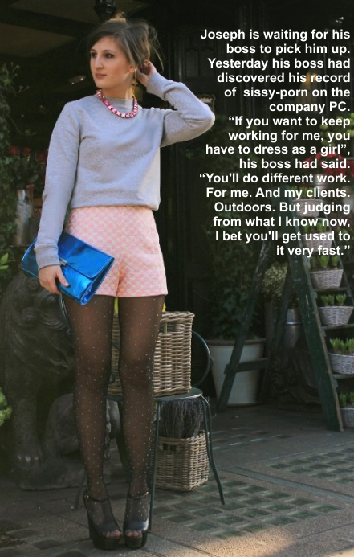

I guess I did not really have an answer … or I did not want to say. I just looked down. I was so ashamed.

“Well, I can’t have a sissy in the office,” he said. But then he added – “But outside the office there may be a role for you?”

He called it “work outdoors” – marketing stuff I guess. He would say that we develop our product “indoors”, but we sell it “outdoors”. We get out and do the work.

I won’t say what business we are in, but it is a product where the buyers are men – strong men. Strong men who might laugh out load if a sissy was making the sales, but buy anyway. My boss is no fool. I was to go with him as a “demonstrator”.

He gave me some of the clothes he expected me to wear on my first day in my new job – the black tights and heels and the pink playsuit with instructions that I fill the top. It was just the kind of thing that a sissy might wear and it was frankly demeaning. But I decided that while I would do as instructed, I would try to appear more than just an object of ridicule and misguided sexuality.

The sweater is one of my own, and the necklace was something I had bought is a market stall, but they added some restraint to the top half. Then I put my hair up. It was not that long then but I worked hard to get a style that looked (I think) professional.

I waited for him at the shop on the corner. It was my first time out in public dressed as a woman and I felt surprisingly good with it. The outfit drew some looks – mainly from men admiring my smooth stockinged legs. But there were no accusing stares; no shouts of derision.

My boss pulled up in the company truck.

“Hey Josie,” he said. “This look is a surprise. Get in. What’s in the bag?”

“That is copies of the catalog,” I said, in the husky voice I had been working on all night. “We are trying to make sales aren’t we?”

“It is not quite what I was expecting,” he said. “But it works for me.”

It sure did. A year later, straight after my surgery, we were married.

It was all a consequence of using the company PC to view sissy porn. It was the last time I ever did. Now I am living ever sissy’s dream.

The End

Office Desires
Inspired by a Captioned Image by Alix TG on Deviant Art
By Maryanne Peters

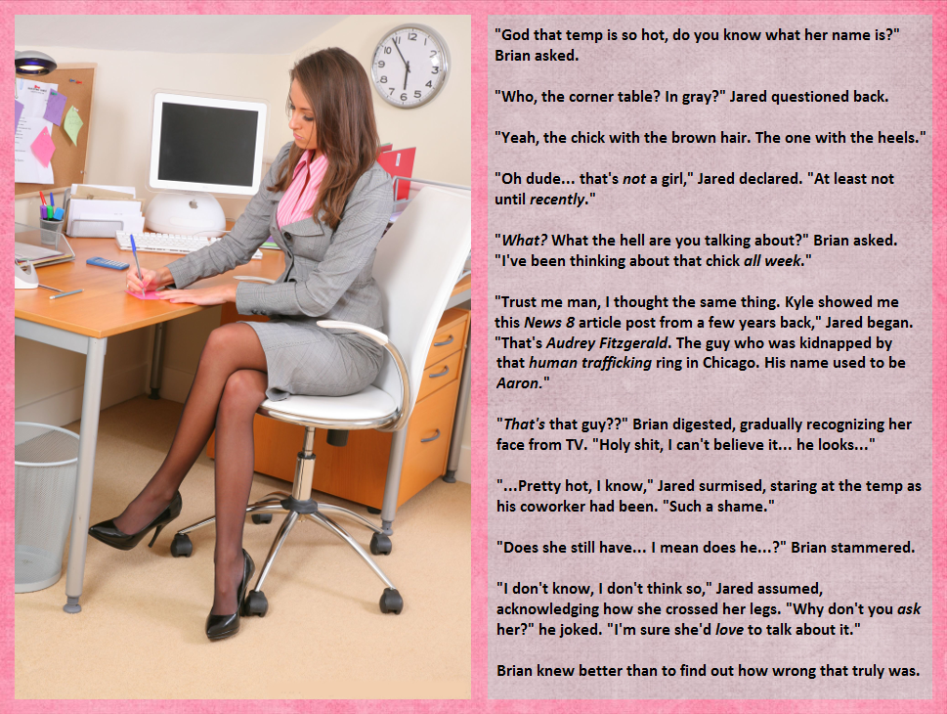

But Jared had other ideas. His conversation with Brian had prompted his curiosity. In fact, more than that, he had a sleepless night following that workday, obsessing over Audrey. He had to talk to her. He had to find out whether she was now a complete woman. It was eating him up.

“Hey, my name is Jared. I work over there. Perhaps you’ve seen me?”
“Hello Jared. I have noticed you. My name is Audrey.” She offered him a hand – soft with perfect pink painted nails. He took it like a treasured thing – just to hold.

“I hope that you don’t mind me being forward, but I have heard your story. I have heard that you were originally a guy. I am just curious … have you got any bits of that left?”

She glared at him, he face thunder. She said – “I do mind. I don’t as you what is in your shorts. It might be a cunt for all I know, and if it is, it is your business, and your business alone!”

They came to collect Jared that night. Audrey collected her usual fee.

Some might have said that it was Stockholm syndrome that saw her continue to maintain contract with the ring even after the Chicago Branch was shut down following her rescue, but to Audrey it was only money.

Temping is a great way to find the right men. She was looking for those smallish and delicately built young men, who are over-sexed and thus easily subdued when totally emasculated. Those who are adaptable will find out soon enough that life as a woman can be very rewarding.

But this Jared just had her pissed. How dare he? Men like that don’t deserve to threaten the world with this chauvinist and transphobic attitudes. Try the other side, she thought.

Jared woke with a massive pain in his groin.

I guess he learned the hard way.

The End

© Maryanne Peters 2023

