News for Dad
A Vignette
By Maryanne Peters

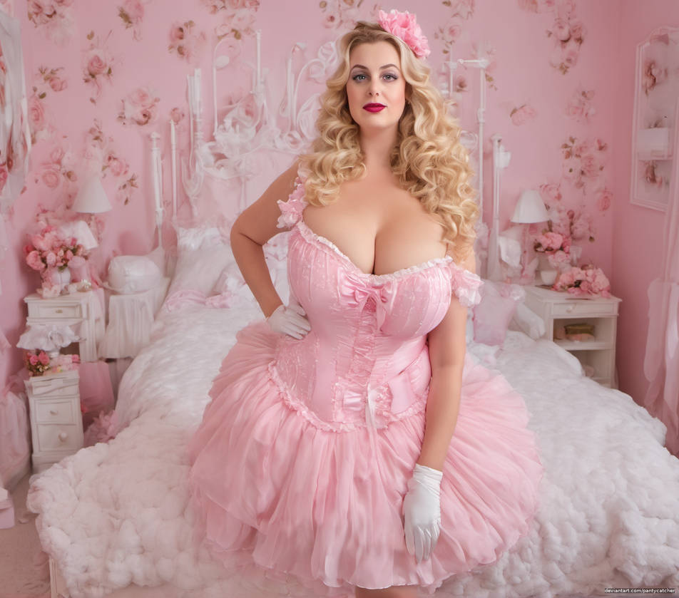

I wanted to be closer to my father, and they say that daughters are always closer. I tried to be the son he wanted me to be, but I failed miserably. I decided that what I would do was to spend the money I received on the death of my rich uncle, to become his little girl. Well, not exactly, because I am not that little. It is just that I needed to be the very opposite of the son that I was – the young man he described as “a total disappointment”.

I told him that I had taken aboard all his criticisms and that I was going away to make serious changes in my life.

“Perhaps you will feel more attached to the new me when I get back?” I said, forcing a smile. I did not get one back. Fathers can be like that with their sons. Some will never rise to the expectations of their fathers, but daughters are just expected to be attractive and cheerful. That was more me.

But becoming attractive and feminine was a mission in itself. My good fortune was that I took to hormones like a duck to water. Once I was rid of my testicles and on a fulsome dosage I quickly started to change shape. My late mother was a buxom woman – some said that my father married her only for her tits. I had the genes that allowed me to grow broad where a broad should be broad, and soft as a warm sofa. The hormones helped with my hair too, which grew to my waist in the two years I was away.

Two years was what I needed to develop a totally feminine persona. It all started and ended with pink. To me that is a color that I need to wake up to – and roses and ruffles as well. I wanted everything to be beautiful, but most of all, me.

I thought that I looked a lot like my mother, although maybe with my father’s jawline. I think that it works. The thing is to have curves and good skin. I think I have a cleavage that calls out to be dived into head first.

I worked on my voice too. I could have made permanent changes there, and I still may do, but what I wanted was to be able to telephone my father and invite him to visit me in my new apartment. I wanted the last words in my male voice to be – “I’m in the bedroom at the end of the hall, Dad. Come on through!”

Can you imagine his reaction when he did. I had posed for this encounter dozens of times, so I was ready for anything. There I was, his disappointment now changed forever – pretty, buxom and female all the way down. And so close to the image of the woman that he had married, now restored to youth. I arranged my hair just so, and I prepared my smile.

As he entered, I raised my voice to what is now the timbre I speak in every day to say – “Hello Daddy!”

Can you guess his reaction?

The End
527

Prom Perfect  A Vignette  By Maryanne Peters  It was just like Mom said it would be. There they are, both in blue, Stacey and Nell – the mean girls in our school, laughing at Riley in his dress. They didn’t even notice me – the tall girl with her long fair hair pinned up and wearing a low cut crimson dress. They might not know me, but I was just another pretty girl at the prom. It was just like Mom said – “a boy in drag will be laughed at, but if you look like a girl then nobody will laugh even if they recognize it is you, Logan.”  That’s right, the girl in red hanging off the arm of Justin Hall, is not a girl at all. That is me. | 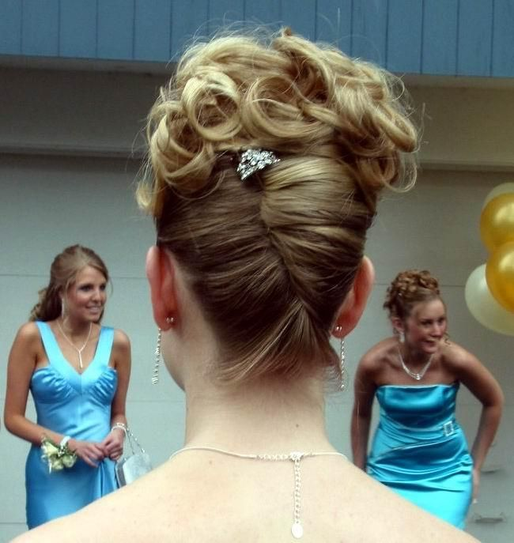

Riley and I got into serious trouble in the weeks leading up to the prom, and Principal Jones told us that we would not be allowed to attend, and that was only part of the punishment. It was just that the girls we had humiliated went to him and suggested that we could be allowed to if we seriously presented ourselves as women. Principal Jones made that an order – if you want to graduate turn up to the prom in a ball gown!

And no half efforts either. Principal Jones would be looking out for us, and he would be judging if we had truly got in touch with our feminine side. Stacey and Nell would be watching too, and ready to pick holes in our get up. The shoe was on the other foot on prom night and if they could use it to kick us, then they would.

I was almost wishing that Riley would not come over. If he did, they might suddenly realize that Justin’s girl was Logan Giles in a dress. But I had to be there for him.

Justin stepped in front to save me, saying – “I think you look pretty passable Riley, but it looks like your pal Logan did not turn up to take his punishment.”

Riley smiled knowingly. He did not even look at me. He just walked past teetering on his high heels, said something like – “Thanks Justin. I hope you and your girl have a great night.”

I looked across at Justin and he was looking at me. It was a moment. I just did not want the spell to end.

I could see principal Jones looking for somebody and I could guess who that was. I thought I had better go over and make myself known to him, but I steered Justin in his direction. We Justin walked right up to him but the principal was still looking over my shoulder There is nothing like a boyfriend to keep a girl looking more like a girl.

I had to say – “Principal Jones, It’s me Logan Giles.”

“Oh my God! How can that be, the poise … and the hair. How did you do that?”

“It’s my hair at the back, Sir, but the curls on top are not.”

“It’s quite … beautiful,” he said. “You’re quite beautiful. Don’t you agree Justin?”

“I wouldn’t have asked her to be my date if I didn’t think that,”said Justin. Those words made me almost explode with Joy – especially his referring to me as ‘she’.

“Please don’t let on, Sir,” Justin asked the principal. “Lo is just enjoying being incognito for the time being. Not that she is ashamed of who she is, but I just want her to enjoy being the person she wants to be.”

Principal Jones nodded, still with a look of disbelief on his face and walked away.

“What did you mean by that?” I asked Justin. “Who is the person you think I want to be?”

“Come on, Lo,” he said. After the break we are headed to college. You can be whoever you want to be, but I want you to be who you are tonight. I want you to be Loren … always.”

“I’m having a wondeful time being her, but what you are talking about is a big call. I’m not sure that I am ready.” I wasn’t – not then.

But those graduation proms are events that mark major transitions for so many. For many young women in particular, they mark the beginning of maturity and an new understanding of the power of sex. It was no different for me that night, although I was not a woman … at that moment. That happened later. Justin cemented my femininity that night.

It was perfect.

The End

761

This is the New Me  A Vignette  By Maryanne Peters  It is very simple – you are who you are, or you want to be. I wanted to be a girl … no, I needed to be a girl. That is who I am. As the term ended, I was done with pretending. I was ready to drop the male pretenses. I was ready to be me.  I have always been determined. It was what made me a success as a male, for as long as I was ready to that. It made me do well in most classes and excel in some sports where my lack of size did not matter. But determination makes things easier. It makes things simple. You do what you have to do, regardless of the consequences.  My father was shocked, but only because I had never told him my feelings. I had always been female on the inside. He just needed to be told. He knew me well enough to know that I would follow through. That is what I do.  My mother said that she thought that I had put those feminine thoughts behind me. I had for a while, and because of who I am, I could … for a while. But you cannot really change your essence. You have to change everything else. I think that she understood that. | 

So, this is the new me on the first day of a new term, striding down the hall dressed in loud pink to announce that this is my color. Not pastel pink because I am no fragile flower. I am a woman – proud and determined, and my sandals have a small heel so that on the hard floor, people can hear me coming and look around. Who is the new girl?

They will work it out. I am not changing my name – at least not yet. It will work for now. I am still who I am – just female.

But some may not recognize me straight away, with the long, freshly shaved legs, the new hair extensions, light makeup on a pretty face and first effects of a vacation on estrogen just visible. Guys on my team will approach me – I can tell you which ones will be first.

“Hey, you’re new around here. What’s your name?”

But I am not new. I am me – just the new me. Get over it.

I am ready.

The End.

400

Eye Level  A Vignette  By Maryanne Peters  I was always taller than Manny, but he was the man I wanted. The only problem that I had was that I was not a woman. I was not a woman, and I was over 6 feet tall.  “Never mind that,” he said. “Your breasts are at my eye level. I just want to rub my face in them whenever we are close enough.”  It was on the dancefloor at the “Exotica Club” and I was in full drag. For tall girls like me, that was our release. If you are not passable it is hard to be a woman, but easy enough to be a drag queen.  “I can see the way you look at them, so I am sorry to disappoint you,” I said. “They are not real. They are latex rubber with gel inside. Fake tits for a fake girl.”  “I see only a woman under the makeup,” he said. “Let me buy you a pair of real breasts – implants and hormones.”  “What a lovely little man you are,” I said, although he was average height. “But how will I explain breasts at my day job?” | 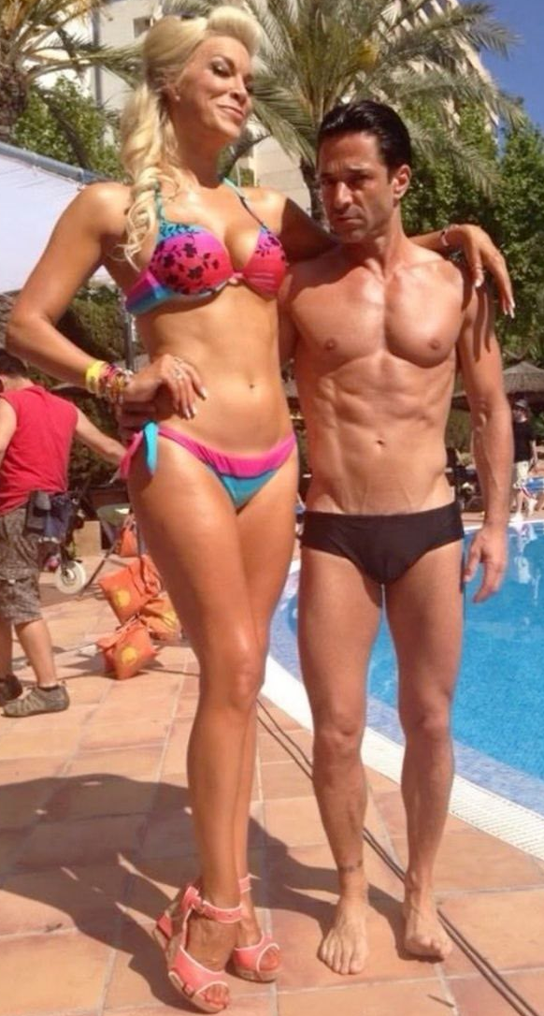

Quit that job,” he said. “Come and work for me at my resort hotel. Take any job you like just so long as it will be as a woman … if that is who you want to be.”

What did I want? To me it was always that the choice was not real. Others with my feelings could decide to live the gender they were born with because they had the bodies to allow it. I did not. For me it was like the future would never allow me to have a good job or a long term relationship as a woman. People would always say – “that has to be man!”. And suddenly, here was somebody who could offer me all the things that I wanted. And he was a hunk too. Not such a big hunk, but a hunk.

I could have gone for breasts larger than those I chose, but I did not want to lug around anything too weighty. He is very happy with what I have. You might see that he finds it hard not to stare at them. I just put a finger under his chin and lift it up.

“Try looking into my eyes every now and again,” I like to scold him just a little.

“I am very happy to do that, Cariňo,” as he likes to call me. “You are my blond goddess!”

I feel like that too, and it is all down to him. He is very wealthy and could pay for the breasts and the face and scalp and voicebox work so that even with my height, strangers are not quick to judge. There are tall women out there, after all.

I even discussed with him the possibility of height reduction surgery, but he would not have it. He bought me the wedge sandals.

“I want my wife to stand out in a crowd,” he said. “And I like the view at eye level, and all the way up and down.”

The End
500

Mom’s Business  A Vignette  By Maryanne Peters  The 1990s were the peak for Avon Products in the USA, and my mother was making a lot of money. The only problem, as she put it, was that there were too many doors and not enough hours in the day.  She asked whether I could help and how could I say no. Dad was long gone and she was raising me and my younger brother. Being an Avon Lady was now her full time occupation, but it was doing well for her which meant that for the first time we were enjoying a few luxuries. | 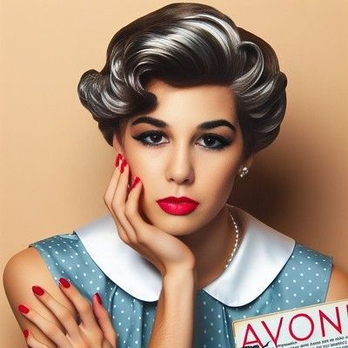

“The problem is that Avon Ladies have to be ladies, so I would be asking more of you that most mothers would ever have to do,” she said. “You need to have the look that we need to sell the products. Skin and hair care for mature women. Foundation and blusher, eye makeup and lipstick, hand cream and nail polish. Would you be prepared to do that, to help me and your little brother?”

I was the oldest child and also “the man of the house”. These things place a heavy responsibility on a young man. But the oldest child is often ready to take on the burden, and I was one of those. I simply asked that I not be so changed that I could not attend school as a boy with nobody being able to detect that I was an after-hours Avon Lady.

She said that my hair needed to be just a little longer, so that she could style it with Avon products but then oil it flat for school. My eyebrows were untouched and only brushed into shape for my rounds selling door to door, and the fingernails were stick on and painted just before I put of my dress to do the job. The earrings were clip-on and the makeup could be removed, but as a part of the pitch I need to know a thing or two about application. Within no time I was doing my own makeup and ready to instruct my customers on how to achieve “my look”.

But the problem is that I was becoming two people, and they were starting to merge into one. I thought that I could be a boy during the day and a woman on the weekend and some evenings. I thought that it was easy to slip into my feminine persona from the moment I clipped on my name tag, and then shed it with my dress when I got home.

Maybe I was even guilty of starting to believe my sales spiel. It was all about bringing out the woman inside of all of my customers. I never imagined that there might be a woman inside me.

But the biggest problem was that I started to get pretty – really pretty. Was it the products or was it just my determination to be the best possible representative of my mother’s business? I was I really a pretty girl all along, just ready to shed the dull mask of boyhood and become the person that I always should have been?

Whatever is going on, the feminine me is starting to show at school. I even feel closer to the girls in my class than the boys. I am starting to give them tips – not just trying to sell them Avon products, but just letting them know about the importance of a good skin care regime, and how conditioning the hair is essential.

But instead of the guys looking at me as if I was gay I have had some people asking me whether I the girl selling Avon lately for some reason attending school as a boy. What am I supposed to say to that? I am starting to wonder if that might be the best explanation, especially if the guy asking is a real hunk.

And then there are the sales. I am making my sub-seller’s commission and collecting heaps, but I am spending it all on clothes and shoes, and not the kind that I can wear to school. I don’t want to give up on Mom’s business. Maybe I should just give in and go to school as a girl? Decisions!

The End

© Maryanne Peters 2024

