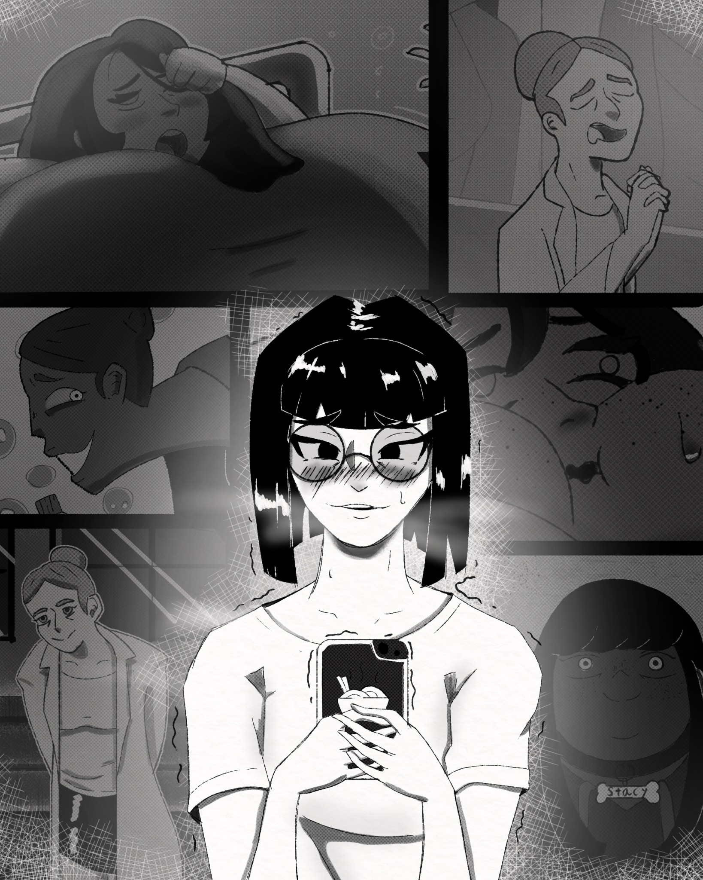
Ms. Kim took out her phone and scrolled through her contacts. she hovered over McClain's, her thumb over the call button. Kim NEEDED to end this, to get help, to be better.
“You are NOT broken, you do NOT need to be FIXED. YOU are fucking PERFECT do you hear me? Anyone who told you otherwise can BURN!”
Lannas voice from that fateful night rang through her mind. No one has ever said those words to her before.
“ I can protect you! If you just do as I say, then we can pop as many hungry cuties as we want, together forever.”
That sounded so good, too good to be true.
“We're sisters Cho.”
Lanna had said those words with such sincerity, such passion, it made Kim feel connected to someone in a way she never even dreamed possible… Was she really considering abandoning her? Kim stared at her phone for a long, long time. Before she scrolled down and pressed call.
*Click*
“Have you decided?” Came Lannas voice
“Yeah,” Cho answered.
…
“Kimmy we really don't have time for this” Ms.Butters said, as Cho led her down the sub basement of San Graso.
“It's okay silly, I just want to show you something.” Cho said, saccharine sweet.
“But why was Prom postponed? I thought this was something the project heads were super strict about.”
“They changed the time last minute, you didn't get McClain's Email?” Butters looked confused.
“But why so last minute? Prom was supposed to be tonight, I already prepared so much food”.
They finally made their way down the stairs and into the cold damp space, lit only by flickering fluorescent light.
“Oh I know, and after I got all dressed up and everything! Well don't worry what I've got down here should answer all your questions.” Cho said.
“hey…hey Kimmy are you feeling alright? You've been acting…well, weird.” Cho came to school in an uncharacteristically revealing black dress. It hugged her body, the cut revealed most of her slender back and tight belly. She chose to wear her contacts today which she never did and even stranger still she actually wore makeup, her lips glossed and eyeliner generously applied; the effect made her look like a completely different person.
“Fuck, Butters whats got you so worked up? I'm fine, just…I'm being my best self tonight. That's all.” Cho gave butters a wide smile.
“Oh okay hehe, sorry I guess I'm just imagining it.”
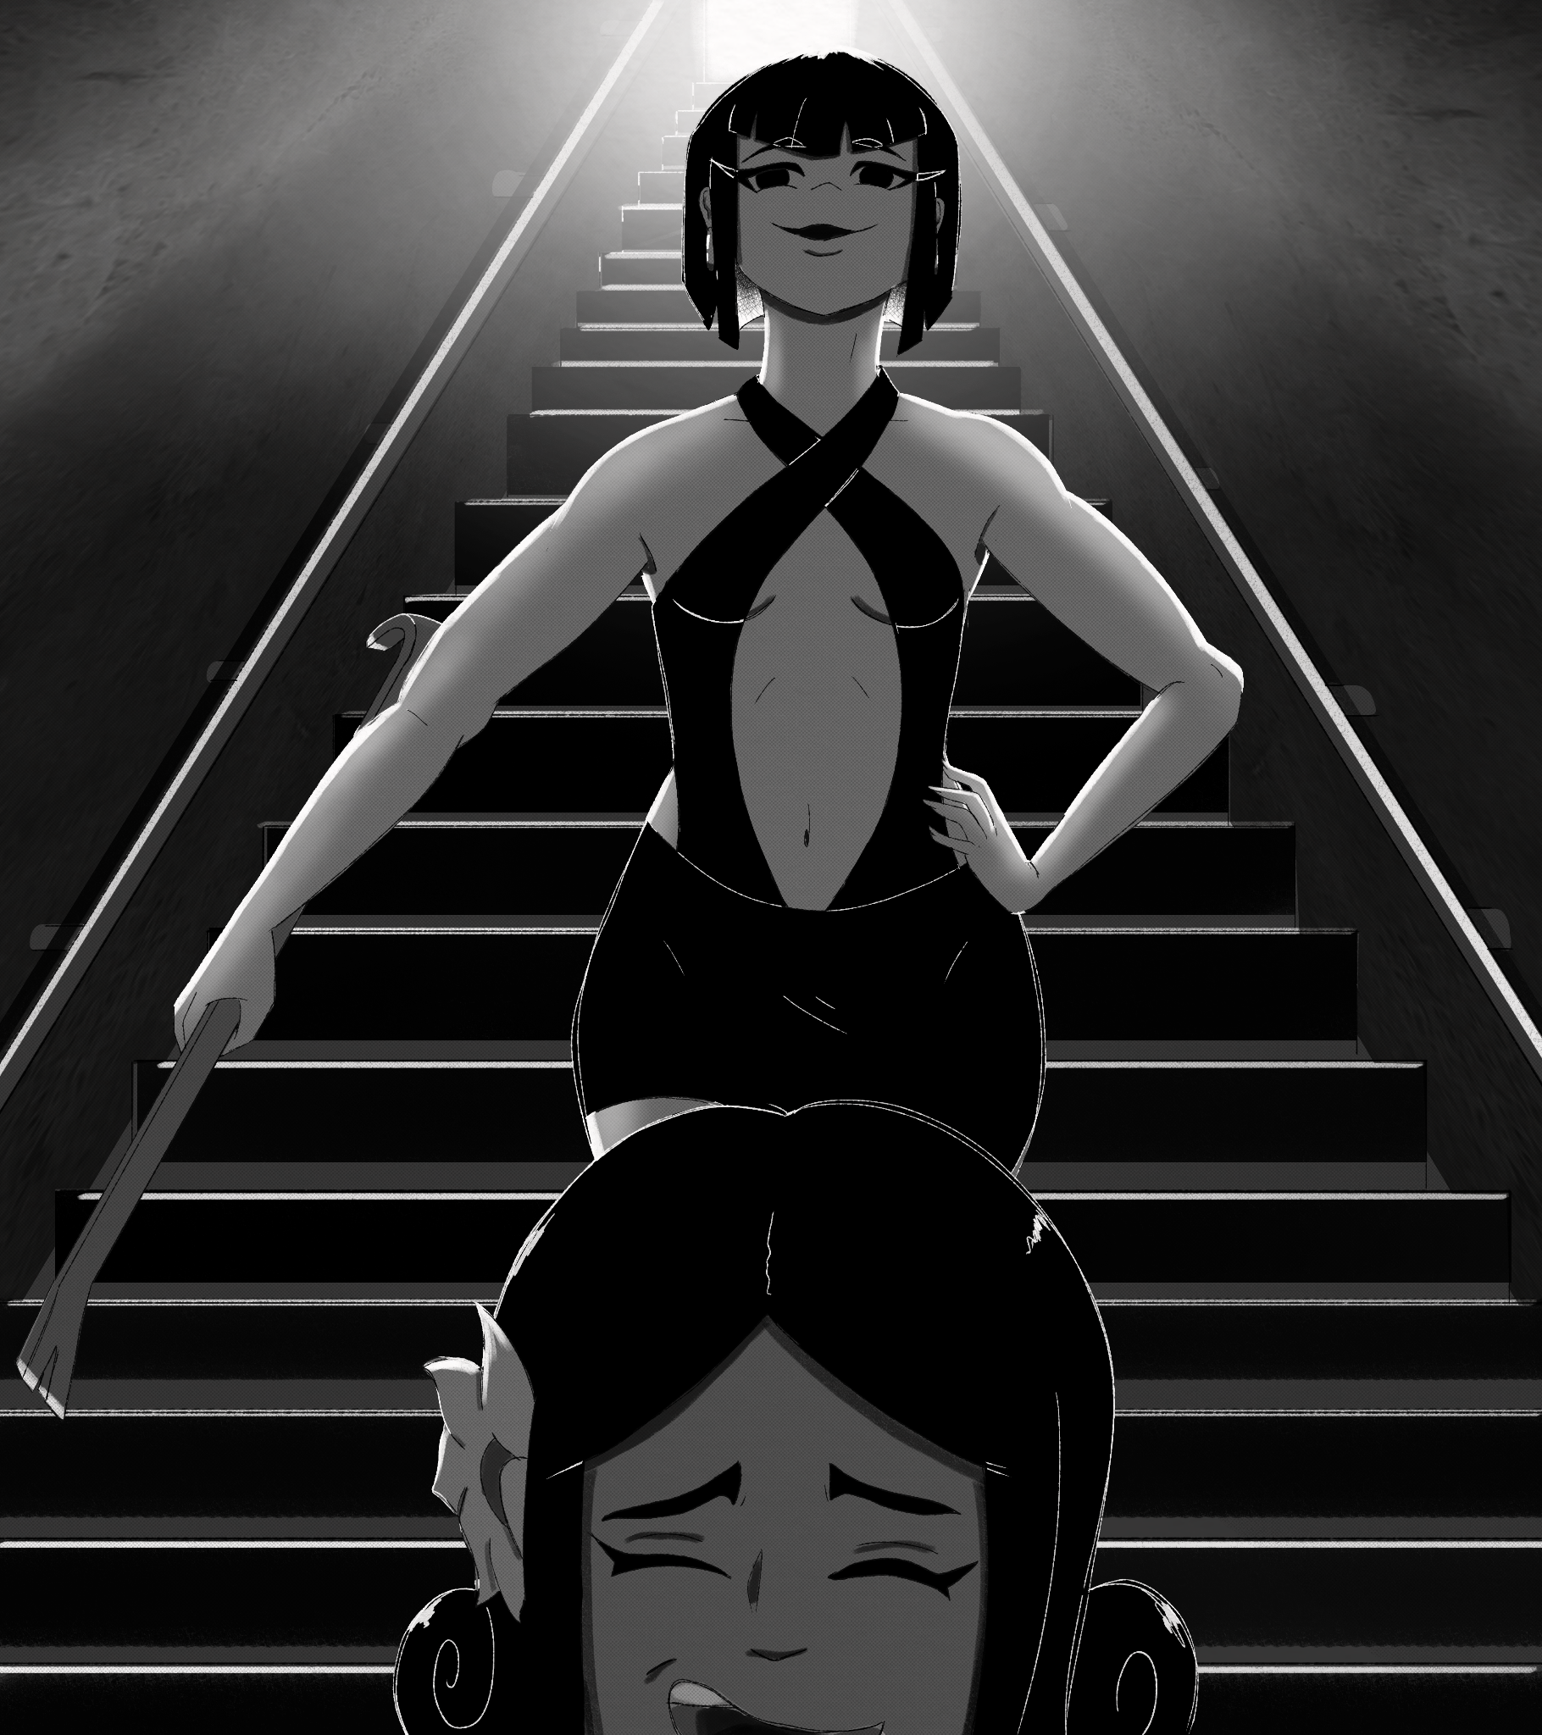
“You think too much,” Cho whispered.
…

Stacy sat in the middle of the dim room, as she shoved another handful of jelly in her gullet. She was on her 3rd bucket now, and she still had a ways to go. Gotta fill up with as much of this stuff as I can, can't disappoint Mistress. Stacy's round body jumped as she heard the tell tale THWACK! From near the boiler room entrance. Sounds like she got the last one. Stacy thought as not but a moment later she saw a concussed Ms.Butters being dragged in by a crowbar wielding Ms.Kim. Or Cho I guess, god I'll never get used to calling her that.
“Where's Lanna?” Cho asked.
“Mistress shaid to *Omf* meet her in her wab *ULP*” Stacy said through full cheeks. Cho smirked.
“Look at you stuffing yourself down here, you know what all that goop will turn you into right?” Stacy blushed, looking down at her engorged belly, then at the at least 20 more buckets she had left. Her fat little heart started to race; oh yeah, she knew exactly what it would do to her.
“Yesh…and I'm sho exshited!” Stacy said, as she stuck her whole face into the bucket, gulping the mysterious slurry down like honey. Cho only chuckled, as she tossed the limp form of Ms. Butters in with the rest of the faculty. Mistress had sent a mass Email through McClain's PC, telling most of the staff that prom was postponed. Of course though some faculty including the real McClain were still here causing problems, so they had to be taken care of. It had taken them all day, one at a time leading staff into this place and knocking them out, but at last they were all stuffed in this basement, now no one could interfere with Mistresses plans. Stacy glanced over at the project heads bound and gagged together. That had been the hardest part, since they had a whole security detail, but of course Mistress had thought of everything, so the moment they entered the building they had all been gassed; Mistresses own creation of course, colorless, odorless, instant.
“Welp I'll leave the rest of this to you Stacy, enjoy yourself” Cho went to lock a big metal door behind her. “It was nice knowing you” she said before sealing her in with the faculty. Those final words filled Stacy with an exquisite mix of terror, excitement, and arousal.
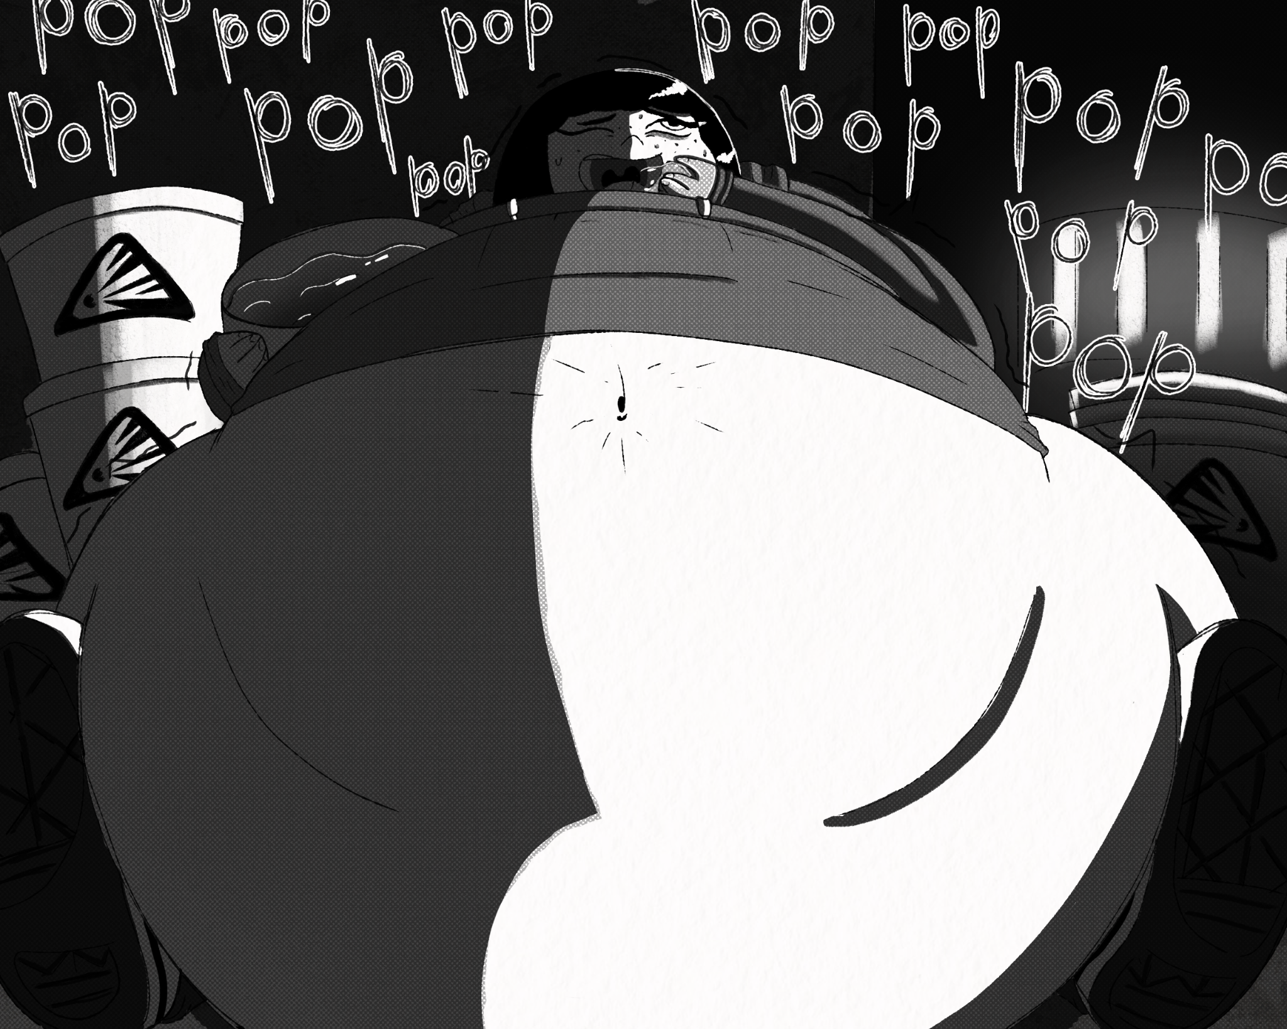
…
Cho walked into Lannas lab, to see her standing over a large vat. The whole thing reminded her of a witch standing over a cauldron. Lanna looked up with an annoyed expression.
“What do you- *Gasp* CHO!'' Upon seeing her partner in crime, Lannas face lit up and she went to glomp the asian woman.
“Is it done, did you handle that bitch Butters?” Cho nodded.
“Yeah, that's the last of them, Stacy will take care of the rest”. Honestly Cho felt a pang of guilt when she knocked Butters out. She had always been so good to her and the depth of Cho's betrayal was not lost on her, but oddly enough she didn't really care. When Ms.Butters said she was acting differently she didn't know the half of it. Cho FELT different, like her very personality was shifting, like the person she was before was an old shell. Her own thoughts, feelings and actions surprised her, like a new person was in her body; honestly it scared her a little.
“Good, oh everythings gone perfectly! Trust me this is going to be the most fun night of your life!”
But looking into Lannas eyes, nuzzling into her arms, that fear all melted away. Cho smiled excitedly and pointed at the vat.
“Is that it?” she whispered; Lanna took her over to look over the rim. At first it kind of looked like rice, millions of little white grains in a big vat of warm water. They both knew better though, they both knew that this was no rice. Lanna spoke.
“This will go in all their food, and knowing our students you know they'll eat a lot of it, they'll eat and eat and eat, grow and grow and grow, then once these have incubated long enough…that's when the real fun will start.” Both women shook with arousal.
“This is so fucked up, like I cant believe how amazingly fucked up this is!” Cho said in a girlish squee. Lanna looked tenderly at the tiny asian woman.
“And I still cant believe I found someone as adorably fucked up as you-U” she booped Cho on the nose. Both women stood there giggling…
Over the vat of what looked like rice.
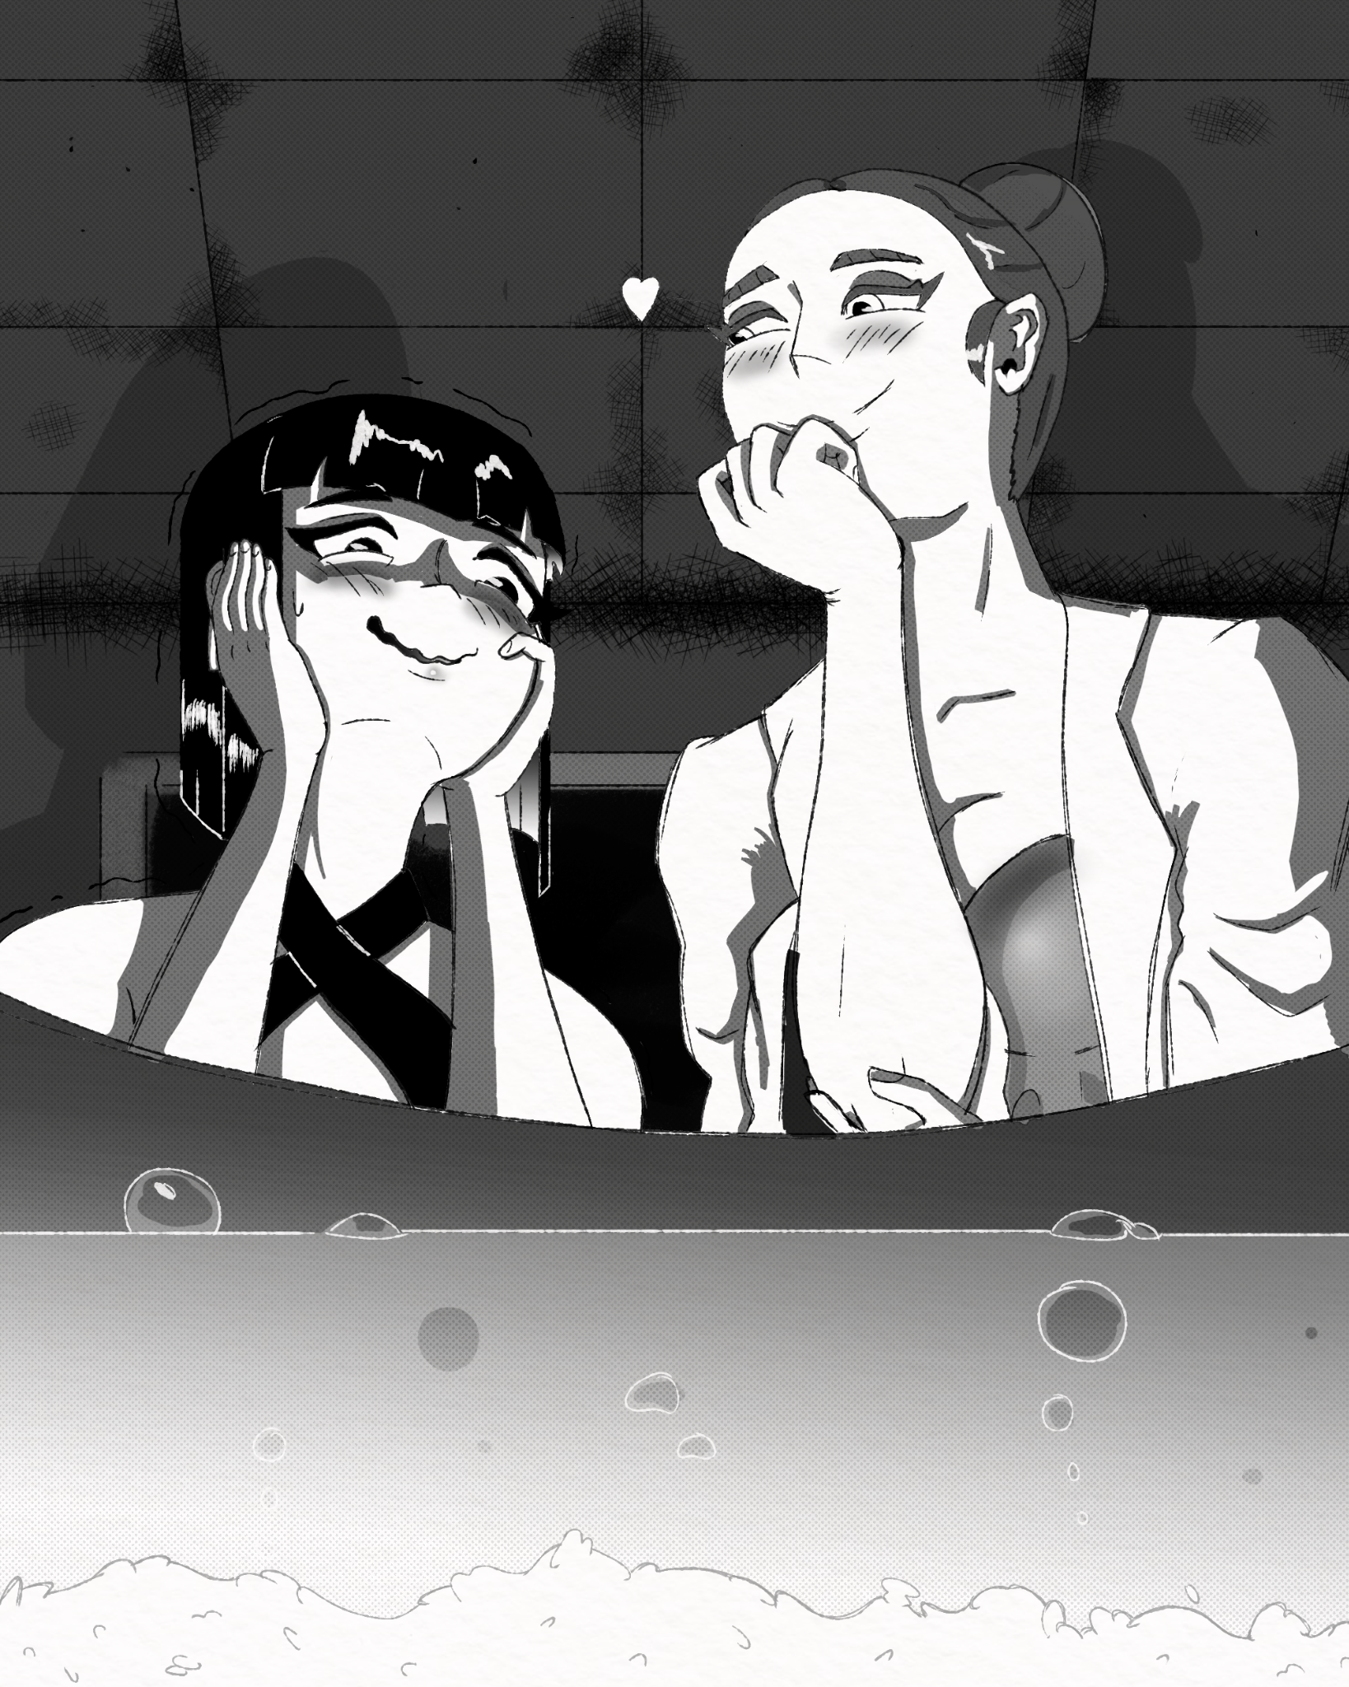
…
It was 7:00pm and the sounds of students waddling their way to the cafeteria could be heard above the boiler room.
“Ish time *ULK* they're here *HURP* Gotta eat da lasht *BELCH* Bucket.” Stacy grumbled. after Cho left, she hauled herself in front of the door while she was still mobile, but that was 19 buckets ago. Her body had become so engorged feasting on the buckets of slime that she even dwarfed how big she'd gotten when mistress blew her up with bubbles. She was the size of a volkswagen her stomach dominating her form, making her look like a big fat bubble. “BLEHC done!” she gasped, as the last of the goop had been consumed. Stacy panted, in a stupor, and feeling an ache in her core that would have made any other girl call an ambulance. Still, Stacy felt a sense of pride, she had eaten herself this big all on her own, the months of mistress stuffing her and bloating her organs to the max really paid off because now her capacity was insane. She smiled. “I did it Mistwiss Im gonna *URP* make you sho pwoud of me” her speech was a mix of extreme nausea, bloatedness, and girlish delight all in one.
“What…what's happening?” came the voice of Ms.Butters. It seemed some of the faculty were starting to wake up. Most of the teachers weren't there, just cleaning staff, McClain, Tanner, the project heads, and Butters.
“Wha…Stacy? Is that you?” Butters asked, clutching her head. Stacy was too full to talk anymore, just moaned like a cow. “Oh my god! Stacy, what happened to you? What did you eat?” Butters looked around for an exit. “Where's Kim? Why is everyone else down here? Did Merkel do this? I swear to god if she-” Stacy swelled before Butters very eyes.
“What the?”
“Yessshh” Stacy mumbled. It was starting, the reaction was building up inside her, she could feel it. “Shoooo guuuuud OH!!” again Stacy swelled, taking up even more of the room. “OOOHHH Dat one wash even bwigger uuungh~” Stacy continued to moan and bellow, reveling in her body's forceful expansion. As she did, the noise woke up more of the staff, and they all looked in awe and fear of the once small little butter ball.
“Stacy…what. Did. you. EAT?” Butters asked, backing away from the growing girl. Stacy just smiled and moaned again, as the blasting jelly continued to thicken her up from the inside.
…
It was 7:00pm and the sounds of students waddling their way to the cafeteria alerted Cho and Lanna.
“Come on Lanna it's time”
“I know, I know, just making suuuuure there, all done!” Lanna finished mixing the rice-looking stuff into the food that the students would be gorging on tonight and moved to toss the vat in a nearby dumpster. “Ok lets go!” Lanna said. The two women walked up to the stage in front of the cafeteria, Cho looked down to see a sea of fatties, each poured into dresses and evening wear that seemed to barely hold back all that hot young pork; speaking of pork.
“Hey what's the deal? Where are the tables?” one girl asked. All of them were confused to see that the rows of tables had been replaced with rows of troughs, all presentation and decorum was abandoned, piping hot food was thrown haphazardly into the things. along them were tanks filled with different high calorie beverages, all leading to hoses that hung from the ceiling, so the little piggys wouldn't get too parched.
“Welcome San Graso to the Barnyard Ball!” Lanna spoke into the mic, and Cho joined in.
“Yup, this year we're changing it up with a fun new theme! Why get served food at a table when you can eat and drink straight from the tap!?”
“Y-yeehaw!” Lanna shouted. Hearing the German chemist say “Yeehaw '' already made this the best night of Chos life, but the fun is just getting started. The girls all just looked at each other and shrugged before the smell of food caused a chain reaction of rumbling guts.
“Whatever, I'm digging in,” a girl in the crowd yelled. And so the feasting began, girls got on their hands and knees and started eating, obviously no silverware was provided so most simply used their hands.
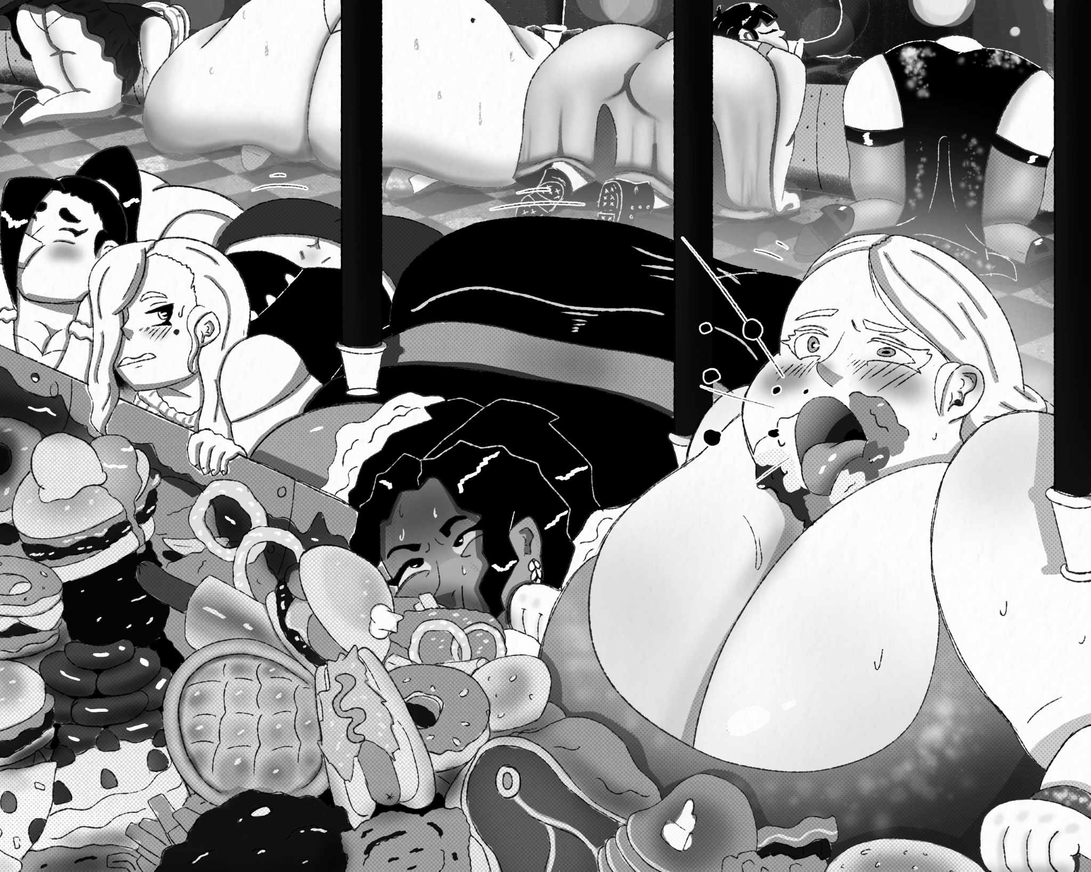
The sounds of gorging filled the air, along with the grumbles and belches of the herd of hungry heifers. Cho and Lanna walked across the rows and rows of glorious back and ass fat, helping speed up girls who fell behind in their eating, coaxing girls to take bigger bites, all the while Cho noticed the little white flecks in the food; barely noticeable if you weren't looking for them, the girls gulped the things down no problem.
“Hey Cho!” Lanna shouted from across the room. “Is it getting hot in here?” she said, in mock distress. Surprise surprise, the body heat of over 500 morbidly obese teens won out over the AC in the end, and as the girls stuffed and glutted themselves, things grew hotter.
“Hey…*BURP* stop rubbing against me you sweaty pig!” one girl shouted
“*Mhf* deal with it *Urp* just take something off lardo!” the girl next to her responded. Hot bulging bodies continued to rub and slap each other as the night went on, the girls started reaching for the hoses for drinks more and more. Cho could hear the delightful sounds of bellies sloshing with liquid as the girls swelled with drink. The Troughs made eating messy, and after an hour or two there was about as much food on the girls as in them. Eventually Cho bumped into Lanna who was in the middle of stuffing a girl who claimed to be “way too full” about half an hour ago.
“So, Lanna um…This is great and all but when does…you-know-what start?” Cho was bouncing in place in anticipation. Lanna smirked, shoving another chicken leg down her students throat.
“There really is no satisfying you is there? don't worry, you'll know when it happens” Lanna perked up as she got an idea. “Hey since the AC barely works anyway, why don't we turn up the heat a little?” Lanna grabbed a high heeled shoe off her foot and threw it like a shuriken into a nearby thermostat. Cho let out a low whistle.
“I like how you think.” Cho started to slide out of her dress, revealing lacy black lingerie.
“Wait what are you- OH MEIN!” Lanna`s eyes nearly bulged out of her head. “Oh, OH WOW, Cho I've never seen you so confident…I like” Lanna gave Cho the eyes. The student next to them spoke up.
“I don't think that's appropria-Mmf '' Cho shut her up with another chicken leg. Cho wasn't the only one losing clothes, with the AC off, the room became extremely humid, and along with eating like pigs, the girls started to sweat like ones too. This however did not seem to phase most, as the mind blowing food kept their attention locked. Dresses started ripping and splitting open, making moist pink flesh bulge out, fighting for freedom. Others didn't dress so modest, as they became more bloated and swollen, some girls were left in just their underwear. It still wasn't enough for Lanna and Cho though, as the duo went around ripping clothes off by force to get at the juicy tender flesh underneath.
“Hey my outfit!”
“Where's my blouse?”
“*UUUUURRRP*...I remembered to wear clothes today right?” Even this assault on them didn't break the fat teens attention for long, some were even relieved to let their fat breath. 3 hours or so into the night the food was about halfway done, but the girls were beginning to slow down. By this point most of the girls bellies were pressed into the ground, bulging between fattened legs, so wide that each stomach gently pressed into the two at its side. They were all covered in food, though not much else, as panties and bras were all Cho could see. Is this it? Is this all the girls could handle, even with Cho and Lannas insistent stuffing? Groans of fullness filled the air.
“Full”
“*UUUURRRP* so stuffed”
“Shtap rubbing against me, I'll pop for sure”
“*GRRROOOOOAAANN* OOOHHH!!!” suddenly one girl nearly screamed, so did her gut. She immediately dug back into the food, with more gusto than she even started with.
It's happening!
“Wow, Jenny like *urp* calm down your gonna get sick if you*GROOOOAAAN* Oh shit I'm like *GROOOOAAAN* fucking starving!” a second girl joined in, then a third, then fourth, one by one girls would clutch their stomachs in anguish then would shove their faces back into the precious food like their lives depended on it. Lanna sprang up, smiling at Cho!
“Cho! It's working better than I could have imagined! They hatched, and they're already releasing so much Ghrelin in the girls stomachs that they think they're starving! Phase 2 is underway!” Cho was looking around like a kid in a toy store, as the girls all shoved their heads directly into the piles of food not even using their hands, just submerging themselves in gluttony, trying to hide from hunger. One student saw this and looked up at Cho fearfully.
“hatched? What's she talking about? What's happening to everyone? Ms. Kim I'm scared.” the girl teared up a bit, Cho looked down at her. This girl was asking Ms. Kim for help. Of course she would, Ms. Kim would have helped her students. Ms. Kim would have put her students' well-being first. Ms. Kim was a caring and responsible adult, she would know how to help. They trusted Ms. Kim.
Cho smiled warmly, crouched down, looked the girl in the eyes and said.
“We made you eat worm eggs, now they've hatched and they're going to make you eat and eat until you're nothing but a big ball of fat, food and worms…then you'll explode.” Cho patted the girl on the belly. The girl's eyes widened.
“You're joking right? ri-*GRRROOOOOOAAAAN*” The girl's belly shook so fiercely and her fat rippled, her eyes rolled into her head, her mouth started drooling before she dunked her head in a pile of bacon. “*CHOMP* CHOMP* *GULP*” was all the noise she made now. The girl was gone, all that was left was a hungry pig.
The half naked girls now truly resembled pigs, their bodies fat, flush, and sweaty, the only thing they could even think of was filling themselves more, eating more, stuffing more, hunger was all they were now, gluttony was all they were now.
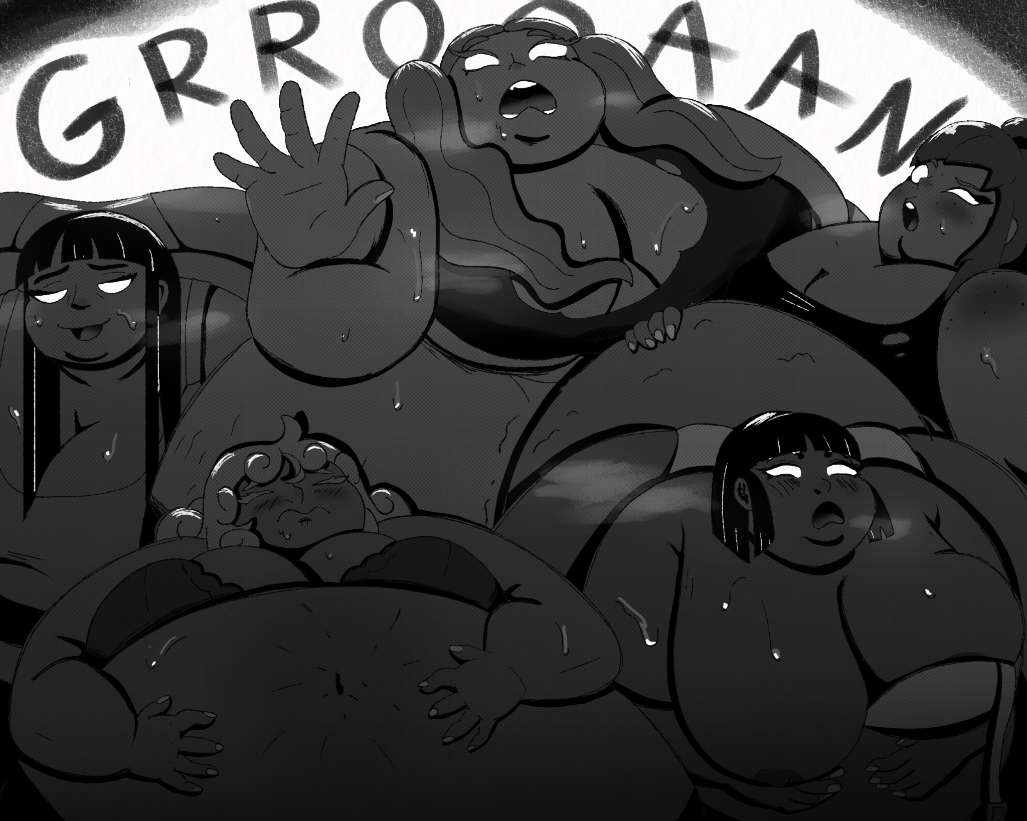
the food had started to mix and melt together in the troughs, becoming a slurry of sweet and savory. Ice cream mixed with meat and cheese, fats and oils floated to the surface, little eggs sprinkled in. Much of the chomping and chewing sounds were replaced with loud hungry gulps as the overloaded babes drank it in faster and faster, letting as much calorie packed sludge enter them as possible. Each girl's body began to grow anew, fat filled them as hunger consumed them, the flood of hunger chemicals released by the worms ate at their little minds like termites. Cho could hardly even move, as she was mesmerized by the raw gluttony on display. Lanna tapped her shoulder.
“Looks like we might not have enough.” Cho didn't know what she meant at first, but that's when she noticed that the fat slurry seemed 2/3rds of the way gone. Cho never thought in a million years that the literal metric ton of food they prepared wouldn't be enough but…there it was.
“What should we do?” Cho asked. Lanna smiled.
“I told you” she pulled out a little remote, seemingly from nowhere.
“Phase 2” she pushed the button and the tanks above the troughs seemed to hum to life. The hoses, which only produced beverages until now spewed a pink sludge into the troughs, much of it getting on the girls fat bodies.
“*gasp* Is that the stuff you fed Zoe?” Cho asked excitedly. Lanna nodded with pride.
“New and improved formula”, just as Lanna said the words, the new mixture seemed to be affecting the girls' bodies. They grunted and groaned as they all experienced sudden and severe growth spurts. That was it, any remaining undergarments had given up the ghost.
*Bang* *POP**POP**SNAP**RIIIIIP* was heard as the girls billowed up. Their swollen nakedness smushed and pressed into each other relentlessly putting undue pressure on each girl. The students were positively creaking with calories and shining with sweat, both from the heat and the ever growing fullness; well they should have been full at least. One girl raised her head to speak.
“Uuugh, what's wrong with me, I'm so full but *UUUURRRRP* Fuck why am I still hungry?” she said before she resumed glutting herself. Another girl spoke.
“Wah-wahs going on? Why is it soOOOOHHH! Hard to think? *GRUMBL* More, I WANT MORE!”
“I feel sick, *ULK* It feels like somethings wiggling inside me *GULP* *GULP*”
“OW! Mave, Stop squeezing me!” Cho noticed one of the bigger girls was almost crushing a smaller one under her growing mass.
“I can't help it, *UUUUUURRRRP* it won't stop!” Cho noted then that the bigger girl kept growing despite not eating. Lanna laughed.
“See that Cho! That's the new formula for you, even if they stop, that stuff will take days to fully digest! now grow mein piggies, fatter, FATTER! HAHAHAHA!!!” This madness went on for hours, eventually all of the eggs were inside the girls, and their hunger was truly insatiable. By the 4 hour mark they had run out of real food, and now guzzled pure weight gain formula, piling untold millions of calories on top of their inner buffets. As Cho and Lanna had their fun with the students, they started to feel what must be hundreds of the little worms wriggling inside them. By the 6 hour mark, The girls had to be hose fed. Their massive bloats had started pushing them too high off the ground to reach and so now each girl was left to simply suckle like dumb animals, each gulp accelerating their demise. The formula pushed their fat bodies toward detonation, and the worms made spitting the hoses out not even enter their fat brains.
Hour 8.
“*pant**Pant* I can't believe they're all still in one piece” Cho said, nestled between two bean bag breasts and a car sized ass..
“*Gulp* I know, even I didn't foresee their bodies being able to withstand this kind of bloating” Lanna replied, downing a bottle of water. The girls…were not ok. They had been pumping themselves with the calorie dense mix, for over 8 hours straight and now they all barely looked human. The girls of San Graso had been inflating with lard until they were nothing but a pile of big fleshy water balloons. They had lost most of their definition, all rolls and cellulite filled and expanded and rounded until they were all just giant bellies, boobs, and asses; smooth, shiny and tight.
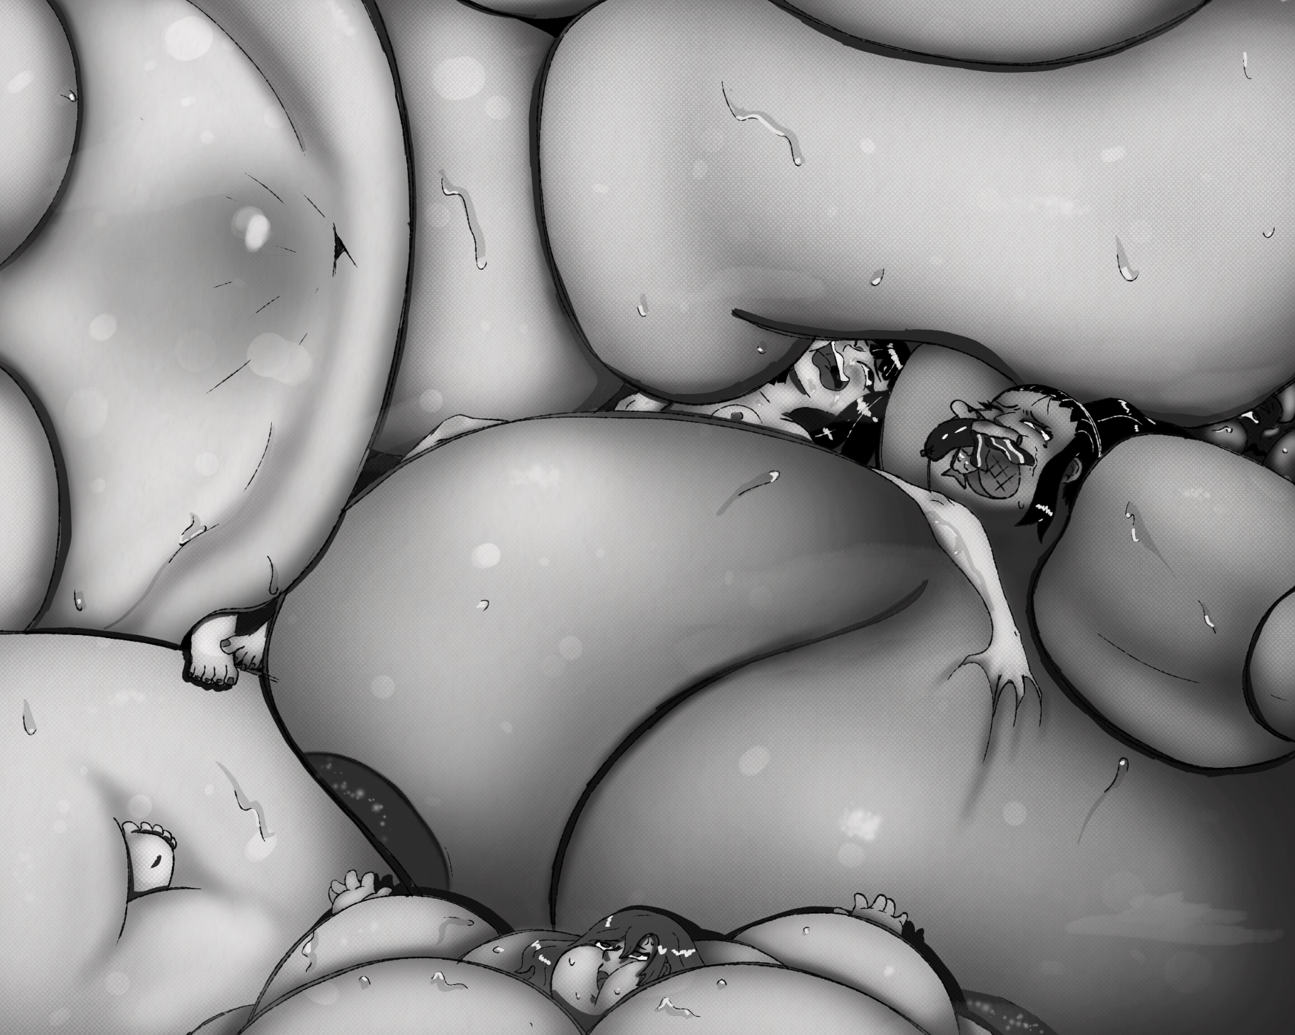
They all were also incredibly unstable. Their bodies were all a shade of pink or red, purple stretch marks lining their planetoid swells. blue veins could be seen throbbing painfully underneath, the girls had all stretched to the point where their skin was almost translucent, and Cho could swear she could see the vague shapes of internal organs rumbling in distress. Cho had been swimming amongst the sea of fat the students had become and while it was super fun the first 8 hours, she was still waiting for the main event.
“AAAAHHHHH! DON'T SQUEEZE ME!!!” a girl shrieked in agony, clearly too full to handle her light touch. Cho slid from the quivering pulsing girls to look for more to feed them; then scowled in frustration at all the empty tanks and troughs.
“Please no more!!!” one girl pleaded.
“It feels like I'm coming apart,” another added.
“Buh! I just felt something move in my guts!”. Cho could tell that the girls were doomed, there was no coming back from the state they were in, not to mention most were still feeling the effects of the weight gain formula and were still growing. Though it had slowed to an agonizing crawl; It was almost 5:00 AM and teachers who stayed home would be arriving soon.
“I swear to God if I get blue balled tonight” Cho swore.
“Well, I guess I have no choice,” Lanna said, pulling a duffle bag from under the stage.
“What's that?” Cho asked, a bit of excitement seeping into her voice again. Lanna tossed her a spray can and said.
“Worm repellent. trust me, you’ll need it for what comes next” Lanna pulled out a second can, and sprayed herself down, Cho did the same.
“Well, don't leave me in suspense.”
Lanna smirked, and pulled out a vial, inside was one of the worms, but this one was about 5 times the size.
“while this wasn't my intention, I figure this will be a good time to test the effects of the stomach worm queen on a human host”. Cho liked where this was going. “You see Cho, the worms not only incubate inside the stomach, but they breed there as well. Once a queen is introduced into a suitable environment, well…would you like to find out?” Lanna asked.
“Oh I always love helping you with lab” Cho said sweetly. Lanna handed her the vial.
“Simply place the queen near an orifice of the host and she’ll find her way inside.”
Cho held the vial with shaky hands. Out of all the fucked up things they did tonight this was just…MmMm! Cho looked around the room. That's when her eyes landed on one girl.
Perfect.
Amy McDonald was next to the 3 largest girls in all of SanGraso; Gabby Mendoza, from her first period, Lauren Fleece, from her third period, and Debra McTaggart, from Butters first period. Amy sat upright, most of her mass was in her lower half and belly, so she couldn't even lay down. Her arms were stuck out useless, bloated to the point she couldn't even bend them. Her feet were nearly swallowed by enormous haunches that had rounded out and fused her thighs, calves, and buttocks into a single round swell. She was actually the smallest of the 4 titanic teens, but Cho thought it appropriate that the first girl she met at San Graso…be first.
“Aaaaaamyyyy”, Cho called. Amy's eyes widened, and she looked at Cho with fear.
“Ms.Kim, I can't take anywmore, I think *GLORP* I need to go to the hospital *UUUURRRP* I ate shooooo much!” The other three girls joined in.
“It feels like somethings moving inside us” Cried Gabby
“It feels like we’re still getting bigger” moaned Lauren.
“Why are we still hungwy?” asked Debra. Cho ignored the cries of her students, just focusing on amy. She stroked the poor things belly, eliciting a pained whine from Amy. The girl was definitely still growing, still packing away more calories with no end in sight, but this was taking too long. Cho undid the cork on the vial, and dumped the worm queen on her belly, immediately it started inching its way toward her mouth.
“Ew! What duh? What is MHF!” the worm tried to slide into her mouth, but Amy shut her lips just in time. This was Chos favorite part. Making a girl pop herself.
She gently started rubbing the girl's sweaty, growing bulk, causing her whole massive body to shiver at Chos touch.
“*Sigh* ok, you don't have to eat it, I can just rub your belly until it feels better”. And so, she did, for a while Cho just sat there, gently rubbing Amys, throbbing, rumbling body. Before Amy's belly, gurgled hungrily.
In a display of gluttony that abandoned any thought of self preservation, Amy sucked the worm in her mouth like it was spaghetti; and swallowed.
For a long moment nothing happened, the sounds of girls' bodies whining and gurgling went on uninterrupted, and then.
“Ugh…hey guys…*GURGLE* somthings wrong” Amy said, looking worriedly at her gut. Gabby responded drunkenly.
“I know, I don't know if I'll last the rest of the night*urp*”. Amy shook her head, her wide face growing more afraid.
“No, I mean inside ME. something's OOOOOOHHH! It feels like AH! LIKE I'M FILLING UP!” Cho got a truly demonic smile.

As the words left her mouth, her growth accelerated rapidly, causing her to scream. Her inside started to writhe and wiggle, the queen seemed to be rabidly making new worms, and the new worms began filling Amy like a horrific balloon. First her stomach grew, but then the worms started invading her whole body, they made their way into her ass, her legs, her arms, her breasts, every part of her being was being violated by a whole population!
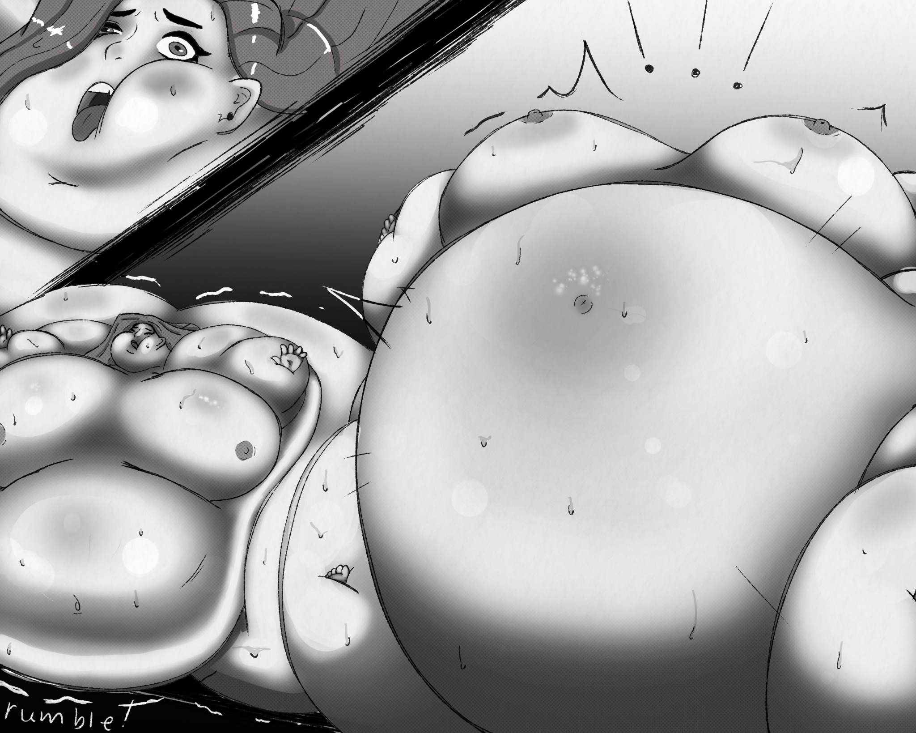
“I can't stop growing! OOOOH GOD STOP MAKE IT STOP MAKE IT…w-what the OOOOOOH!” Just then the girl's face went from fear, to contorting in pleasure, as worms suddenly shot out her vulva, then her ass, then her mouth, even her breasts started leaking the things; it was clear the worms had brought her to climax. Cho backed up, drinking in the sight.
Guess they ran out of room
*KABOOM!*
Amy went everywhere, the fat within her flew through the air and landed in big piles of jelly. Cho was knocked to the ground, and started cumming herself, the sheer absurd hotness of the night finally driving her over the edge. But it wasn't over, as the worms that had filled Amy were now looking for a new host. Lanna screamed in mad delight.
“Look at them Cho! The queen made millions of babies in mere moments, now they will spread, now they will spread to new hosts and breed new queens as well! OH CHO ITS BEAUTIFUL!” the mad scientist screamed in ecstasy. The new queens all quickly found new hosts, taking thousands of worms with them, screams of panic started to fill the cafeteria, as girls were violated and invaded from every angle, mouth, ass, slit, nipples, even belly buttons weren't safe. Moans of agony and ecstasy came from the behemoth girl's mouths as they were rendered not but enormous wombs, planets for the alien forces to ravage. All the girls grew and swelled, before.
*POP*
*BANG*
*SPLOOSH!*
One by one, girls met their demise, swelling and popping like bubbles.
“NO MORE!” *POP*
“IT'S TOO MUCH!” *POP*
“I'M CUMMING!” *POP*
“YESH ME NEXT!”*BOOM*
Cho was a twitching mess on the floor, after each girl exploded she would cum, her body being assaulted by orgasm as the students were being assaulted by worms. After each explosion, the worms from the last girl would be added to all the others, leading to even faster detonation. Only the largest girls were left now, some brushing against the rafters before *BANG* Eventually only the 3 biggest girls were left. Gabby, Lauren, and Debra. They filled the whole cafeteria, Cho had to move to avoid getting crushed, and as her mind reeled at their size, she felt another orgasm cumming on. “This is to much, I'm gonna go crazy, this is just soooo *NGH* SOOOO GOOOOOD!” as another orgasm hit her.
Gabby was being crushed by the two larger girls, and she belched uncontrollably.
“*UUUUUURRRRRP* FUCK *UUUUUUUURRRRRP* DEBRA! *UUUUUUUUURRRRRRP* LAUREN UUUURRRRAAAAAAAP SHTAAAAAAP SQUEEEZING ME-*KABOOOOM*!!!” Gabby went, a huge gust of wind came with her explosion however. God that girl was gassy. Lauren and Debra were left neck in neck as Gabby's worms added to their own mass, at this point even identifying them as human was difficult. They were two perfect spheres, with massive hills as breasts. Their fingertips poked out from their all consuming incubator bodies.
“OOOHHH DEBRA! We can't get any bigger we have to…have to…OHHHHH!!!” Laura started to cum, all her resistence gone in a moment. “DEBY I wanna get bigger! I neva want it to end! The pain is sho good? Lets grow together! GET BWIGGER FOR EVA GWOW BWIGGER THAN DA SCHOOL BWIGGER THAN DA WORLD AAAAAHHH!!! *KAAAAAABOOOOOOOOM*!!!” a geyser of worms burst out her fupa, before her whole form blew up.
Seems she lost her mind in the end…I don't blame her.
As all the worms from all the girls from all of San Graso entered Debra, she didn't say a thing, after all, her head had been completely engulfed by her body. Her breasts were mountains of meat the size of entire other students. Kim held herself and squealed in delight. Lanna continued laughing at her creation.
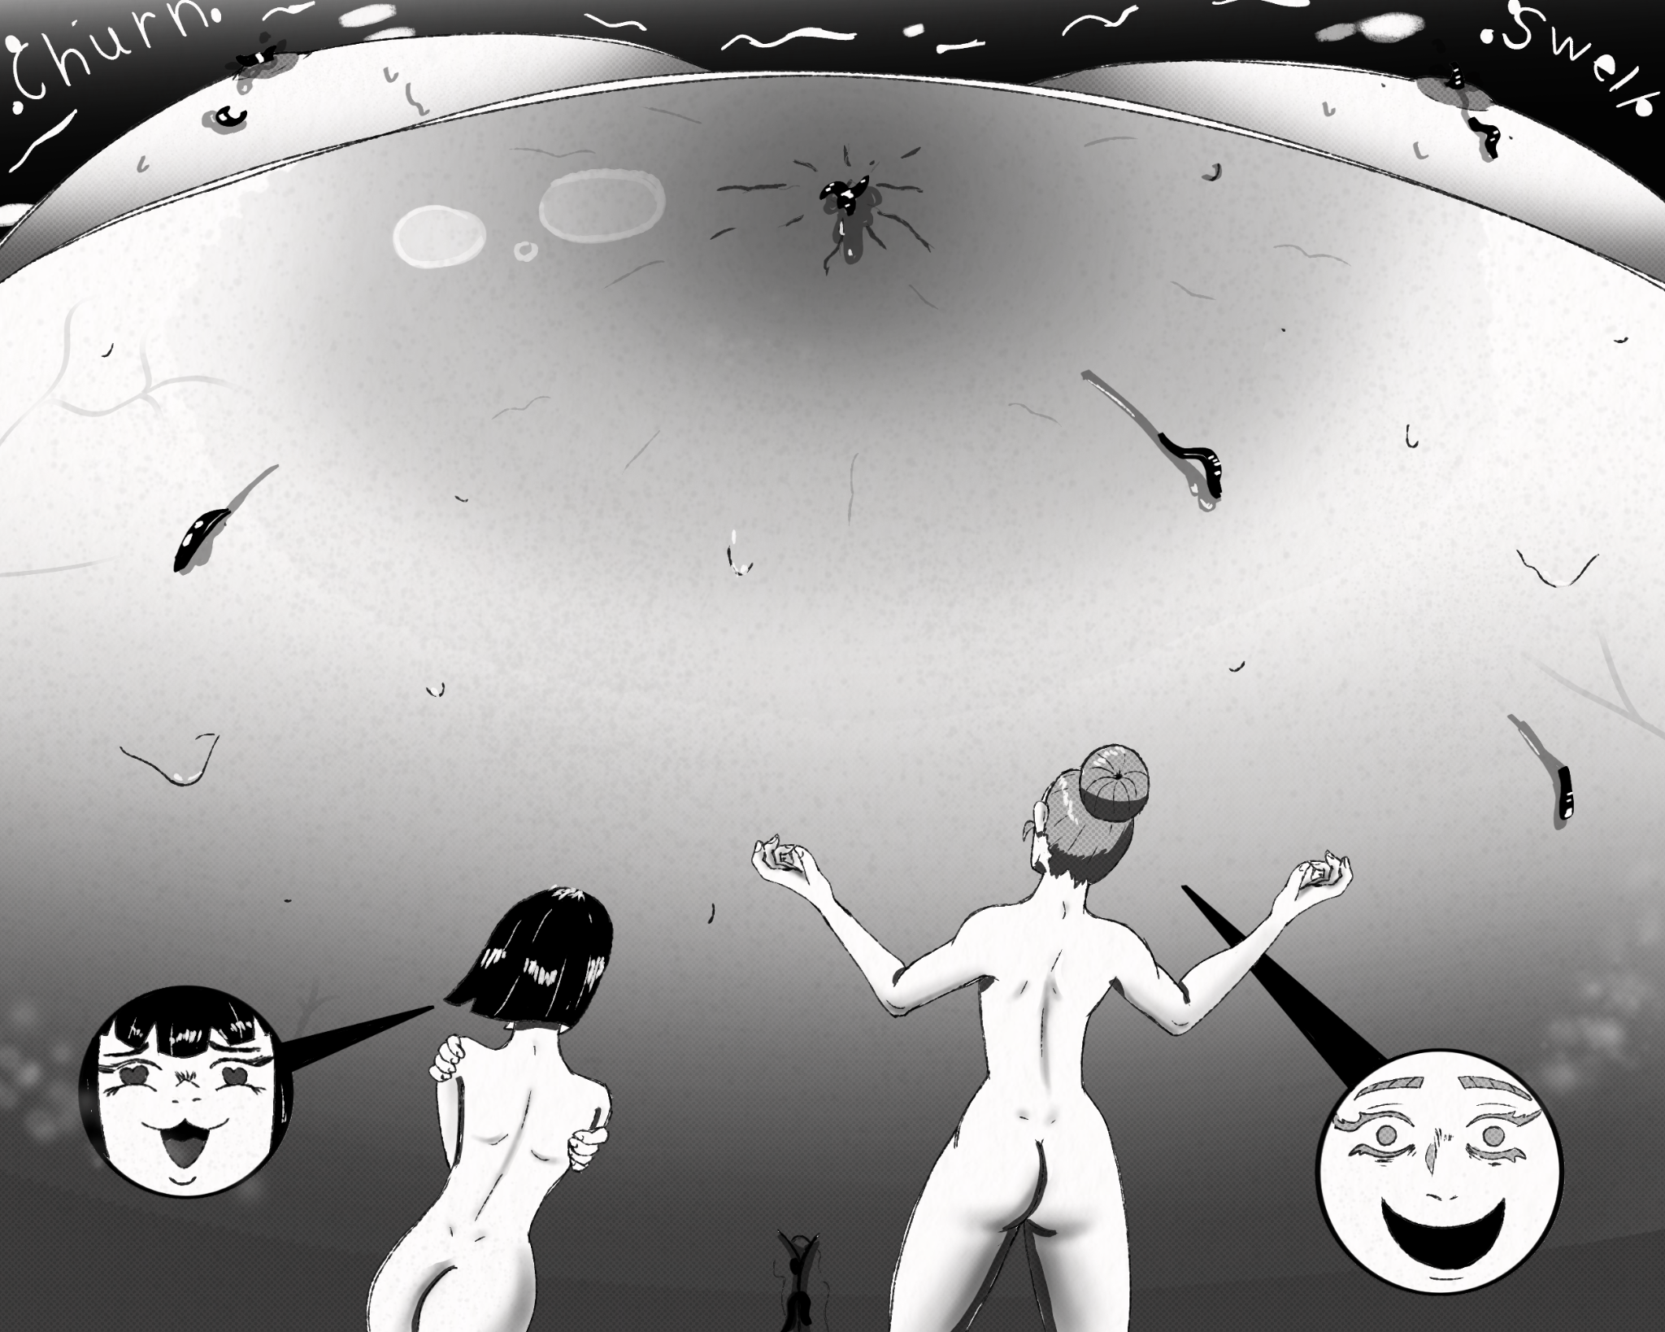
“I wonder if she's still in there, or maybe the worms destroyed her mind already? I hope not, I hope she feels every moment of this, I hope she knows she’ll never be human again! I HOPE SHE KNOWS SHE'S JUST A SEXUAL OBJECT FOR US LANNA!!!” Cho wailed, in rapture.
Debra was a vast sea of blimping girl meat. She started to rumble, worms burst from her nipples, her ass, her slit, her belly button. Even as worms started leaking out of her over stretched pores, the heavyweight champion of San Graso seemed intent on staying in one piece.
“JUST POP ALREADY YOU FUCKING TEASE!!!” said Lanna, as she kicked Debra in the side, detonating her.
*BOOOOOOOOOOOOOOOOOOOOOOOOOOOOOOOOOOOOOOOOOOOOOOOOOM*
…
Cho had blacked out for who knows how long before Lanna woke her up.
“Come on Cho, wake up it's almost five.” Cho felt dizzy as Lanna helped her up. She could see the first hints of sunrise through the-now blown out windows. It seems Debra’s blast had knocked everything away in the shockwave, because the cafeteria was fucked. Lanna was dragging Cho to the door by her arm, clearly not having the time for Cho’s delirium.
“Come on Cho seriously, teachers could be on us any-”
“I love you”...
The words just came out of Cho, a hint of fear in them. Lanna went slack jawed, her face beat red.
“This…this was the most fun night of my life…a-and it was all thanks to you…I never met anyone like you Lanna I…I never want to be away from you!” the words were all tumbling out now. “You're perfect, your brilliant and fun and your just as fucked up as me!'' The little woman was positively shaking now as she laid her soul bare. "You're the only person I've ever truly related to Lanna! You're an insane, immoral, homicidal, megalomaniacal, perverted nutcase and I love it! I want us to do this forever, I don't care if they catch us as long as I'm with you. I LOVE YOU LANNA!” she said, like she was confessing to her high school crush; which in a way she was.
“Cho,” Lanna breathed, her voice shaky. “S-so it's not one sided? You really *sniff* you feel the same way I do?” Cho shook her head vigorously. Lanna just stood for a moment, she opened her mouth, shut it, opened it, let out a little noise. She couldn't even speak, The pure elation she felt at Chos words made her throat clench. For a second Cho thought Lanna was going to throw up, but eventually she collected herself and said.
“Not here, *SNIFF* we need to get to safety first” Lanna said.
The two ran out to the parking lot, both got in Lannas van still naked; they weren't sure where their clothes were. They sped out the front gate, about to start their new lives together before.
“Oh shit Stacy!” The Van stopped as Lanna remembered the last step of the plan. “Cho sweetie, hand me the remote in the glove box”. She did, and handed it to Lanna. “I almost forgot her reward, she pushed the button and the whole school exploded in a great fireball, as the living bomb that Lanna had made Stacy into went off, destroying the school, the remaining faculty, and all evidence they were here.
“Mmfh” Lanna looked at Cho, who just jerked and let out a strained little sound. Both women looked shocked.
“Did you just cum?” Lanna asked. Cho blushed.
“Mhm.”
“...so is it all explosions now or…?” Cho put her face in her hands, turning beet red.
…
3 years later
The two sat in their underwear on a couch, in some dark apartment, in some distant city. They were watching the news; they were on it.
“These strings of Serial burstings are still under investigation, though no new suspects have been identified,” the news anchor said.
“Ooh she's cute, wanna pop her?” Lanna asked.
“Who, the news anchor? That would be pretty funny” Cho replied.
“Mmmmf” said the couch.
“Schweigsam, couches dont talk!” Lanna slapped the morbidly obese woman that the two sat on; almost a couch.
“Honestly we’ve burst, how many girls this month; five?” Cho shifted to her stomach looking at Lanna with a bored expression. Lanna raised an eyebrow.
“What? Getting burnt out?”
“No, it's just” Chos expression went from bored to pouty. “Valentine's day is coming up and…I don't want other girls around, I just want you.”
“O-oh” Lanna blushed; Cho had gotten dangerously good at that lately, she was a far cantor from the shy timid little thing she had been all those years ago.
“So *Gulp* what did you have in mind?” asked Lanna. Cho pounced on Lanna like a cat, making the couch ripple and groan.
“I think for the next week you are going to stay in this apartment and fuck the shit out of my tight little asian body, OH and CUDDLING I demand CUDDLING!” Cho said. Lanna's dopy looking grin made its way on Lannas face, as she gazed at her fiance.
“Alright schnucki, just you and-”
“MMMFH” said the fat woman.
“COUCHES DONT TALK!!!” Cho and Lanna said in unison, before fucking on the couch all night long.
