Hair Model  Inspired by a Captioned Image by Think Pink  (https://www.deviantart.com/think-pink1)  By Maryanne Peters  He came in through the skylight. The bank next door would not have a skylight, but he did not pace it out. Then he managed to get tangled up in the wiring. He took an electric shock when he struggled, so he just hung there until I came back to check the power surge. The poor boy was terrified that he would electrocuted if he moved. He must have been the worst burglar in the world.  I should have been mad, but I just took photos of the hapless criminal. It would be a great story and the police would laugh about it too. I was ready to call them, even though nothing was missing, and the damage was minimal.  He said: “I would never survive jail!” and I believed him. He was small and weak, and “a pretty boy”. He would quickly become the plaything of some prison brute, and I told him as much.  “I can repay you, or surely I can make it up to you somehow,” he said.  “What would I do with a boy. This is a beauty parlor. Not to mention that I would have to doubt you competence to do anything if this in any indication of your skills. Big brown eyes and a mop of good hair might be enough for you to get by as a girl in the world, but they don’t do much for a young man.” | 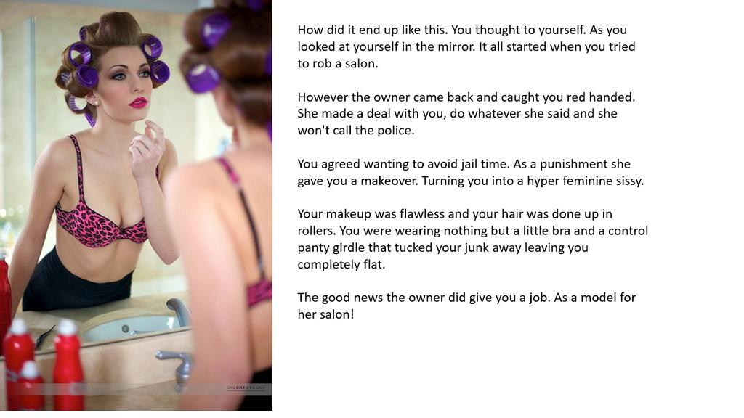

It seemed like those words suddenly made sense to both of us.

“Let’s just get that hair of your washed and properly conditioned,” I said. “Maybe … just maybe, we can find something for you to do around here, and give you the chance to stay out of jail.”

He had been caught up in a web of wiring, like some hapless bug, but now he found himself in a new web – the silken web of femininity. He could struggle or he could relish that soft silk. Anything was better than facing the consequences of his crime.

That was over a year ago now. To look at him now you would never guess how it all started. The hormones have done their work, and while the boy was far too clumsy to be allowed to use a pair of scissors, he proved very competent with makeup, and practices on his own face constantly. He started out as a hair model, and is still happy to show off the pretty hairstyles I have him wear each day, but now he does facials and makeovers as well. There is no need to resort to crime when you look that good.

The End.

Selling Cars  Inspired by a captioned image by SilversTG  By Maryanne Peters  Sex sells and sex sells cars really well. I don’t have to spell it out. Guys buy prestige cars. Guys like sexy women. Hell, many of them buy their cars to pick up women. So women sell cars. I don’t have to spell it out, but I just did.  “Oh, I would really go for a guy who drove a car like this one. And the sound of the engine! Put you foot down – soooo sexy.”  The right kind of women can get the buyer excited, but women are no great closers. I don’t mean to sound sexist or anything, but the reel them in with talk like that, but don’t get them in the boat. It can be frustrating.  I am a career salesman. It is what I do. My Mom tells me I was born to the job. I was selling her stories from the moment I could talk.  But the first thing about selling is to know your limitations. Don’t make a representation unless you know what you are talking about. Don’t try selling to somebody who would rather buy from a colleague.  It was just that I saw buyers walk with a salesgirl’s phone number in their pocket, and even if the guy stayed and I made a sale, I had to share my commission with some bimbo. | 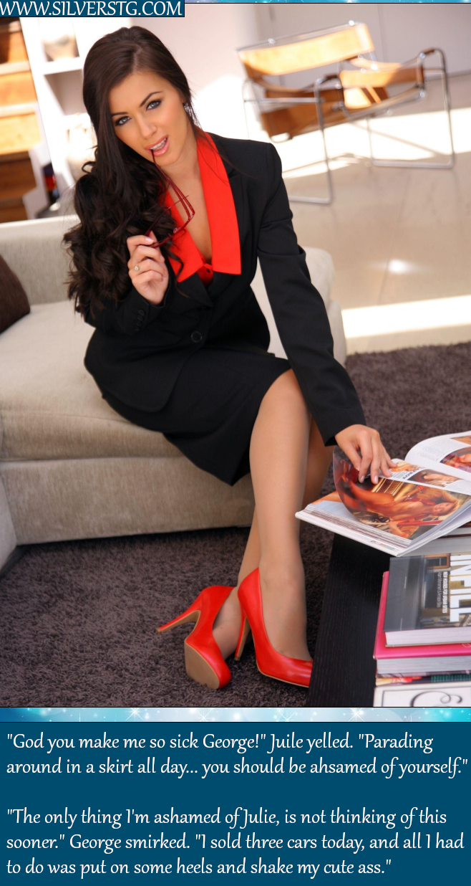

“Maybe you should wear the short skirt,” one of them said. “I have seen your legs and they are pretty good for a guy.”

I just sneered at her. But it did get me thinking. I had the skills they didn’t have and most of all I was motivated to make sales – lots of them. I just did not have the gender. That is what they call it these days – gender. People talk about changing it from day to day.

“Hey, today I feel like a chick, so I am putting a dress on.”

Is it really that simple? Anyway, I decided to pay a visit to the transformation boutique.

“You could easily pass,” the woman said. “You have fine features and good bone structure. You have a good head of hair and you are of slight build – not too tall to wear heels. And you have beautiful blue eyes, they just need to be revealed with the right eyeliner.”

I thought: ‘What the heck. I am here. Why not?” So I took the makeover.

That was last year. August. I have ditched the wig. It was uncomfortable. The extensions are better – it is just that it takes effort to look after hair this long. But it pays off when you swing it around in front of a guy, or let it fall in his face when you are showing him the dashboard.

I am making big money. Both the salesgirls have moved on. I rule the roost now.

Is there a downside? Well my girlfriend Julie has always been saying that I took this way to far, so last week she finally walked out. She never liked me flaunting my body to sell product, or maybe she just didn’t like the body? I have better legs than her, that is for sure. And now bigger breasts.

Or maybe it was the way sex fell off when I started taking hormones?

Whatever. Everything else is going great. If I want an evening out I am never short of an invitation, and now I don’t even pay.

I’m selling cars.

The End

A New Career  Inspired by a cap from Anne Michelle’s World  By Maryanne Peters  The headline sounds a bit drastic, but of course there was a story behind it.  The truth is that some of my earliest memories were imagining myself strutting the catwalk in a dress, with long hair bouncing around my shoulders. I used to like to watch Fashion TV almost as much as I liked watching baseball. I loved both. It was just that my father had expectations of me.  When you are a boy what you fear most is disappointing your father, especially if you admire him the way I did. I always thought of him as the kind of father most boys dream they could have. He was good looking, strong, forceful with others, but gentle and kind in his family life. I adored him.  And I did love baseball, just as much as he did. He coached me well, because he had played to a high level. I became good at it, and that increased my passion for the game. We both hoped that I would go far.  It was a right shoulder injury. I should have recovered from it, quite quickly, but there was some medical misadventure involved. | 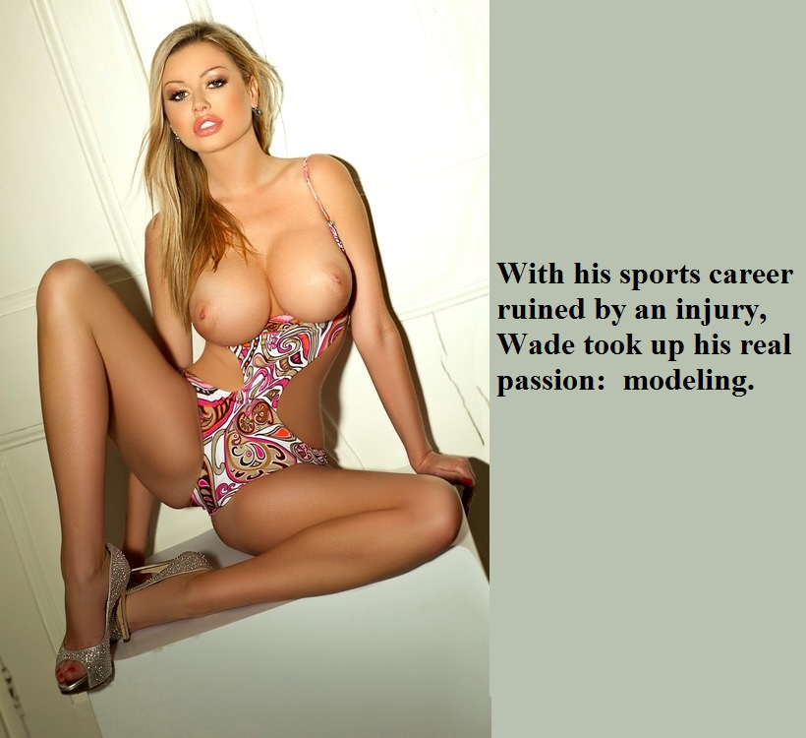

I pitched ball right-handed, so without a good shoulder that was over. I taught myself to bat left-handed, which has some advantages, but you still need to throw a ball in the field. It was obvious that my baseball career was over, just as my time at high school was coming to an end.

I sued the hospital. My case was based on my losing my career in pro-ball, which looked like a certainty before the injury. The hospital agree to a pay out, and it was a big one.

“It is your money, Son,” my father said. “It is up to you to choose a new career – a new future. This money will pay for it. You choose something. What else do you feel passionate about? We had hopes for a life in professional sport, but whatever you choose, I will back you.”

I said – “Really Dad? Any career I choose? Because there is a career that I have been even more passionate about than baseball, but it will require major changes.”

“Anything at all, Son.”

So, the money bought the body that you see before you. I have to say that the breasts are a little over spec for fashion modelling, but they are what I have always wanted. But get plenty of work in the lingerie and swimwear areas, and when I am asked to pop them out.

Of course, my father was shocked by my choice, but he was true to his promise, and to his goodness as a parent.

He is fully supportive of my new career.

The End
Dressing her Hair
Inspired by a Cap Image by SpottyCat44
By Maryanne Peters

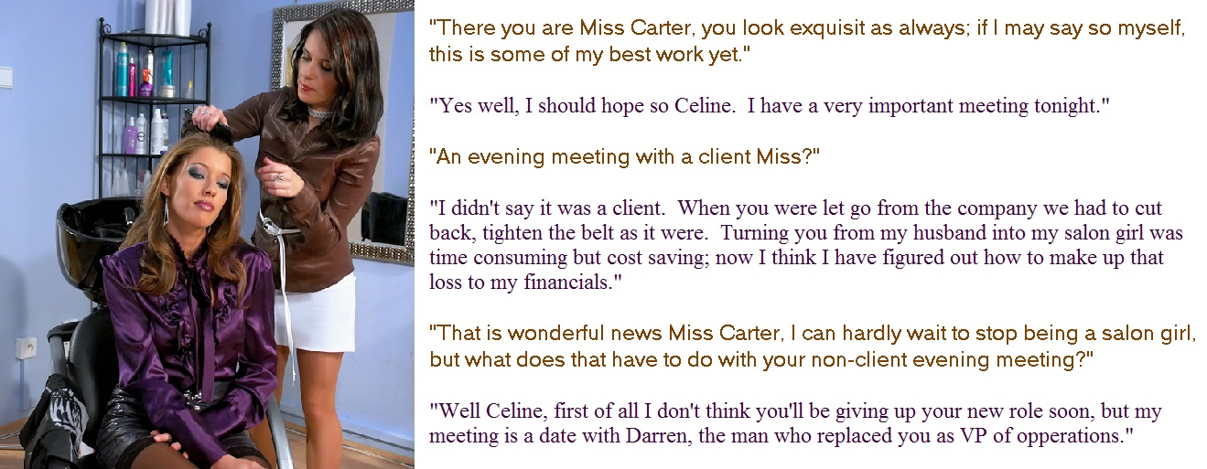

When I married Madeleine Carter, I thought that I was the luckiest man alive. It was not so much love as worship. She seemed like a goddess to me. She was beautiful, rich, and successful – a powerful woman in every way. It never mattered to ne that she had been born a man.

She was bigger than me, sure, and with heavier features, I guess. From the moment we married she was always saying to me that I would make a prettier woman than she did. I never thought so. To me she was just stunning, and most of all she had that beautiful hair.

I have to say that I have always had a thing for hair. I don’t think that is such a weird thing for a guy. I loved to brush her hair. If we showered or bathed together, I loved to wash it for her.

“I like my hair long, but it is high maintenance,” she said. “Maybe you should be my live-in hairdresser in addition to your other chores?”

I had become the house husband not by choice. I was laid off when the small bank I worked went bust and I ended up doing everything around the house including taking extra pride in making her restaurant quality meals.

“Why not,” I said. “I love playing with your hair”.

So she set a little salon in one of our many spare rooms. It had a styling chair, mirror, wash station, shelves for products and all of the equipment we would need.

I loved getting her ready for work every morning and then doing her hair at night for when we went out.

I never thought about growing my own hair before, but now without a job and with our own home salon I could not help but try to do something with my own hair.

I am not sure when Madeleine lost interest in me as her sexual partner – the person she described as being “VP of Operations”. I think it came before I started taking her hormones, but it was certainly confirmed when they affected my erections. Whatever! Estrogen is just so good for the quality of your hair.
She said the if I could not share her bed then I could only serve her as salon girl. I was happy so long as I served her, and so long as I could do her hair.

But I new things were changing when she started calling me Celine and insisting that I address her as “Miss Carter”. It was only a short time after that when she brought Darren home to share her bed and I was slept in another room.

I continued to do her hair, and I felt privileged to be able to do it, but I felt depressed that I had lost a deeper relationship with Madeleine. I suppose that I am just one of those people who needs a strong person in their life, telling me what to do and rewarding me for doing it well.

But Madeleine has so little time. Work comes first. She is always busy.

I would be lonely, but Darren and I have struck up a friendship which makes time alone at home bearable.

Darren says Madeleine was right, I do make a prettier woman than she is. What do you think? Even if my penis makes my white skirt tent a little.

The End

The Value of a Good Secretary  Inspired by a Caption by Amy Harris  By Maryanne Peters  It really was Tim’s business. I had just a small stake – less than 20%. I worked in the backroom. He was the face of the business. He was the expert. He won the contracts and made sure they were followed through. He was that kind of person. I had always admired him … no, more than that – I worshipped him.  I just kept the score. He needed somebody who could, but he asked me. He could have hired anybody to do it, but he asked me. Maybe because he knew that I had the skills. Or maybe because he knew that his success was what I wanted. It’s a strong motive.  I always said that I wanted to do more, and I did. But little guys like me can never be at the front of a business like this – It would make things look bad.  “What I need is a secretary,” Tim said. “Actually, more than that – kind of a personal assistant who could be with me taking notes and getting me what I need.” | 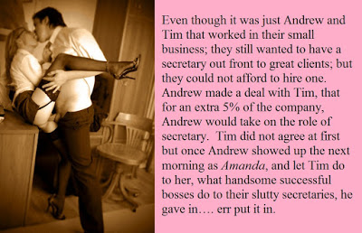
It sounded to me like a dream job.

“Female of course. Pretty but clever. Loyal.”

“Everybody wants that kind of secretary, so they don’t come cheap,” I explained. “At the moment we simply cannot afford it.” It was not entirely true, but I just did not want anybody else around, not the least somebody who might turn his head. From the job in hand that is. “Lord knows if I could don a skirt and heels and do the job for both of us, I would.”

“Really?” he said. He sounded interested.
I suppose any normal man who heard those words and saw the quizzical almost expectant look on his face would have laughed and turned away, but I didn’t do that.

“I suppose I could give it a try,” I said to him. Then, realizing that I was taking on something very strange for too easily, I added – “For an extra 5% of the company.”

“I tell you what Andy,” he said with a disbelieving smile. “If you can be the personal assistant that I am looking for then you can have that 5%.” My guess was that he did not think that I would be able to meet his idea of the person he wanted, but I wanted the 5%, and I wanted something else as well.

I told him that I was taking the afternoon off. It was mainly to get ready, but also because it just felt weird staying there having made a deal like that. I was determined that I was going to make the right impression, and not allow Tim to back out.

I arranged to go to one of those transformation boutiques. I told them the whole story and they agreed to work on me then and there and have me back early in the morning to finalize the look.

“But from now on you are going to be Amanda,” said the lady in charge. “You are going to live and breathe as a woman this afternoon and tonight, go to bed as a woman and wake up a woman, and then after we have finished with you, make this man of yours believe that you are a woman.”

She got me started on “developing a feminine voice” and then the face and body waxing was next, as that would need time for an inflamed skin to settle. Then came the breast forms, stuck on with glue and with the edges rendered invisible using foundation, and the hair extensions.

“From now on you must live with boobs and hair,” she said to me. “And we are going to tuck you too. We are going to use surgical glue to remodel your genitals temporarily. But be warned, an erection will be agony, so we will give you something for that.”

She was right, if you want to learn that being a woman is very different from being a man, try doing things with breasts on your chest; try only being able to piss sitting down, try constantly pushing hair out of your eyes or from your mouth.

I took the two ladies from the boutique out for a meal – just three women together. It was a great learning experience. We were approached by men more than once, but we declined.

“Just remember that with what you have there can be no sex other than anal sex,” they explained. “Tell them it is your period. Have you had anal sex before? Do you know how to prepare? It is always good to be ready. Preparation is the key. Without it things can get painful.

It just seemed like a nice way to finish the evening. A threesome of a sort, but with the only being penetrated being me.

In the morning they did the makeup and presented me with the feminine eyeglasses which capped off the look. What with the short skirt, black stockings and high heels it was definitely the slutty secretary look, but the blouse was sensible. The bra beneath was see-through lace in scarlet red.

“Open your blouse and he will go crazy,” was the suggestion.

I sauntered into the office and sat at the end of his desk, with his diary open in my lap and a list of appointments for him to prepare for.

“Andy, is that you?” he said.

“Amanda.” I purred the correction in my practiced way. “Your sexy secretary and personal assistant ready to attend to your every whim.”

The crazy thing was that I could see his pants and I knew what was going on inside them. I was thrilled by that. Like I said, I worshipped Tim, in my own way. To be desired by him in a way that his body was displaying to me, was gratifying to say the least.

“Save that for later, Boss,” I said, pointing my pen at his crotch. “Let me see, you have a gap around three. It so happens I do to. I have a gap, that is. A gap to be filled, if you know what I mean.” I looked at him over my glasses and batted my false eyelashes.

He filled my gap alright – at 3:00 and 3:20 and 4:00.

I made sure I was available to him. I always do. That is the value of a good secretary.

The End

© Maryanne Peters 2022

