Moving in with Kevin  Inspired by this captioned image by  TGForcedFemCaptions on DeviantArt  By Maryanne Peters  People say that mind control is a thing, but I am not so sure l believe that. All that stuff about brainwashing through mind altering potions or brain-warping sounds. It is not so much that I don’t believe in the science, it is just that I cannot believe that my Kevin would do that.  It was just that one day, after riding with him to work everyday and sitting beside him in the passenger seat, and watch his strong arms holding the wheel, I just found myself thinking how nice it would be if I was a wife, and my husband was driving me somewhere – out to dinner or a show or something. I started to look down and think what it would like to be wearing a dress instead of these pants, and what it would be like to have a pussy instead of this other tackle crowding my crotch.  Not the weird music. That would have affected him too – right?  Did I pass out? Maybe I did. Maybe I tasted sick in my mouth because of it. Ok, so I cannot remember having thoughts like that before, but for some people it is just about realizing that something is wrong – I was not really meant to be a guy. For some it comes later in life - right?  I told him what I wanted to do and he was accepting of me. I think that is where the feelings came from. You suddenly realize that your life is all wrong, and there is one guy standing with you. | 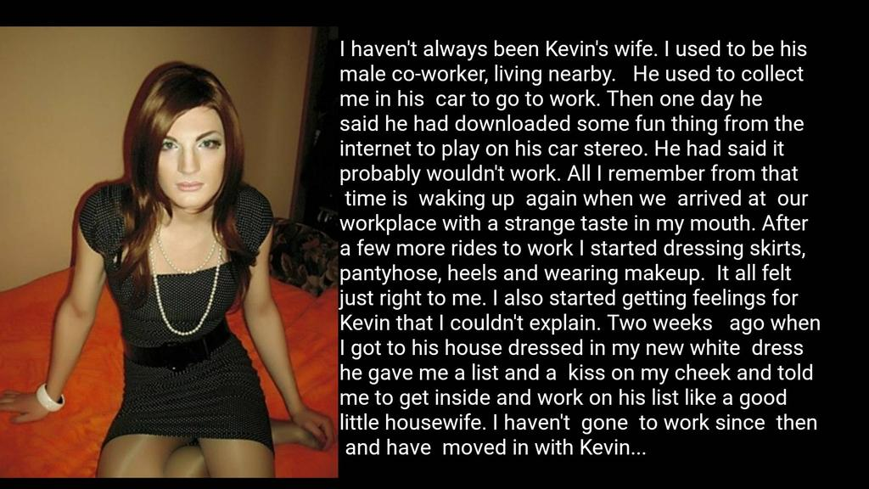

“You have to be who you have to be, Babe,” he said. He called me “Babe”, as if I was a real girl – maybe even his girlfriend. I could not explain it at the time, but now I think that I can. He was there for me. He said that I made a great looking woman. I needed to hear that. I ached to hear that.

He told me that he is the kind of guy who just can’t function without a woman at home.

“But no woman will every understand me,” he complained. “Except maybe you. You have been a guy. You know all about it. You know what a guy really needs.”

“Like a clean house, food on the table, beer in the fridge, a warm bed and sex on demand.” That was what I said. He just smiled. He asked me to come around.

I wore my white dress. White is the color of purity. It was like I was a virgin or a bride, preseting herself to a man. I was ready to commit myself to making him happy. Women do, you know. It is not like they are brainwashed. They just want to make their special somebody happy. It is their choice. It was my choice. I wanted to be his housewife.

But if you are going to be a woman and be a proper woman to your man, you need to be attractive. Not just to him, but you need to make him proud when you cling tightly to his arm as you walk down the street, or when you sit beside him in that passenger seat dreaming of the day when he can get inside that new pussy that he bought for you.

It is not mind control if it what you want.

The End’

Perfection  Based on a TG Forced Fem captioned image  By Maryanne Peters  I don’t to be gay, but if my relationship with Kitty makes me gay, the so be it. I still think of myself as being the very opposite of a gay man. I am attracted to women. It is just that I cannot find any woman who is woman enough for me.  Some girls may accuse me of being old-fashioned or even sexist, but I like a woman to be feminine. I like her to be concerned about her appearance and concerned about my comfort and my feelings. In return I want to meet her needs, and be concerned about her comfort and her feelings. To me that is a proper relationship between a man and a woman.  There are people who would call this view sexist, or male dominant, or they may even claim that it is built on stereotypes that no longer apply. Sex is no longer binary. There are infinite shades between male and female. It is a spectrum.  Well, if it is then I am infrared and Kitty is ultraviolet. And that’s the way I like it. Okay, so Kitty has a penis, which I guess takes her through orange to red, but we are going to fix that.  It all came about because I was complaining to my buddy Kevin about just this thing. I was saying that my search for the perfect woman seemed like an endless quest.  “You deserve the perfect woman”, he said to me. “If I could make her for you right here, right now, I would”. | 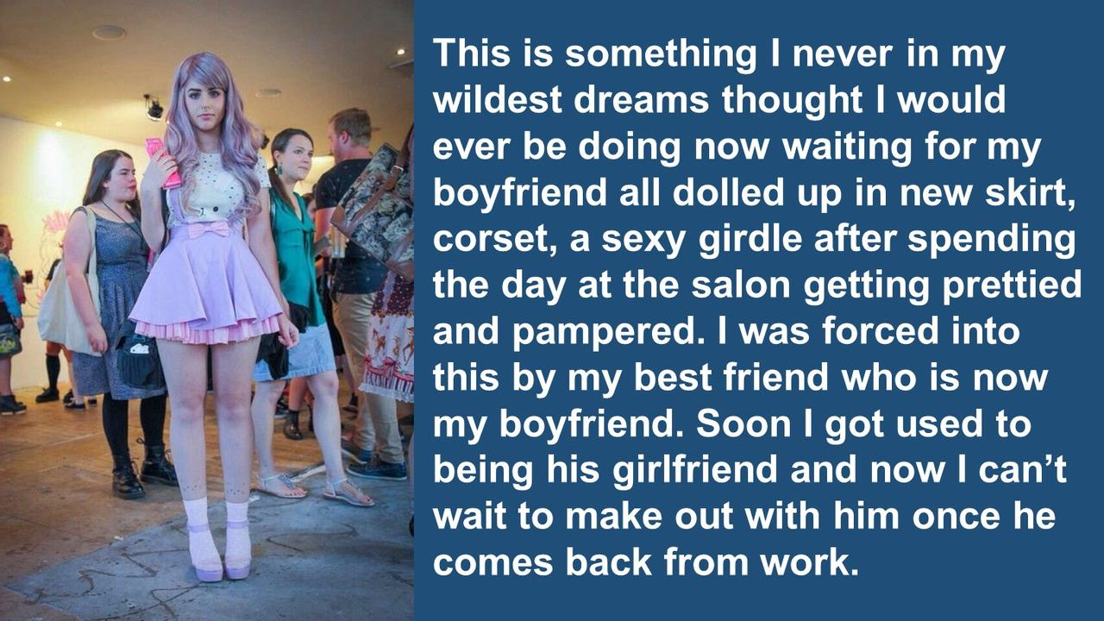

Honestly, that was one of the nicest things that a guy could say, which I guess shows how close we were. I am not one for this kind of thing, but I call him over and I gave him a man hug. He just pulled closer to me. Maybe I was too insensitive to notice.

If he says I forced him that is not quite true. He was the one who started it. He was the one who described my perfect girlfriend and told me that her name was Kitty. It was just that once she was born out of him, I could not allow her to leave me.

I mean, I do miss Kevin, sort of. But I simply cannot imagine a life without Kitty. She is everything I want. She wears her hair long and her skirts short. She is never seen without makeup on her face, or with a hair anywhere on her body. You will never see any aggression or anger. She is always passive and sometimes sad, but I know that it is my job to keep her happy.

My only requirement is that she never leave me, and that means that Kevin is gone for good.

Without Kevin there is nobody who knows me better than Kitty. She knows what I like and what makes me happy. She knows that what really makes me happy is that Kitty wants to be pretty and she wants to be mine. That makes her almost perfect.

Just a little nip and tuck is all that is needed for true perfection.

The End

Destined To Be  Inspired by this captioned image by  TGForcedFemCaptions on DeviantArt  By Maryanne Peters  I thought that once I got married all of this would stop. I thought that my compulsion was sexual and that regular sex would be enough. All I needed was to suggest that my wife go on top and I could lie back with my legs slightly apart and imagine that our genitals were reversed and that a man was plunging into me.  I longed to wear the wig, the bra and the stockings and suspender belt to bed, but I dared not upset her. She knew that I dabbled in fetishes when she married me, but she had the same idea that I did, together and with real love, we could put an end to these things.  But that is not the way it worked out. Some things are stronger even than love, or seem to be when she is away.  I started online, inviting admirers to contact me, and sharing with them sissy thoughts, about being treated like a woman – kissed, stroked and impaled. I even bought a tool to penetrate myself with, to lay back and imagine what this might feel like with the weight of a real man across my weak body.  Some wanted to meet me but I always declined. But there was one in particular who lured me in. He spoke about finding the perfect sissy who was soft and smooth and yielding, but uncomplicated in a way that only a person brought up as a male can be.  I ached for this man. | 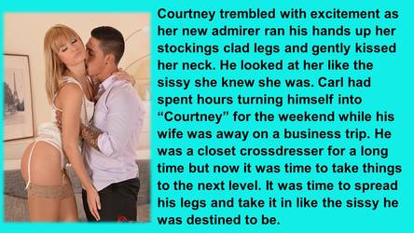

When the opportunity presented itself I proceeding shamefully. I put everything at risk in shaving down my body, plucking my chin and shaping my eyebrows in a way that my wife would surely know what I had been doing. I put my marriage at risk for a momentary thrill.

I made myself into Courtney so completely that when we met he was stunned at how beautiful I was.

As he had promised, he took me out to dinner and paraded me on his arm, so proud that I was his woman, whether or not anybody noticed that I may not be that.

I willingly went with him to his apartment, and I stood as he gave all the physical love he had assured me that he would. For the first time I felt the meat of a man inside, as stiff as bone. For the first time I felt him buck and spurt, and I felt my body welcome his seed.

Sadly for my marriage, I knew at that point that my life as a man was over. This is what I was destined to be.

The End

Bully to Bride
Inspired by this captioned image by TGForcedFemCaptions on DeviantArt
By Maryanne Peters

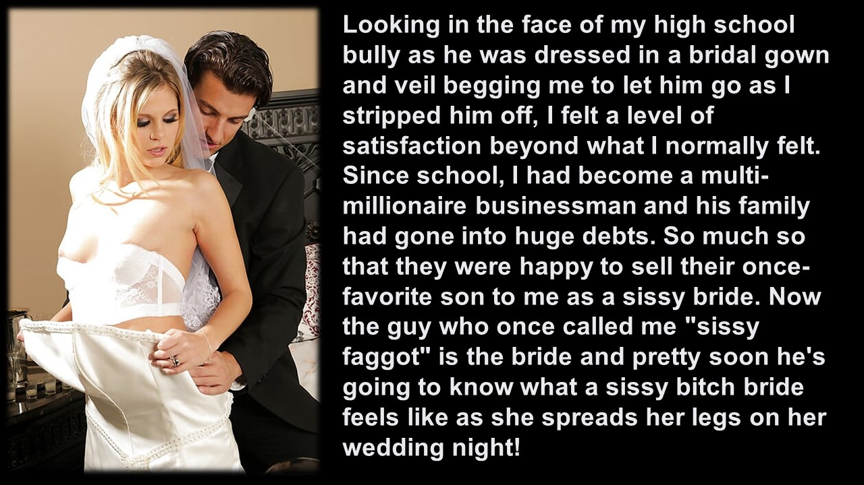

His family was always rich. He thinks that he is so clever, which he is. But maybe not a smart as me.

Yes, I was a bully. He was tall and skinny when we were at school. I was short but aggressive. Why? Because I was angry. I was angry that I could not be normal. I was angry that I could not get what I wanted; be the person I wanted to be. I am sure I am not alone. Plenty of people like me react that way. Plenty of transwomen.

He steered my father into debt. He did it to get back at me. But I had no idea until it was too late. And by the time he approached my father he felt that he could demand anything of my family.

“He wants to fuck you,” my father said. “I mean he really wants to fuck you … like in the butt hole. This guy is depraved. Whatever did you do to him?”

Of course, the look he got back from me was one of horror. I did my best to give him that look. Submitting to anal sex with a man was fine by me, but I did not need to tell my father.

“What’s the deal, Dad? Okay, so I gave him a hard time at school, but nothing serious. And now this! Dad, you know I will do anything I can to get you and all of us, out of this mess.”

“He wants you to dress up in woman’s clothing and take his cock inside you. He is a raving faggot.”

“No Dad,” I explained. “Not if I am a girl. Not if you explain to him that as a family we are opposed to sex before marriage … sex of any kind.”

It was like a dream come true. He was so keen to achieve his aim that marriage must have seemed like a small thing. But the truth is that once he had paid for the changes, he fell in love with me. I made sure of it.

As I explained to him, I was made by him for him. I was not the school bully anymore. Look at my breasts. I grew them for him. Now look between my legs. That was made for him. He could take me up the back if he liked, but I suggested that he come around the front, and look the school bully in his pretty blue eyes as he fucked me, and fucked me hard.

I was irresistible. I still am.

The End

Real-Life Princess  Inspired by this captioned image by  TGForcedFemCaptions on DeviantArt  By Maryanne Peters  I was a total shit to my sister, and I know that now. It seemed to me that all older brothers give their little sisters a hard time, but I went way beyond that. I told Mom that I would take my punishment like a man.  “I am thinking quite the opposite,” she said. I had no idea what she meant by that.  She had time to do a real job on me, and it started with hormones. I had no idea that she would cramming my food with these things – drugs she was being prescribed for a difficult menopause.  “I figured that they would do you more good than they would me,” she told me later. “The best way to understand that men can be so cruel is to take on a little of a woman’s chemistry.”  I had no idea why my muscles were falling away, and why my beard growth stalled and I was having mood swings and tearful episodes. It was not until the flesh on my chest became obvious that I started to get worried, and by then the party had been arranged.  “Don’t worry. There is no permanent damage,” Mom said. “I have made my point and I won’t be tampering with your morning shakes from now , but at least we have something to work on for cleavage!” | 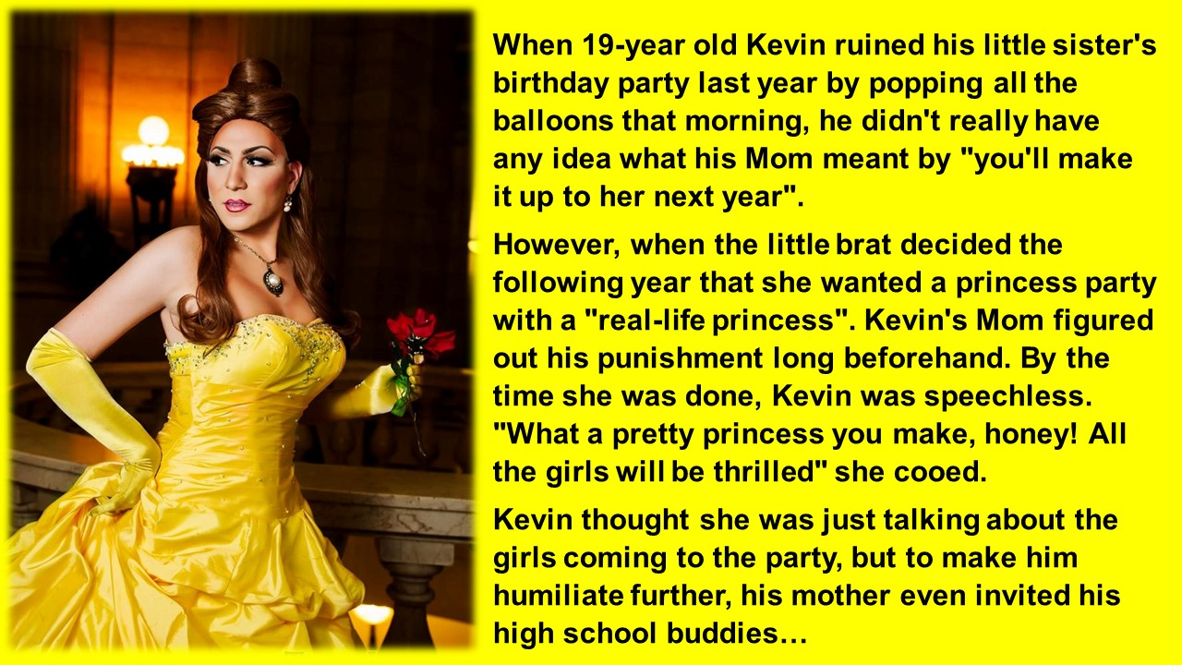

Cleavage? I knew that my sister had wanted a full one “Princess Party” for her 16th birthday, and that Mom and she would be dressing up as princesses, but I had no idea that my punishment required me to be a princess too!

But that was her plan all along. She had the costume all lined up, and a wig styled in a princess hairstyle – you know, a little bun on the top and long down the back. All I needed to do was to struggle into the special underwear that tucked my junk away and gave me curves, pressing my flabby chest up so that it looked like I had a respectable pair of tits. Then all that was required was makeup, plus a total waxing of my face, arms and legs.

“Why my legs?” I asked her. “I have these long skirts.”

“Don’t be silly,” she said. “Princesses don’t have hairy legs.”

I decided that I should really not care. To be honest, the hormone thing would probably have seen Child Services throw Mom in jail, but she and my sister are all I have. I figured that who cares if I am a princess for the day, and only them and all of my sisters group of friends would know.

But Mom just had to catch it on camera – the moment that I turned around to see all my high school buddies walk in. I was so embarrassed that I thought I would drop dead, or at least that seemed like a good idea.

But what do you do in that situation? I just decided to double down. I told them all that I was a princess for the night, and if they wanted to dance with me then they should stand in line. I have to say that I probably went a bit over the top with my antics – I guess I was flirting. It was just that my high school buddies are part of that group that aren’t so good with the girls, so a chance to dance with a princess even if she was not a real one, was something a few of them wanted to push.

Then a girl is faced with a choice – which I my pals deserved my favor? Who would get a kiss?

It was supposed to be just a joke making the best of a bad situation. But is this situation really so bad? Are my responses just a joke? Somehow none of that seems to be true.

Being a real-life princess is really just be surrounded by guys who are all determined to treat you like one. Well, here I am. A real-life princess.

The End

© Maryanne Peters 2022

