Who is Driving?
A Vignette
By Maryanne Peters

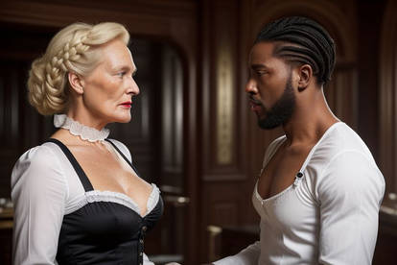

You might say that I made a huge mistake hiring Damascus Brodie as my driver. It was just that he was the man of my fantasies. I suppose that as a timid gay white man, I nursed a dream of have my butthole invaded by a huge black cock and having a good looking African male ride me hard. These sorts of fantasies don’t leave you when you get older. If anything, they grow stronger, like whiskey in a barrel.

Dam realized what I was quite early, and he used to make fun of it.

“This is like driving Miss Daisy – you know the film – right? Like, I am Morgan Freeman, but younger and better looking, and you … you are my Miss Daisy … ain’t you, Miss Daisy?”

Perhaps I should have ended it then and there, but I have to say that he kept the “Miss Daisy” thing purely as our private joke. He was always respectful, even deferential, in public. But in private, he knew that I was hopelessly in love with him and that he could play me like a fiddle.

Then I decided to retire. I had made enough money, and I quickly learned that this was inverse to the number of friends I had made. I knew nobody. It was just me and my servants – Mrs. Miliszewski my cook and housekeeper, and Damascus my driver and black god.

“Now you could be Miss Daisy full time,” he said. “That Mrs. Miliszewski is getting way too old, and she must be set to retire like you. I wonder if you couldn’t do anything about the house that she can do, and you get on and just be Miss Daisy? You know you want to do it. I think that you would make a great lady, and you have all that white hair where most men your age have none. You could be the pretty white lady and do a little dusting and all, and I could just drive you around all over the place. Imagine that, Miss Daisy, your own Morgan Freeman, but younger and better looking.”

I think that it was the thought of him deep inside me, driving my head into paradise that made me agree to this crazy idea. But he was right – I did need something to do, and I have always like to cook. And I always insisted on a tidy home and would sometimes get home from work and find that Mrs. Miliszewski had missed a spot of dust, and have to clean it myself.

I had the good fortune to have that hair as he said. I was quite proud of it, and I decided that I would grow it longer, whether or not I was to accede to Dam’s suggestion that I be my own maid. But somewhere along the line I decided to try estradiol, and that improved my hair enormously. I think that I had witnessed how Hormone Replacement Therapy had achieved incredible results in women my age – staving off the worst things about growing old. Perhaps it sounds naïve, but I gave little thought to the consequences.

But time marched on and things grew … everything grew. My hair became long, my chest turned into breasts of significant size, my skin grew soft. I seemed to be getting younger by the day, and Damascus Brodie was growing more amorous. He observed that I was turning into a woman, and as he put it, he liked women. He said that he was always attracted to women who took pride in their appearance no matter how old they were. It seemed like an invitation.

It was not as if I had anything much to do except spend time on myself – turning myself into a woman who might be just a little bit attractive to my driver. I kept at it, increasing my hormone intake through suppositories and going the hairdresser and the beauty spa regularly. I came to enjoy the labors of beauty in a way that was quite unexpected.

Dam kept on flirting with me, but still it seemed my fantasy of his cock inside me would stay forever that – a fantasy. Was it ever going to happen? In a way I feared it as much as I craved it. Would his cock tear me apart? In older people the skin becomes more fragile.

I decided that maybe I would need to prepare myself. I had avoided anal sex for years, prefer men to pleasure me, but I wanted to so much to be just like a woman underneath the hard ebony body of Damascus Brodie.

And then, one day it happened. Dam said that he wanted to meet with me to discuss something important, and I decided that when he met me I would look as feminine as possible, with my hair done right and a tits hiked up on full display. I wore a maids outfit to tell him that we were two servants together, stealing a moment on the back stairs.

I must have looked how I felt – a combination of trepidation and lust.

“Well, Miss Daisy, you sure look pretty,” Dam said, looking at me with those big brown eyes. I felt weak at the knees.

“Could you help me to make the bed,” I cooed, in a girly voice. “Actually I have to change the sheets, so maybe before we make the bed, we could use it … for a short while?”

“Now, Miss Daisy, are you sure this is what you want?” he said. “I wouldn’t want to hurt that pretty little girly butt you have been growing.”

“I’ll take whatever you have,” I said.

He needed no further invitation. He pulled off his shirt and dropped his pants, and he was everythin I feared – he was the shining image of manhood cut from polished obsidian and holding in his hand the cock of a black stallion. I fell back as if I was fainting, as I was. He pulled away my dainty panties that seemed to have turned into a rag, and his hot tip wrestled its way into my body, with every inch a moment ecstasy heightened by whatever pain I felt.

He drove into me, again and again, as if I was ragdoll stuck on a pole. Even his ejaculation seemed to be a liquid bullet fired into me. He moaned and I squealed. I had enjoyed a long life to that moment, only to discover that nothing could better the enjoyment of those few seconds.

“Now, it seems like you really are a woman, Miss Daisy,” he said.

“Thank you for driving me home, Damascus,” I said.

“That’s my job, Miss Daisy,” he smiled. “Which is why I wanted to talk with you this afternoon, Ma’am. I was thinking about moving on, leaving your service, but maybe I might reconsider after what has just happened?”

“Did you like it?” I could no help but bask in his pleasure and let him see it. He was right – I really was a woman now, and I felt like one. “Don’t you get any ideas, now. If you want more of that then I am happy to allow it, and I think your wages should reflect you additional services.”

“You are a classy lady, Miss Daisy,” he said. “Classy and hot.”

Which is indeed, what I am.

The End
1230

Finding my Home  A Vignette  By Maryanne Peters  I am not looking for sympathy when I tell you that I had a hard life. My past is a fact, and your past shapes the way you are. And my shape has always been stocky.  I was born male, you see. It was as if nature had played a cruel trick on me, and I say nature because God does not make mistakes.  I choose the word “stocky” on purpose – sturdy and solid, and wider in the shoulders for my height. It is the very opposite of what might be called “a girlish figure”. It all seemed very cruel.  I dreamt of being a woman but it seemed impossible. It was just all wrong for me. I was living inside a body that could not really be changed, and all those beautiful “successful transitions” just seemed like added torment.  How could I ever find my place in the world, a home to live in as the woman I should have been? | 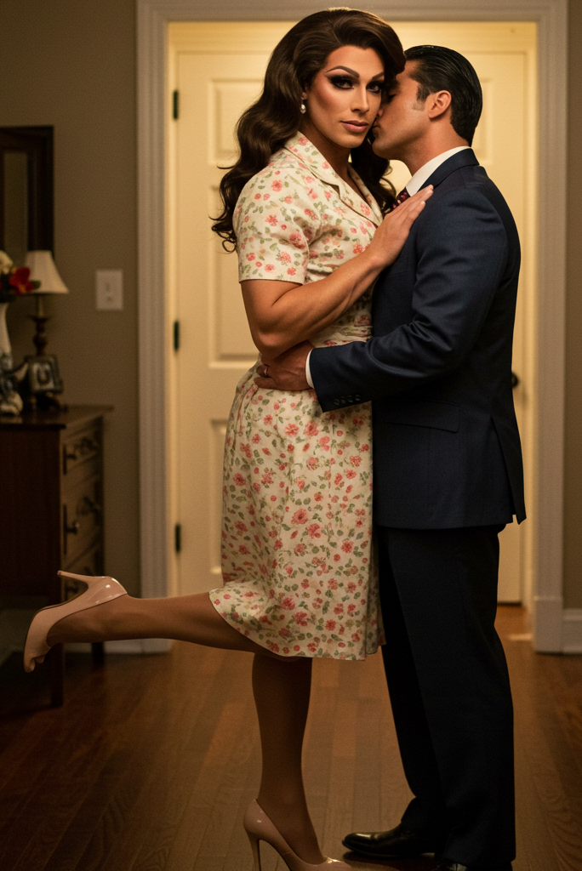  The image is from Kathleen43

Let me tell you, it comes down to resolve. Everything comes down to resolve. You just reach a point when you need to try to do the impossible in order to preserve your own sanity.

I started on the hormones and I booked the orchiectomy. It sounds like a drastic step but I needed to do something irreversible to show myself that I was ready to be myself at last, no matter what anybody else thought of me. Castration is such a step.

To my pleasant surprise I started to show signs of feminization almost immediately. My breasts sprouted and to begin with they looked quite ridiculous on my plucked chest, but with massage they gained size and shape. My hair softened and even sprouted where I had been thin, and it grew very quickly. Much of my muscle just disappeared, and my smooth legs started to look very good, in particular when I was wearing heels.

The problem with wearing those heels was that they took me up to almost six feet in height. As a woman I would stand out as being very big, but I decided that I was ready for that. I was myself, defined by my shape and not ashamed. It was at this point that I was ready to cast off the last bit of manhood. I burned my male clothes and I announced to the world that I was a woman.

It was no surprise to many those who knew me and had observed the gradual changes in appearance and choice of clothing. I suppose those that the man I had once been would call friends would fall into three categories. Those who did no want to know the woman I was – sadly, the largest group; those who were supportive but reluctant to publicly associate with me; and those who fully accepted me – a handful of true friends.

I suppose that I could have chosen to associate with other transwomen, and I met several during my recovery from surgery – but that was not my course. I have never wanted to be a transwoman – only a woman. I support all those who share my experience, but my way is my way.

I think that is what drew Kevin to me. He said that I came across as powerful and maybe a little fierce, but I told him that what I wanted was to be gentle and placid. He smiled and told me that he wanted to learn more about me. We started dating.

He knows that my appearance turns heads, but he likes that. I used to think that somehow he got off on taking home the giantess and fucking her brains out, but now I understand that he loves me. I don’t know what put us together and I don’t care. We love one another and that is all that matters.

I have found my home. It is his home, and I am his wife.

Perhaps you want what I have got? You just need to go for it.

The End
675

Betrayal  A Vignette  By Maryanne Peters  When I look at this image, I feel so guilty. It makes me think of how good she was, and how much I owe her for being the person I now am. It makes me realize how selfish I was, and how I betrayed her.  Yes, that’s me on the right, who once was the man she married. When we first discussed the subject of marriage, I simply told her everything. I told her that I loved her, and I did; I told her that sex with her was great, and it was; and I told her that I was transgender and that I always had been.  We just sat staring at one another for a moment, both on the verge of tears, when she said – “It’s the person I love, not the gender.”  Who could not love such a woman? Who could not hold her close in that moment and commit to her for a lifetime? That is what I did. I made a promise that I intended to keep. | 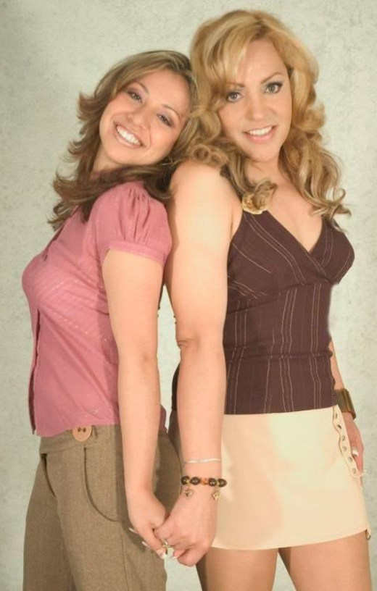

She helped me through everything, even my bottom surgery, which finally put an end to that kind of sex, and forced her to become a lesbian. She loved me even through that. She never wanted to be a lesbian, and (as I was soon to discover) neither did I.

What virgin woman could not be curious about what it would be like to be entered by a man? I wanted my vagina just to be female, but as everybody said at the clinic, a proper vagina must be able to accommodate what it was designed to receive. As somebody once told me, the word vagina comes from a word for sheath – a sheath for what? We all know.

She gave me plastic. She wore the strap on and she played the man, just because she understood that sometimes I needed to receive like a woman. We used the double dildo too, when scissoring, but plastic is not flesh. It didn’t even seem that my thoughts were unfaithful. I just wanted to experience something that my new bod was designed to experience. I told myself that once would be enough.

But I was wrong. Once was not enough. Real human flesh throbbing inside you and then spilling its load of life within me, is such a thrill. And then there was the thrill of sin itself – knowing something is wrong and yet doing it anyway. I seemed to me that these feelings were in my nature, and maybe in others too?

But it was betrayal. Once trust has been broken, it is hard to restore, and even harder when you promise it will never happen again, and you break that promise.

We are no longer together and for that, I am solely to blame. I keep that photo to remind me of that fact. I am weak and lustful. Some women are just like that.

Oh well, live goes on. And there are so many men out there.

The End
500

His Dream and Mine  A Vignette  By Maryanne Peters  We played tennis together and by that, I mean we played against one another a few times a month. We kept playing after everybody else gave up the game. People used to call us “Bondy and Clyde” because he was Clyde Mackey, and I was Richard Bond.  It came as a shock when he said that he would be going away. He said that he was retiring from work and that his ambition had always been to sail around the world on his 40 foot sailboat “Annabelle”.  He had bought the boat after his wife died, but it was not named after her. He said that it was a name that came to him in a dream. The name of a dream woman.  “What is your ambition?” he asked me. “If you could have anything in the world – if you could be anything in the world – what would that be? I have always wanted “Annabelle”. | 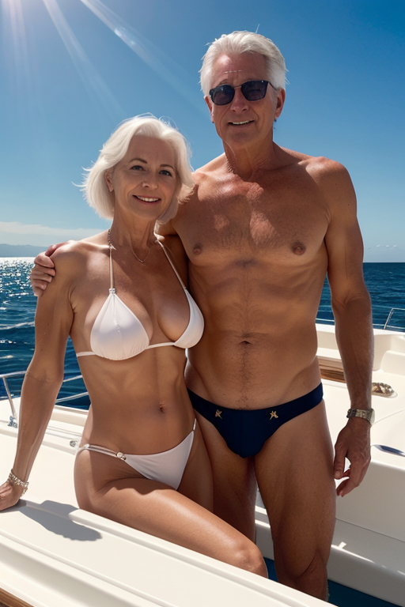

Maybe because after this I would not see him again, or maybe deep inside me I just had to set free the secret that had been gnawing at my soul for so many years. I just blurted it out – “What I really want is … I want to be Annabelle.”

He looked puzzled so I had to explain – “I have a dream of a woman too, but that is the woman I have always wanted to be. I don’t want to burden you with my problems, but if we are not to see one another after this, you might as well know that I am transgendered. I have been all my sad life. There is a woman trapped inside this body, Clyde, I have just kept bashing her down. She might appear for a moment or two every few weeks, but no matter how hard I have tried to suppress here, she is still there.”

He just looked at me for a moment, but not in horror. I knew that he was a good man – I just didn’t know how good.

“I would like to meet her,” he said. Let her loose. Perhaps it is time to retire the him, and be her. Like me, just do it. If you want, I will wait for you.”

I was amazed. Somehow I had always though that if I had ever had the courage to transition I would end up living alone (but happy) in some isolated cottage. I neer dreamed that there would be a man in my life, le alone a man I cared for an admired.

I knew that I had just one chance. Before he met the woman I wanted to be, she had to be beautiful. I suggested a date night the following week and I took leave from my job for the time in between to prepare myself in every way. On the day itself I went to one of those feminization boutiques and came out looking totally passable. Because of my preparation I had a voice and gestures to match my look.

“Annabelle, you look fantastic,” he said. “Just like the woman in my dream.”

I hope I look a bit more like her now, with my own hair and the contrast of brand new youthful breasts, and a youthful bikini now that I have the crotch to allow it.

His dream and mine.

The End
555
Witchy  A Vignette  By Maryanne Peters  I have to admit, I was terrified of Morgana, but there was just something about her that drew me in. I don’t believe that she cast a spell over me, as some of my friends have suggested.  “She’s a witch,” they said.  She once told me that she was, or she wanted to be.  “I couldn’t stay being Marcus,” she said. “Males can’t be witches. They can never have the same relationship with the source of power.”  It may sound a little crazy but I liked it when she said things like that. I even quite liked the fact that she had once been a guy, and then had simply decided to be somebody else after a summer break years ago. If only it were that easy.  But I don’t believe in magic. I think that it is something inside me – an attraction to things exotic, and perhaps a little dangerous. | 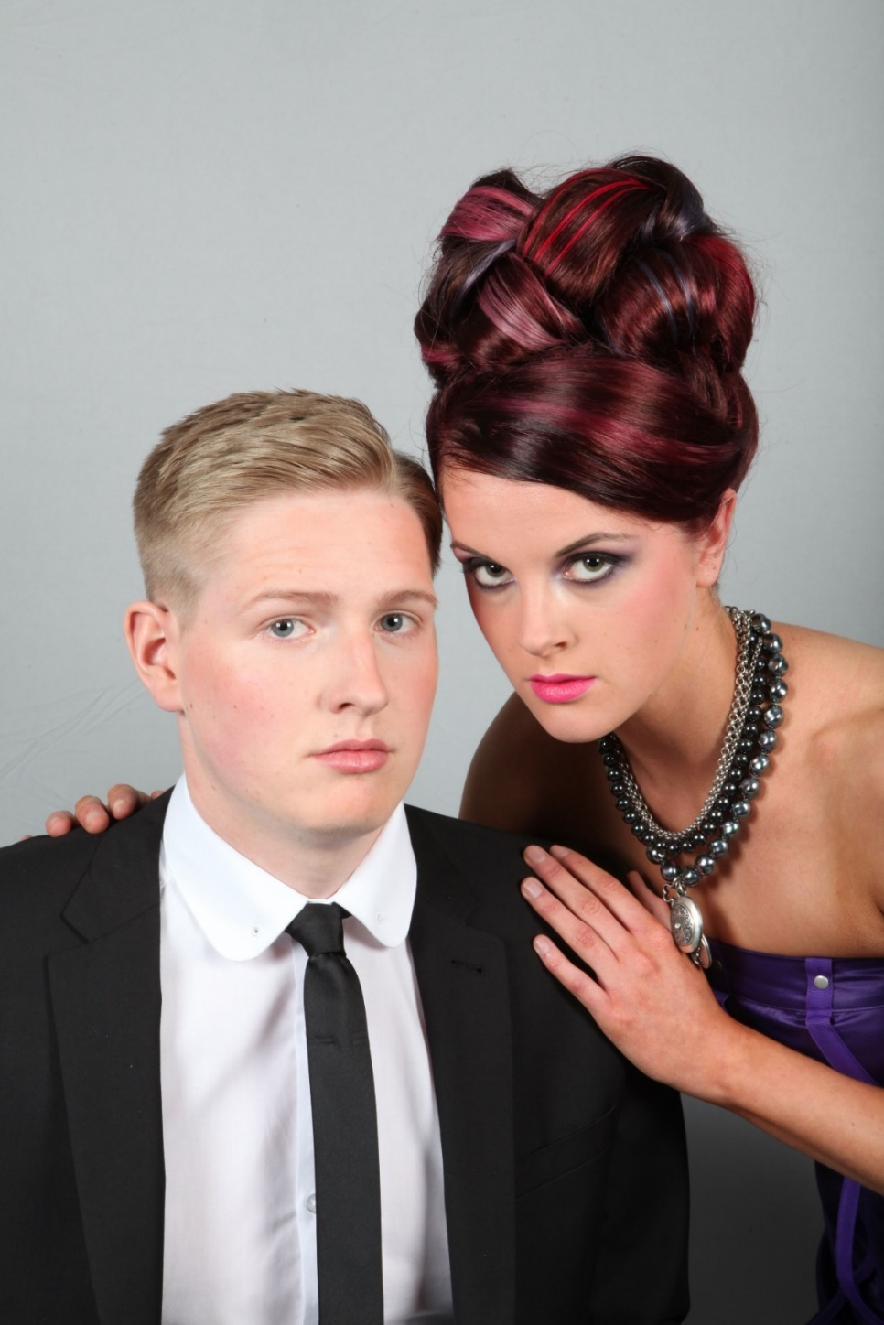

But nobody can deny how beautiful she is, and a lot of that is the way that she carries herself. There is a confidence in the way she moves, and even a sense of that power she talks about. She really doesn’t care about anybody else thinks, except maybe me.

“It is truly wonderful being a woman, but sadly in this world a woman needs a man,” she said. “You are my man. You are my familiar.” Whatever that means.

I have to say it, that people who have seen that prom photo say that she looks kind of creepy, but I don’t see that. Do you? I just see how beautiful she is and how much she wants me. She is wearing the locket with a snip of my hair in it, which I admit is a little strange.

My parents have never taken to her, and I am sad about that. I think that part of it might be that she is trans and that if we are to marry, I could never be a father. Her response was to tell me that they have no understanding of the world we live in, and that I will be a father and we will have a family – although I am not sure how that will happen.

“Believe in me,” she says.

I do.

The End
375

© Maryanne Peters 2025

