Anything for Her
Inspired by a Captioned Image by Courtney
By Maryanne Peters

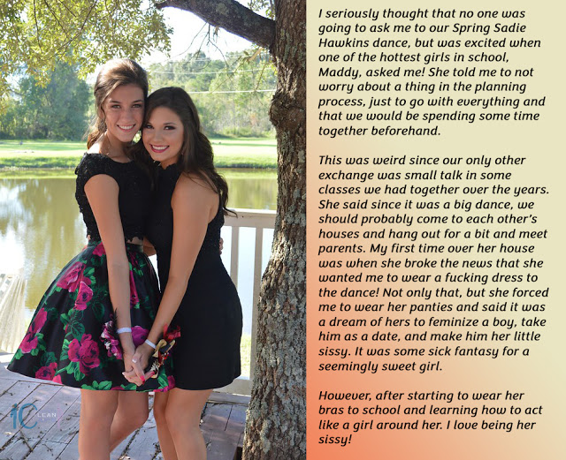

Yeah, that’s me on the left. I used to think that my nose and chin gave me away, but nobody would say that now. I am a total success. I am her success. Completely feminized.

I was horrified that first visit to her place, when she told me her condition for being her date. The truth was that I was so sweet on her I was prepared to do anything for her.

It was just supposed to be the dance. I wore a wig that night. I did my best to be a girl for her, but I told all the guys that it was just a joke. Maybe I told myself that it was, and that after that Spring Sadie Hawkins Dance I would go back to the old me, but Maddy was never going to agree to that.

For a while I tried to be a girl for her and something else the rest of the time, but that just didn’t work. If the guys call you a sissy, I guess you can only deny it so many times and then you just have to turn to them and say – “That’s right. I am a sissy. So what? What are you going to do about it?”

All that mattered to me was that I keep Maddy happy and keep her as my girl. The fact is that I would do anything for her, and she knew it.

She pushed me more and more, and I just agreed to everything. I grew my hair and I started taking the hormones. We had sex like lesbians do. I just had to hid my junk because she never wanted to see it, let alone touch it. She had a strap on and I would take that up my butt.

I called it a sick fantasy when we started out, but I came to think of it as love. She loved me so much that, despite the fact that she preferred girls, she was with me, and all I had to do was sacrifice my masculinity.

I suppose I learned that what masculinity I had must have been pretty thin. Why else would she have picked me out the way she did? How else would she know how easily I would slip into sissy behaviors? How could she see that I was deep down a very feminine person?

Was I? Or was it her?

It was just that in the end I was not girly enough for her. We look so happy in that picture, but it is the last image of us together. Abigail is a born girl and, although she is not nearly as pretty as I am, she has a vagina, and I don’t.

Well, not yet anyway. Zac says he wants me to get one, and he is the new love of my life so I am certainly giving it some thought.

The End
Everything I Wanted
Inspired by a Captioned Image by Courtney
By Maryanne Peters

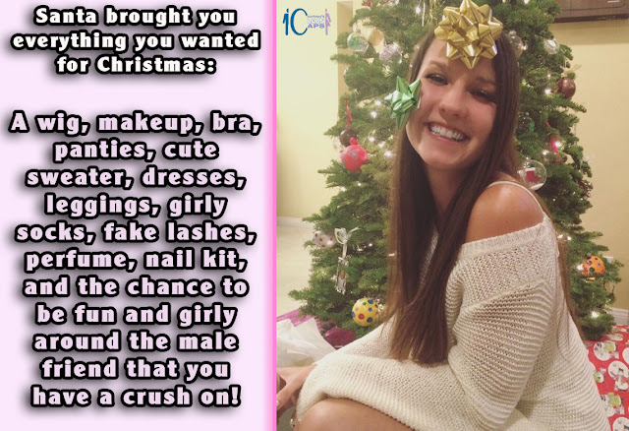

Do you remember Christmas 2020. For almost everybody it was ruined by Covid19. You had to celebrate with who you were with, and only Gabe was in the same “isolation bubble”.

Gabe had always been a friend, but being close to him over that December seemed to give rise to all kinds of unnatural feelings in me. Even the smell of him turned me on.

“We can celebrate Christmas together, but no gifts,” I told him.

“Sure,” he said. “But Santa might come calling.”

Well, it was years ago that I was told that Santa was not real, but now I am not so sure. It was all there under the tree.

“It looks like your Christmas wish came true?” he said, as all the stuff lay there on the floor surrounded by torn wrapping paper.

“Or yours?” I said. But I was smiling, and he could see it.

“Well, you had better try everything on,” he said. “You may need to go on line to check things out, but we have time. It is cold outside and the whole city is locked down. I will get our food together and you need to get pretty.”

That was Christmas 2020. As for Christmas 2021, well that is the photo. My gift to him with a couple of rosettes stuck on, was me. After a year of growing out my hair and taking the hormones, the big surprise was that he now had a vagina to play with – mine.

The End

Evolution
Inspired by a Captioned Image by Courtney
By Maryanne Peters

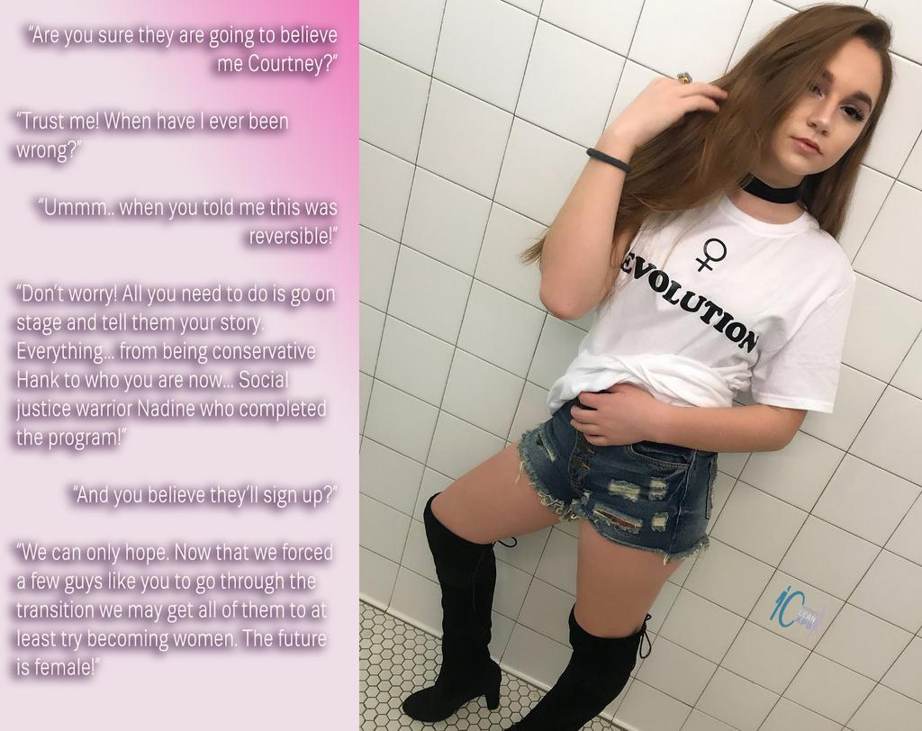

Hey Guys! I want to explain to you about who I am and how I got here. I know I have your attention, but try looking up from my hot pants and knee boots for just a minute. I need to get serious and tell you about why the future is female.

You guys have had control of the planet up until now and look what a mess you have made. Over-population, global warming, the threat of nuclear war. It is all about your need to control women, get bigger and faster and show all the other guys how strong and powerful you are. It’s all driven by your body chemistry, so maybe it is not your fault? You just need to lose those androgens and let female hormones take over.

You can become female just like me. I used to be Hank, and ambitious guy who wanted to leave my mark on the world and didn’t who or what suffered to do that. Not a mark on the world, but a scar. It is just the way guys are. I know that now.

Just a little snip and a good dose of the good feminizing stuff and here I am now - Nadine, social justice warrior, ready to put things right.

You really need to become one of us. You really need to understand that women can do a much better job because of the way we are. We are caring and nurturing by nature, and that is what this planet needs.

I have to say it, if you are not with us, you’re against us. I don’t mean that as a threat – threats are male things. I mean it as a statement of fact. Men are on the way out. The world is changing. Read the writing on the wall and the writing on the tee-shirt. Evolution. Human beings are evolving. Men are the dinosaurs of humanity. Be aware! Be a woman!

The End

Talking to an Old Friend  Inspired by a Captioned Image by Courtney  By Maryanne Peters  Guys are supposed to look after their friends, but when I comes to anxiety and depression, I guess most of us just lack the skills. We just think that maybe things can be solved by getting drunk or getting laid or both. It is like it should be easy for guys to forget about rejection and distract yourself with something new.  I guess that we knew it was going to be harder for Ben. He was a sensitive guy. He tried to be one of us, but he was not into sport and drinking in the same way. Still, he was a friend and we all agreed that we should have done better in offering his support.  The problem was that time had gone by. He wore his hair quite long when he hung with us, then one of the guys said that it was now down around his shoulders, and there had been other changes too.  Some of the guys said that Ben had gone to see that crazy campus counsellor Courtney – the one who keeps saying shit like “the future is female” and talking about how “The patriarchy has caused all the problems in the world”. Apparently, Ben was just soaking all this shit up like it was gospel.  We heard that this Courtney had got Ben into a sorority. The story is that she said that he would get – “the support that was needed among women.”  To us that sounded like an insulting – insulting his friends and also insulting all men. This guys said that as true friends we needed to rescue Ben from these crazy women, and be supportive. | 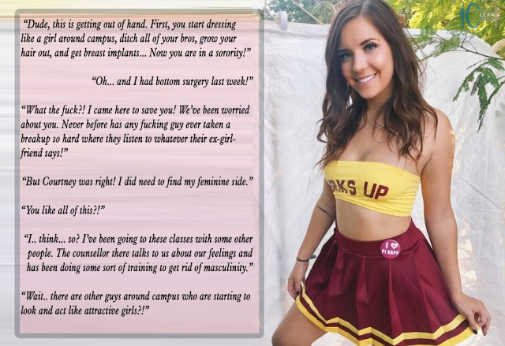

I was given the job of going around to see him, and he was happy to see me. He said that he was working out in the sorority studio, and he would be alone for a quarter hour. I walked in and the only person there was thing hot-looking chick in a cheerleader outfit. I stood waiting for Ben and she walked over to me.

When she got close I could see that it was Ben although it seemed to make no sense. The skimpy top was really just a boob-tube and breasts were real. And I had seen some tumbles that showed the crotch under the pleated skirt was empty. But the yes belonged to Ben, and he knew me.

“Ben! That can’t be you?” I said.

“I suppose it isn’t,” she said. “Not anymore anyway. I used to be Ben but I’m Becky now. Now and forever, because I had bottom surgery last week. I have left everything male behind. The future is female, you know. Our sorority is committed to making a difference. We are going to change the world. I wanted to be part of that.”

“But what about your pals? What about the guys? OK, so we were a bit slow in showing it, but we did care about you. I care about you.”

She looked at me. It was kind of weird. She seemed to look straight through me.

“You know, I never would have notice it before my operation, but I see it now. Yes, of all the guys you have always cared about me,” she said.

“That’s right,” I said. She was coming closer to me, stepping right up, like I could feel her breath close.

“You know, we just want to put the world right after years of destructive patriarchy, but we still have needs – physical needs.” She was purring like a cat on heat.

I was there to talk to an old friend, but I could see that it was going to be nothing like that. This person was somebody new, and very exciting. And we were not going to be talking for long.

The End

Back to High School  Inspired by a Captioned Image by Courtney  By Maryanne Peters  The thing is that I always looked younger than I was, and the female hormones seemed to knock another five years off my age. I just decided that I would take my new identity and alter her age, and go back to high school.  It seemed to me that I would be forever at a disadvantage having never experienced girlhood. I figured that adolescence is the most important phase in the development of a woman. That is the time when they acquire the physical form of a woman and the capacity to reproduce, and it brings on changes that shape there lives.  In a way hormone therapy had taken me through the physical changes, but in a way that was out of place. I was going through puberty at the age of 20. With all the hair removed from my body and the intensive skin treatments I had the skin of a pre-teen. It seemed that I had a chance to pull it off.  I would get to go to the prom in a ball gown after all, three years after I had graduated high school. But before then I was keen to show off my new female body and just be a girl among other high school girls. I was excited. | 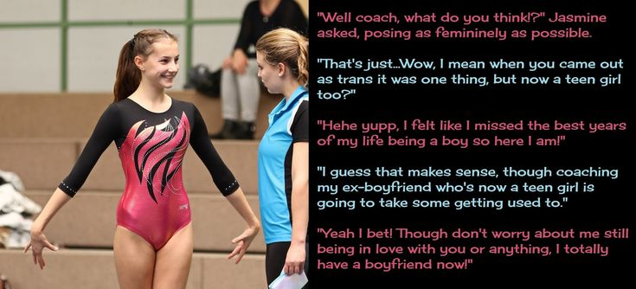

So, imagine my surprise when I saw that the gymnastics coach was a girl that I used to date when I started college. It was not as if I could hide. So, I just decided to bounce on over and introduce her to the new me.

She knew that I had come out as trans but I guess that she must have been shocked to see me in that leotard. Of course her eyes went to my crotch, but that is now perfectly feminine with my awfully male bits cut away and discarded and a new pussy recently installed.

It was not true that I had a boyfriend then. I just wanted to let her know what my sexuality was and to assure her know that there would be no complications if we were to become friends in future. The fact was that I was a virgin as a girl because I was not fully healed and I did not like the idea of anal sex.

But the fact is that I had worked hard on my body and I had a pretty with naturally dimpled cheeks. More importantly, I had the maturity of at least three years over any boy who wanted to ask me out. The knowledge of those years and my experience and their side of the fence gave me all the skills that I needed to get guys competing to take me out. It was just a question of landing the big one, and there were plenty of hunky candidates.

It makes me smile to think of my girlfriend watching pretty little Jasmine playing the field. Still, I learnt a bit from her too, and not just in the gym!

The End

© Maryanne Peters 2023

