The Music Festival  Inspired by a Caption  By Maryanne Peters  We met these two guys, Jack and Ben, at the music festival. I mean, you are never going to meet two bigger assholes than these guys. Dirty long hair, beards, smelly clothes, loud, objectionable, and out of their tiny minds on weed. | 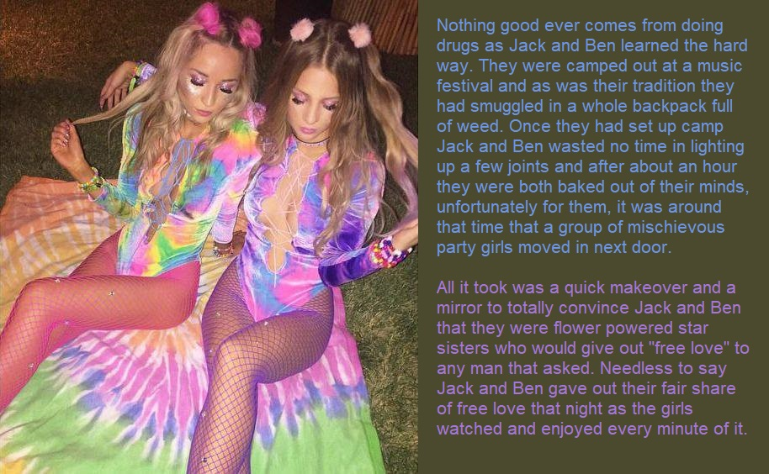

They had a van parked up next to our plush RV in a section of the camping ground set aside for auto-campers. They made our lives a misery from the day we arrived, two days before the music even started. So, my girlfriends and I got to thinking about how could deal with it. Short of killing we needed to send them away. Have them look for “free love” elsewhere. And to do that we needed to put these guys under our control.

We had party drugs, but we also had something special. I won’t give the name because guys out there will want to find it and use it for all the wrong reasons. But we had that stuff, and also a bunch of other “Non-recreational” drugs. You see, all four of us were studying pharmacology and two of us (me included, I have to admit) were a little light-fingered when it came to discarded pharmaceuticals.

Anyway, one of the girls said: “If only they were girls instead of guys, we would not have a problem.” That got us to thinking. Could we?

Well, we had the stuff on hand. We had sedatives to sow them down, soporifics to knock them out, facial depilatory compounds to rip out their beards, creams to condition their faces, wax to strip all the hair from their bodies, and powerful hormones and hormone blockers to play with their bodies.

It was easy to lure them into our RV and do everything. Plus we had everything we needed

We were all very surprised how well they turned out. They really did look like girls. Their hair came up really well, and with a bit of color it was spectacular. They must have had good enough bone structure, because the makeup we applied transformed them.

“It’s a pity that these massive doses of hormones are going to take so long to take effect,” somebody said. “These new girls need to have the bodies to match those gorgeous heads.”

There was nothing for it, we needed to order some made to measure body shapers from Glamor Boutique and have them forwarded by DHL direct to us. They arrived just before the first act went on stage. We squeezed Jackie and Bella into them complete with the matching tie-dyed leotards and fishnet hose.

We gave each of them a shoulder bags containing just the essentials for a music concert: Lipstick, mascara, Kleenex and condoms.

These Glamor Boutique body shapers are incredible. With a little concealer the boobs look totally real and feel like it to. There is a built in cincher and some hip and ass padding to create that hourglass shape. The groin area tucks away little penises no problem at all, and best of all they come with a string coming out of that realistic fake pussy and a hole surrounding the asshole. Woops, it’s rag week but give it to me up the back!

I can tell you, they got plenty of that free love they were looking for.

Jackie and Bella staggered out of our RV and off to the action in about the same state as we found them, drugged up to the eyeballs and not sure whether they were Arthur or Martha. But we know that it was definitely Martha, right?

The End

Devin Plays his Part
Inspired by a Captioned Image by Misogynist to Maid of Deviant Art
By Maryanne Peters
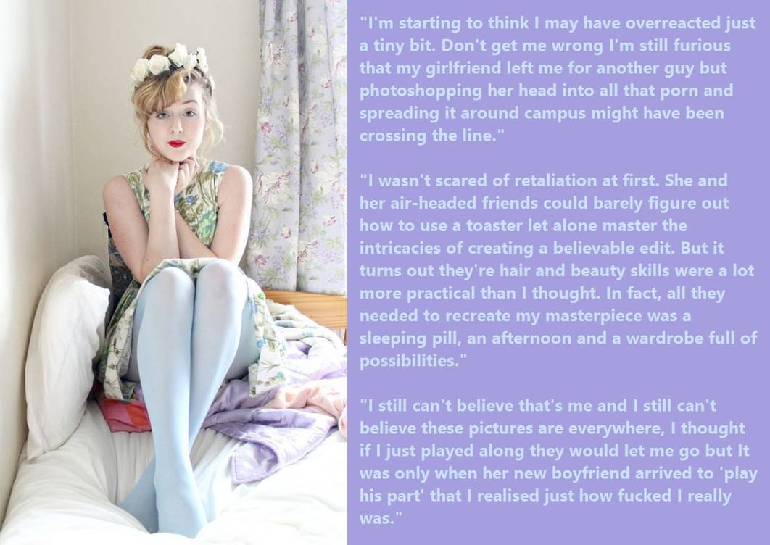

James sat on the bed looking at Devin, his ex-girlfriend’s new boyfriend. There were no other clothes to wear. He had been unable to get the flowers out of his hair or the makeup off his face. Not only had they been able to remove every hair underneath the makeup but somehow they had managed to plump up his face and lift his brow to give him a permanently vacuous look.

He was still dressed in the floral dress and the powder blue tights. More than tights, they went all the way up and over his shoulders to give a female shape to his chest and butt, and to conceal his small genitals, now tucked away with just the tip of his penis next to his butthole exposed.

“Well, this isn’t photoshop,” said Devin. “I bet you wish that she was as good at you are on that stuff. No, this is real life”. He moved towards Ivan to get a closer look.

“You may not be the prettiest thing, but there is no mistaking you for a boy, is there? He angled the mirrored door of the closet so that James could get a good look. James’ hands went up to his throat, his red painted lips pursed.

“What are you going to do to me?” James croaked.

“Well, I was just told to come in and take a few photos for circulation,” said Devin. “But I have to say, completely unexpected, but I have some circulation of my own going on.”

James’ eyes followed his hand to his crotch, and the unmistakable sight of an erection straining at the denim fabric. He gulped.

“But you’re not gay, are you Devin?”

“Hell no. But it looks to me like I am the only guy in this room.” He came closer, close enough to smell her – the smell of white roses. “If you think otherwise, you will have to tell my dick.”

In confirmation, or so it seemed, James started to whimper. He was wishing that he had never done it. He had never had a girlfriend before she showed him a little favor, and when she told him that he was not man enough for her, he was furious. In fact, she had said to him that she was not really her boyfriend at all – just a friend. That seemed to make it even worse.

Girls were so difficult. All he wanted was somebody to be a partner. Somebody to go out with. Somebody to stay in with. Somebody to snuggle up to. Somebody to love him.

Now here he was, a fragile little thing now dressed as a girl, and feeling the rough hands of one of the biggest guys in school rolling him over.

“I like your hair up at the back like that, Jamie,” said Devin. “Is there anything sexier than the back of a girl’s neck ? And what do we have here. A little hole in your underwear? A little pee hole and behind it a little rose, like the roses in your hair only pink.”

“Please don’t hurt me Devin.”

“I don’t want to do that, Sweetie. But this skin so soft and pale, and the sweet smell or flowers and fear, I am afraid it’s not me you should be talking to, it’s this.”

There was no mistaking what was pushing against his fiercely closed backdoor. James was wondering when the blow would come. If he did not yield would the first blow come to the head?

“Come on now, Baby,” said Devin. “I have a feeling that this could be something very special.”

Why did he give in? Was it fear? Or acceptance that only when it was over could he get away? Or was it something else? Perhaps understanding that as Devin said, this was beyond thought. Other organs were in charge. The limbic cortex governs this – the four F’s: Fight, Flight, Fear, Fornication. It seemed that it was time for number 4.

And when Devin was spent and lying beside James receiving kisses, it was Jamie who knew that she had been looking in the wrong place for love all along, but it had found her.

The End

Anything for Love
Inspired by a Captioned Image by Misogynist to Maid of Deviant Art
By Maryanne Peters

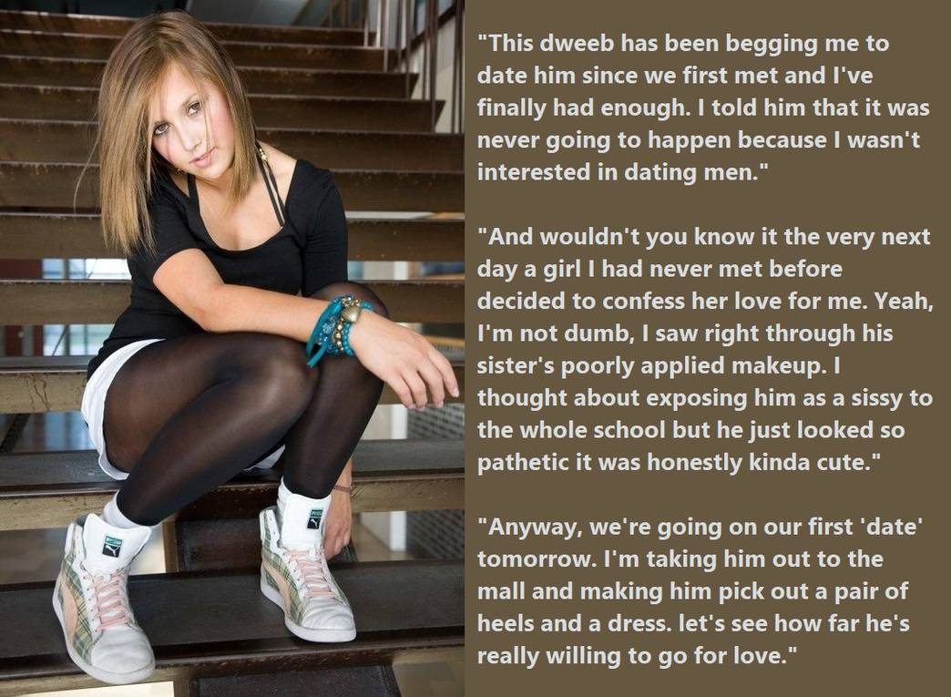

I could pretend it was not him. That would mean that it was not gay. I told him that I don’t date guys, and then “Helen” turns up. The poor lovesick puppy dog. To be honest, I sort of got a kick out of being desired like that. He helped me with some science projects and shit, so I suppose I owe him something. I guess I thought that so long as he looks like a girl, I could go out with Helen once or twice, just as a return favor.

And he did look like a girl. He had washed and straightened his hair, and his sister had plucked his eyebrows and gone to work with eyeliner and lipstick, and his chest had been padded and squeezed together to create what looked like a cleavage and a waist under that tight black top. But it was the yes that drew me in – the way they looked at me. Nobody had ever looked at me like that before. It made me forget what was lurking under those tight white shorts.

So when “she” suggested a date, I said “Sure”, wondering where this would go. I suggested the mall and a movie in the adjoining complex. I pointed out the outfit is the shop window and suggest that she buy it. And there were shoes to match. It all screamed girly girl, and Helen just jumped at it.

I bought the movie tickets. I suggested that we go Dutch at the diner afterwards, but she said that if I paid maybe she could offer me something sexy for afterwards. I was intrigued.

“But, it is just that I am having my period at the moment,” she said. “I would love to have sex, but it will have to be anal – do you mind?”

It is the gay people have sex, but girls take it up the butt too, and if she looks like a girl even if you know she’s not, then that is not gay – right?

I have to say that I did not take too much convincing. I mean she looked cute in shorts, but in a dress and tottering around in those heels, she looked hot. And there was no doubt about her willingness. And it is not like any other girls are offering anything to me, back or front.

And there were those eyes again. Here was something who was prepared to offer anything for love. That is a powerful aphrodisiac.

The End

A Permanent Thing
Inspired by a Captioned Image by Misogynist to Maid of Deviant Art
By Maryanne Peters

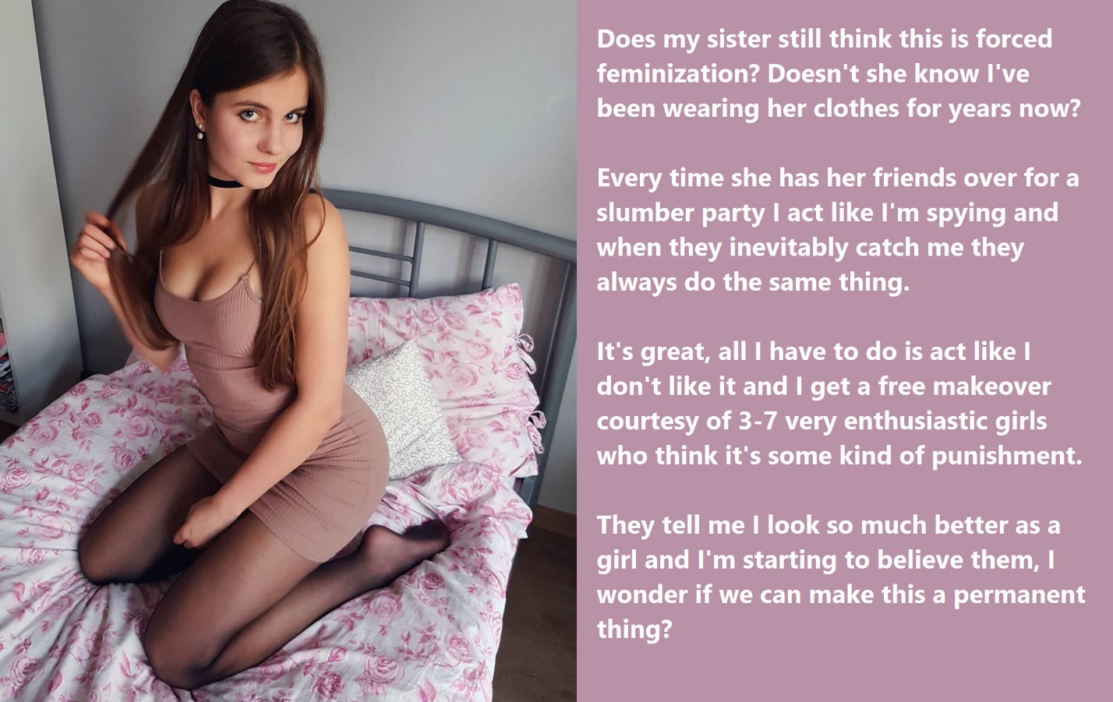

Are you surprised … really? Yes, they are implants. As we are going out with your girlfriends – or should I say OUR girlfriends tonight, I thought I needed to wear something revealing – something that flatters this body. That would be the body that you and your friends created! How you could have believed that those hormone “energy shakes” – oh yes, I have worked that out all by myself – would not destroy my ability to function as a male, I will never be able to understand. You all knew what might happen to me, and so congratulations – it has happened. I have to face my reality.

I mean it has been over a year. Look at my hair. Sure, it may have been a little bit long when you first caught me spying on your slumber party seepover, but look at it now! It is down past my new breasts. And look at my face. Do you think that this face could ever grow a whisker? That is down to you and your gal pals.

Don’t you consider me punished enough for a boy’s natural compulsion. Now look at me! I won’t be spying anymore because I can’t. Spying is for boys. Thans to you I am not a boy anymore. My life has been ruined.

Hey, Sis. Calm down. Come and sit on my bed. I don’t hate you … in fact I have a confession to make. Sit. Let’s talk – girl to girl.

The truth is, I used you. It is me who owes you the apology. I think that I have always wanted to be just like you. I wouldn’t have called it being transgender until all of this started. It seemed more like just sibling envy. But the fact is that I love wearing dresses, and I love doing things with my hair. And when I am with you and your girlfriends, I feel like I am one of you. I am transgender and I have known it now for some time. I just pretended to spy on you so you could catch. I pretented to complain and resist so you could force me. But it’s what I want. It is exactly what I want.

So, thank you, Sis. Thank you for everything. Now, you were talking about going out and cruising for guys? I just want to let you now – I am a starter for that.

The End

Ladies Poker
Inspired by a Captioned Image by Misogynist to Maid of Deviant Art
By Maryanne Peters

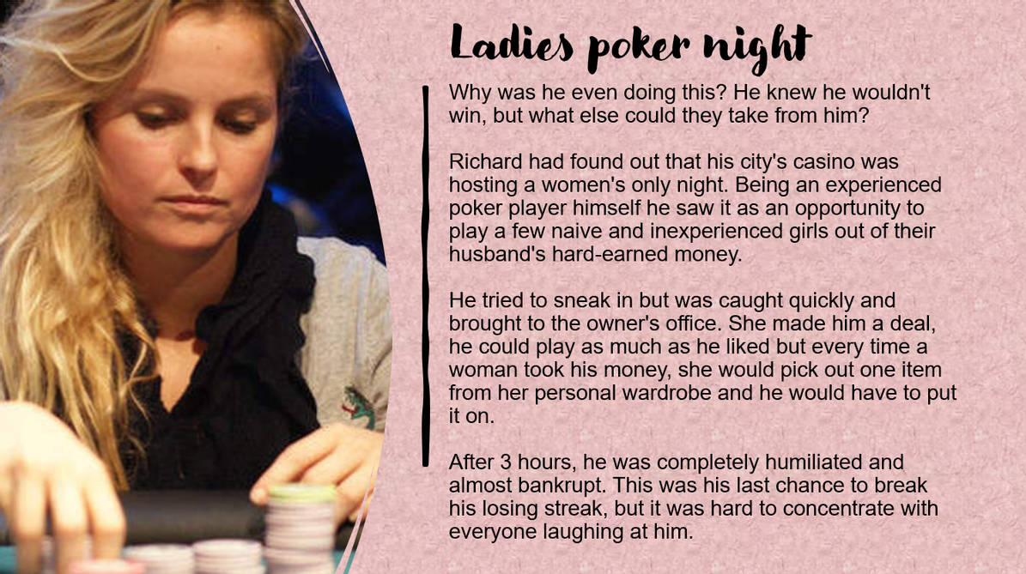

There is no substitute for experience when it comes to professional poker. You learn from your experiences and I sure learned from mine.

The idea was right. There were plenty of casinos offering ladies-only games, and there were plenty of women with money to lose – especially from those who only had to go back to hubby to ask for more. These are women who prefer to play with other women in order to level the playing field. Men can be hard to play because women can not always read men, although they will never admit that.

The mistake I made that first night was to get caught, and to be caught by a female pit boss, whi turned out to be the owner. She made a point of taking all my money (which any casino operator can do if they want) but also humiliating me for doing such a bad job of presenting as a woman.

Looking back, it seems that I was the naïve one in believing that I could pass. I thought that a wig and heavy make, and a body stocking under a tight dress would do the job. I was so wrong. Look at me now. Undetectable hair extensions, very little makeup but with flawless lasered and nightly cleansed facial skin; sensible clothing, low heels; short nails with clear polish; a carefully practiced voice and demeanor. The hormones just helped to keep me feeling the part, and the effect of them just crept up on me, and over me.

I just never went back to that first casino ever again. There are plenty across the country, and now I have enough in the way of winnings to travel about, looking for those ladies-only nights, or even ladies-only tournaments with a big payoff.

The problem is that if you want to pull all of this off it needs to be full immersion. I learned that by having to endure those women laughing at me. It was a hard lesson, but with every new item of clothing I had to parade in, I learned. There is no substitute for experience and bad experiences teach better than pleasant ones.

To start with I resolved that when I was on the road, staying in casino hotels and playing in casino card rooms, I would live and breathe the feminine me – Rachel, Rose, Rebecca, Ramona, Rita, Renee – it pays to have more than one name. I almost forgot all about Richard. And then as I was never not on the road he quietly disappeared.

I devoted myself to my work. Through these ladies-only games I was now able to achieve my dream of becoming a professional poker player. Part of being successful is to shut out the attentions of others. I had achieved my aim of totally passing by not trying to be a man’s dream of what a woman should be. I looked like what I was, a feminine woman in control and at work.

But as was pointed out to me, I turned out to be pretty, or at least attractive.

And even a devoted gambler understands that what may be a pleasure for some is work for others, and we all need to escape from time to time. I received overtures from men, and I suppose I thought – ‘If he wants to buy me drinks and dinner, or take me to a show, where’s the harm in that?’.

It is just that James is getting serious. He is very rich, divorced and loves having a good time, with me.

It is like being dealt a royal flush. You never expect it to happen. What do you do when it does? Do you pass and put your cards face down on the table and wait for a more normal hand? Or do you go all in and put everything on the table, including your future as a man? This is the kind of decision where experience is no help because it will happen just once.

But gambler’s gamble – right?

The End

© Maryanne Peters 2023

