My Father’s Debts  Inspired by a Captioned Image by Think Pink  (https://www.deviantart.com/think-pink1)  By Maryanne Peters  Do not think for a minute that my father traded me to pay his debts. My father loves me, and I love him. If I had refused, he would have taken a bullet for me. I don’t doubt that. I was just not prepared to let that happen.  “The Red Room” private club was an illegal joint, and nothing short of cash would satisfy them. My father offered to do any work for them, and I offered too. I said that if they wanted a floor show I could do my “Polly Tix” comedy drag routine that I had put on at the college revue. It was not a great act, but I looked good enough.  The manager said that if I was any good, I might buy my father a day or two, so I did my best. What I was not excepting was for Enzo to fall for me.  I guess that he was gay. He knew that I was a guy. It was just that he liked his boys to be girls. He was quite particular about what he wanted.  Once I understood that, I led him on, I guess. I wanted my father to live. I told Enzo that I would do whatever he wanted if he would make sure that my father was not maimed or killed.  “Baby, all I want is you,” he said. | 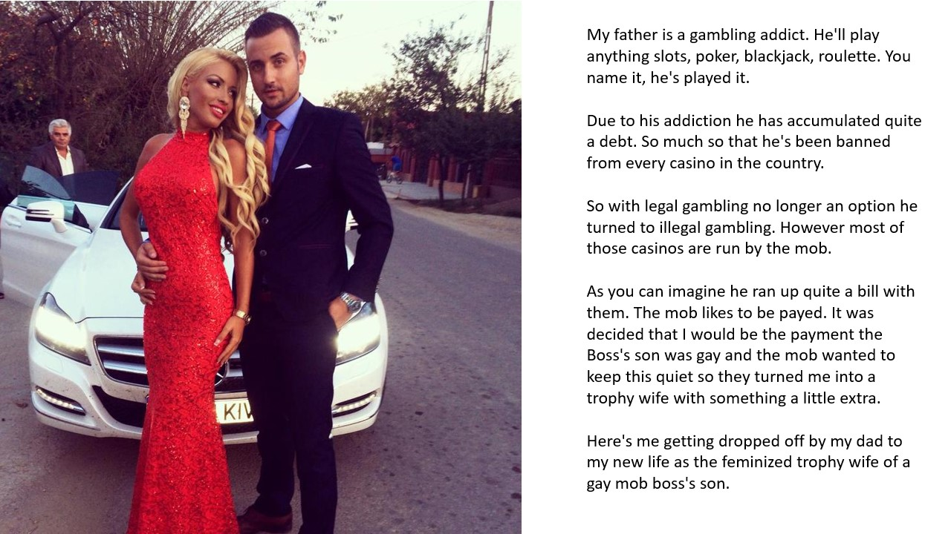

That meant he wanted me the girl on stage, to be his girl, 24 hours a day, seven days a week. It could no longer be an act. It had to be full time. No wig – hair extensions; No falsies - breast implants; and hormones to soften my body.

It sounds like a horror story, but I was ready to carry my father’s debts. And after a while, that became no burden. As it turns out, life with Enzo is cruisy. He likes the good things in life, and (as I have discovered) so do I. But most of all, he likes me, and he likes being with me. He says that there is no other woman like me, and I have to agree, because (as I like to say) I am not one.

Although with every passing day I am not so sure of that. Because each day as Enzo’s girlfriend makes me a little more of a girl. I wonder if it is love. Can it be?

Dad is Enzo’s driver these days. That is him stepping out of the Mercedes to admire his beautiful daughter and her handsome man. He is safe now. He knows it and I know it.

I think when it comes to giving me away, he will be a proud man. But I have made it clear to Enzo: If he wants me to say yes, he will have to scrub my father’s debts.

The End

© Maryanne Peters 2020

The Proposal  Inspired by a Caption image by Think Pink  on Deviant Art  By Maryanne Peters  The dress was way over the top, but the message was simple – I AM NOT A GUY!  It showed that I have breasts and a great pair of legs. Okay the heels made me taller than him, but is one thing hormones and surgery cannot change. I still have the bones that I was born with. The breasts and the pussy are brand new.  The hair I decided to wear down. I mean I have been growing my hair for years and I am very proud of it. It goes right down my back.  So the ruffled skirts and the shocking pink color might be considered to be going too far, but I am done with hiding. He knows that. If you want me you get the whole package. I can be a little loud, and a little forward, but you will get nothing short of 100% from me – commitment and effort in bed.  You know what they say – “T-Girls try harder”. We do. We know that there are some things that we cannot give a man, so what we can give, we give more of. We give more of ourselves. We want to please our men. We want to make them proud and feed their egos.  Who was it who said it? The kind of girl who will keep her man’s belly full and his balls empty. | 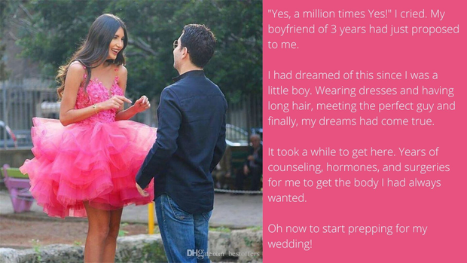

I suppose even cis girls know that there is always the chance that he might his head turned by a womb, which is something that I cannot give. But who needs that when you’ve got this? Am I right?

He thinks so. All I said when I turned up wearing this outfit was “I hope you like your girl to be girly?” And I just tittered a little as a girl should.

“Will you marry me?” He grinned.

“Yes, a million times yes!” You can never be too gushy when a man commits himself to you.

If only he really knew what this means to me. I am not a guy. Not now. Now I am going to be a bride!

The End

Hair Model  Inspired by a Captioned Image by Think Pink  (https://www.deviantart.com/think-pink1)  By Maryanne Peters  He came in through the skylight and managed to get tangled up in the wiring. He took an electric shock when he struggled, so he just hung there until I came back to check the power surge. The poor boy was terrified that he would electrocuted if he moved. He must have been the worst burglar in the world.  I should have been mad, but I just took photos of the hapless criminal. It would be a great story and the police would laugh about it too. I was ready to call them, even though nothing was missing, and the damage was minimal.  He said: “I would never survive jail!” and I believed him. He was small and weak, and “a pretty boy”. He would quickly become the plaything of some prison brute, and I told him as much.  “I can repay you, or surely I can make it up to you somehow,” he said.  “What would I do with a boy. This is a beauty parlor. Not to mention that I would have to doubt you competence to do anything if this in any indication of your skills. Big brown eyes and a mop of good hair might be enough for you to get by as a girl in the world, but they don’t do much for a young man.”  It seemed like those words suddenly made sense to both of us. | 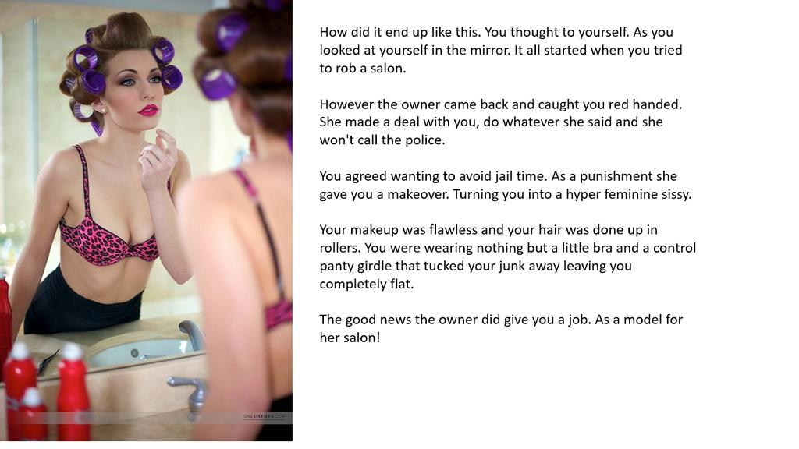

“Let’s just get that hair of your washed and properly conditioned,” I said. “Maybe … just maybe, we can find something for you to do around here, and give you the chance to stay out of jail.”

He had been caught up in a web of wiring, like some hapless bug, but now he found himself in a new web – the silken web of femininity. He could struggle or he could relish that soft silk. Anything was better than facing the consequences of his crime.

That was over a year ago now. To look at him now you would never guess how it all started. The hormones have done their work, and while the boy was far too clumsy to be allowed to use a pair of scissors, he proved very competent with makeup, and practices on his own face constantly. He started out as a hair model, and is still happy to show off the pretty hairstyles I have him wear each day, but now he does facials and makeovers as well. There is no need to resort to crime when you look that good.

The End.

Blonded  Inspired by a Captioned Image by Think Pink  (https://www.deviantart.com/think-pink1)  By Maryanne Peters  Life is hard for a young man of color in this town … Hell, in this whole damn country. In particular if you are small, with not much flesh on your bones, and your only assets big brown eyes, a good set of teeth and a fine head of straight hair. And what kind of assets are those? Well, those were what pulled me out of poverty, and made me rich and happy.  I had to be gay. My mother says she knew it from when I was a baby.  “You are just way too pretty to be a man,” she would say. “Some real man is just going to eat you right up.”  What kind of thing is that to say to a young man? But I guess I just assumed that it would happen. I only hoped that whoever it was would care for me and love me, rather than just fuck me.  My hair was straight so I grew it long and kept it in an oiled braid down my back. It was like one of those Chinese coolies of olden days, so some folks called me “China”. My mother would call me her “China Doll”. | 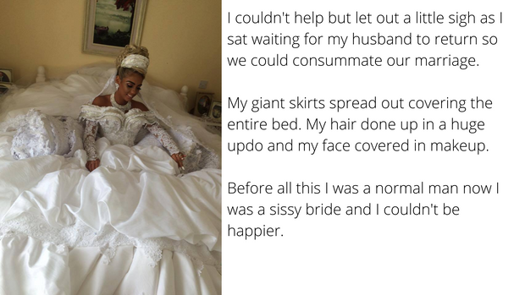

I was not in a position to take offence. I just kept myself to myself and tried not to get hurt. It may sound like a simple enough task, but it is hard for a boy who seems fated to be called a sissy for his whole life, just by the way he looks.

“If only you were a girl, then menfolk would fall over themselves to look after you,” my mother said. “You would just be such a pretty thing.”

I guess that put an idea in my head. I couldn’t do much about school where I was widely known as a sissy boy, but I learned that if I washed my hair and put it in a high ponytail, and I wore a girl’s top with my sneakers and jeans on the street or at the mall, nobody would shout abuse at me. If anything I would get a wolf whistle.

I suppose one thing led to another and I just started to spend more time as a girl. My mother supported me because she wanted to see her child safe. What she said was right – whether or not I was gay was not important – dressed as a girl I was not a sissy – I was normal.

But at school I was now even more of a sissy than I was before. I could not wait to leave. I got a job at the mall working as a shopgirl. I worked in all kinds of stores, but it was when I was working in menswear that I met the man who was to marry me.

“I think you would be prettier as a blond,” he told me.

“If you hadn’t noticed, I’m African American,” I said. But I decided that I would try something new, so I went to the salon and asked for a dye job.

I am not sure if that set me on the path I took or whether I was already on it, but somehow seeing myself with blond hair just made the boy in me disappear completely. With it went any thought that I might have sex with anybody other than him. I gave myself to him completely, and from that point I knew I was not just going to dress as a woman – I needed to be a women – his woman.

Was I ever a normal man? Perhaps I could have been, but as my mother said, I was just way too pretty to be a man. Was I gay from the start? Does it matter now? I am his, and happy to be.

But look at my hair on my wedding day. I am blest with great hair, now blond. I think it suits me. What do you think?

The End

Makeover and Dress Up  Inspired by a Caption image by Think Pink  on Deviant Art  By Maryanne Peters  The games we play as children prepare us for life – don’t you think? We learn to play roles through those childish games. I learned my role that way.  And yet there are plenty of boys who are raised in a house full of girls who did not grow up to be like me. I suppose that means that was different from other boys right from the start.  I howled about being dressed up at first. It was just that the only clothes in the house apart from my own were hand-me-downs from my four older sisters. I wanted to be the price or the cowboy, but I was always consigned to being the princess or the squaw.  As they got older they became more interested in hair and makeup and the game became “Makeover and Dress Up” which really was a game all by itself. One of my sisters went on to make it her profession. All of them practice beauty on a daily basis. They are all very attractive women, my sisters.  So where does that leave me? I used to think that an occasional makeover was all I needed, but now it seems that it is just not enough. | 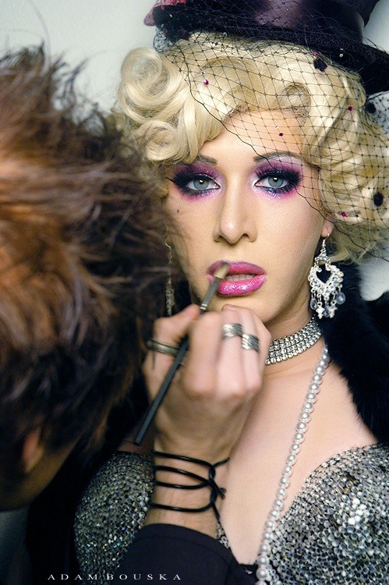  Growing up with all girls in the house was tough. My sisters would only allow me to play with them if I joined in with their girly games. But their favorite was Makeover and Dress Up. They would always be the hair and makeup artist and I would always be the customer. They would dress me up all sorts of outfits. When I complained to Mom she would say that they would grow out of it. Now where adults they still play Makeover and Dress Up with me.

The games we play as children prepare us for life. “Makeover and Dress Up” was always my favorite game. Somehow if makeup and woman’s clothing are not a bigger part of my life it seems as if it is hardly a life at all. I am not sure where this will lead me, but I have a feeling that I am going to love the journey.

The End

© Maryanne Peters 2022

