TG Dream  Inspired by a Captioned Image (??)  BY Maryanne Peters  I suppose people have erotic dreams all the time. I just decided to make my dream a reality. But was it really my decision?  I suppose that I must have had some gay or trans traits deep inside me to get me started, but if I did, they did not emerge until after I was married.  A psychologist might say that I had deep insecurities that allowed Mark to walk into my business and then into my marriage and just take over. I am sure that he would say that the cuckold fantasy is built around that – that I get off on the humiliation. But I don’t feel humiliated.  Perhaps it is David who changes the dynamic. My darling David. How does he fit into this? | 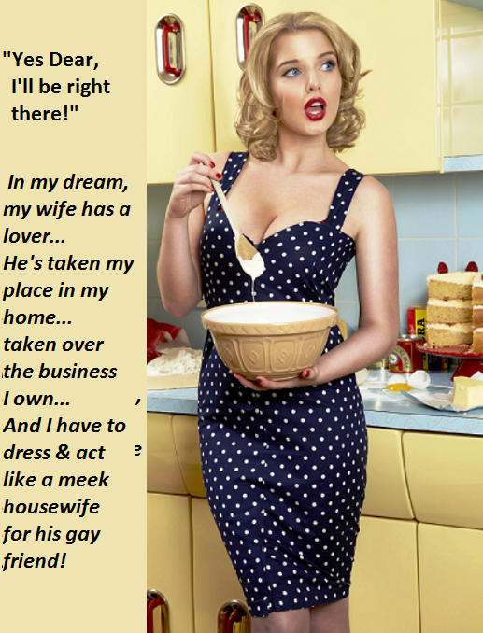

Mark said that his friend was gay. He said that if David fantasized about having me in his bed then he must be gay, because at the time I was living as a man, and a husband. But by then Mark had taken my wife to live at his place that left me in my house with his friend David. If David was gay he might have suggested that I wear short pants in black leather, or a sailor suit. But instead he said that I had to wear dresses all the time, and only leave the house with his permission.

And somehow that was my dream. I dreamed that all of the pressures of the business were lifted from my shoulders, and all the pressures of performing sexually for my wife were too. I was never very good at either. And instead of those pressures all I had to do was to bake cakes and look pretty, and just lie back and let somebody else do the fucking. And it turns out that I can do all of that with no trouble at all.

Don’t try to analyze me and my dreams. Analysis is the first step towards treatment and that is not what I want. I am very happy right where I am.

“Yes Dear, I’ll be right there!”

Best Wife  Inspired by a Captioned Image (??)  By Maryanne Peters  I married my first wife when I was young. All my friends had paired off and had steady girlfriends, and she thought I was great, so I guess I was attracted to her for that reason. We did things with other couples, and as they got married the big question was when we were going to do it. She suggested a date and so I proposed. That was it.  We had three kids. That was probably one more than I wanted, but I love them all. They are my flesh. I am happy to be together with all of my kids, but there came a time when I was not so happy to be together with their mother.  People grow apart … or whatever. I just put up with her. She was always demanding and yet never gave me much. She was lazy, not good at looking after the house, a lousy cook, not great in bed, and not as good a parent as I was. | 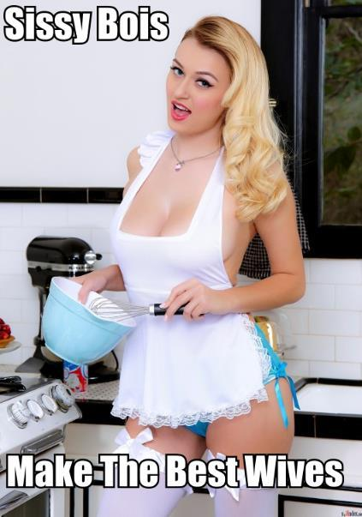

I am not saying I was blameless. You can probably guess – I have my opinions. But I think I am a good person, and better without her.

And after we separated, I found that my business took off too. I paid her out with the house and a lump sum for alimony and then I went to work. There was extra effort, sure, but without her, my head was in the right space. Things went well.

I had my kids every second weekend, and I tried to make that at least a three-day weekend sometimes more. That is giving your kids a better part of you. After all, when their parents were together, they hardly saw the real me. They just saw the man arguing with their mother.

People asked me if I would consider remarrying, but I always said no. My friends who stuck with me after the divorce would sometimes set me up with women, or even put my profile up on dating sites. I just never found somebody suitable.

“Women are too demanding,” I said. “They want to change you and if they can’t they hound you. If they succeed in some way, then they grow to hate the changed person. Women run hot and cold. You never know who you are going to wake up next to. If only there was a woman who really knew what a man wanted. I am not talking about a servant, but an equal - someone focussed on my happiness, not just themselves.”

Ok, so I can go on like that. But I really felt that I was not going to put my hand back into the same fire. I had been burnt once.

Before I start to talk about Crystal, I should state quite clearly that I am not gay. I would not be ashamed of it if I was, but I am not. Or that is my opinion, and you may have another.

One of my friends had a younger brother. I never knew the guy – he was much younger that both of us. This friend asked me whether I would consider giving this brother a job, because he was finding it hard to get work “in his present circumstances”.

“He is trans,” this friend of mine explained. “You know – a sissy boy. Living as a girl full time. He is clever but can’t get the job that he is qualified to do because of the way he dresses. If you say no, I understand. But I have to ask – could you give him a job.”

I looked at the resume and it was just what I needed. It is not that I am a “positive discrimination” employer or anything like that, I just figured that I needed somebody and why should I care what they wear to work provided that it is tidy. So I gave Crystal an interview, with my HR woman beside me.

I have to say that I spent most of the interview trying to see how anybody could mistake this woman for having ever been a man. She had a great body with big breasts under a sensible top, and she had dyed blond hair wore up in a professional style, and she was pretty in a clearly feminine way.

She looked like a woman, so I treated her like one. Sissy boy seemed like an insult in so many ways. I started to think that his brother, my friend, was a bit of a prick.

I think that I could see the way she looked at me, even then. But I am a man, so I guess I just read it as admiration for my achievements as I outlined the business. She just hung on to every word. It is a sure way to ensure that I would give the nod of approval. But my HR assistant confirmed that she ticked every one of her boxes too, so she got the job.

Although she worked mainly in another part of the building, she made a point of bringing stuff to me personally, and when she did it was often accompanied by a beverage and a tasty treat.

“I love to bake,” she said. “I am just a homebody at heart.” Her food was always great. Other stuff too. She said: “I would love to cook for a classy dinner party, but it is just me.”

She lived alone, just like I did. But she cooked and I didn’t – except a plastic tray in the microwave.

I am not sure if it was her idea or mine, but when some overseas visitors suggested a traditional home-cooked meal, she was happy to act as chef and hostess. It is a hard thing for just one person, as I am no help at all, but she did an amazing job.

After they left, I went into the kitchen where she was washing up and offered to pay her for acting as caterer and pay her well.

“No, please. I enjoyed it. I love to cook, and I love people. And your guests were charming. I had a wonderful evening.”

She had cooked and served us an sat with us at the table and nobody had thought for a moment that she was not what she appeared to be - a woman. Perhaps I had drunk a little much wine, but I don’t think so. I was grateful and she was modest and accommodating. And she was dressed well with those impressive breasts on display, and somehow the apron on top of that outfit made her look even better – if that was possible.

I just kissed her – on the mouth. She was a woman, and I was a man. I suppose I was her employer and should have respected those boundaries, but this was my home. It seemed to be not a big issue.

But before I knew it we were in bed and I was fucking her like a man possessed. It never even occurred to me that this was the first time I had ever entered an anus. It was there and it was on offer, and it was tight and squeezing me with practiced skill. It drained me dry.

All I saw and felt were her soft jiggly tits and her long blonde hair. And those eyes. I knew what that look was now: She adored me. There is no aphrodisiac like it.

That is her making me French toast the morning after. The panties and the stockings and that apron. I love that photo. The morning after our first night together. And every morning since seems just as good.

She moved in. My kids love her just as much as I do.

I have a code. No workplace relationships, so she had to resign, once I made her another offer, one where the relationship is the job.

So I married again after all. Maybe just not to a woman, although she is one of those legally now. But she still jokes that: “Sissy boys make the best wives”. Who could argue? Not me.

The End

I Cannot Stop  Inspired by a Captioned Image (??)  By Maryanne Peters  This is first photo she took of me. My girlfriend said that I should call her “Mommy” because she was going to show me who to grow up to be a girl. Maybe I look a little uncertain, maybe a little happy? What I don’t look like is a man.  It’s a wig of course. That was before I grew my hair. The eyebrows were prepared with concealer, which was how I had to do them before they were plucked. The body was all padding, long before the hormones did their work, but those are my legs.  The hormones have now taken a little of the chunkiness in those calves, and in the shoulders. After a year or so you lose size in your muscles, and in your penis.  Back when this image was taken I would have been horrified to imagine that I look the way I do now, but all I saw in the mirror back then was something truly beautiful – something that had to step forward.  After that first experiment with cross-dressing, I found that I could not stop. | 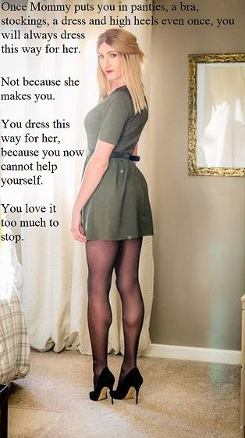

I have heard people call it a fetish. You know – slip on stockings and heels and then you jack off into a tissue. Well, it was not like that for me. Once I saw myself dressed as a woman It was as if I saw myself for the first time. Men’s clothes no longer belonged on my body. It made me sick to wear them. When I got home from work, I would tear them off my body as if they were on fire.

I started think constantly about how I could make changes in my life so that I would never have to wear men’s clothes ever again. That means making the decision that I should live my life permanently as a woman.

You can call it a compulsion if you like, but it was not sexual. It was higher than that, or deeper … or whatever. It was outside my control.

“Mommy” started to worry. I understand why. She wanted a man to have sex with. But she had traded him in for somebody to turn into her very own living doll, a human of (as it turns out) very fragile gender for her to turn into her very own girl-child.

It is not cross-dressing any more. That assumes that you are one thing and cross over to the other side with what you wear. Now I am definitely on that other side, thanks to Mommy.

The End
Division Pink
Who is responsible for the Captioned Image below that inspired this?
By Maryanne Peters

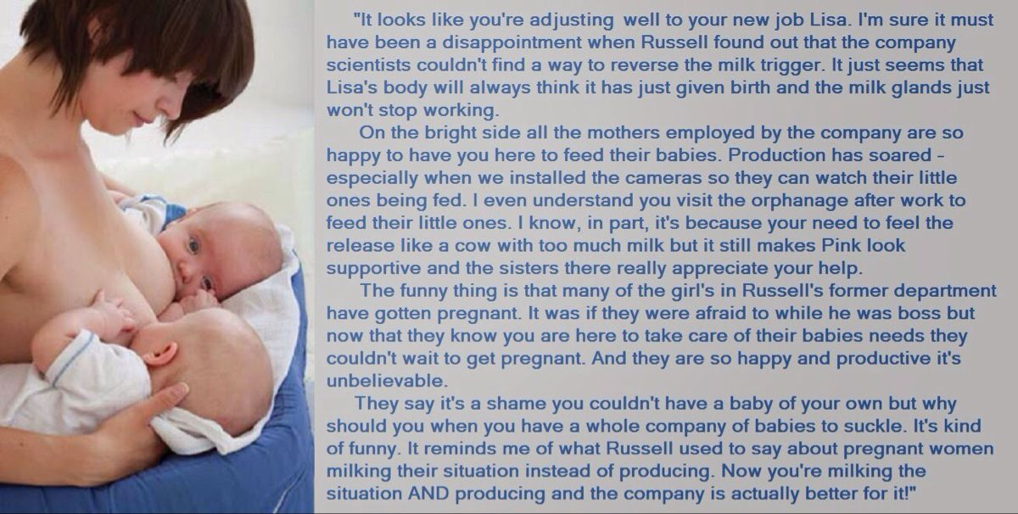

To be honest, I cannot even remember why it had to be me. Maybe it was because I was not one of them. As they say, I can’t be a mother, but that means that I can always produce milk. I have become a permanent whet nurse.

The company had developed a hormone treatment designed to improve the volume and quality of mother’s milk. It may not be well known, but for many mothers their milk is not plentiful enough to feed their newborns, and in some cases does not have the nutritional value that we always expect it should. Some put it down to toxins in our bodies. I don’t know much about it.

In fact I don’t know much about anything anymore. Did I used to be called Russell? Did I used to run Pink, the production division. Everybody calls me Lisa now, and I like that name.

In fact, I like the job. I know that it was given to me as a punishment form making some comments about breast feeding mothers that were way off, even if I had not been working in Division Pink, but now I have learned to love it. The answer is to keep your nipples in good order, and keep your breasts in constant use. Then you can fully appreciate what you are doing when you have small human beings sucking from you, food that your body has created. It seems like a miracle – a beautiful miracle.

The hormones have made me a different person too. I am now a nurturing person and a passive person. I no longer function sexually, but I think that I would be happy to take a passive role in sex. I think that would suit me, if the right guy came along.

But then I don’t have the time. Here, another pair of twins – one on each nipple. I love that.

The End
Dancing Penance  Inspired by a Captioned Image by (??)  By Maryanne Peters  I come from a family of dancers. My parents met while they were both dancing professionally. It was easy to see why they wanted their daughter, my sister, to achieve at the highest level.  I was always looking for something else. Something other than dance. Perhaps something a little risky.  I admitted that the accident was my fault. It was carelessness on my part. She trusted me and I was stupid. I was big enough to take responsibility.  The problem was that it was not only that she would lose her chance to perform the lead role, it was the concern that she would never be able to dance at the highest level again. That would mean that my parent’s ambitions for her would be over.  Then Mom had a searing realization: “You could do it. You could dance the fairy princess!” | 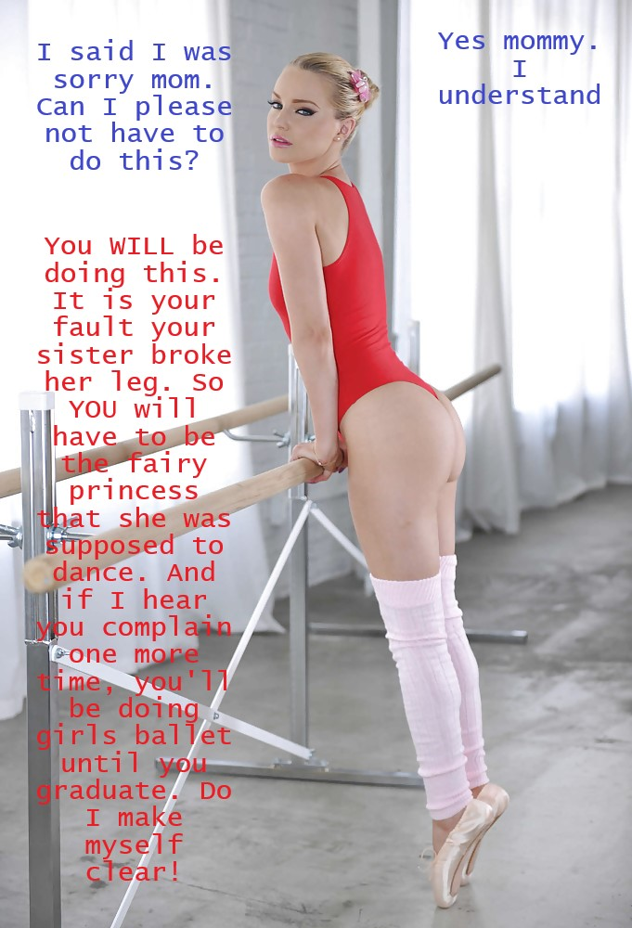

It was true that with a dance room above the garage with mirrors and a bar, the whole family had danced. I had to be included. But I had never even had ballet lessons other than from my parents.

“That is your penance,” my father said. “Tie back that shaggy hair of yours and get ready to become a ballerina. We will introduce you to your sister’s dance master as a cousin and a potential substitute, but you will need to work hard to secure the role.”

“If you do, it will be penance served,” said Mom. “Otherwise you will be doing girls ballet until you graduate.”

It sounded like a horror story. A boy forced to become a ballerina. Forced to cram his junk into a tight panty thing and wear his hair in a bun, and makeup on his face, and to prance around in pink leggings and a tutu.

But I discovered something: Dance is in my blood. Ballet is my heritage. I am naturally graceful. I was born to do this.

I won the role, but I did not stop. I could not stop. Once I had discovered the beauty of dance, I wanted to stay a ballerina, always.

It was not as if I could even drop the female roles and become a male dancer. My place was in the arms of a male dancer – that is what I discovered.

When I graduated I graduated as a woman. More importantly, a woman with a female groin, which is so important for a ballerina. How could I risk doing a penche, an attitude, an arabesque, let alone a grand jete with the risk of having something awful drop out of the bottom of my leotard?

The End

© Maryanne Peters 2022

