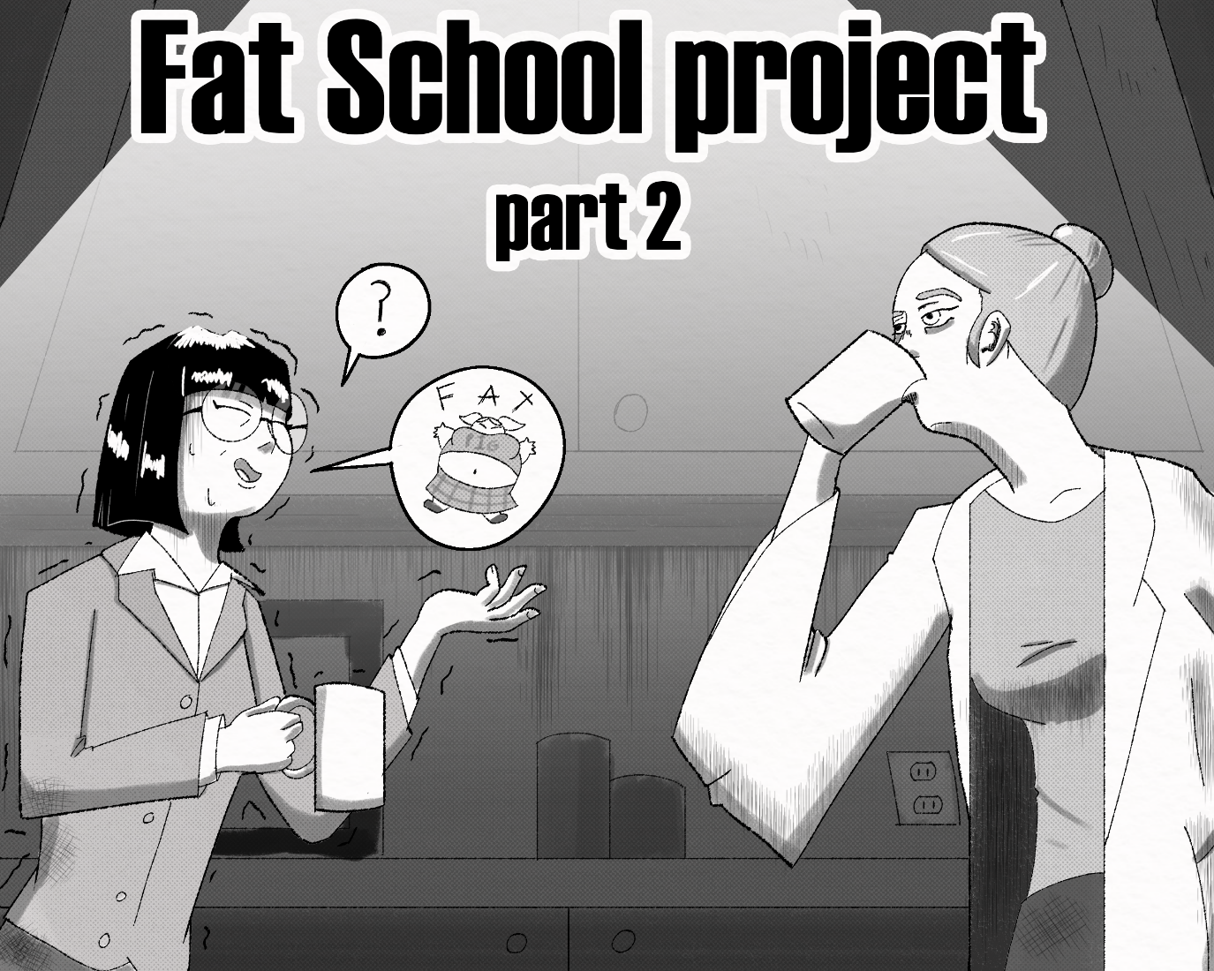
“So, the students get two lunch periods?”
“Yes”
“And if they don't finish their food, it hurts their GPA?”
“Yup”
“And...and the meal portions are triple the national average?”
“Why are you repeating everything I just said?”

It had been 2 months already and Mrs. Kim still wasn't used to this place. She had started to make friends with some of the teachers and they all seemed nice, however.
“B-but isn't that… too much? Don't you think it may be leading to the students becoming a bit...big?” Mrs. Merkel looked at Kim with the same look every teacher gave her when the students' weight was brought up. What, you're not in on the joke? What are you, stupid? Didn’t you get the memo everyone else got?
“Uh, well yeah, what's your point?” The chemistry teacher said, her hands slid into her lab coat pockets.
Ms. Kim fidgeted for a moment.
“I-I'm not trying to body shame, I-I-I j-just, well don't you think, um.” Merkel arched an eyebrow.
“...Never mind”, Ms. Kim relented.
Merkel shrugged.
“Whatever. look I have a lab to teach in five, so I better get going.” she said in a bizarrely standoffish manner.
“Dass sie groß sind, ist der Punkt, du Spaßbremse.” Muttered Merkel. That didn't sound very nice. German never sounded nice but whatever she just said gave Ms. Kim anxiety.
“Oh, I hope I didn't upset her somehow”. After a moment, her curiosity and insecurity got the better of her and she pulled out her phone.
“Um…Dass sie groch sind,..uh...ist der Punkt, du Spachbremse.” she spoke the words into google translate as best she could remember them.
The fact that they're big is the point, you buzzkill.
She just stood there, staring at the translation; the nagging feeling that people at this school were mocking her, intensified.
“Ok that's enough, I'm getting to the bottom of this”.

...

“Ok Class, today we will be learning about chemical reactions!” Exclaimed Merkel in an excited tone. Wow, I've never seen her even smile, let alone get excited, Ms. Kim thought, as she peaked into the chemistry class. She had decided to eavesdrop on other classes to try and glean, well, SOMETHING.
Her own Class was going to have to wait for today, she was utterly fed up, and she was going to figure out what the deal was with this school NOW. I hope no one sees me.
Like every classroom at San Graso, the chemistry lab was huge. And like every classroom, it was full of fat young girls. They had just returned from their second lunch period and most of them looked ready to pass out or POP. The glutted girls huffed and puffed, as their bodies desperately tried to digest.
“I'm sure all of you know what happens when you mix coke and mentos”. Merkel dropped a small tablet into a 2-liter bottle of coke and watched it erupt, fizz going all over the table the bottle was placed.
“This is of course caused by the candy providing a surface for the carbon dioxide in the soda to form bubbles. A 2-liter bottle only contains 15 grams of carbon dioxide, but that can expand to fill over 8 liters.” Mrs. Merkel looked around the classroom, rubbing her chin.
“For today's experiment I'll need a volunteer”
“*BUUUUUURP!!!*”
The sound startled Ms. Kim and caught the attention of Merkel. A devious grin spread across the chemistry teacher's face, as she found the sound’s source.
“Aaahh, Stacy. Feeling a bit gassy, are we?”

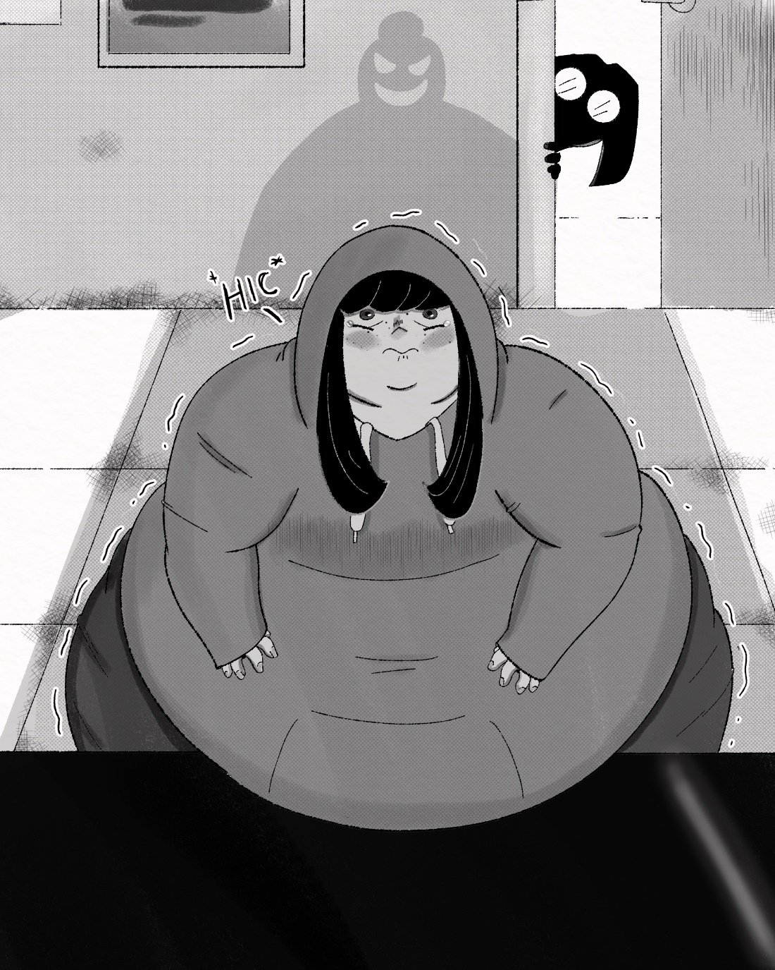
The aforementioned Stacy sat in the corner, clearly trying not to be singled out. She wore a grey hoodie, her eyes covered by dark bangs. She was very short, and very round. Her heavy clothes constrained her soft body into an almost perfect sphere.
“N-no, YES! no, uh...yes?” she stammered. The round little thing looked absolutely terrified. It was obvious that she was, like the rest of the students, extremely full, and she held her ball of a body in fear.
“Of course, you are! Which makes you the perfect volunteer for today's experiment”. Merkel clapped. Stacy's face went pale as a ghost, and she let loose a scared little burp.
Ms. Kim noticed that the other girls seemed visibly relieved, like they all dodged a bullet.
“Ok” squeaked Stacy. I'd love to make that ball squeak and squeak all day lo- FOCUS!
Ms. Kim shook her head and watched Stacy reluctantly go to the front of the class, visibly shaking.
“To demonstrate, I will now have the subject-er- I mean, sweet little Stacy here, take these tablets.” Merkel handed Stacy a roll of mentos and a glass of water. Stacy's body bubbled slightly, and she hiccupped.
“Mrs. Merkel...um *HIC* Do I have to? *HIC* I feel really *urp*...bubbly” Stacy whimpered.
The chemistry teacher shot Stacy a look that could kill and whispered.
“Is that a question?”
Stacy downed the mentos so fast she nearly choked on them. Mrs. Merkel's smile returned.
“Now of course, Mentos contain no carbon dioxide, and once the mento dissolves, the reaction ceases.” Stacy was looking at her gut and gently rubbing it, a look of worry in her big round eyes. Merkel then handed Stacy a 2-liter bottle of soda. This time there was no protest, she obediently started chugging. Wait, is she really going to do a coke and mentos reaction in one of her own students? It was completely ridiculous. And yet Ms. Kim bit her lip in excitement.
“We’ve all done this experiment in grade school and let's be honest, it's gotten old”. Little Stacy let out a small *urp* as she finished the soda.
“Which is why that isn’t soda, and those weren't mentos”. Stacy’s eyes widened in fear.
“W-*urp*what?”
What?
“You see, I wanted to test the limits of this reaction. That liquid you drank and those tablets you took are designed to react with your own stomach acid to produce vast amounts of...ah look its already started”. Stacy suddenly seemed to sway from side to side like she was about to fall over. Her guts started getting loud, gurgles and rumbles sang out from her body and even reverberated out through her throat. Stacy covered her mouth in embarrassment, as her body started to…
Oh. My. GOD.
She started to grow.
“OOOOOHHHHUUUUUUUURRRRP” a moan of discomfort led into a deep long burp. Her stomach, which was already difficult to contain, swelled in one massive growth spurt.
“AH! Don't look at my belly!” Stacy squealed, turning away from the eyes of the class. This did nothing to hide her expanding body though, as the reaction pumped her fuller and fuller.
“Noooo*HUUUUURRRRP*”.
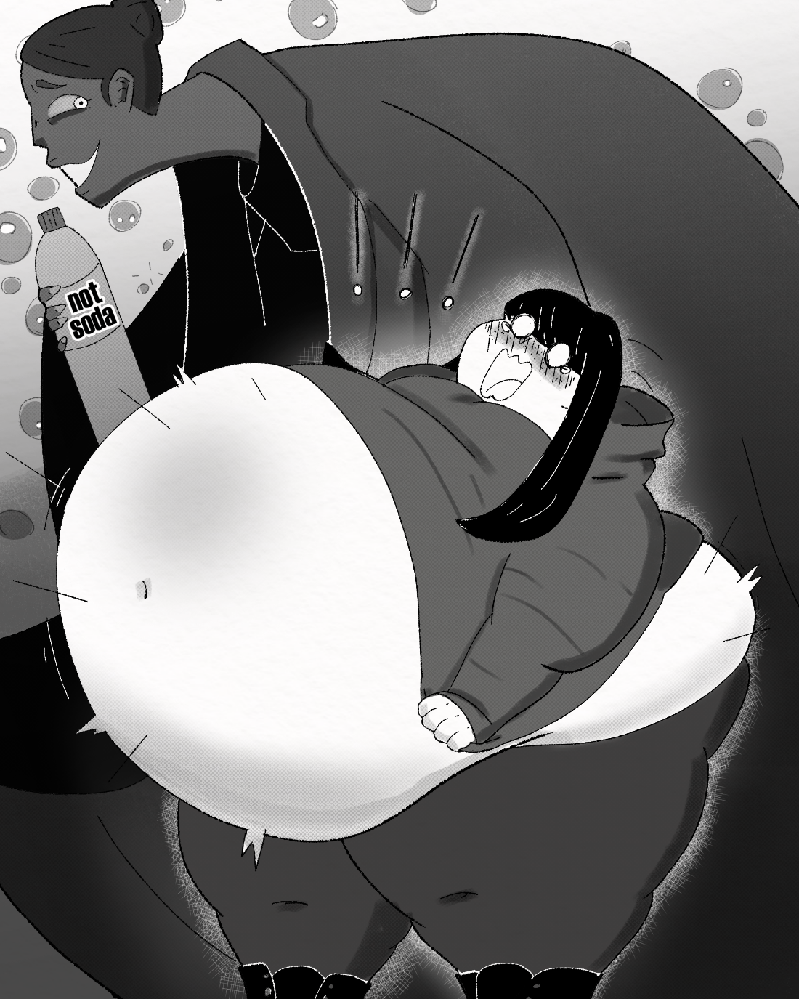
The poor thing was becoming overwhelmed, her fat little butt started to puff out over her sweatpants, her legs spread apart as plump thighs grew into meaty barrels. Her arms grew more rigid, as they grew more bulbous. Even her modest breasts puffed and swelled, two warm marshmallows desperate to escape Stacy's sweater, much to her dismay. No matter how hard she struggled, no matter how much gas she let out, she couldn't seem to get her own growth under control. Then, as soon as it started, it stopped, and her insides quieted down.
Stacy just stood there, humiliated and so, soooooo bloated. She was worried that the slightest movement would shake her up too much and she would simply burst.
“Hm, the reaction stopped...that won't do” Mrs. Merkel then pushed Stacy over with one long finger; the girls' turgid form made it very easy.
“Ah!” Stacy yelped
Ripples went through her body as she hit the floor, making her insides slosh around like a water tank. Ms. Kim leaned in, knowing she should probably intervene but far too invested to stop it now.
“Mrs. Merkel, *HIC* please, no more, I'm so fu-HURP!” Merkel sat on the girl's belly like a yoga ball. This forced a huge amount of gas out of the girl.
“AH! Mrs. Merkel..uuuuhhgh...too-tooo muuuuch”.
''Halt’s Maul!” Merkel slapped the girl's belly in anger, though it seemed less like real anger and more like...Role play.
Kim started to get damp. That's when the German Chemistry teacher started straddling the girl's belly in front of the whole class, her hips engaging in a very sexual gyration.
“Ooooooh god, Mrs. *UUURP* Mrs. MERKEL!!!”
The swollen babe screamed, and Merkel's movements were making Stacy's balloon of a stomach churn and stir. Gradually, Stacy began to grow anew, the reaction coming back on with a vengeance. The other students looked on in amazement, some even seemed to be getting a little too excited.
“YEAH WOO! Pop her Mrs. Merkel!” one student cheered.
Merkel looked over at the cheering girl, as she continued to stir Stacy.
“Warms my heart to see you so..ohhh...enthusiastic about science Brittney...mmmhh..would you like to be tomorrow's test subject-er volunteer?”
The girl in front -Brittney apparently- nodded her head vigorously.
“YES YES YES!!!” said Brittney.
“AAAHHHH Mrs. Merkel, Im gonna!” cried Stacy.
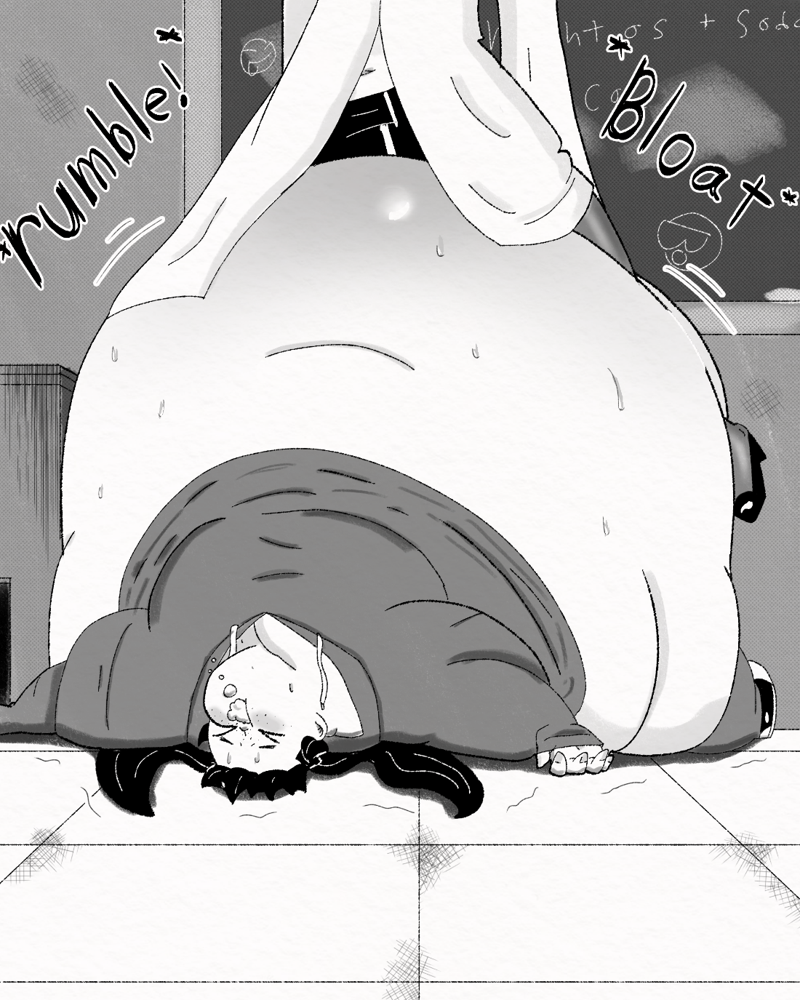
She was beyond massive at this point, her belly was completely round and suddenly seemed to stop growing. Stacy's face went from nauseated to surprised before foam burst from her mouth like a geyser.
“*HICBLUUUUEERCH!!*” The white foam went all over her belly, as well as Merkel.
“What, fatty can’t hold anymore huh? Well, I hope you plan on cleaning this up later you freches luftschiff”.

I need to get out of here.

Ms. Kim Shakely backed away from the Bizarrely erotic scene.
“Ok, what the hell was that?” As she walked away, more sounds could be heard from the home economics class. Dare she look?
Mrs. Kim bit her lip again and cracked open the door. It looked like all the girls in the room had passed out, most looked to be in food comas, as bare bellies were covered in crumbs and sauce. The floor, counters and tables were covered in empty boxes and plates, like there was just some great banquet here. Whatever had happened here it seemed to be over. The girls were stuffed to the gills and supine, their soft vulnerable bellies working overtime while their owners recovered; That is, except for one.
“Well Debra? Can you tell me all the ingredients that went into this pie?”
A motherly looking woman, Ms. Kim knew as Mrs. Butters-No seriously-was standing before an utterly massive student, a true blob of a girl.
“Um...blueberry” Debra huffed.
“Yes” Butters clapped
“fl-*BELCH* flour”
“Yeeees” Mrs. butters agreed
“B-Butter”
“Oh shoot, not quite” Mrs. Butters snapped her fingers
“It was lard. My, my Debra, does someone have too much fat clogging their brain?” Mrs. Butters laughed warmly, like a mother.
Debra looked very tired, Pie filling covered her face, and what Ms. Kim thought was an apron at first, seemed to actually be a massively fattened pale belly. It nearly brushed the floor, and despite how soft and jiggly it looked, how much it protruded out from the girl's body implied it held a truly massive gut load. How much food is inside her? How much more could she hold? How much would it take to make a whale like that completely round? Oh god I wanna know!
It was becoming harder for Ms. Kim to silence That part of her brain. Her thighs were becoming slick with need, and she was glad she didn't wear a skirt, otherwise she would be dripping all over the floor.
“Try again” Mrs. Butters dropped another pie down on the girl’s pontoon bosom.
“Another, OH GAWD” Debra seemed to not want more food, but that didn't stop her from shoving her fat face into the pie to gorge herself even further.
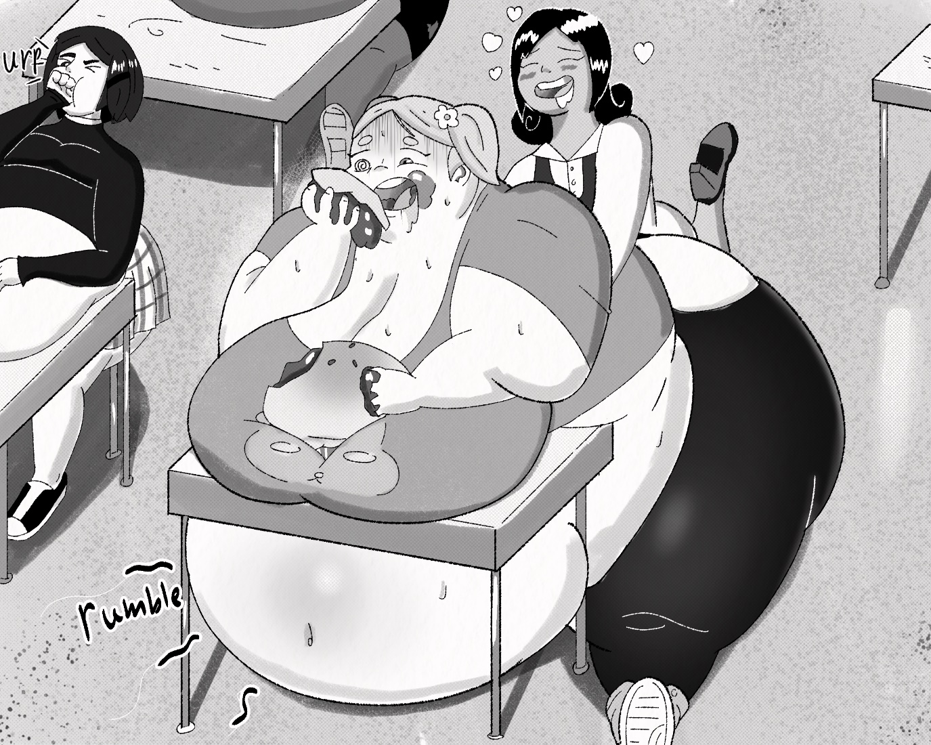“Shoo fuuuul, but pie *OMF* Shoo goood”

The girl was like a dumb cow, her ham planet of a body wobbled as she excitedly chowed down, she had a hungry yet scared look in her eyes, as if she both wanted to keep eating forever, but was terrified of what that would lead to. Awwww is fatty worried about exploding? Hehe, maybe you should be. Mrs. Butters suddenly got a very aroused look and started fondling her student, Squeezing her vast girth.
“Come now Deby weby, if you don't start studying more, then we’ll have to keep doing these extended lessons. I might even have to KEEP YOU...after class I mean” She nuzzled the gorging girl lovingly, looking to be in soft, jiggly heaven. Oh, god, I-I want that, I-I NEEEEED THAT
“What the?” Mrs. Kim jerked back, as she realized that she had been touching herself.
“No, nononononononNO!”, it was coming back, her old desires, her old self, she was-
“Hey who's there?” Mrs. Butters asked from inside. Ms. Kim didn't care about stealth anymore, she just needed to get out of here, so she bolted from the scene. She needed to leave, she needed to get away from all this fat! All this fat, soft juicy delicious-
“NOOOOOO!” she cried. She immediately burst through two double doors into the school gym hoping at least the gym might have some thinner students.
“…Uh oh”
“Come on ladies, you call that cheering!” A row of cheerleaders stood in the gym, bodies flush and fat, slick with pools of sweat. While the cheerleaders were definitely not as fat as some students, that really wasn't saying anything. The uniforms were tight and revealing, clearly made for girls that were not over 200 pounds. Asses were only partially covered by fraying miniskirts, some round, some flat, some smooth, chunky, but all were big, fat and glistening.
“Alright, I guess you girls earned yourselves another food break” Coach Michaels nodded
The chub filled cheerleaders looked at the coach with hopeful eyes.
“But first, ONE. MORE. TIME!!!”
The group groaned and whined before assuming a cheering position.

“FATTIES FATTIES YES WE ARE!
WE ARE BIG FAT SUPERSTARS!

BELLIES BIG AND FULL OF FOOD!
WE EAT MORE THAN ANY DUDE!

ASS LIKE CAKE WE’RE BIG AND FAT!
THUNDER THIGHS GO SLAP SLAP SLAP!

TORPEDO TITS TO FIGHT FOOD WARS!
ALL WE WANT IS MORE MORE MORE!

HELP US FILL OUR APPETITES!
TILL WE BLOW LIKE DYNAMITE!

GOOOOOOOOOOOOOOOOOOOOOO FATTIES!!!!!”

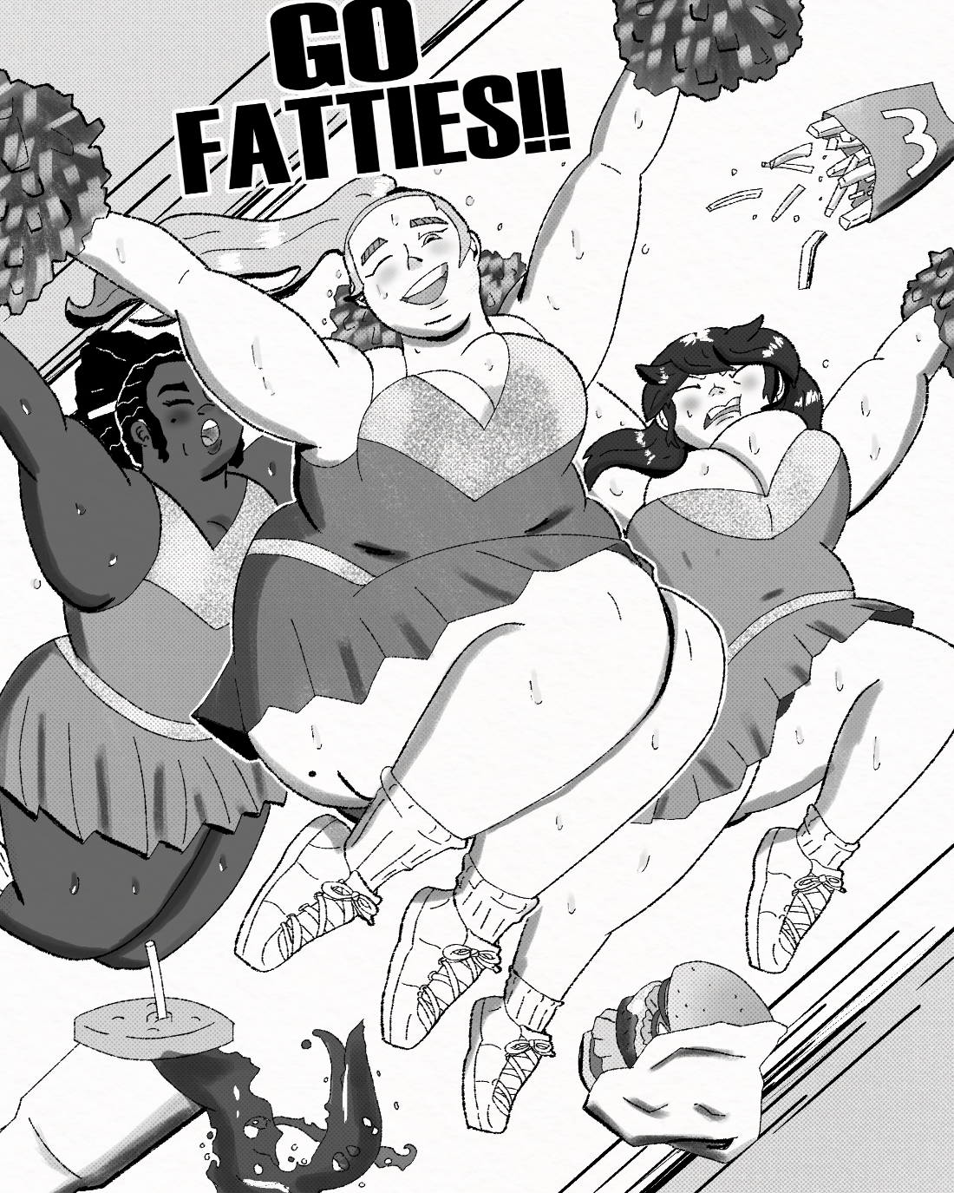

The cheer sent their girthy bodies jiggling and swaying wildly, one girl's tits were so large they nearly jumped out of her uniform, leaving the top half of her mams on full display. Once the cheer ended, the girls collapsed. Some even slipped on the sweat soaked court.
“YEEEAAAH!!! That's what I'm talking about! Great job girls!” The coach gave each of the girl’s large bottles of Gatorade. They all started chugging like people dying in the desert, a few girls even poured the stuff all over their massive overheating bodies. And so Ms. Kim watched, as the group of at least 18 fat, juicy cheerleaders wallowed on the wet floor, like seals. Gulping down air and sugary sports drinks, then started begging for food.
“Huff-Huff, Cooooaaach, I need to -Huff- eat something?”
“Cooooaaaach I’m like, totally-Huff- blech, dying over heeere”
“We can't wait till next period! Pleeeaaaase!” The gym coach laughed.
“Ok ok, wouldn't want my girls going hungry now, you’ll need all your energy to cheer on the eating team this season...Hey! Is that Ms. Kim I see?” Coach Michaels jogged over to the math teacher, all smiles.
“What brings you down here? Math too boring for ya?” she laughed.
Ms. Kim did not respond.

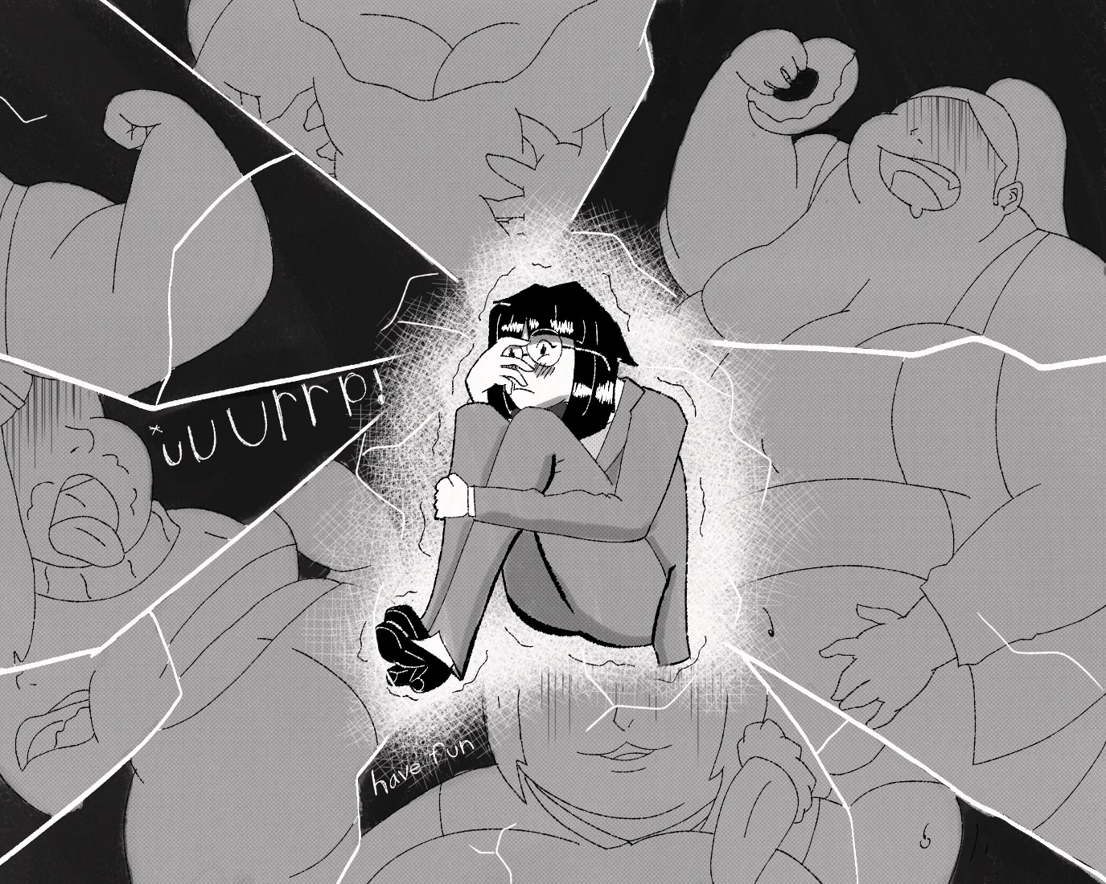
She was sitting with her knees against her chest, and she seemed to be subtly rocking back and forth muttering.
“Uh...hey Ms. Kim. Are you...like...ok?” Michaels asked, her bright demeanor wavering slightly.
“Want...touch...fat…fat girls…so cute...so hot…not fair…”, Kim was muttering like a crazy person.
“Uh...should I call the nurse?” Michaels asked.
“Huh?” Ms. Kim sprang up, startled.
“Oh uh...sorry I was just…” watching the show
“Leaving”, Kim walked away, legs trembling.
Coach Michaels looked at the retreating teacher with concern
“Seriously Mrs. Kim, you don't look so hot”, Your cheer squad sure does.
“Im-Im fine” Mrs. Kim opened the doors, ignoring Michaels concerns. Like babies, the cheerleaders called out again
“Coooooaaaach FOOOOOOOOOD!” they all started whining, nothing but useless piles of meat until they ate something.
“Oh right, hold on girls I just need to-!” Michaels turned back to face Ms. Kim, but she was already gone.

…

“So, I'm very grateful for the position but, I just don’t think I’m right for this school; I’m sorry”.
Across the desk from Ms. Kim was the only man at San Graso High. Principal McClain was a well-built man, tall and lean, with that clean cut look that many government types had. His desk was huge and elevated, making Kim feel small. An aquarium with a back light was all that illuminated the room, creating an ominous blue glow.

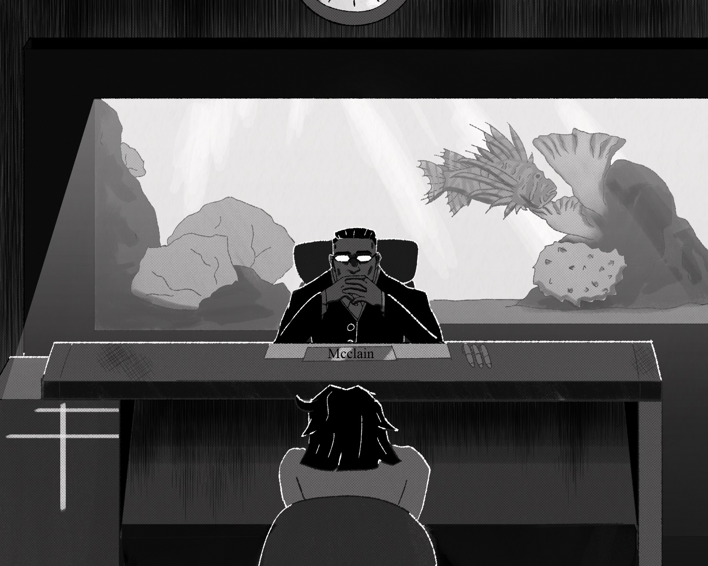

“I see”. There was a deadly silence in the room, and Ms. Kim suddenly felt like there was something wrong.
“Tanner!” The principal called the fat VP from the other room like a dog. There was a loud shuffling and crashing as whatever work she had been doing was most likely on the floor now. Ms. Tanner came in with a smile.
“YES MAST-” she saw Ms. Kim.
“Uh...ehem, yes Mr. McClain?” Why was she blushing?
“Get Ms. Kim's file” he said it while having his eyes locked on Kim. Ms. Tanner rushed to fulfil the demand, another crashing and shuffling later, she was back, with a…Wow.
The file was huge, more like a novel than a file really. Ms. Kim just sat there in nervous, curious silence.
“Tell me Ms. Kim, have the other teachers told you about their previous occupations?” McClain asked. Previous occupations?
“N-no I can't say they have”, Where was this going?
“You’ve already met Mrs. Merkel, right? Well believe it or not she used to be a member of SYNLAB, one of the top medical labs in Germany, hell one of the top medical labs in the world” there was a pause.
“That is, until she started making drugs that induced obesity, increased gastrointestinal activity, turned people into giant blueberries, increased people's appetites to inhuman levels, etc. Of course these were all labeled as side effects in the fine print. It took us a while to realize that the random cases of people expanding out of control were connected, eventually we noticed that all the victims happened to be on the same medications”. He started looking through Ms. Kim's file.
“Mrs. Butters, our sweet home economics teacher, was a head chef at one of the most popular buffets in the Las Vegas strip, until she started making food that would make the Heart Attack grill look like a Whole Foods. Customers had to be fucking rolled out of the place, when they could fit through the door that is. Hell, she even kept one woman trapped in the basement and would feed her leftovers until she filled the damn room; anyway”. Ms. Kim had no words.
“I could go on, the point is that every teacher and faculty member at San Graso was handpicked from different walks of life due to their particular interests, do you understand?”
There it was, the answer that she had been hoping for, but honestly, she never thought she was actually right.
“But...but…” she was stammering, at a loss.
“Why?”
McClain smirked and looked out the window.
“You see Ms. Kim, here's the truth. San Graso is part of a secret government project”.
Oh god
“San Graso, as well as a few other select schools across the nation, have been built with the sole purpose of turning a portion of the female population into a fat, dumb, obedient consumer class; As a way of establishing greater control over the public as well as stimulating the economy.” He spoke coldly, clinically, like he was just talking about work.
“WHAT!?” Ms. Kim stood up, her seat falling down. She was flabbergasted at what she just heard.
“But that's...That's…immoral it-its unethical! Illegal! its-”
“Tell me, does the name Sandra Stewart mean anything to you?” asked McClain.
Ms. Kim froze; her blood turning to ice, her face to stone.
“H-how do you know that name?”
The principal had stopped on a certain page in her “file” and continued reading it.
“It says right here you two used to date. you met in 2009 and dated for 3 years, right?” Ms. Kim didn't answer.
“Over those 3 years she gained over 570 pounds and was described by family during that time as being constantly round and full. This continued until her body couldn't fatten or fill anymore, and she burst from overeating on November 3rd 2012 at 3:45AM.”
Ms. Kim was shaking now
“2013, only one year later, it says here you started dating one Sheila O Connor, this time things lasted 5 years, over that time she had gained a staggering amount of weight. Over 1,260 pounds, though her exact weight could only be guessed at. Until one day Sheila’s neighbors noticed a massive fleshy sphere growing and oozing through her doors and windows. Which then proceeded to turn a deep shade of pink, then red, then BOOM!...apparently it took two weeks to clean your girlfriend off her house, and the streets. But you know it's funny?” McClain eyed Kim.
“At ground zero of both explosions, covered in buckets of food and fat girl...was you.”
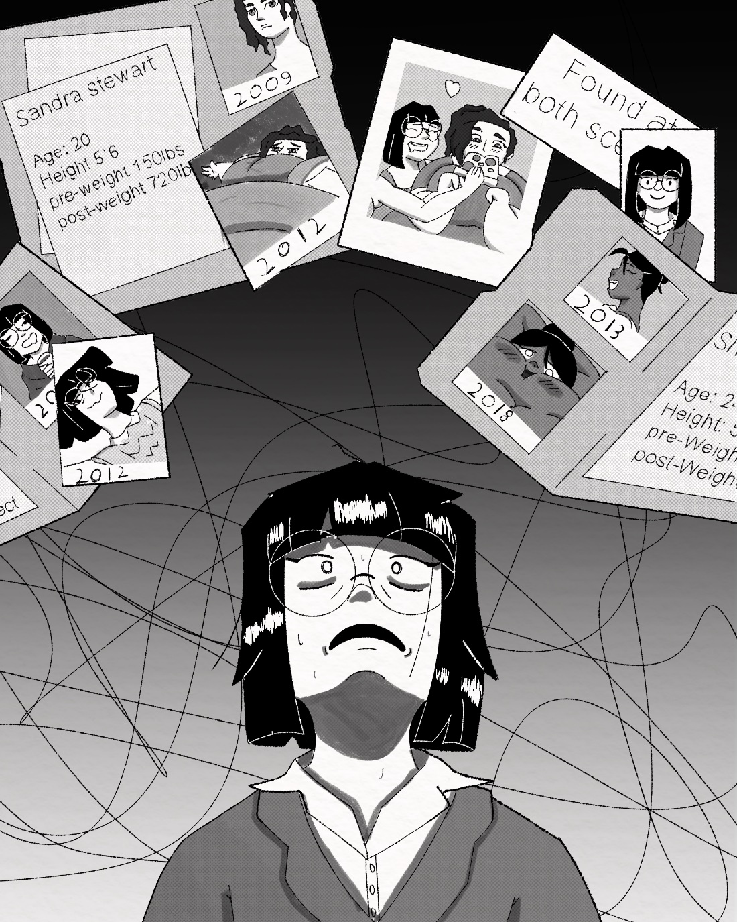
Ms. Kim was hyperventilating now, not only at having such personal information on some FILE…but at remembering the demise …of her former lovers…And how mind blowingly HOT their detonations had been. God I still get wet thinking about it. Principal McClain had walked to the other end of the desk and was standing right over Ms. Kim.
“Usually when we get people… as advanced as you on our teaching staff, they go along with the whole fattening up student’s thing without any questions, when I first saw your file and learned you were a serial Burster well” he chuckled. “I was shocked to find out how resistant you were.” This was madness, absolute madness. This was Hot, so absolutely fucking HOT!
Government conspiracy, hiring dangerous people as teachers, fattening up students. It's just like one of those fetish stories I shlick to every night, is this a dream oh god nobody pinch me! SHUT UP! This is wrong, very very wrong! How can it be wrong if it feels so right?
Kim's face grew more and more horrified.
“N-NO! You're wrong!” she shouted.
“I'm not a burster! Bursters are lunatics with no respect for girl's bodies! I-I just had no impulse control back then! Ok maybe I had a bit of a kink…but I'm better now!” At least that's what the psychiatrists said. McClain rolled his eyes
“Yeah sure, look here's the bottom-line Mrs. Kim, you could quit. You could tell everyone about San Graso, but no one would believe you. You'd be labeled a fat shamer at best and a lunatic at worst; or.”
He leaned forward.
“You could do what you love, what you're best at. you could do what I know you've been dying to do since you got here.” He leaned even closer.
“feed”

…

It was the following morning and first period had started. The students of Ms. Kim's class were relieved to be here, after all, it was probably the one place they wouldn't be relentlessly stuffed by their teacher.
“Hey, I don't mind, every other period I get so fucking full I think I might explode.” one student said.
“What? But that's the best! Getting so full and stuffed, feeling like another bite could set you off, it’s nirvana!” retorted another.
“Seriously Beth, you're gonna end up like one of those girls you see on the News If you don't get your appetite under control”.
Beth scoffed.
“pfffft, you mean those girls that pop just because they eat a little too much? Please, my belly's way tougher than those skinny bitches. just you wait, one day I’ll be so big you’ll have to roll me from place to place, you’ll see!” she slapped her gut proudly.
“Why are you like this?”
As the lardy ladies continued gabbing and babbling about food and their ever-expanding bodies, the door suddenly banged open. Without a word, Ms. Kim walked in, and she was hauling a massive cart. The students all looked on in curiosity, unsure of what to make of the thing.
“Ok Class, today.” Ms. Kim unveiled the cart, revealing stacks and stacks of pizza, at least 50 in total, the students collectively gulped, most in nervousness, some in excitement.
“We are going to be doing some word problems”
Ms. Kim began writing on the white board, seeming to ignore the steaming stack of pizzas entirely.
“Let's say one large pizza contains 400 calories and is cut into 8 slices. How many slices then, would I need to get 1,600 calories? Gabbi!” Ms. Kim pointed her marker at Gabbi, the same girl who had nearly exploded Kim’s first day here.
“Uuummmm”, the problem was something a grade schooler could solve, but for the girls of San Graso it may as well be calculus.
“400!” she said with a confidence only held by the stupid.
“Oh sorry that's wrong, the correct answer was 32”.
“Dang it”, Gabbi snapped her finger.
“Let's try again after you finish your pizza,” Ms. Kim said cheerfully.
Gabbi looked confused.
“What?” Ms. Kim smiled and said,
“The correct answer was 32, so you have to eat 32 slices”. She then proceeded to drop four large pizzas on Gabbi's desk.
“Eat up!”
“Well,” Gabbi fidgeted.
“I guess I am pretty hungry, I'm never full after first lunch”. Gabbi dug in. She was clearly a seasoned eater, taking 4 slices stacked on top of each other and shoving them in her mouth. After 15 slices she was full, after 30 she was stuffed; after 32…
“Uuuugggghhhh *Burp*”, The swollen Latina lay there, stomach round, bloated; face flushed and stained with sauce. Her eyes began to drop, as the food coma was starting to take hold.
“Okay let's try another problem, are you ready for another Gabbi?”, Gabbi's eyes shot open.
“Huh?”
“Oh, you're going to answer questions until you get one right, got it?”
“Uhhh g-got it” Gabbi said reluctantly “I guess I have a little more room”
“Good, now, same problem. 400 calorie pizza and is cut into 8 slices. How many slices would I need to get 4,000 calories?” Gabbi got a look of food drunk determination; using the few brain cells she had, to solve this one problem.
“Uuuuuuuuugh iiiiits uuuuum-No no don't tell me!- uuuuuuu mmfffffffpfpfppfpf… 400?”
“NOPE!” 40 slices, that's 5 large pizzas landed on Gabbi's desk.
“Here I'll help you eat!” Before Gabbi could protest, Ms. Kim grabbed a slice and shoved it in her mouth
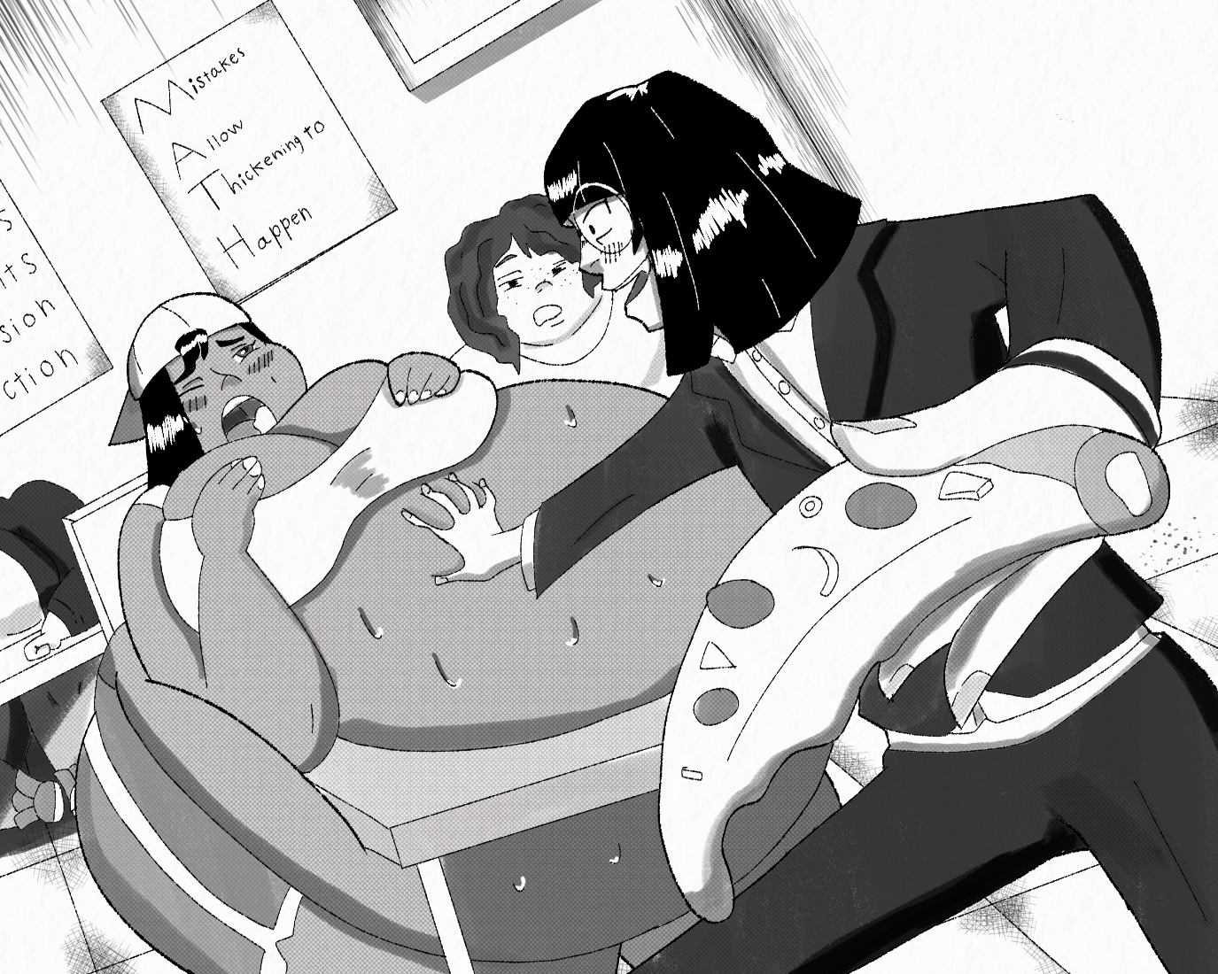“MMMMMMH!” Gabbi moaned
“Don't worry Gabbi, if you fail again, you'll just have to sit on my face as punishment” Chirped Ms. Kim, with a smile that sent chills through Gabbi's blubber. indulging just a bit won't hurt right? we’re not going to pop anyone this time, right? just fattening them up a little, what difference would a few extra pounds make right? RIGHT?
Ms. Kim could feel herself unraveling, the self-control she had spent years building up, was crumbling to dust. And fuck if it didn’t feel good.

