Walkthrough for Shuggerlain v0.90

Prologue Part
After the short intro on the wall, you go to the city. Talk with the wolf girl, Aurora. After that, go to the tavern and talk with Fredic. Keep going and soon you’ll find Aurora again. No matter what you choose, here you will find the first sex battle of the game (tutorial).
After that, go home to keep going with the story.
In the first Battle, the defense of Bertresh, it’s really really hard to lose, but anyway, just feel free to get used to the mechanics of the new system of battles. And yes, the boiling oil is a bit OP. Use it ;)
Before reaching Littanos, you’ll find an event where you save a girl from the attack of a Feran girl. Nothing to do here yet. Keep advancing and go to Littanos.
In Littanos there’s a succubus battle hidden. Check Succubus Guide on this walkthrough to trigger it.
NOTE: Keep in mind that triggering this event makes possible the sex training with her later, when you advance to Eldrien/Nocverchis.

In Littanos Battle just follow the tips on the “Battle Guide” of this walkthrough.
After all that Dynae and you finally share your feelings with each other and magic happens. So here you’ll get the first H-scene with her.
Next morning Saraith will come, then the tale about the 2 dragons will be explained and you finally will find Izuin.
The next day you will recruit Luth, an araxian soldier, as Izuin’s babysitter.
After that, Fredic (that old drunk man from the tavern) will explain you that you can get some special currency after defeating a succubus girl and he will give you some presents you can use to boost your relationship with the girls later. He will also give you some new information about the succubus. Follow the girl to unlock a side event and an H-scene with her.
After that, you can freely depart to Yalen.
YALEN
-Character to unlock: None
-Type of unit to unlock: Mages/range
Go ahead through the plot and soon you will find that an army is waiting for you. Check the “battle guide” for more info about this battle.
After the battle you’ll be able to access to the camp. Do what the game says and visit Nadine to congratulate her for her great job in battle.
Surprise! She’s masturbating thinking about Nulkan. At this point you may want to save your game because you’ll have to decide: let her relieve you or go back to your tent.
-First option will unlock Nadine’s handjob scene + 30 XP points of relationship with Nadine.
-Second option will unlock Dynae’s blowjob scene.
After that, there’s not much more to do so go to your tent and Rest.

The next day is pretty linear, just go ahead and... see what happens.
The next day, you’ll only be able to visit Dynae’s ceremony. Do that.
After the HAPPENING, you’ll talk with Dynae and among other things, she’ll give you the stone of Spatial Convergence. This will be useful for dating other girls.
Ok, so... you’ve heard Dynae. With the current situation, you’ll have to start getting to know better the girls of the game. So from now on, you can spend time with the other girls.
Talk and Ask with them. When your level with one of these girls is 3, you’ll be able to date them. On level 6 you will unlock Date 2 with them, and in level 9 Date 3.
On the dates you’ll only need to select the correct choice to trigger the H-scene. Check the part “Dates Guide” for more info about them.

ADVANCING TO ZONE 1 NATIONS
Note: In Shuggerlain you can ONLY advance to neighbor nations to the one you currently are in the game. For example, you can’t advance from Fernia to Necrosia because there’s Dir-Klou between them. Take this into account while advancing through the map.
You also CAN’T go back to previous zones!
NOCVERCHIS
-Character to unlock: Vex
-Type of unit to unlock: Flying
After the initial dialogue, in the camp just spend some Action points until the evening comes. Vex will show up in the camp, warning you about an attack next day.
Once you’ve won the battle, go ahead and you’ll be in the camp again. To advance through the plot, visit the Shaman.
After talking with the Shaman and once you’re in the camp again, now select Explore the north of Nocverchis, to keep going with the plot.

ELDRIEN
-Character to unlock: Yraselle
-Type of unit to unlock: Archers/Range
Eldrien is pretty linear for now. Just advance through the dialogue. Once in the camp, just spend some AP or you can also directly rest to keep going with the plot.
In the battle you may notice that after 2 enemy turns in the 3rd one Pyrus will appear and cast a fire explosion (this starts happening in the first enemy turn). This is a dangerous attack that inflicts a good amount of damage, so keep in mind to activate Defensive tactics before Pyrus attacks. Other than that, just follow that chart of unit weaknesses and strong points that is some pages below on this walkthrough.
Once the battle is won and you are in your camp, you’ll receive an invitation from the King Aenor. Visit him. After the conversation with him and later with Yraselle, choose “Aenor, you promised me the best archers of the kingdom” otherwise Yraselle will get mad at you (This is not really important, she will only get mad at that moment).
Both options will lead you to an archery tournament with a simple minigame.
You must tell Yraselle the strength and direction of the wind before any shot to make sure she’s able to defeat her opponent. The correct combination is:
1."Strong wind, from the North"
2."Weak wind, from the North-East"
3."Medium wind, from the South"
4."Weak wind, from the South-West"
5."There's no wind at all"
6."Strong wind, from the South”
7."Weak wind, from the South"
8."Medium wind, from the West"
9."Strong wind, from the East"
10."Weak wind, from the North"
And that’s it. Yraselle has impressed everyone thanks to your help and she’ll be ready to join you. If you fail this mini game, later she’ll also join but you won’t be able to improve your relationship with her until you advance to a Zone 3 nation (you can’t reach that zone at this point of development).

IMPORTANT
About Luth: If you don’t reach at least level 7 with Luth before advancing to Zone 2, your relationship with her will get stuck, she won’t be interested in you anymore.

ZONE 2:
FERNIA
-Character to unlock : Atzi
-Type of unit to unlock: Spearmen
In this update you can only advance to Fernia if you are in Eldrien (as it’s the only country in this update that shares borders with it). It is much recommended to advance to Fernia only when your army is pretty recovered from the previous battles.
Advance through the plot that is pretty linear until the fight happens. In the 3 different waves there’re 3 different kind of enemy units so make sure you are using the most effective unit to make sure you don’t suffer too many casualties. As it’s the first battle of Zone 2 and you are almost facing 2 Legions, this is probably the hardest battle for now but luckily, the battle ends once the HP of the wave 3 is reduced to 50%.
Keep going with the plot and when you visit Atzi again after the battle. Just select the option “"Ehm... Ahh... Oof.." as it will give you a small boost of XP points with her.
Atzi will request you to help some of her citizens before departing to a new nation. You can just ignore and keep moving but doing it it will give you a good boost of XP with Atzi, so it’s recommended to do this part to make things go faster with Atzi.
You can visit a dogtor (hah!), a farmer and an actor. All they want different stuff you’ll have to get. Visit the Farmer first. She will give you the alcohol that the doctor will need. Visit the doctor and give him the alcohol, and after that you’ll receive some painkillers that the actors will accept with gratitude. The actor will give you a hat that you’ll have to give to the farmer.
When you’re done, Atzi will express her gratitude (nothing sexy yet, wait a little bit for that, geez). You will receive extra XP with her and you will be able to keep going with the plot.

NECROSIA
-Character to unlock : The Night Queen
-Type of unit to unlock: Mages

Advance a little bit through the plot and a battle will happen. Beat them (you can’t use Nadine against them). To do so, you need to make their HP go under 5000 twice.
After that, at night, the Night Queen challenge will begin. In this challenge you will have to take some decisions. If you get the answers wrong 5 times, the Night Queen will run out of patience and she will kill Nulkan.
The Correct answers for the Swamp path are:
- The water of the swamp
- I see something I don’t like
- I see a betrayal
- Myself
- I Betrayed Bertresh

The Correct answers for the Crawling souls path is:
- We can’t control everything
There are no bad answer for the Mirror Path. Just use all the options until a 4th one appear “Is there anything you regret”?

Alright, you succeed on Night Queen’s challenge and now she will join you. But soon you’ll realize no all the troops are exactly comfortable with the new allies.
You can Play Luth’s game to calm those troops, but you will spend 3 days on this (nothing important in this part of the game, but it will once “DAYS” are a scarce resource).
or
Skip Luth’s mini game and the next day 2000 soldiers will desert.

DIR-KLOU
-Characters to unlock : Hazel/Teigan
-Type of unit to unlock: Healing/Heavy Cavalry
Dirans (Dir) and Klouties (Klou) are the inhabitants of this region of the Neverending Forest. You need to visit both factions and talk to them to try to convince them to join Nulkan’s army. You will need to choose which one you want to help, or just don’t do anything and refuse to recruit any of them.
If you refuse to pact with any nation, you’ll have the option to set a patrol guard between them in an attempt to stop the hostilities between both factions. This has a cost of 4 days but in exchange you will discover the truth about the recent hostilities between these both factions. You will face 2 succubi that were taking advantage of the situation.
This is the hardest sex battle of the game. The possibilities of winning are very low if you hadn’t sex trained enough (we recommend a sex battle HP of around 1800 to be able to win). So basically this route implies fighting and sex training with a good number of the previous succubi.
The reward to this is both Hazel and Teigan joining you BUT just the girls, not their soldiers and that means that you won’t have them in future battles, but you’ll be able to date them both from now on.
As you see, everything has a cost.
If you decide to help one of them, the other will (desperately) ask for help to Arax and they will attack you.
After this, Nulkan will be a bit upset, but Teigan/Hazel will try to cheer him up with the 2nd part of the story of this nation. This part also changes depending and which girl is with you (Hazel or Teigan), and it’s optional. You can leave Dir-Klou without completing the 2nd part, but it’s recommended because it’ll give you more units or more mana for next battles.
You can now choose in your tent “Advance to Kemeq” or Geinvrik (first nations of Zone 3).
However, this won’t take you straight to these nations. The army will set a camp in the middle of the journey. This is something we called zone 2.5*. After a few days resting there, Dynae will ask you to continue your journey. Just accept it.
If you visited Fernia before reaching Zone 2.5, after 3 days Jilliana’s event will trigger and she will join the Ashteran army.
If you didn’t visit Fernia before, Jilliana WON’T join the Ashteran army.

KEMEQ
-Characters to unlock : Zira
-Type of unit to unlock: Flying
Once you reach Kemeq, the plot here is pretty straightforward. Just advance, meet Zira and after that visit the Pharaoh. After the events, you’ll have to attack Lashut, the capital of Kemeq.
Once you win the battle, Zira will ask you to find a girl named Amira, the daughter of the Pharaoh who many people considered dead.
You’ll find her in an orphanage of the city. You’ll need to prepare her for her duty with Kemeq, to be the new Pharaoh of the nation.
You can choose between spending 2 days and help her in her instruction or save those 2 days and keep advancing. If you spend those 2 extra days, Amira will give you 400 more soldiers for the army.

GEINVRIK
Character to unlock: Ragna
Type of unit to unlock: Infantry/Cavalry
The introduction to this nation is rescuing the Geinvrians from the siege of the 5th Legion.
Once you win the battle, just accept the invitation of Ragna and visit her that night.
After the interesting happenings of the banquet, if you have any intentions of developing Ragna as a dateable character, accept go hunting with her. Otherwise, any progression with her will be totally blocked.
During the hunting, there’s a mini game. No matter if you fail to get a lot of preys, Ragna is already a character you can flirt with, but if you want some extra XP with her and unlock the event where she suddenly has a crush on Nulkan, try to hit all 10 targets. With all 10 targets you’ll also get extra soldiers. There’s an auto save just before the hunting mini game begins. So feel free to try as many times as you need.

SYQUA
Character to unlock: Koa
Type of unit to unlock: Spearmen (not available yet in v0.73)
To be able to travel to this archipelago you have to complete Kemeq first, as Nulkan departs to Syqua from Kemeq’s port. It’s also very recommended to go there when you have completed date 2 with the girls in the camp (reason explained 3 paragraphs below).
Then just select this option on the map on your tent.
The plot is pretty straightforward, you meet some new characters and stuff and in the end you’ll find youserlf challenging Kao’le to a Pa’kua match.
After some days of training, you’ll have to complete this minigame and win to be able to recruit the Syquanites. During the training you can practice a little, and we recommend you not to skip the training until you know the mechanics.
Keep in mind that losing against Kao’le is a Game Over. So better save before the match in case you need to try several times to win.
After winning, it comes the second part of the “plot” in Syqua which is spending 7 or more days there with the girls until you can return to Kemeq with your troops.
So basically you can spend some time with the girls until you are able to come back or just pass days to be able to return to Kemeq.
Each girl has a side event (spend the day with her) and each event has an H-scene animation that will be available ONLY if you completed date 2 with that girl (in other words, you already had sex with her). So that why going to Syqua with some progress with your girls is a good idea if you want to unlock their Sex scenes.

SIANN
Once you completed any of the battles of the nations in Zone 2 that share borders with Siann, you will be able to proceed to this nation. Just take the decision on the map in your tent. A soldier will show up announcing that 2 Siannese fox girls arrived, they are Lin Shun and Lin Mai.
After this event, you will keep advancing to Siann. Once there, Wellion’s army will be waiting for you. After chatting with him, you’ll see you have the option to make a deal with him to avoid that battle. If you want to receive the Siannese Unit, be able to date Shun and Mai and keep increasing your army size, you’ll have to refuse any deal and fight.
During the battle, every 3 enemy turns, a volley of Siannese Musketeers will hit you. Try to enable defensive tactics always before receiving their attack or you could lose the battle.
Once you’ve achieved victory, you’ll be able to improve Siann’s government with an event that takes 4 days. Completing it will give a boost on your relationship with Mai and Shun and you’ll receive even more soldiers for your army.
In this update, once you’ve completed all this, you’ll be able to Advance to Arax! But this, for now, will only trigger and event about Taulon and Wellion. This event goes to the credits of the game, so save before if you want to keep doing stuff on the camp.

ARAX (Part1)
Once you complete any of the nation storylines in Zone 3, you will be able to cross the Araxian borders and venture deeper than ever into enemy territory.
Before doing so, it's important to note that depending on which country you are in within Zone 3, you will be able to enter Arax through one of three distinct regions: GreyRock, Velmor, and Frostmere.
Access to these regions is as follows:
- Kemeq: GreyRock and Velmor
- Sian: GreyRock, Velmor, and Frostmere
- Geinvrik: Velmor and Frostmere
Why is this important? Because each of these regions offers two different types of boosts for your army to aid you in the upcoming battles in Arax.
Therefore, it’s crucial to consider the biggest weaknesses of your army and try to compensate for them with one of the available boosts.
The options and boosts offered by each region are as follows:
GreyRock
- "Trust Izuin": Increases Izuin’s attack rate.
- "Coordinate the soldiers to evacuate everyone": +1 Action Point in battle.
Velmor
- "Dynae, freeze the waterfall": You’ll start the battle with 250 extra mana points.
- "Dynae, use your thunder to trigger the trap from a distance": Attacking 4 times in the same turn creates an additional attack.
Frostmere
- "Dynae, you must stop the blizzard”: Extra mana is generated after each turn and after every attack (Requirement: Hazel recruited.)
- "We will advance slowly using defensive tactics": Defensive tactics are now more effective.
After completing the storyline rest and after a few days Qurmenith event will trigger. More info some pages below on the succubi section

Dates guide
These are the correct decision that will trigger the H-scene on the dates with every girl.

Nadine
Date 1: Kiss her
Date 2: No. Enough for today.
Luth
Date 1: Obey the voice.
Date2: Get to know her better.
Date3: I see the bravest woman I know.
Saraith
Date 1: Move her away by her shoulders.
Date 2: I will not be prey.
Date 3: Awake her demon side.
Vex*
Date 1: Think about it.
Date 2: Offer her some bread and some lunch meat you have.
Date 3: That means nothing.
Yraselle*
Date 1: Did you really want to marry Pyrus?
Date 2 : Choose talk with Dynae or with the Night Queen (if available).
Once you choose one of these options, you can’t change your decision, so you can’t redo dates 1 and 2 with her. If you choose the Night Queen, Yraselle will change her hairstyle and hair color, and she’ll wear a dark staff.
Date 3: You know you are only delaying the inevitable…
Atzi*
Date 1: Honestly, I’m unable to think properly.
Date 2: Stay with the creature.
Date 3: The same as Drascys had in mind
The Night Queen*
Date1: Look at it.
Date2: Expel the demon.
Date3: Well, then. What are you waiting for?
Hazel*
Date 1: In that case, I guess we only need to find...
Date 2: Yes. Let’s do it.
Date 3: You can count on me.

Teigan*
Date 1: Just look at her.
Date 2: Don’t you need to get some exercise like on our previous date?
Date 3: Encourage her to drink more.

Jilliana
Date1: There’s a demon that makes you feel horny 24/7.
Date 2: Reply to her.
Date3: Soldiers should defend civilians, not the other way around.
Zira*
Date1: Alright, Zira. There is something you can do for me.
Date2: You have reason enough to wish for that.
Date3: My muscles are still sore. A massage would feel great.
Ragna*
Date1: No, I don’t.
Date2: I delivered her from her curse
Date3: To your house, like the time you invited us to a feast.
Koa*
Date1: Is that what I think it is?
Date2: The night is young!
Date3: Let’s do it anyway.

Lin Mai & Lin Shun*:
Date 1: Say nothing and focus on resisting the urge.
Date 2**: I’m sure everything is fine. Just keep waiting.
Date 3: Let's continue exploring the city a little more.
**After completing Shun and Mai date 2 they will join the Siannese Muskeeters in battles and unlock this unit’s second attack.

Izuin
In Zone 2, visit Luth and an event with Izuin will trigger. From now on you’ll be able to visit Izuin in her own tent. Dates at this point of the game are basically spending some time with her. There are 3 differents events that can happen if you visit Izuin while she’s a teenager.
Once you are in Zone 2.5, Izuin will be an adult woman. There will be an event introducing this change and also you can talk a bit with her in her tent. Nothing too relevant at this point.
But after completing the plot in Kemeq or Geinvrik, there should start an event where some Araxian soldiers kidnap Izuin following the orders of Agasitre.
After this dramatic event, you will have to choose what Izuin means for you:
-If you choose “To lose my child, again” you consider Izuin your daughter and she considers you her father, so this will be your relationship from now on. This unlocks a new talk option in the tent but nothing more so far.
-If you completed her teenage events you’ll be able to choose "To lose the woman I love, again.” If you see this option in grey, that means you didn’t do her teenage events.
With this option you’ll consider Izuin as the woman you love and a sex scene will happen. This also will unlock a few new options in her tent, new talk options, kissing her and intimate, where quickly Izuin and Nulkan will have sex in her tent.
After getting 5 points of intimate interactions with Izuin (Intimate = 2 points, Intimate talk = 1 point or Kiss = 1 point), there will be a new option called “Event!”. This will make you advance one more step on your relationship with Izuin. A new sex scene will happen in this event.
Izuin has 3 different relationship status levels:
1.Strong attraction
2.Lovers
3.Soulmate
To unlock the new relationship level just keep interacting with her and there eventually show up again the “Event!” option that will lead to a new event with her and a new H-scene.
The soulmate level also unlocks quickie sex with her. As the rest of the girls, just interact twice with her and then kiss her, with a corruption level above 50%.

*Dates with these girls are available once you are an ally of their nations.

Succubi Guide
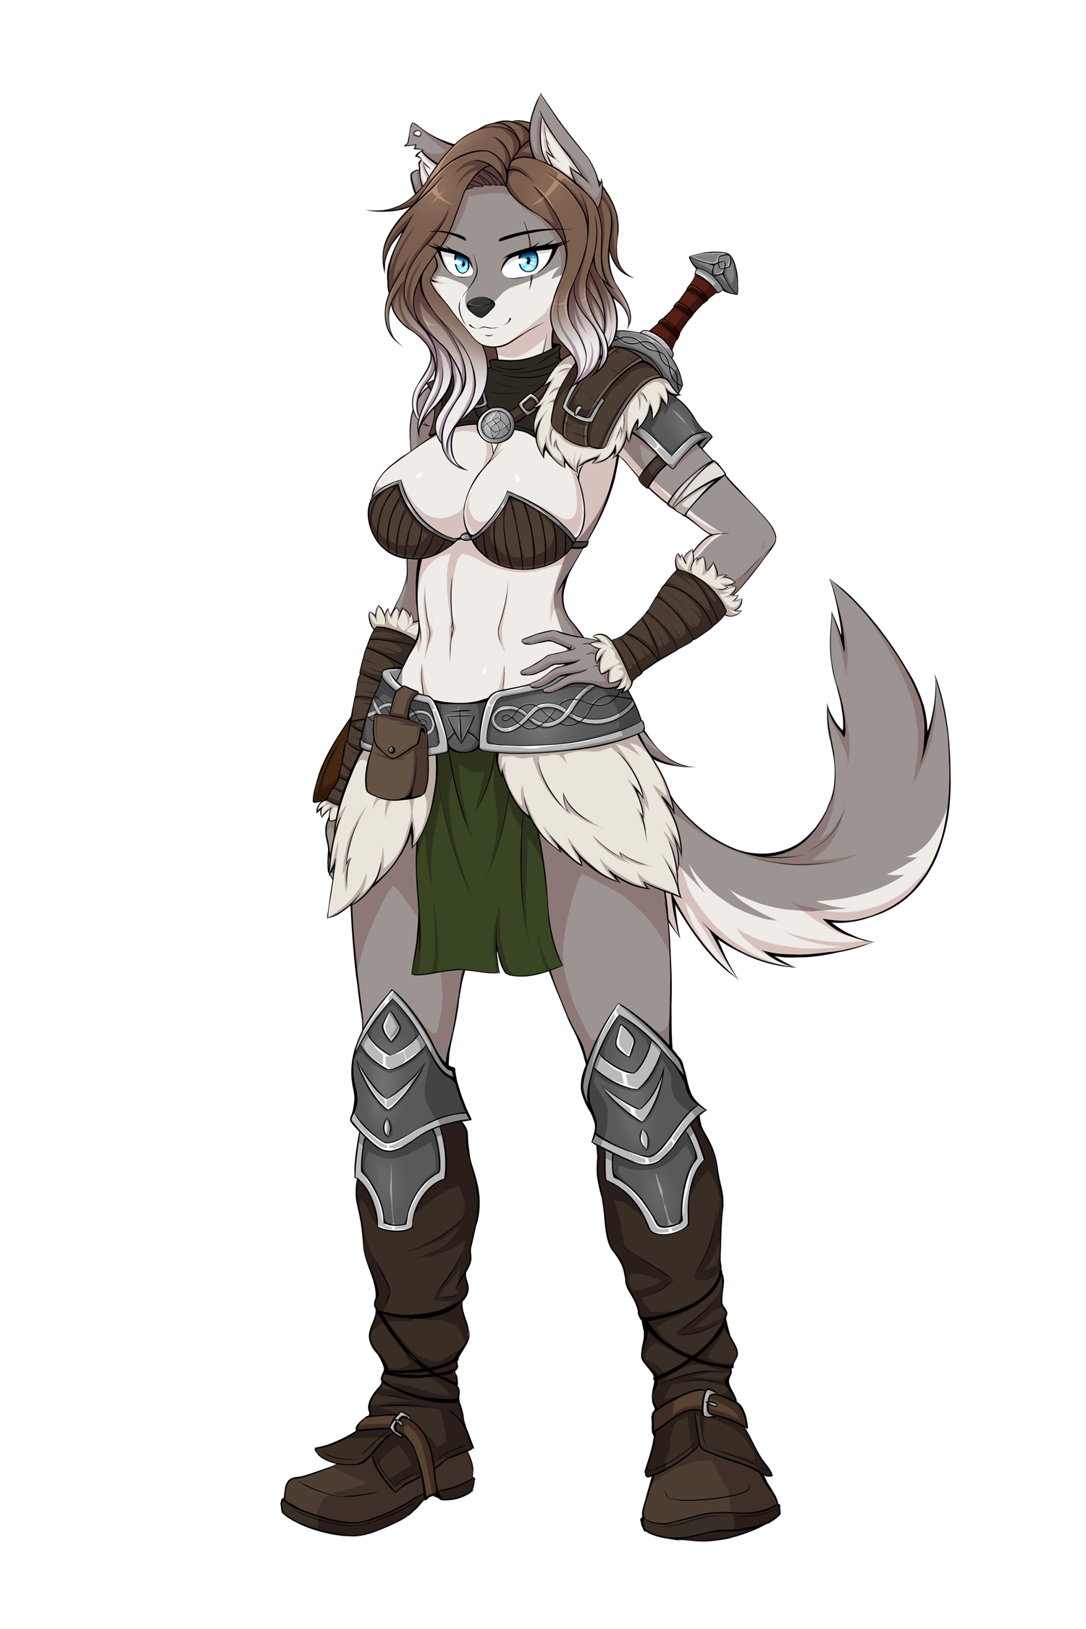

AURORA SEX BATTLE
Start the game from the prologue. You’ll see her in Bertresh. Talk with her, after that go to the tavern and after that choose “Follow her”.

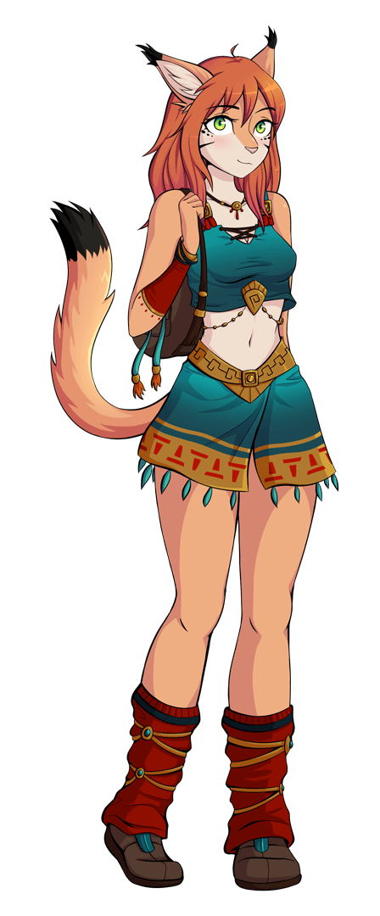

MISHA SEX BATTLE
Just to make sure to trigger the succubus battle in Littanos, make sure to have breakfast both times you have that option available. Otherwise she won’t appear and you’ll miss the event.
After that, you only need to have a walk at night with Dynae to activate the event.
After Dynae leaves with the two Ashteran girls, Misha will appear. At that point select free her to start the combat. “Scare her” option will do exactly that and you’ll miss the event.

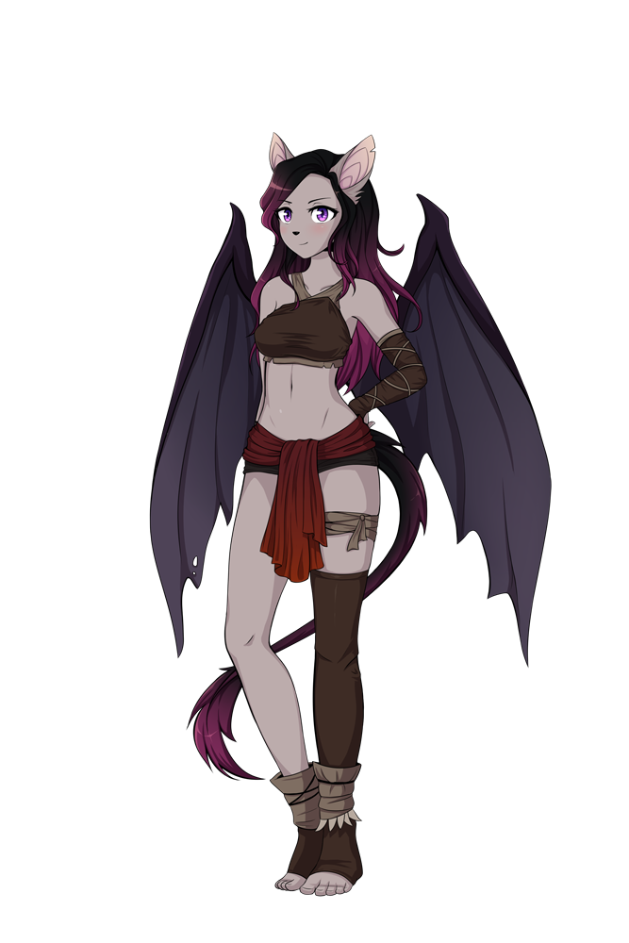
GIFRIX SEX BATTLE
To trigger it, wait at least until day 7 in Yalen. Then, in the camp, select “Take a walk through camp’s surroundings” when your actions points are just 1.
Tips
Gifrix is a Nocverchian, a bat-human race. She will regenerate after any attack where she uses her mouth and gets Nulkan’s fluids. These attacks are:
[You kiss her] [She kisses you] [Lick tip] [Blowjob]
You want to avoid these attacks. Well, in fact, the only thing you can avoid is kissing her, so at the beginning just kiss her neck.

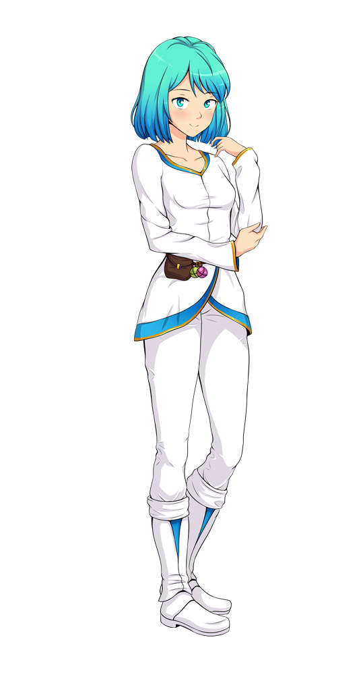
IONE SEX BATTLE

To trigger this event you need to spend 6 days on the camp being in Nocverchis. When the event starts, three Yalenite mages will talk with Nulkan. Select “Go ahead with the tests”
Now you have 3 different options. All of them will unlock some sexy content:
- Go behind the trees: Ione will drink Nulkan’s cum from a flask.
- I’d need something enticing...: shows a topless Ione.
- Reject: to start the sex battle.

This battle is a bit harder because Ione has some really powerful attacks and some supposedly Nulkan strong attacks don’t do much damage on her. Some Sex Training can help making things easier.

Tips:
-Her neck is her weak point. Focus on it at the beginning.
- Fingering is not much effective
- Sex is effective, but Nulkan also will suffer damage from this move.
- Assjob, blowjob and especially titjob are the most dangerous attacks from her.

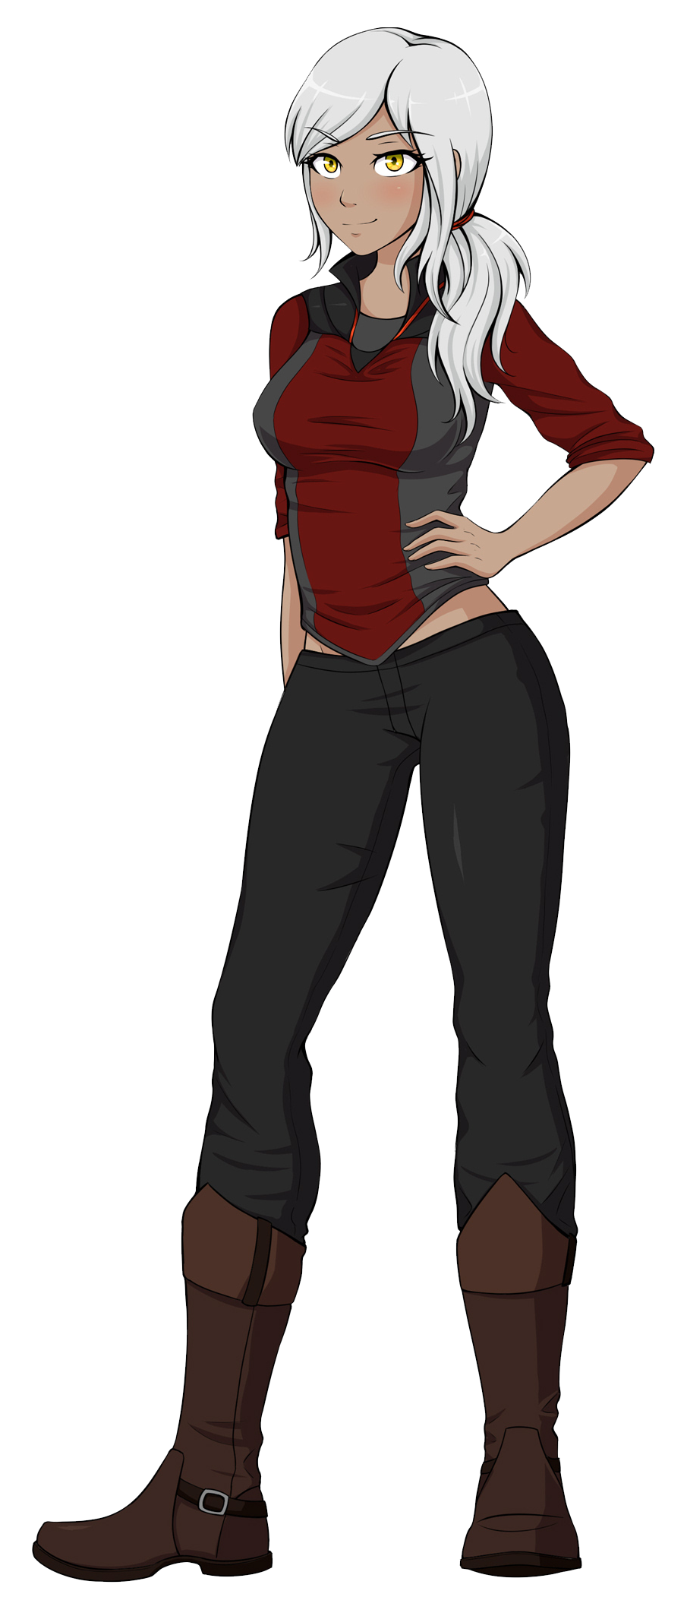
ZOE SEX BATTLE

Zoe appears in your tent after you visit Nadine twice being in Eldrien. Nadine will come and they both will have a bit tense moment.
After that happening Zoe will come back. Then you should select:
"I can’t do that. Nadine is an important person to me."
After being refused she will come back again and then you need to choose:
"No. I don’t want to hurt Nadine."
And Sex battle will start.

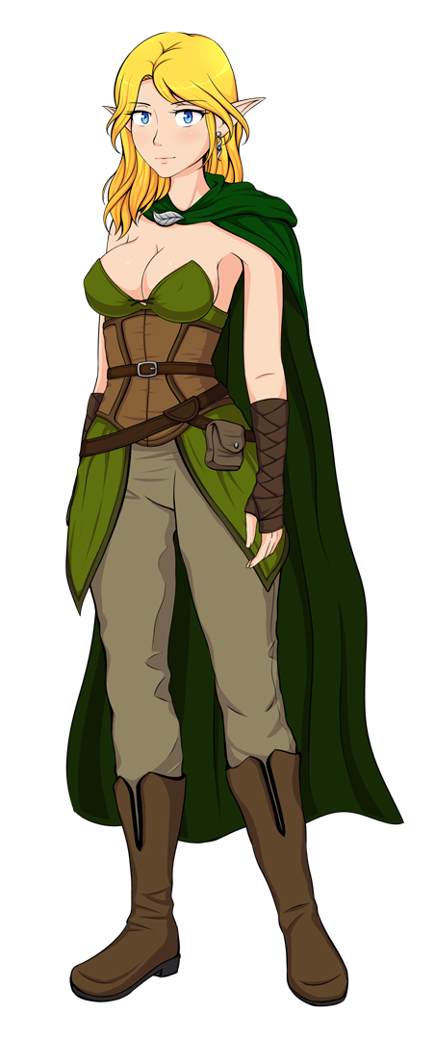
ANWEN SEX BATTLE
To trigger the event you first need to reach level 3 with Yraselle and also 5 days should have passed since the Battle of Fernia.
Yraselle will come to you and she will introduce you an Eldrienite with red eyes.
From that day, at night you can visist Anwen’s Watch. Don’t accept the offers she will make you to avoid the fight.
After that, the sex battle with start.
If you decline the first offer to leave you alone but accept the second offer, you’ll get crystals, but you won’t fight with her.

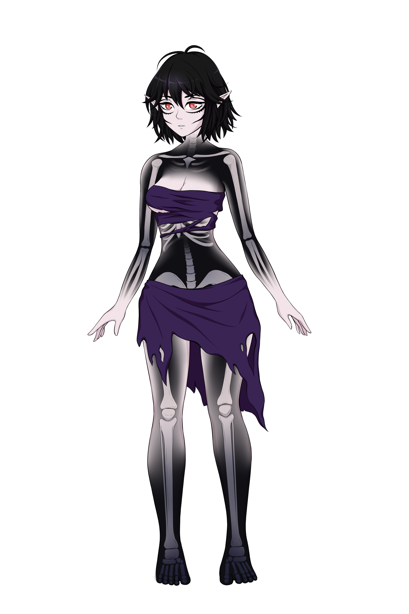
ULAITHEL SEX BATTLE
In first place, you need to recruit the Night Queen in Necrosia. Then
Once you decide to play or not Luth’s game, Ulaithel will appear 5 days after that. That means if you played Luth’s games (which cost 3 days) you still will have to wait 2 more days. If you didn’t play the games you just have to wait 5 days.
After these days, you’ll find the Night Queen on the bottom left part of the camp. Click on her to activate the event.
After this conversation, check camp surroundings 3 days after the conversation with the Night Queen, and there you will find Ulaithel.

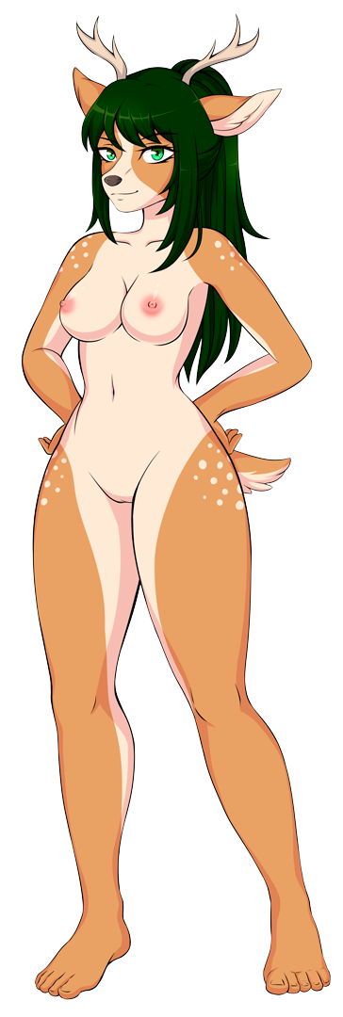
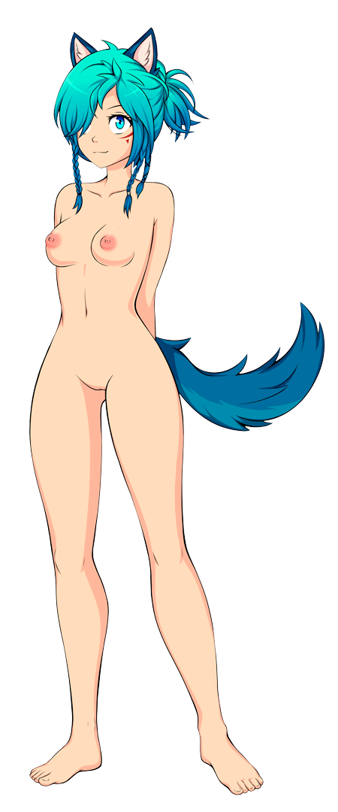Khara and Maple Sex Battle

As it is explained in Dir-Klou plot, you don’t pact with any factions and accept setting a patrol guard.
The 4th day of patrol they will show up.
At least you should have around 1800 HP if you want to win this fight. They have more HP than any other Succubus, and some of their attacks, especially assjob and anal, are very strong.

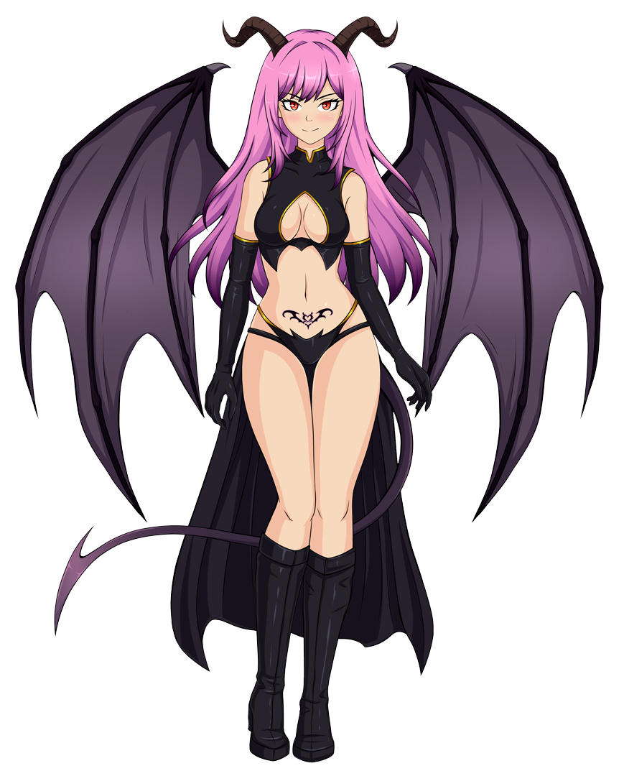
Aries Sex Battle
The first High Succubus of the Game. Direct servant of the Queen Succubus Qurmenith.
You will find her in Kemeq if you beat at least 4 of the previous succubi and completed Kemeq’s plot. Then walk around the camp at night and you will find her.
This girl ignores kiss and neck attacks, so she’s dealing more damage from the start. Also delivering from her attacks is a bit harder as you should also hit a moving lock after the resist phase. If you miss, the attack keeps going and you’ll have to start again the resist phase.

Nuditon sex battle

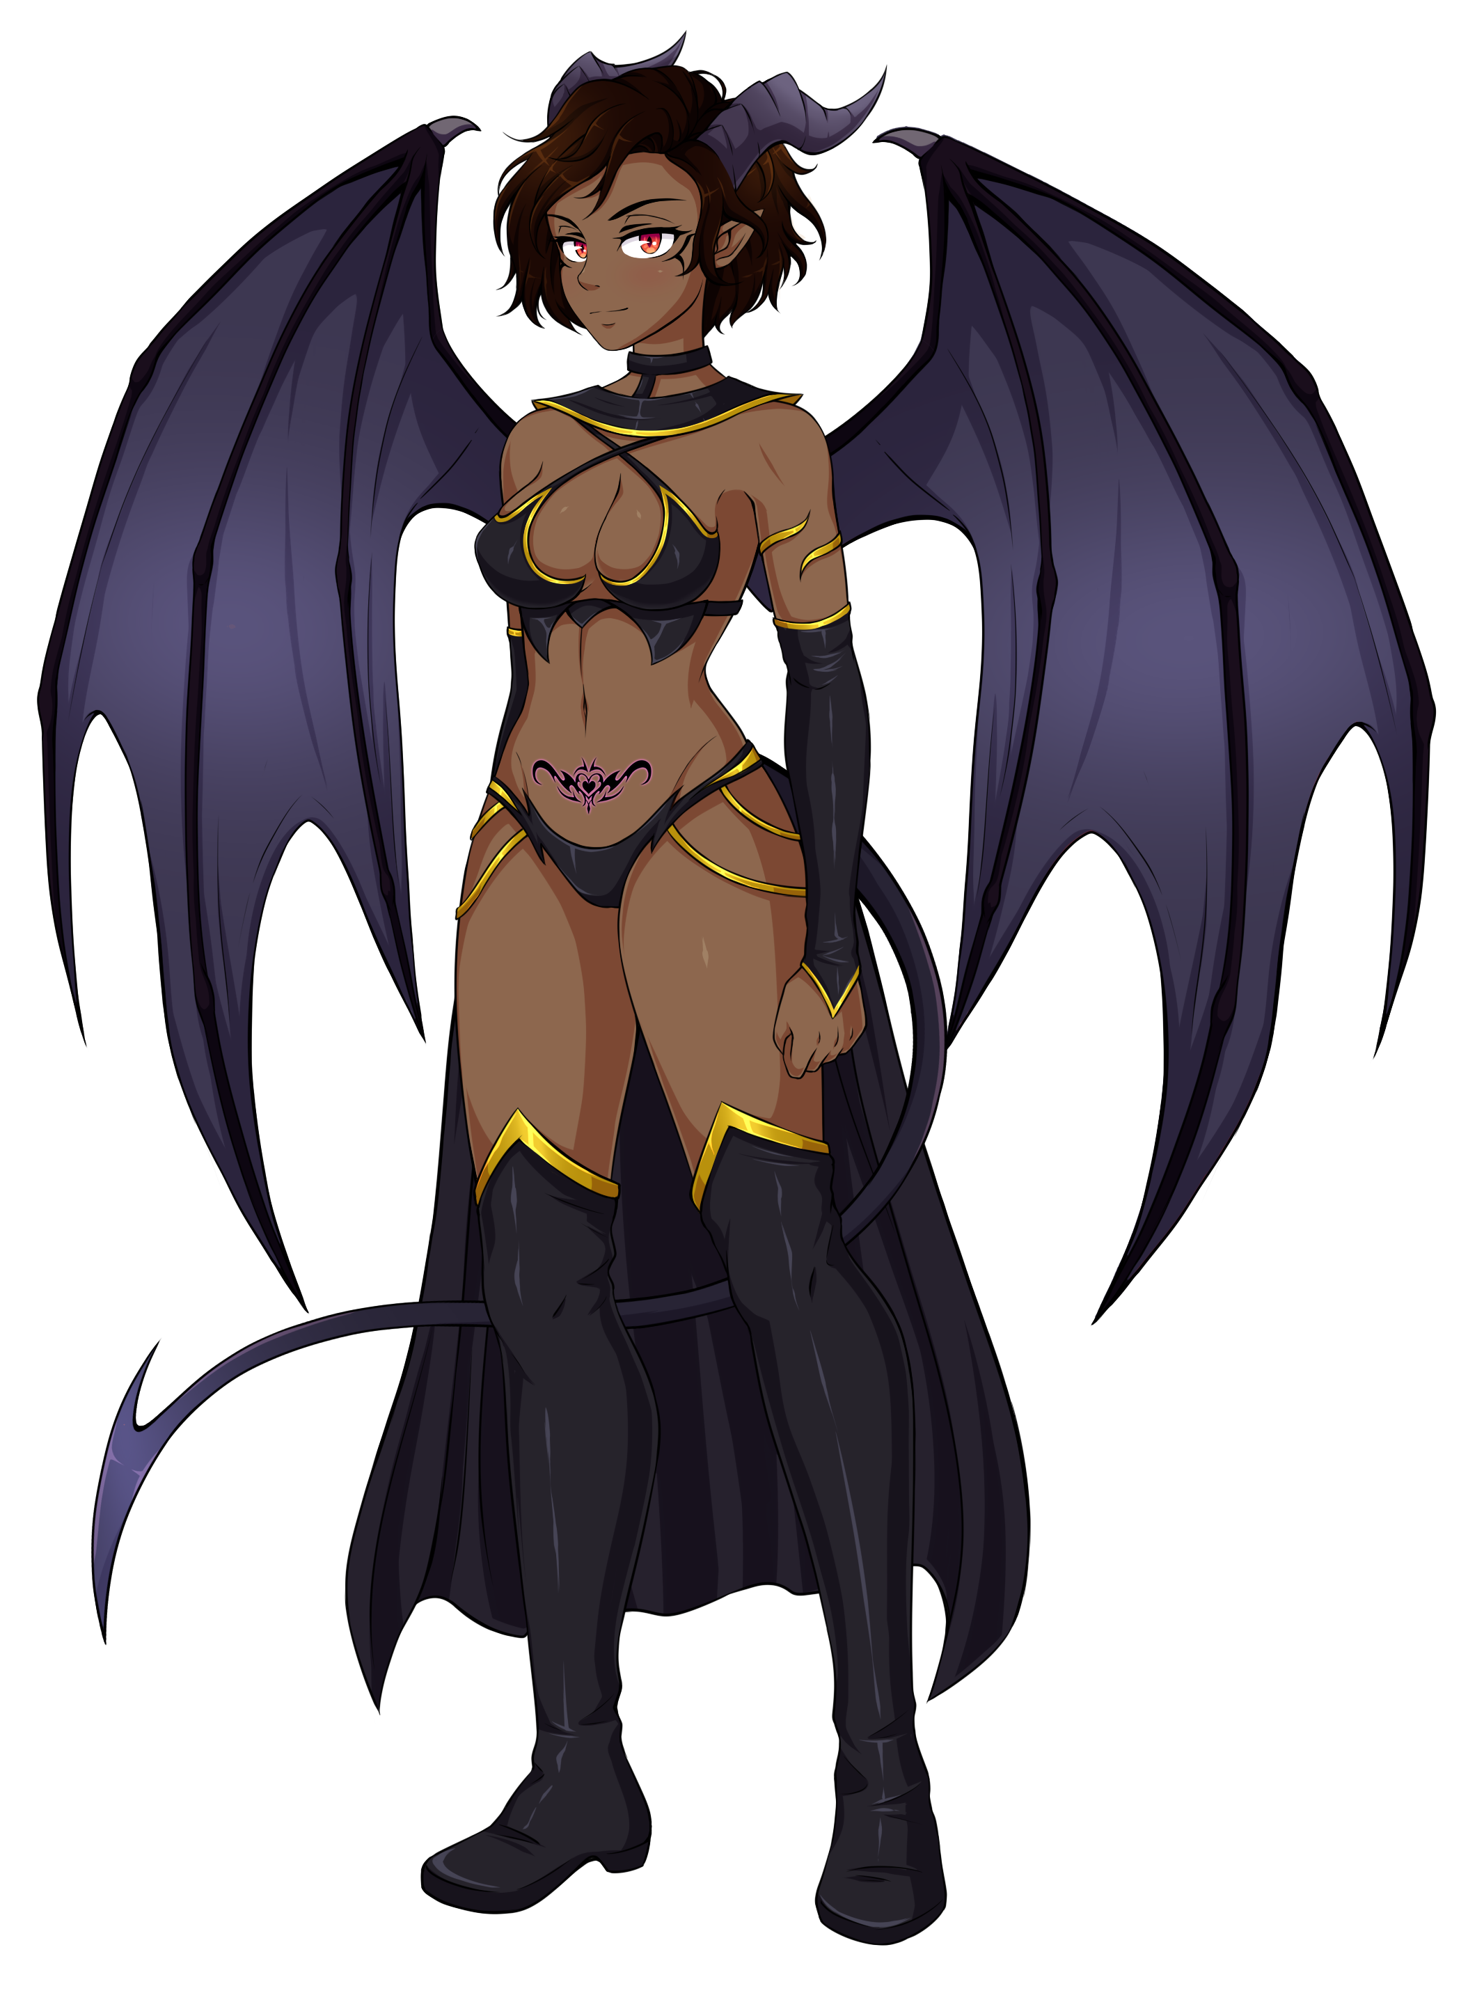The second High Succubus of the Game. Direct servant of the Queen Succubus Qurmenith.
You will find her in Syqua . Make sure to beat at least 4 of the previous succubi. Then use the option available during your stay in Syqua to have a walk to the beach 3 times. Then Nuditon’s event will trigger.
Like Aries, Nuditon deals more damage from the start. Also delivering from her attacks is a bit harder as you should also hit a moving lock after the resist phase. If you miss, the attack keeps going and you’ll have to start again the resist phase.
Be very careful with your vaginal sex attack. It’s still the attack that deals more damage to her, but she replies back with her vaginal sex attack, causing in you almost the same damage you did to her. Fingering her is the best attack to deal damage without consequences for you.
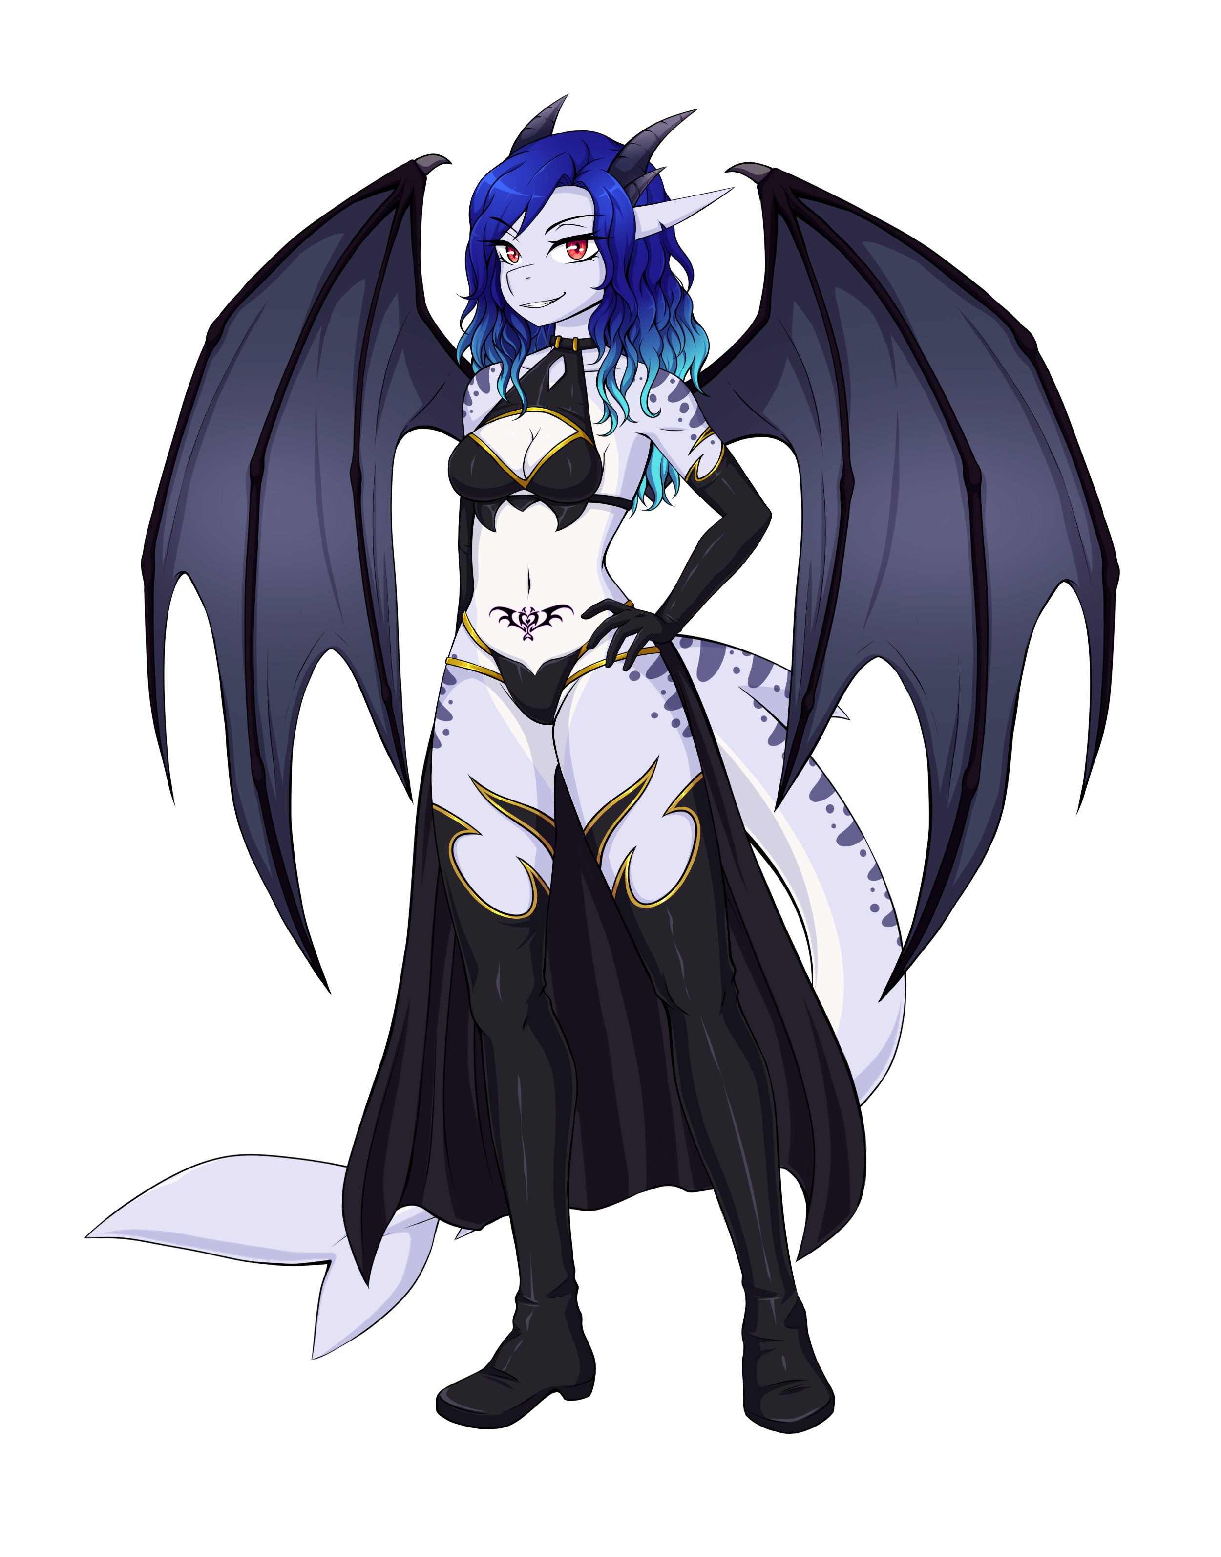

Nerida Sex Battle
3rd High Succubus of the game. You can find her in Siann. Be sure to have defeated 4 succubus before, or she won’t appear. After the battle of Siann, you need to wait at least 3 days, then having exactly 3 action points, go for a walk.

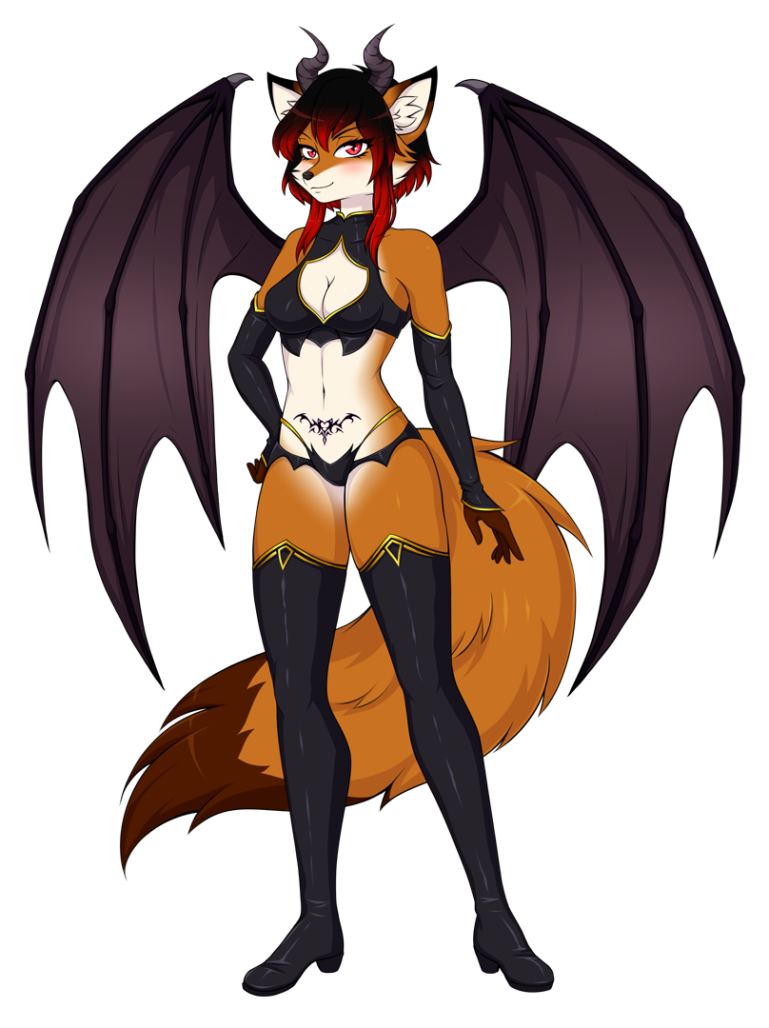
Zharyel Sex Battle
Zharyel is in Geinvrik. After defeating Executor Goriath and defeating 4 previous succubi, visit Geinvrik’s town twice to trigger her event.

QURMENITH BATTLE
After completing the storyline rest and after a few days Qurmenith event will trigger.
Minimum HP needed: 2000 HP (it’s possible with less, but it’s even more challenging…)
Qurmenith defends from your attacks. Guide to avoid her to block your attacks:
Defense position 1 –> available spot
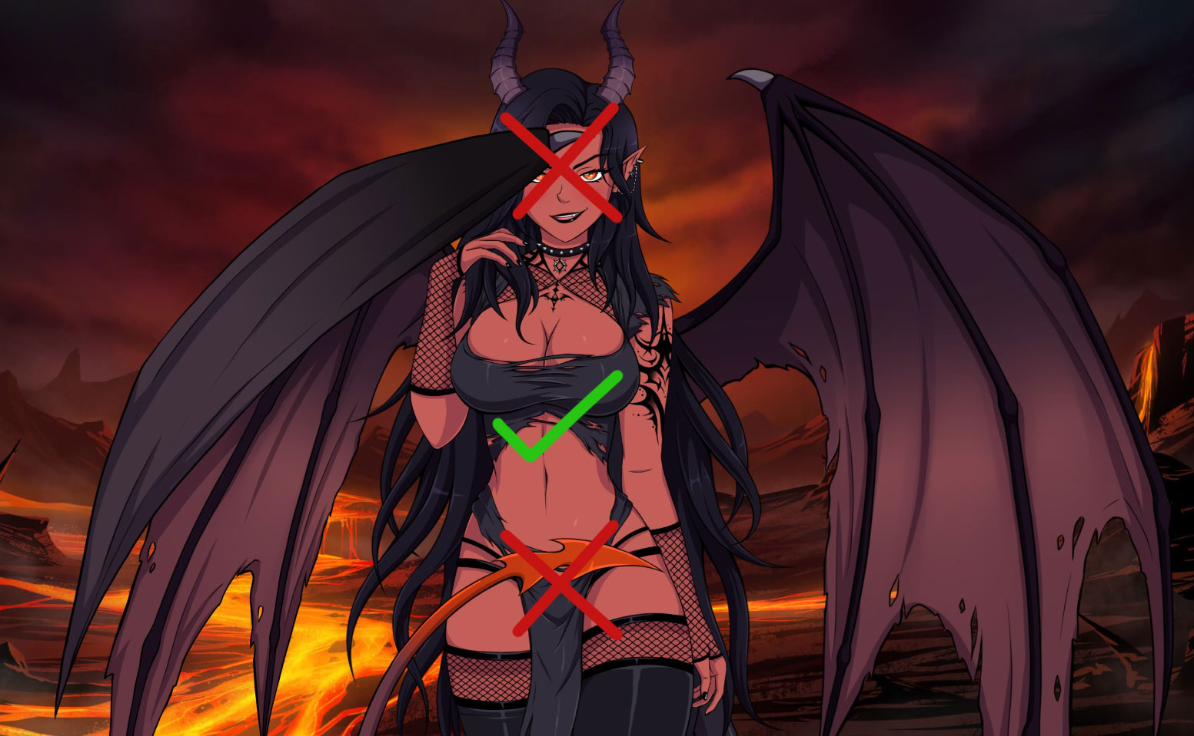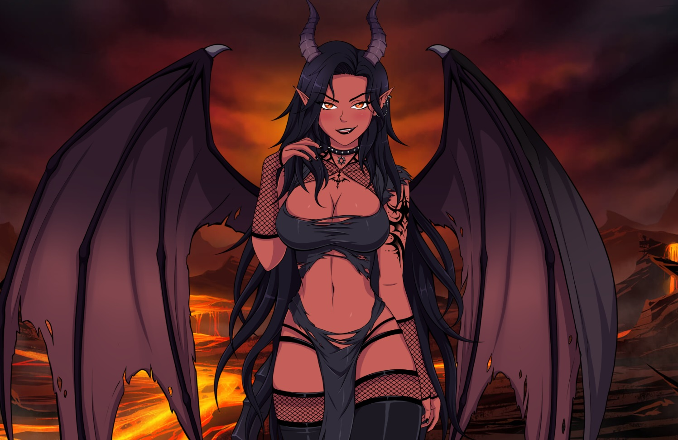

Defense position 2 –> available spot
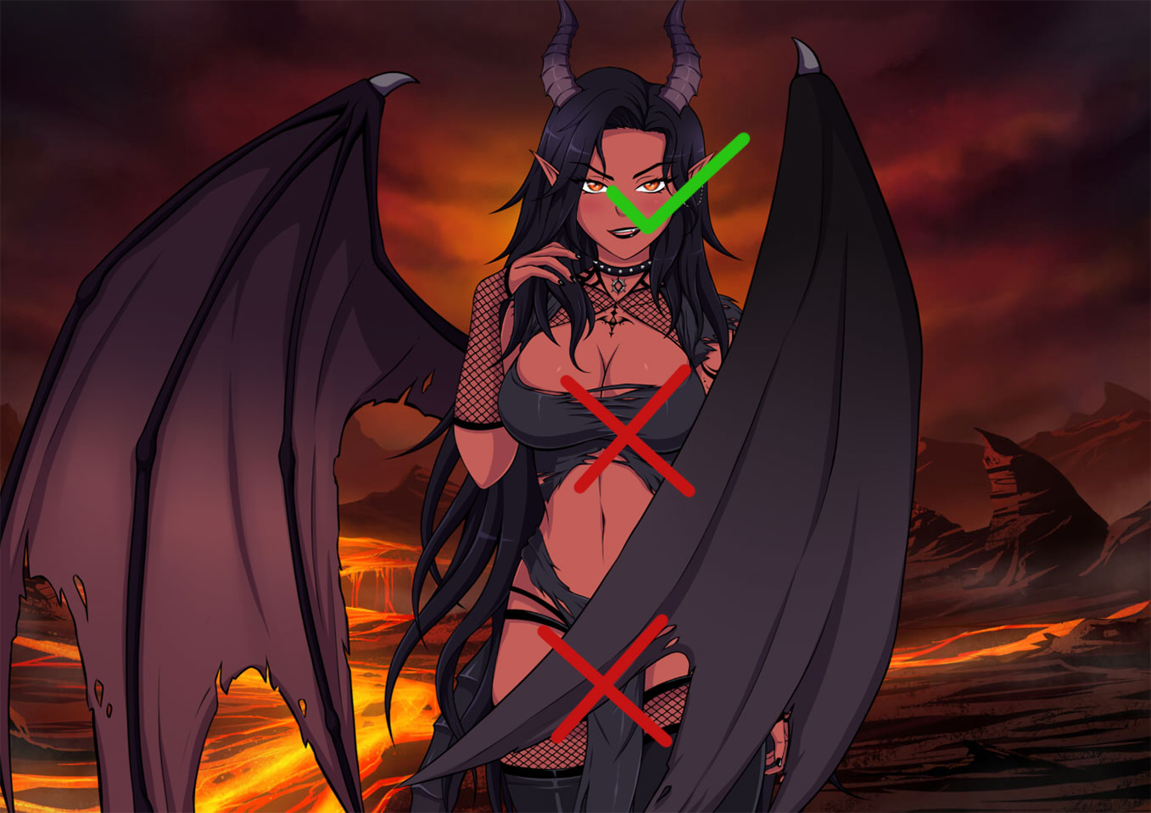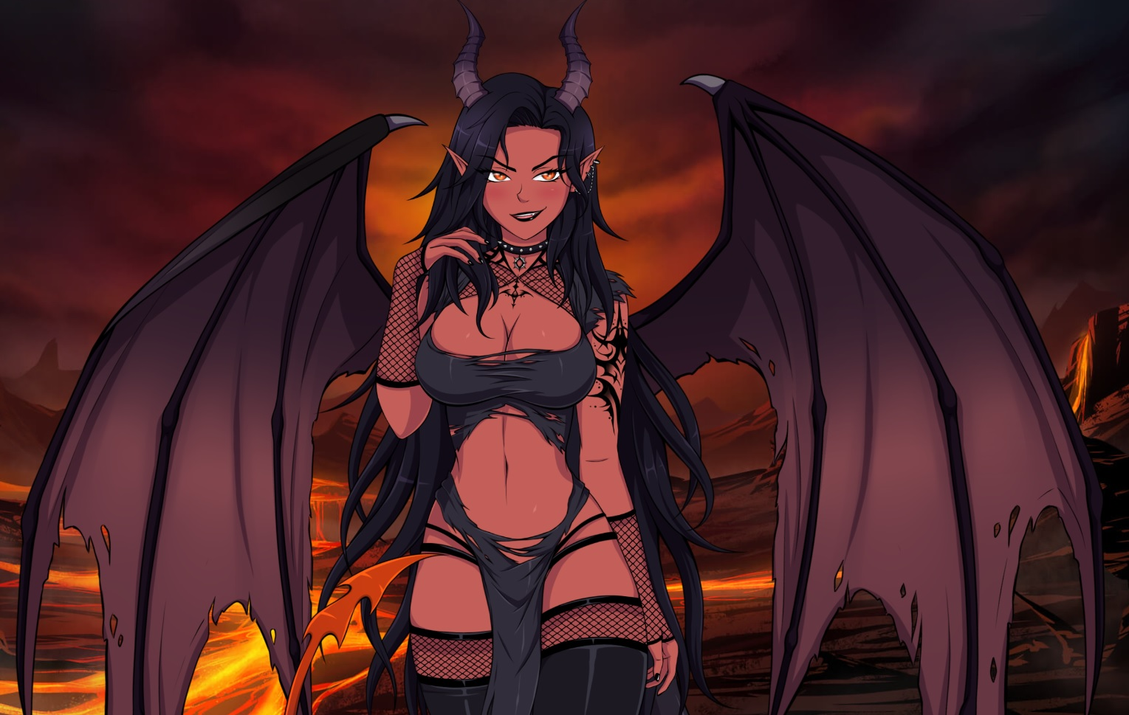

Defense position 3 –> available spot
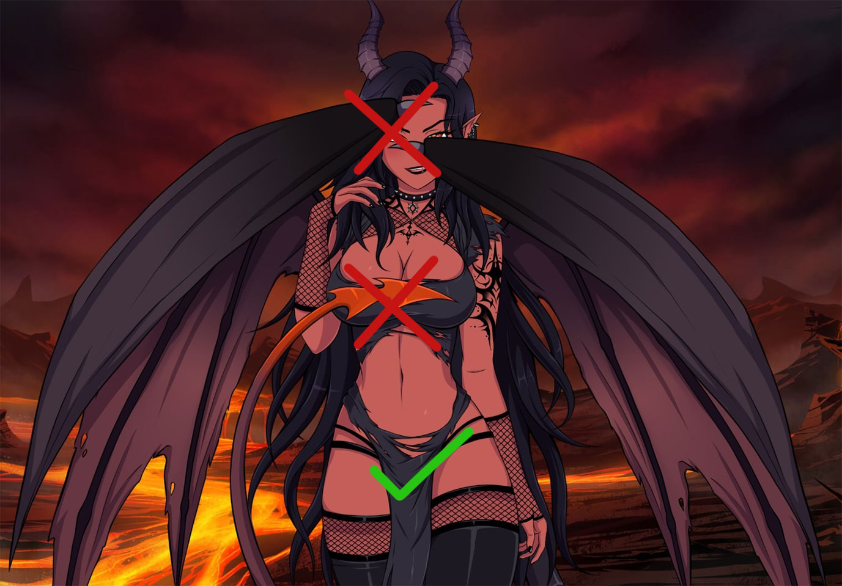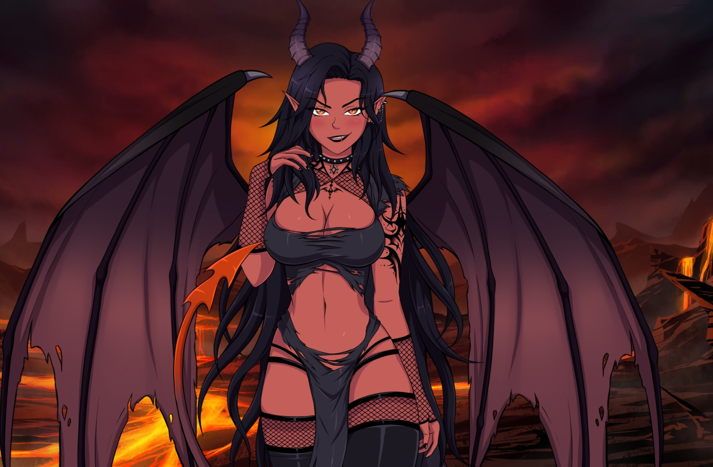

H-scenes with Succubi
Once you defeated a succubus, eventually she will join and they will help you to train your endurance to defeat other succubi. Each girl will perform one of her attack to help Nulkan training.
If you do this at least 3 times, you’ll be able to choose between keep training or skip training to unlock a new H-scene with the Succubus.
In this update the H-scenes available doing this are:
Aurora
Misha
Gifrix
Ione
Zoe
Anwen
Ulaithel
Khara & Maple
Aries
Nuditon
Nerida
Zharyel

Side Events
- Eiha Event: In first place, you need to help Fernian people (after the Battle). Once you are done, Atzi will introduce you to Eiha. After that, investigate the source of the sound after completing the 2nd Date with Atzi. This won’t happen if the camp is in Necrosia.
- Nadine’s Handjob scene: be sure visit her on her tent after winning the battle of Yalen. Accept her to relieve you.
- Dynae Blowjob scene: same than before but this time select the other option. Leave Nadine’s tent and go to your tent.
- Saraith Unleashed scene: This event happens in Zone 2 (right now, just in Fernia). You need to get her affection level above 7 and had been asked about what she’s not into, in the interactions “Questions / Ask me”. Then, you just have a walk and the event should trigger. You can’t get this event in Necrosia.
- Fishing with Atzi: The event triggers when you meet ALL the next requirements.
-Be in Dir-Klou.
-Reach level 5 of affection with her.
-At least 6 days after the battle in Dir-klou.
-After this, she will be outside her tent (bottom right part of the camp). Click on her to trigger the event.
- Stop Nadine’s succubization!: Be sure to get Vega’s event and H-scene (don’t skip the prologue). Then, reach affection to level 6+ with Nadine being in any zone 2 nation (Necrosia, Fernia or Dir-KLou). She will be in the city. She will act a bit suspicious. Look for her in her tent. Depending on the option you choose, the H-scene will be Vaginal Sex or Anal Sex
- Xania’s Event: This one is a bit tricky to get. Requirements:
-Vex at level 6
-In Dir Klou, be friend of the Klouties (Teigan)
-Then give Stardut to Vex. (gifts are bought with crystals in the city)
-Ask Teigan about Xania’s father
- Dynae is learning Potioncraft:
Perhaps one of the most important events. If you keep talking with Dynae in her tent during maximum Zone 1 (Nocverchis and Eldrien), she will eventually tell you about some books Eshimin gave her about Potions crafting. Dynae read about a recipe that could make her be an adult woman like she was before. If you go to Zone 2 before she explains you this, you won’t get the event. To unlock this you’ll need to gather 3 ingredients that can only be found in zone 2 nations. Nulkan needs to have a walk on those nations to find the ingredient. To check what ingredients you have, you can see it at Dynae’s tent. Be careful, remember that if you complete a country and go to the next one, you can’t go back.
On Necrosia Grey Ivy leaves
On Fernia Oak root
On Dir-Klou Denterus Agina sap
Once you’ve found all 3 of them, go back to her tent and the event should start.

- Akila’s blessing. Being in Kemeq and having sex at least 3 times (sex training also counts) will trigger her event. Nulkan will suffer cock pain and Zira will suggest him to visit Akila, the Goddes of Love.

- Najalah, the Artisan Goddess. 5 days after the battle of Kemeq, Zira will come to your tent and tell you there’s a issue with the Kemeqian smithers. Don’t give them money.
Choose : We have our own blacksmiths. We’ll find a way to make it work.
Your corruption should be above 50%, otherwise Najalah won’t be totally satisfied and you won’t see some steps of the H-scene. You can try again once you have more corruption, though. Go to the city to get to Najalah’s temple.

- Lumina the moth girl: to trigger this event you need to be in Necrosia and have a walk. It could take several attempts, but after a few tries the event should trigger.

- Ellie, the raccoon: you need to be in Nocverchis. Then have a walk and the event should eventually trigger.

- Koa’s best friend, Kaika: to trigger this event you should complete date 2 with Koa, first. Then being in Kemeq, you need a level of corruption over 60. The event starts at night.

- Dark magic lessons (Night Queen’s event): complete date 2 with the Night Queen. Then, being in Dir-klou (or Siann, but this nation is not available yet) have a walk at night.
- I have a sandwich for you (Vex’s side event): have quickie sex with Vex (level 7+, interact with her twice with high corruption in her tent…). Do this being in Eldrien, Fernia, Dirk-klou or Siann (Siann is not available yet) and then return to your tent. It will trigger the next day after sleeping, outside your tent.
- The Justice bringer of Yalen, Anya: Complete Yalen part and after that, just visit the city and select explore.

ARMY BATTLE’S GUIDE

After Littanos Battle, all the casualties you will suffer in combat should be replenished. This costs gold. Gold is obtained after each day. The amount of gold you receive each day is increased the more nations are allies of Ashtera. To recruit more soldiers, just visit the city of any of the nations, you will find Hann there and he will get the troops in exchange for gold.

Now, about the new battle system. The basics of this new system are not hard to understand, however, we’ll give you some information that can help you win or minimize the casualties you suffer in each battle.

- The most of the first skills of the heroes generate +25 mana.
- You also get +25 after ending a turn
- When you attack to another melee units with their first skill, you’ll also receive damage.
- Second skills don’t receive reply
- Range units don’t receive reply damage (unless it’s against another range unit)

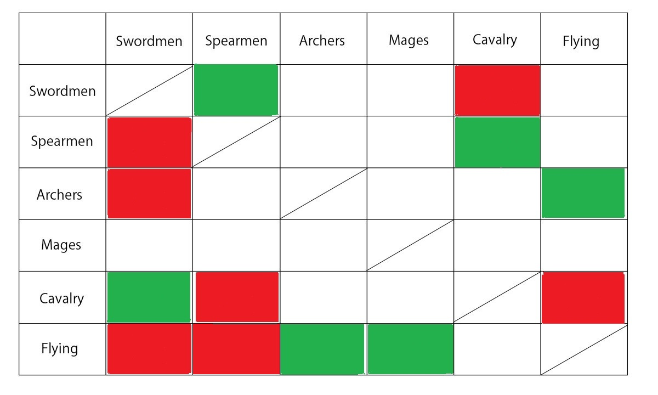And now, here is the table of weaknesses and strengths (the left column is the attacker):

- Green indicates that the squad is effective against the other squad and will cause bonus damage.
- Red indicates that the squad is not effective against the other squad, it will cause less damage and probably receive more damage.
- Empty white slots mean neutral damage.
So you know, look for green combinations and avoid the red ones.

You will also realize that at the beginning of every wave you should make a decision. The effects of these decisions are:

Bertresh Battle

1.1- Wait for it just under the city gate" +50 Mana points
1.2- Go find them” You suffer 300 HP of damage
2.1- Hide behind the walls > +50 Mana points
2.2- Keep fighting You suffer 250 HP of damage

Littanos Battle
1.1-Soldiers, keep your forces! Dynae, keep gathering mana
+50 Mana points
1.2- Start casting spells against them
You start the battle without mana, but you cause 250 HP on the enemy
2.1- Pressure her consumes 25 Mana Points
2.2- Calm her down generates 50 Mana Points
3.1-Araxians! Yalenites! Look how your Executor is trying to run away!!" Some enemy flee. You cause 500 HP on the enemy
3.2- Just focus on your battle Nothing happens

Yalen Battle
1.1-Soldiers, hold position! Dynae, keep gathering mana +75 Mana points.
1.2-Start casting spells against them You cause 250 HP damage to the enemy. Your also empty your mana.
2.2- Defensive tactics! Tortoise formation, now! Minimize the damage taken.
2.1- We'll reach them before the cast anything! Cause damage on the enemy, but you also suffer some damage.

Nocverchis Battle
1.1- Don't worry for us Dynae. Focus on gathering mana. We'll protect you!" +75 mana points.
1.2 -Cast something to scare them! you spent some mana and you also cause 250 HP of damage on the enemy
2.1-Put order Nothing*
2.2-We can only keep fighting Nothing*
*Take into account that, if in this battle you don’t gather the required mana before wave 2 starts, the battle will be lost and you won’t have Nocverchians as allies because you are causing too much casualties.

Eldrien Battle
1.1- We need to stop them before it's too late! You suffer 500HP of damage
1.2- We are facing a dangerous pyromancer!! Shields up, guys! Active defensive tactics
2.1- Shields up! Shields up!! Activate defensive tactics.
2.2 -We need to finish them soon to reach Pyrus! You cause 300 HP of damage to the enemy.
3.1- We have some time to recover +100 Mana points
3.2- Recover youselves, guys. But don't forget about your shields +50 Mana points. Defensive Tactics activated as well.
Note: In this battle on enemy turns 1, 4, 7, 10… (+3) Pyrus will be casting his flames against you. This is a dangerous attack. Be sure to get defensive tactics activated before finishing any of these turns.

Fernia Battle
1.1- Nadine, crush them!! You receive 500 HP of damage.
1.2- Keep position! Activate defensive tactics.
1.3 (Only If Yraselle is in your army)
"Yraselle! Remind them why they should use a shield!" You inflict 450HP of damage.

2.1- Shields up! Shields up!! Activate defensive tactics.
2.2 - We need to reach Jilliana! They won't surrender until we defeat her! You receive 300HP of damage.

3.1- Dynae, focus on gathering more mana! +100 Mana points
3.2- We need to be cautious now +25 mana points. Defensive Tactics activated as well.

Necrosia Battle
1.1 Attack Inflicts 500 damage.
1.2 Defensive formation Start the battle with Defensive Tactics activated.

DirKlou Battle
1.1 Keep position Defensive Tactics activated
1.2 Yraselle! Covering Fire! Inflicts 330 damage to the enemy

2.1 Shields up! Defensive Tactics activated
2.2 Vex, destroy their formation Inflicts 470 damage to the enemy
3.1 Dynae focus gathering more mana! Get 100 mana
3.2Hazel, we are suffering lots of causalities! Recovers 500 HP

Kemeq Battle
1.1 Keep position! Defensive tactics activated.
1.2 Take the city! Attack! Deals 450 of damage, you suffer 50

2.1 Soldiers, hold position! Dynae, keep gathering mana +75mana
2.2 Dynae! Night Queen! Gather all the mana you can! (only available if Night Queen is with you) mana+150

3.1 Shields up, guys! Receive 175 of damage
3.2 Dynae, crush them! Receive 475 of damage

Geinvrik Battle
1.1"Keep position!" Defensive tactics activated
1.2"Show them what we are made of! Attack!" Nulkan attacks

2.1"Dynae, we'll need your magic to take them out! Gather more mana! +75 mana
2.2"Dynae! Night Queen! Gather all the mana you can!" +150 mana
2.3"Shields up, guys!"Reduce damage received

3.1 "Defensive tactic, guys!!" Defensive Tactics activated
3.2"Yraselle! We need to reduce their number!" Yraselle attacks (option available only if you recruited Yraselle)

Siann Battle
1.1"Keep position!" Defensive tactics activated
1.2"Show them what we are made of! Attack!" Nulkan attacks

2.1"Dynae, we'll need your magic to take them out! Gather more mana! +75 mana
2.2"Dynae! Night Queen! Gather all the mana you can!" +150 mana
2.3"Shields up, guys!"Reduce damage received

3.1 "Defensive tactic, guys!!" Defensive Tactics activated
3.2"Yraselle! We need to reduce their number!" Yraselle attacks (option available only if you recruited Yraselle)

About Nulkan’s Corruption System
The Nulkan‘s corruption system indicates how long Nulkan has been without “releasing” the corruption of the demonic sword and armor and how much affected he is.
After each day corruption will be increased 15%. Just make sure to release before it goes to 100%. How? Do any sex scene where Nulkan cums. You can also reduce it with Sex Training.
If the Corruption level reaches 100%, the first time that that happens, Saraith will save you but she will warn you, again.
If it happens a second time, that will mean a game over.
HOWEVER, is it possible that you want your corruption to be above 50% at some times...
Why? Because that’s how you will trigger hidden quick sex scenes (not animated though)
Raise you affection with Saraith, Luth, Nadine, Vex or Yraselle to level 7. If you spend 2 actions with her (let’s say, talk with her, and after that make a question…) and then you kiss her, she will tease you a little bit.
Do exactly this on level 8 when the Corruption is above 50% and Nulkan won’t be able to hold himself after her teasings :P
FREDIC GIFTS GUIDE
Fredic’s gifts are the best way to boost your relationship with the girls and probably the only way to get the most of the content with the most of them once the game it is completed.
There are cheap gifts (10 crystals) and expensive gifts (25 crystals).
From this update on, every girl will have a favorite gift that will give you extra points if you give her that instead of another of the same price. Here you have the guide of favorite items.
Nadine: Knife, Wine
Luth: Scarf, Mithril
Saraith: Scarf, Wine
Vex: Sandwich, Stardust
Yraselle: Flowers, Jewel
Atzi: Knife, Jewel
The Night Queen: Book, Wine
Hazel : Book, Stardust
Teigan: Flower, Stuffed fillet
Jilliana: Knife, Wine
Zira: Flowers, Stardust
Ragna: Knife, Mithril
Koa: Scarf, Stuffed Fillet
Mai and Shun: Flowers, Wine

