ALTERNATE (PATREON VOTED LOSING STORING ARCH)

John and Lucas dripping in sweat and cum are stunned by the realization they have just been caught. Paola with a grunt stands up and turns to the two, John is overcome with emotion and before he starts to speak Paola interrupts him.
“You know, It’s one thing for us to be all in the same room agreeing to have sex with each other but for you to go behind my back with this guy and fuck him, I just don’t know what to think of you John.” Paola questioned as she grabbed her studded purse.
“P-Paola, I-I” John stutters not being able to form a sentence.
“And since when are you gay John!? You didn’t think you’d need to tell me that kind of thing, I don’t know, like when we first started dating?” Paola barks.
“N-Not gay I don’t t-think-“ John says before being interrupted by an angry Lucas.
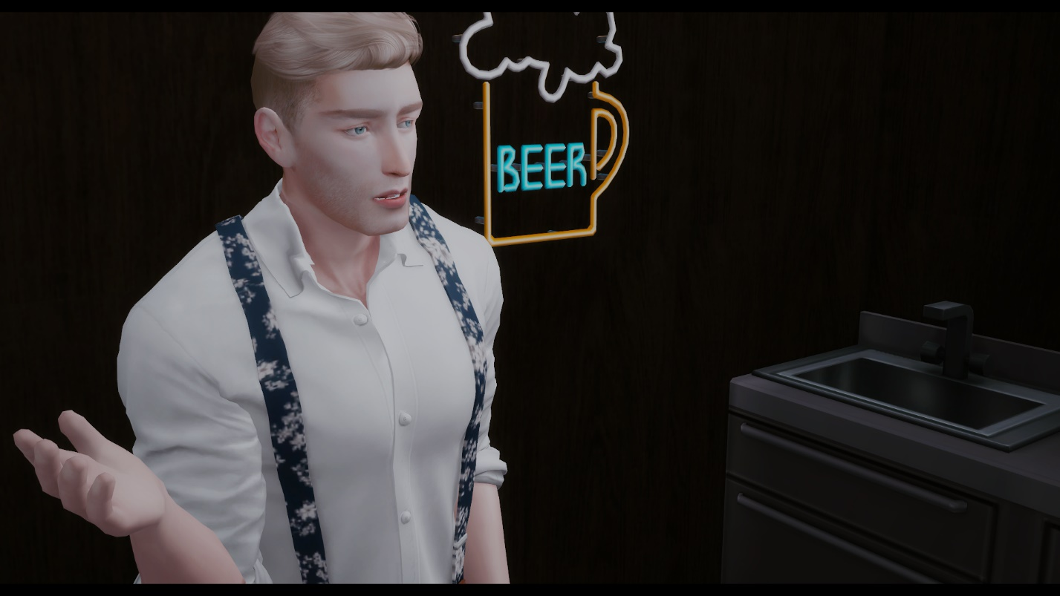

“I really don’t fucking get what’s the deal with you Paola, you let me fuck you before I even met your boyfriend and that didn’t seem to matter” Lucas begins, “ It doesn’t make any sense that you’re now trying to fucking call John out the way you are.”
Paola takes a step back and looks at John who is now stunned by what Lucas just said.
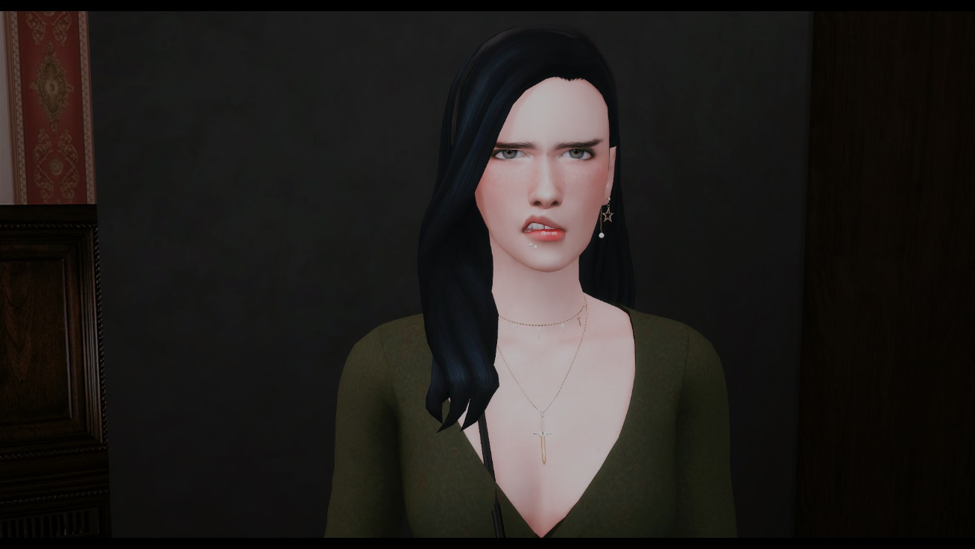
“So you told him about us fucking before that night when you met him?” Paola says “No wonder he’s been acting strange lately. What the fuck happened to keeping it between us Lucas? Huh?” Paola demands.
“You just said I have a boyfriend the first time we met Paola, what the hell is that supposed to mean?” Lucas answered. “It means not to tell him-“ Paola says before getting interrupted “No no, you don’t get to say that now, especially when you asked me if I was ok with having a three way with John.” Lucas barks, “What the hell was I supposed to think?”
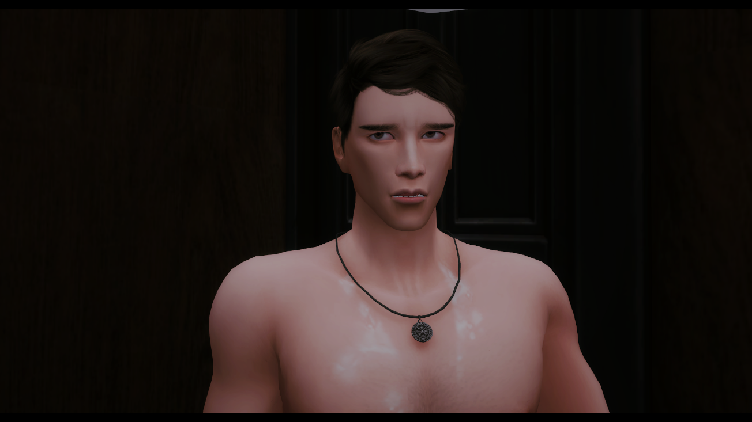
“L-Lucas…” John says in a breathy voice as Lucas continues to ramble at Paola.
“You aren’t being fair to John right now” Lucas finishes.
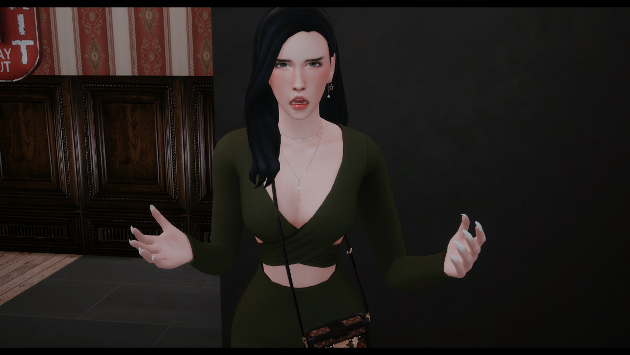
“JOHN!” Paola calls out, “ARE YOU REALLY GOING TO LET THIS PIECE OF SHIT TALK TO ME LIKE THAT AND GET IN BETWEEN US!?”
“WO-HOO, PPIECE OF SHIT!?” Lucas barks back.
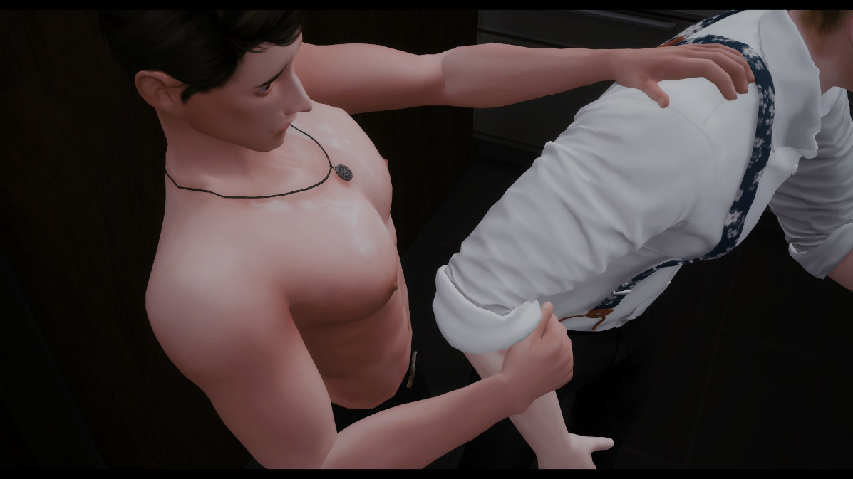
John tries his best to hold back Lucas knowing something like this could only get worse. “L-Lucas pleas-“
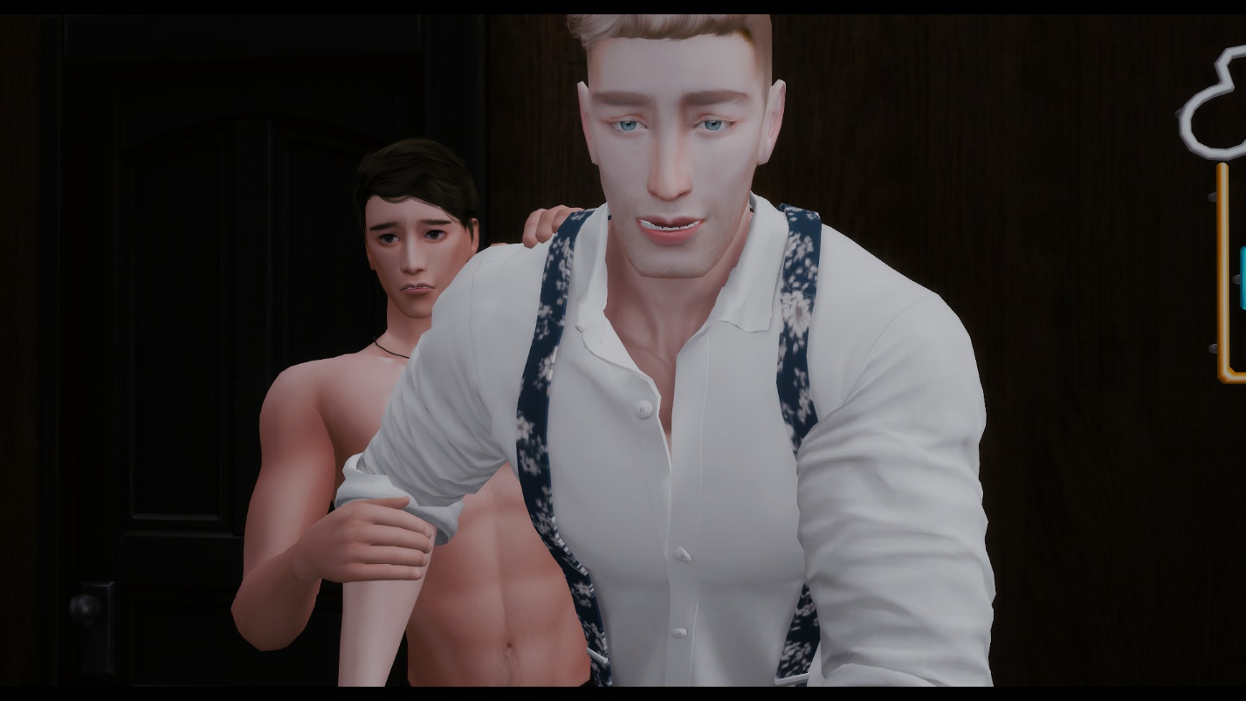
“It’s pretty rich I’m being called a piece of shit when you’re A GOLD-DIGGING MANIPULATIVE BITCH!” Lucas barks, Paola is left speechless. “John doesn’t need someone like you treating him like SHIT!”
The room becomes silent as Paola audibly clenches her first. No words come out of John who’s still holding on to Lucas tight hoping he doesn’t say anything else.
“Yea, I expected nothing would come out of your mouth John, you’re so fucking spineless. I should have trusted what I was told about you from your own family” Paola scolds John who’s beginning to tear “M-my family” John replies.
“So, what now, you two are going to be some kind of gay couple or something? I’m sure your dad would love that idea John.” Paola says, “and I’m sure he’d like to hear about what you’ve been up to instead of what you’ve been telling him.”
Lucas takes a step back realizing he might have messed up. He looks at John and gives him a side hug.
“To tell you the truth I’m tired of playing this little charade John, the way you act with no balls has made me think of you as repulsive.” Paola says, “I know that you know I treat you like shit, but that’s with the condition that you’ll continue letting me do whatever the hell I want.”
“What!?” Lucas says as Paola smirks, “With your knight over here this is going to get pretty tiring fast, so me and you can just end all this here John.” Paola adjusts her purse and dress and turns around. “You guys can continue to butt fuck, I’m leaving” John pushes Lucas away.
Paola exits the Lavender diner while John and Lucas stand awkwardly in the break room.
“L-Lucas, c-can I get the napkins?” John asks.
“Uh- s-sure” Lucas replies as he grabs napkins from the counter drawer and wets them. “ J-ohn I really don’t know what came over me” Lucas says as he tries to clean John’s chest. John grabs the napkins from Lucas’s hand and pushes Lucas’s hand away. “I’m sorry” Lucas says with a faint voice.
“It’s fine” John replies as he turns around and goes back to the storage room for his shirt and cardigan. As John begins to button up his shirt, Lucas walks in trying to gather his thoughts but remains silent. John slips his cardigan as Lucas says. “C-can I take you home John?”
“N-No Lucas” John replies. “I’m sorry you had to get caught in the middle of all this but, I’m going to have to ask you please stay away from me” John says as he adjusted his shirt and walks out of the storage room.
Lucas remains standing in the storage room alone starring at the semen that’s still all over the floor.

