Project Arcade CoinOps Theme Extension Template
This are patch files that will allow addons from Coinops to be used on Project Arcade with a simple copy and paste.
First you need to apply the patch file first before copying or transferring addons coinops.
A typical coinops addon is like:
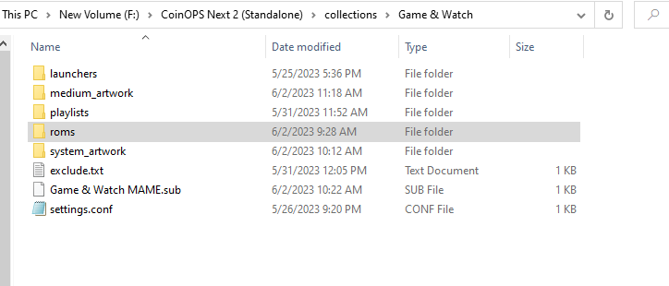
Under the collections folder is the addon folder(Game & Watch as an example) and inside are the primary files namely settings.conf, system_artwork folder and the medium_artwork folder.
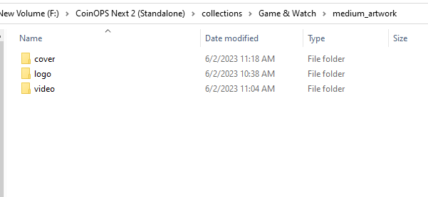
And in the medium_artwork folder there are 3 folders namely cover, logo and video

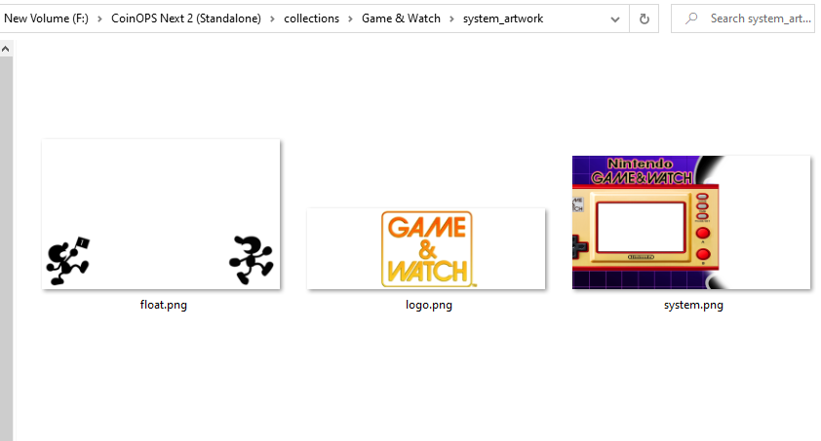
In the system_artwork there the float.png, logo.png and system.png
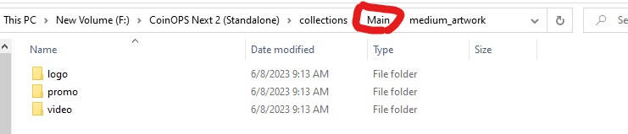
Still under the collections folder is Main folder under it is the subfolder medium_artwork and under it a subfolders logo, promo (fanart/ cover) and video.
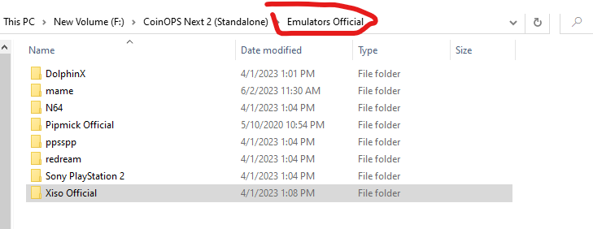
Emulators Official folders, copy this to the root folder if you don’t want to edit the settings.conf of every addon. (Ex: ProjectArcadeBitsBits\Emulators Official.

Just copy the launcher that you need to the equivalent folder for Project Arcade
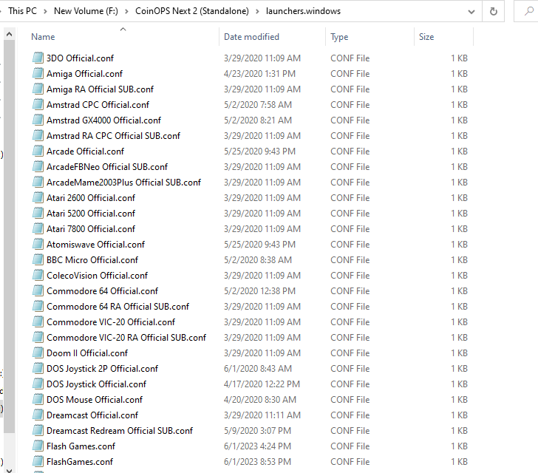

But you can use the existing emulators that came with the base install of Project Arcade with a little tweaking…

Transferring files from Coiops to Project Arcade:
Just copy the whole Addon folder under the collections folder. (Game & Watch as an example below)
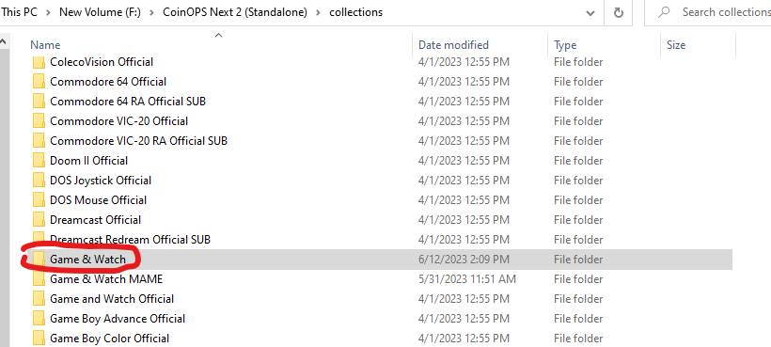

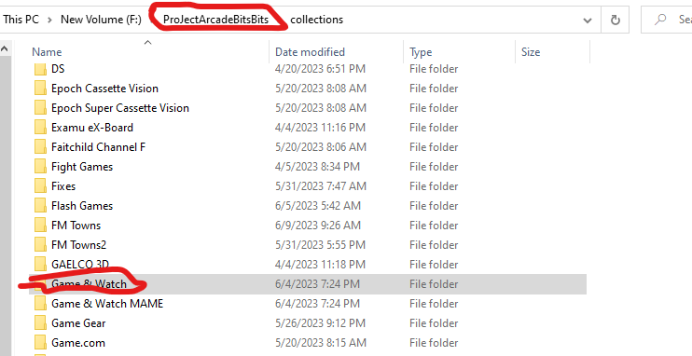
Now copy the files from the Main folder.
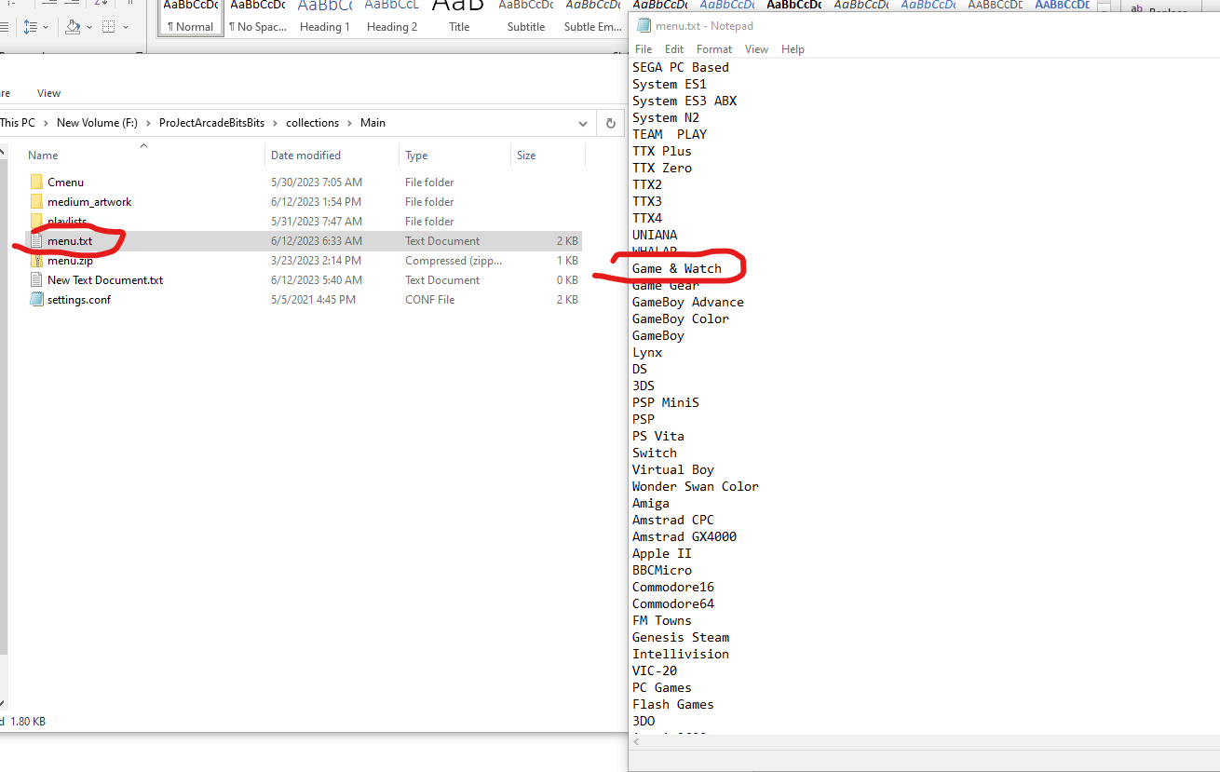
First open the menu.txt with notepad or similar app then add the name of the addon you are adding then save. (See example above)
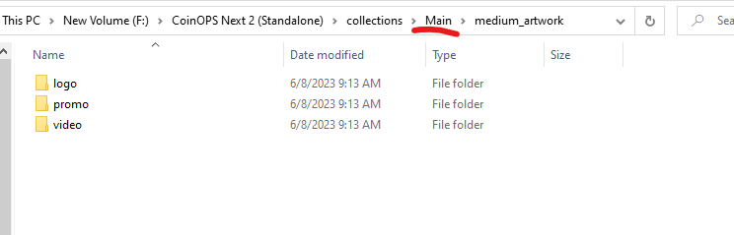
From the folder above
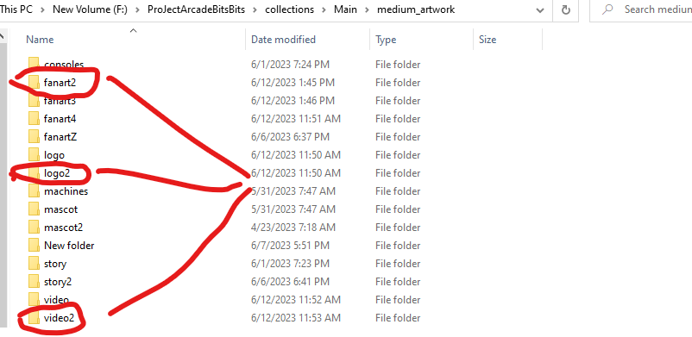
Copy the associated media files to these folders respectively.
Logo to logo2
Promo to fanart2
Video to video2
Important that make sure no default files will be overwritten along the process or it may ruin the theme. So, I recommend to transfer one by one unless you know what you are doing…
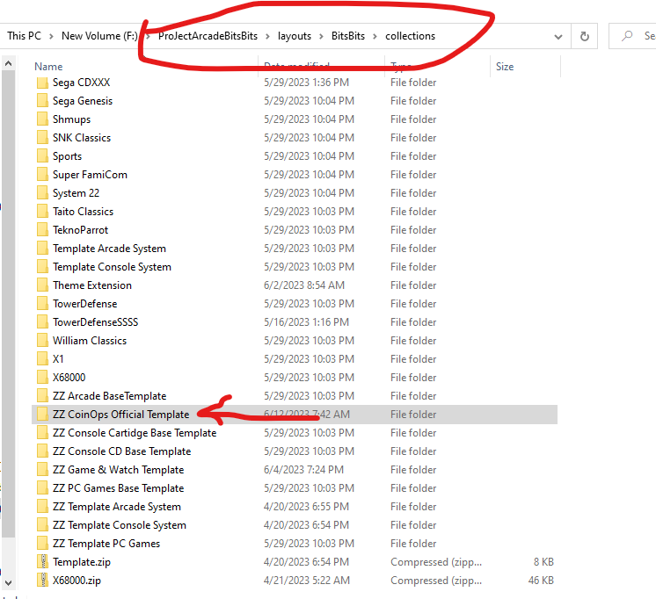
Now got to the ProjectArcadeBitsBits\layouts\BitsBits\collections
You will find the template for coinops.
Just make a copy under the same folder then rename it to what ever the coinops addon you are adding.
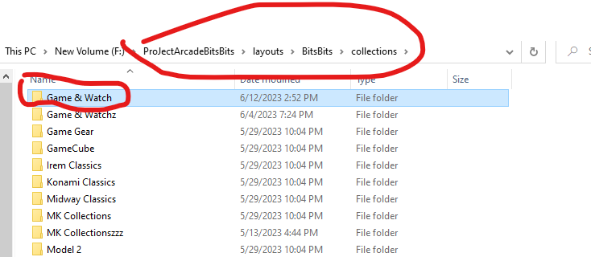
Game & Watch as an example above.

